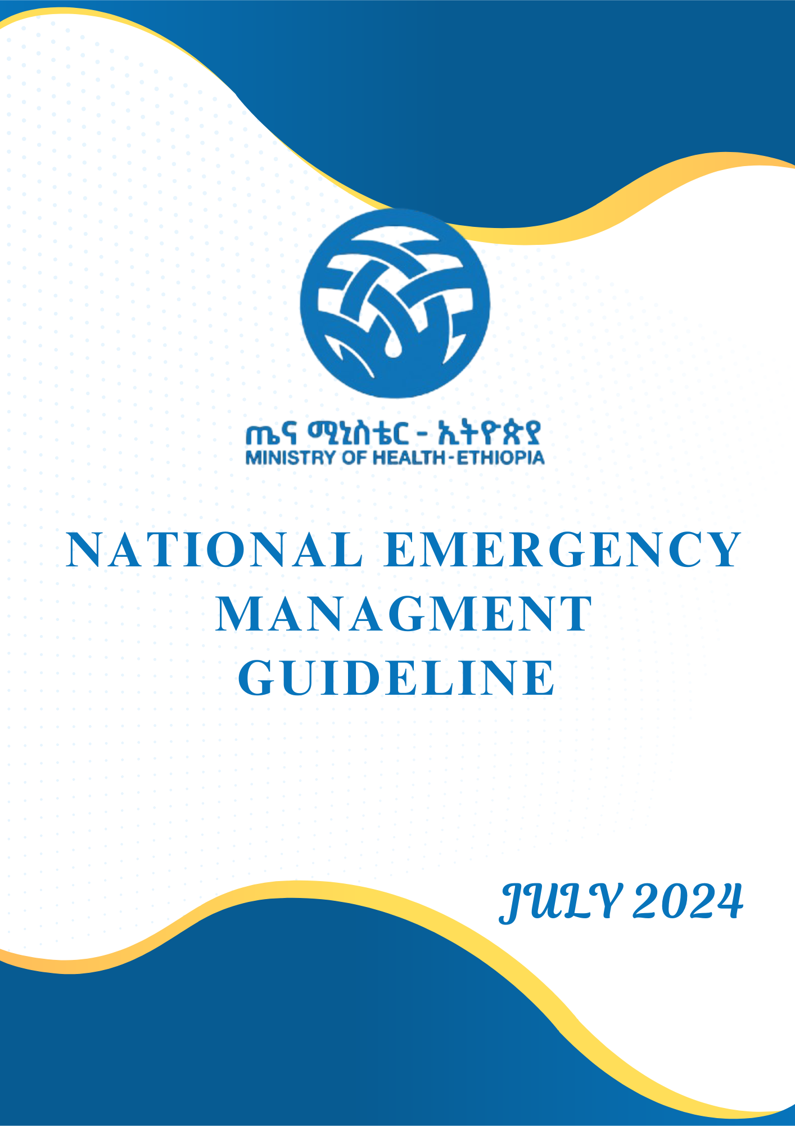
Table of Content

Abbreviations I

Foreword VII

Acknowledgment VIII

Introduction 1

Objectives 2

Scope 3

1. Part One: General Emergency (Pediatric and Adult) 3

1.1. Chapter 1: Triage 3

1.1.1. Introduction 3

1.1.2. Organization and Prioritization of Emergency Patients 4

1.1.3. Clinical Activities of Triage 9

1.1.4. Pediatric Emergency Triage 11

1.1.5. Triage Early Warning Score in Pediatrics 19

1.2. Initial Assessment of the Acutely Ill Patient 20

1.2.1. Introduction 21

1.2.2. Elements of the ABCDE Approach 22

1.2.3. The ABCDE Assessment and Management 22

1.3. Airway Assessment and Management 33

1.3.1. The Difficult Airway 33

1.3.2. Difficult Airway Assessment 33

1.3.3. Rapid-Sequence Intubation Technique and Organization 36

1.3.4. Airway Obstruction 45

1.4 Oxygen Therapy 54

1.4.1. Introduction and Principles of Oxygen Therapy 54

1.4.2. Recommended Management 55

1.4.3. Management of Complications 57

1.4.4. Monitoring Oxygen Administration 57

1.4.5. Disposition 58

1.5. Trauma, Burns, and Poisoning 58

1.5.1. Trauma 58

1.5.2 Traumatic Brain Injury 63

1.5.3. Neck Injury 67

1.5.4. Chest Trauma 71

1.5.5. Abdominal and Pelvic Trauma 76

1.5.6. Musculoskeletal Trauma 78

1.5.2. Burns 79

1.6. Approach to Acute Abdomen and Peritonitis 85

1.6.1. Approach to Acute Abdomen 85

1.6.2. Peritonitis 86

1.7. Musculoskeletal Emergency 88

1.7.1. Compartment Syndrome 88

1.7.2. Acute Limb Ischemia 89

1.7.3. Acute Osteomyelitis 91

1.7.5. Pyomyositis 95

1.7.6. Necrotizing Fasciitis 96

1.8. Ear, Nose, and Throat Emergencies 98

1.8.1 Acute Otitis Media and Mastoiditis 98

1.8.2. Acute Mastoiditis 101

1.8.3 Epistaxis 103

1.8.4. Nasal Bone Fracture 107

1.8.5. Acute Tonsillopharyngitis 110

1.9. Monitoring, Admitting, and Discharging Patients and Medico-Legal 113

1.9.1. Monitoring 113

1.9.2. Documentation and Handling Of Medico-Legal Cases 119

1.10. Infection Prevention and Control in Emergency Department 121

1.10.1. Core Practice 121

1.10.2. Occupational Health 128

1.11. Breaking Bad News 129

1.12. Blood Transfusion 131

1.12.1. Types of Blood Transfusions: 131

1.12.2. Indications for Blood Transfusion in Ethiopia: 131

1.12.3. Transfusion-Related Complications 132

Part 2. Adult Emergency 135

2.1. Respiratory Emergencies 135

2.1.1. Acute Severe Asthma 135

2.1.2. Acute Exacerbation of Chronic Obstructive Pulmonary Disease 140

2.1.3. Pulmonary Thromboembolism 144

2.1.4. Fat Embolism 153

2.1.5. Amniotic Fluid Embolism 154

2.1.6. Air Embolism 155

2.1.7. Pneumonia 157

2.1.8. Acute Respiratory Distress Syndrome 160

2.2. Cardiovascular Emergencies 162

2.2.1. Acute Heart Failure 162

2.2.2 Acute Coronary Syndrome 167

2.2.3. Hypertensive Crisis 175

2.3. Shock 178

2.3.1. Introduction 178

2.3.2 Types of Shock 179

2.3.3. Laboratory/Diagnosis 182

2.3.4. Management of Shock 182

2.3.4. Disposition 187

2.4. Electrolyte Abnormalities 187

2.4.1 Hyponatremia 187

2.4.2. Hypernatremia 190

2.4.3 Hypokalemia (<3.5 meq/l) 191

2.4.4. Hyperkalemia (>5.5meq/L) 192

2.5. Acute Kidney Injury and Other Renal Emergencies 195

2.5.1 Acute Kidney Injury 195

2.5.2. Other Renal Emergencies/Nephrolithiasis and Stones in Lower Urinary Tract 198

2.6. Neurologic Emergencies 204

2.6.1. Stroke 204

2.6.2 Guillain-Barré Syndrome 209

2.7. Endocrine Disease 212

2.7.1 Diabetic Ketoacidosis 212

2.7.2. Myxedema Crisis 214

2.7.3. Thyroid Storm 217

2.8. Infectious Diseases 223

2.8.1. Severe Malaria 223

2.8.2. Relapsing Fever 230

2.8.3. Typhus 231

2.8.4. Typhoid Fever 233

2.8.5. Meningitis 234

2.8.6. Urinary Tract Infection: Pyelonephritis, cystitis, urethritis 237

2.9. Gastrointestinal Emergencies 240

2.9.1. Gastrointestinal hemorrhage 240

2.9.2. Acute Diarrhea 243

2.9.3. Vomiting 247

2.10. Ophthalmic Emergencies 249

2.10.1 Emergencies in Glaucoma 249

2.10.2 The Acute Red Eye 252

2.10.3. Chemical Injuries 256

2.10.4. Orbital and Peri-Orbital Swelling 257

2.10.5. Eye Injuries 258

2.10.6. Pediatric considerations 261

2.11. Dermatological Emergencies 262

2.11.1. Stevens-Johnson Syndrome/Toxic Epidermal Necrolysis 262

2.11.2. Staphylococcal Scalded Skin Syndrome 263

2.11.3. Necrotizing Fasciitis 263

2.12. Psychiatric Emergencies in Emergency Settings 264

2.12.1. Overview 264

2.12.2. Aggressive and Violent Behavior 265

2.12.3. Suicide 268

2.12.4. Delirium 270

2.13. Obstetric and Gynecologic Emergencies 272

2.13.1 Hypertensive Disorder During Pregnancy 272

2.13.2. Antepartum Hemorrhage 281

2.13.3. Postpartum Hemorrhage 285

2.13.4. First Trimester Vaginal Bleeding 291

2.13.15 Abnormal Uterine Bleeding 294

2.13.6. Hyperemesis Gravidarum 294

2.13.7. Labor 298

Part 3. Pediatric Emergency 305

Chapter 3.1. Pediatric Respiratory Emergency Approach to a Child with Respiratory Failure 305

3.1.1. Introduction and Principles of Management 305

3.1.2. Upper Airway Obstruction 306

3.1.3. Lower Airway Obstruction 308

3.2. Pediatric Cardiovascular Emergency 317

3.2.1. Shock in Pediatrics 317

3.2.2. Cardiogenic Shock 319

3.2.3. Distributive Shock 320

3.2.4. Anaphylaxis Shock 320

3.2.5. Septic Shock 321

3.2.5. Obstructive Shock 322

3.2.6. Congestive Heart Failure 323

3.2.7. Hypertension in Children 325

3.3. Fluid Therapy in Infants and Children 329

3.3.1. Introduction and Principles of Management 329

3.3.1. Electrolyte Therapy in Infants and Children 331

3.3.2. Potassium Imbalance 333

3.4. Pediatric Renal Emergency 336

3.5. Pediatric Neuro-Emergency 338

3.5.1. Status Epilepticus in Infants and Children 338

3.6. Pediatric Gastroenterology Emergency 343

3.6.1. Diarrhea 343

3.7. Infectious Diseases 347

3.7.1. Severe and Complicated Malaria 347

3.7.2. Tetanus 349

3.7.3. Measles 351

3.8. Pediatrics Glycemic Control 354

3.8.1. Pediatric Diabetic Ketoacidosis 354

3.8.2. Hypoglycemia 358

3.9. Pediatric Oncology Emergency 358

3.9.1. Hyper Leukocytosis 358

3.9.2. Tumor Lysis Syndrome 360

3.9.3. Superior Mediastinal Syndrome (SMS) and Superior Vena Cava Syndrome (SVCS) 362

3.9.4. Febrile Neutropenia 363

3.9.5. Typhilitis 364

References 365

Annexes 384

Abbreviations
AACG Acute Angle Closure Glaucoma
AAP American Academy of Pediatrics
ABCD Airway, breathing, circulation, and disability
ABGs Arterial Blood Gas
ACLS Advanced Cardiovascular Life Support
AFE Amniotic fluid embolism
AKI Acute Kidney Injury
ALI Acute Limb Ischemia
AMS Altered Mental Status
AOM Acute Otitis Media
AOM Acute Otitis Media
ARDS Acute Respiratory Distress Syndrome
ASIA America Spinal Injury Association
AVPU Alert, Verbal, Pain, Unresponsive
BEMOC Basic Emergency Obstetric Care
BiPAP Bilevel Positive Airway Pressure
BLS Basic Life Support
BMI Body Mass Index
BVM Bag-Valve –Mask
BVM Bag-valve-mask
CABG Coronary Artery Bypass Graft
CBC Complete blood count
CDC Disease Control and Prevention
CDI Central Diabetes Insipid
CES Community Emergency Squad CFAR Community First Aid Responders
CFAR Community first aid responders
CHG Childhood glaucoma
CKD Chronic Kidney Disease
CNS Central Nerve system
COPD Chronic Obstructive Pulmonary Disease
COPD Chronic obstructive pulmonary disease
CPAP Continues Positives Airway Pressure
CPP Cerebral Perfusion Pressure
CPR Cardiopulmonary Resuscitation
CSO Civil Society Organizations
C-spine Cervical spine
CT Computed Tomography
CTA Computed Tomography Angiography
CTPA Computer Tomography Pulmonary Angiography
CVP Central venous pressure
DALYs Disability-Adjusted Life Years
DBP Diastolic blood pressure
DIC Disseminated Intravascular Coagulation
DKA Diabetic ketoacidosis
DMAT Disaster Medical Assistance Teams
DUS Duplex Ultrasound
ECOPD Exacerbation of Chronic Obstructive Pulmonary Disease
ECS Emergency care systems
EFAST Extended Focused Assessment with Sonography in Trauma
EICC Emergency, Injury Critical Care
EMO Extracorporeal Membrane Oxygenation
EMS Emergency Medical Services
EMS Emergency Medical Services
EMT Emergency Medical Technicians
ESI Emergency Severity Index
ESR Erythrocyte sedimentation rate
ETT Endotracheal Tube
FFP Fresh Frozen Plasma
FMOH Federal Ministry of Health
GAS Group A Streptococcus
GBS Guillain-Barré syndrome
GCS Glasgow Coma Scale
GFR Glomerular Filtration Rate
GTP Growth and Development Plan
HBOT Hyperbaric Oxygen Therapy
HDU High Dependency Unit
HICs High-income Countries
HR Heart rate
HSDIP Development and Investment Plan
HSTP Health Sector Transformation Plan
HTS Hypertonic Saline
Hx History
IBW Ideal Body Weight,
ICH Intracerebral Hemorrhage
ICP Intracranial Pressure
ICS Inhaled Corticosteroid
ICUs Intensive Care Units
IOP Intraocular Pressure
IP Infection Prevention
IPC Infection prevention and control
KUB Kidney-Ureter-Bladder
LABA Long-Acting Beta Agonist
LGIB Lower Gastrointestinal Bleeding
LMA Laryngeal Mask Airway
LMICs Low and Middle-Income countries
LMWHs Low-molecular-weight heparins
LPM Liters per minute
LR Lactated Ringer
LUTS Lower Urinary Tract Symptoms
MACE Major Adverse Cardiac Events
MAP Mean arterial pressure
MECIP Major city Emergency and Critical Care Improvement Program
MOH Ministry of Health
MRA Magnetic Resonance Angiography
MSSA Methicillin-Sensitive Staphylococcus Aureus
MV Mechanical Ventilator
NCCT Non-Contrast-Enhanced Computed Tomography
NEICCS National Emergency Injury and Critical Care System
NFA Nasopharyngeal Airway
NGO Non-governmental Organizations
NIPPV Non-invasive positive pressure ventilation
NIV Noninvasive Mechanical Ventilation
NRBM Non-Rebreathe Mask
NSAIDs Non- Steroidal Anti-Inflammatory Drugs
OPA Oropharyngeal airway
ORP Oropharyngeal Airway
PCI percutaneous coronary intervention
PO By Mouth, Orally
PPE Personal Protective Equipment
QI Quality Improvement
RADT Rapid antigen detection tests
RBC Red blood cell
RBS Random Blood Sugar
RHB Regional health bureau
RR Respiratory Rate
RSI Rapid Sequence Intubation
SAH Subarachnoid Hemorrhage
SBP Systolic blood pressure
SDG Sustainable Development Goals
SIRS Systemic Inflammatory Response Syndrome
SJS Stevens-Johnson syndrome
SpO2 Oxygen Saturation
SSSS Staphylococcal Scalded Skin Syndrome
STEMI ST Elevation Myocardial Infarction
STIs Sexually Transmitted Infections
TBI Traumatic Brain Injury
TBSA Total body surface area
TBW Total body weight
TEWS Triage Early warning Score
TEWS Triage Early Warning Score
TIA Transient Ischemic Attacks
TID 3 Times a day
TRALI Transfusion-Related Acute Lung Injury
U/S Ultrasound
UAN Universal Access Number
UGIB Acute upper gastrointestinal bleeding
UHC Universal Health Coverage
VAE Intravascular Air Embolism
VF Ventricular Fibrillation
VS Vital sign
VT Ventricular Tachycardia
WHA World Health Assembly
WHO World Health Organization

Foreword
The Ministry of Health's Medical Lead Executive Office has been working tirelessly to improve emergency medical services across Ethiopia. Although health facilities have existing operating procedures, there has been a lack of standardized guidelines for managing common emergency cases encountered in the emergency room.
To address this critical gap, an easily accessible and practical reference guideline has been developed to empower healthcare professionals to make timely decisions and provide appropriate treatment. The aim is for the National Emergency Management Guideline to play a vital role in enhancing the quality of emergency patient care at health facilities by decreasing unnecessary delays in the provision of lifesaving interventions.
This guideline is intended to be used by all healthcare professionals at all three levels of the healthcare system—primary, secondary, and tertiary—across both public and private health institutions nationwide. It is envisioned that the implementation of this standardized protocol will contribute significantly to improving emergency care and outcomes for the people of Ethiopia.
I would like to express my sincere gratitude to all the individuals and institutions that have made invaluable contributions to the development of this comprehensive management guideline. Your dedication and expertise have been instrumental in bringing this important initiative to fruition.
Lastly, but not least, I special thanks go to Jhpiego Ethiopia RISE Project who support us both financial and technical during the entire time course of revision of this guideline.
Together, we are taking a crucial step forward in strengthening Ethiopia's healthcare system and ensuring that emergency patients receive timely and effective care when they need it most. This guideline represents our unwavering commitment to enhancing the well-being of all Ethiopians and, ultimately, contributing to a healthier and more resilient nation.

Dr. Elubabor Buno Teko (MD, Neurosurgeon, MSc Health Care Quality)

Medical Service Lead Executive Office

Acknowledgment
The MOH would like to express heartfelt gratitude and sincere appreciation to all the experts and members of the National Emergency Management Guidelines Technical Working Group for their valuable contributions and dedicated support in the revision of this National Emergency Management Guidelines. Their expertise, professionalism, and commitment have been instrumental in creating comprehensive and effective guidelines that will greatly benefit emergency care services in Ethiopia.
The Medical Service Lead Executive Office would like to give special acknowledgment to Jhpiego -Ethiopia for their financial and technical support for the revision of the Emergency Management Guidelines.
The Lead Executive Office also gives special acknowledgment to all participants who were involved in facilitating the workshop and incorporated comments to make this Emergency Management Guidelines development a reality.
Finally, we would like to acknowledge the following individuals and their organizations (authors, reviewers, and consultative workshop participants) for their valuable contributions in the preparation of this guideline.
 | Name | Institution
1 | Dr.Elubabor Buno (MD, Neurosurgeon, Medical Service Lead Executive Officer) | Ministry of Health, Ethiopia, Medical Service Lead Executive Office  Email:elubabor.buno@moh.gov.et
2 | Dr. Tigist Bacha (MD, MPH, Associate Professor of Pediatrics, Pediatric Intensivist and Emergency Specialist, Cardiac Intensivist) | Saint Paul’s Hospital Millennium Medical College  Email: tigist.bacha@sphmmc.edu.et
3 | Dr. Tigist Tesfaye (MD, Emergency and Critical Care Medicine Specialist) | Saint Peter Hospital Medical College  Email: tigi_tigist@yahoo.com
4 | Dr. Shimelis Korbo (MD, Emergency and Critical Care Medicine Specialist) | Adama Comprehensive Specialized Hospital  Email: Shimaliskorbu@gmail.com
5 | Degisew Dersso (BSc, MPH) | Ministry of Health, Medical Service Lead Executive Office  Email:degisew.dersso@moh.gov.et
6 | Aman Safewo (BSc, Field Epidemiologist, Initiative Coordinator) | Ministry of Health, Medical Service Lead Executive Office  Email:aman.safewo@moh.gov.et
7 | Ephrem Hassen (BSc, MSc in Critical Care Nurse Practitioner) | Saint Paul’s Hospital Millennium Medical College  Email: Esoeliam4@gmail.com
8 | Dr. Geremew Tarekegne (MD, MPH) | School of Medicine, College of Health Sciences, Addis Ababa University, Advisor  Email: geremewtt@gmail.com
9 | Asrat Fisseha (BSc, MPH) | Ministry of Health, Medical Service Lead Executive Office  Email: asrat.fisseha@moh.gov.et
10 | Dr. Helen Feleke (MD, Pediatrician, Associated Professor of Pediatric and Child Health) | Saint Paul’s Hospital Millennium Medical Collage  Email: yefelekelij@gmail.com
11 | Dr. Mequanent Tariku (MD, OB/GYN) | Saint Paul’s Hospital Millennium Medical Collage  Email: Mequanent.tariku@gmail.com
12 | Dr. Menbue Sultan (MD, MPH, Emergency Medicine Specialist, Intensivist) | Saint Paul’s Hospital Millennium Medical Collage  Email: smenbeu@yahoo.com
13 | Dr. Biruktawit Kebede (Assistant Professor of Internal Medicine, MD, Internist) | Saint Paul’s Hospital Millennium Medical Collage  Email: birukkebatu13@gmail.com
14 | Dr.Fikadu Negash (MD, General Surgeon, MAOL) | Saint Paul’s Hospital Millennium Medical Collage  Email:fikadu.negash@sphmmc.edu.et
15 | Dr. Habtamu Mengie (MD, MPH) | Yekatit 12 Hospital Medical Collage  Email:habtamu.mengie@moh.gov.et
16 | Dr. Yared Boru (MD, MPH, Emergency and Critical Care Medicine Specialist) | Saint Paul’s Hospital Millennium Medical Collage  Email:yared.boru@moh.gov.et
17 | Dr. Muluneh Solomon (MD, Emergency and Critical Care Medicine Specialist) | Saint Peter Hospital Medical Collage  Email: mldawit9@gmail.com
18 | Dr.Nahom Mesfin | Eka Kotobe General Hospital  Email:nahom.mesfin@aau.edu.et
19 | Solomon Abebe (BSc, MPH) | Jhpiego Ethiopia RISE Project)  Email:Solomon.Abebe@jhpiego

Introduction
Ethiopia's health sector has witnessed remarkable developments over the past years, characterized by significant enhancements in the quality and accessibility of healthcare services. This progress is in alignment with the goals of the Health Sector Mid-Term Development and Investment Plan, which aims to elevate the country’s overall health system. A critical area of focus within these improvements has been the advancement of emergency care services, which has seen substantial progress through various strategic initiatives.
Ethiopia's Emergency, Injury, and Critical Care System encompass a spectrum of activities, including pre-hospital care and transportation, initial evaluation, diagnosis, resuscitation, and in-hospital care within emergency departments and intensive care units, as well as an effective referral system. This integrated approach is designed to provide time-sensitive healthcare services for acute illnesses and injuries across all stages of life. It also reflects a holistic approach to injury management, which extends from prevention to rehabilitation.
The prevention of injuries, a vital component of the overall healthcare strategy, involves collaboration across various sectors. In addition, Ethiopia is currently working on a distinct rehabilitation strategy, emphasizing the comprehensive nature of its healthcare approach. In 2016, Ethiopia led the charge in passing a resolution on emergency care at the World Health Assembly, establishing the country's commitment to improving healthcare not only for its own citizens but also on a global scale.
The Ministry of Health, in collaboration with numerous stakeholders, has led transformative efforts such as the Major Cities Emergency, Injury, and Critical Care Program. This initiative is designed to fortify emergency care by fostering continuous capacity building, implementing and supporting quality improvement projects, and providing essential medical equipment. Furthermore, significant investments have been made to renovate emergency departments, ensuring that healthcare facilities are well equipped to manage emergencies efficiently.
A cornerstone of these efforts has been the continuous monitoring and evaluation activities conducted across all levels of health facilities. This proactive approach has been crucial in identifying and addressing challenges in emergency care. As a result, notable improvements have been observed, such as the reduction in the average stay in emergency departments from 18.8 hours in 2023 to 8.17 hours in 2024 and the decline in the emergency department mortality rate from 0.36% in 2021 to 0.24% in 2024.
Emergency care services in Ethiopia have also benefited from strategic investments and reforms. Training programs for paramedics, nurses, and doctors have been intensified, focusing on critical skills such as trauma management, resuscitation techniques, and triage protocols.
Despite these achievements, challenges remain within the emergency treatment system in health facilities. Issues persist, such as resource limitations, infrastructural deficiencies, standardized emergency management guidelines, and the need for ongoing training and capacity building. Addressing these challenges is essential for sustaining progress and further improving the quality of emergency care services in Ethiopia.
To this end, the development of the Medical Emergency Management Guideline aims to provide a standardized and accessible reference for healthcare professionals managing emergency cases. This guideline is intended to facilitate timely decision-making and appropriate treatment, thereby enhancing the quality of emergency patient care across all health facilities in Ethiopia. By standardizing emergency care management, the guideline seeks to reduce unnecessary delays and ensure that patients receive consistent and effective care, regardless of the healthcare facility they visit.

Objectives
- To improve the quality and efficiency of emergency care services across Ethiopia
- To provide a uniform approach to managing common emergency cases encountered within the country's healthier system
- To reduce overall emergency related morbidity and mortality in the country

Scope
The Medical Emergency Management Guideline is applicable across Ethiopia's three-tier healthcare system, encompassing primary, secondary, and tertiary levels of care. It is intended for use by all healthcare professionals per their scope of practices, including those in public and private health institutions. The guideline covers a comprehensive range of emergency care practices, including:
General approach: standardized protocols for triaging patients and conducting initial assessments to determine the urgency and nature of medical emergencies.
Emergency procedures: detailed guidelines on performing critical emergency procedures, such as airway management, resuscitation, and stabilization of patients.
Injury and illness care: protocols for managing various types of emergency injuries and illness, including medical, surgical, obstetric and gynecological, and pediatric emergencies.

1. Part One: General Emergency (Pediatric and Adult)

1.1. Chapter 1: Triage

1.1.1. Introduction
The term “triage” comes from the French word “trier” meaning to sort or choose. It is a method of ranking sick or injured people according to the severity of their sickness or injury to ensure that medical and nursing staff facilities are used most efficiently. In triage, patients with the greatest need are helped first.
Benefits of triage
- Expedites the delivery of time-critical treatment for patients with life-threatening conditions
- Ensures that patients are appropriately prioritized according to their medical urgency
- Improves patient flow and satisfaction
- Decreases the patient’s overall length of stay
- Facilitates streaming of less urgent patients
- Provides a user-friendly tool for all levels of healthcare professionals

Types of triages
Patient to triage
- Patients are relatively stable and can mobilize to the designated triage area
Triage to the patient
- Patients are unable to mobilize to the designated triage area and should be transferred directly to the resuscitation room
- Used less often than patient to triage
What triaging involves
- Controlling the flow of patients through the emergency department
- Rapidly gather sufficient information to determine triage acuity
- Providing first aid or sending patients directly for resuscitation

1.1.2. Organization and Prioritization of Emergency Patients
- The triage nurse should always be available at the triage area with the necessary supplies in place. They need to be attentive to receive the critical patient on arrival.
- All unconscious patients should be evaluated for airway, breathing, circulation, and disability (ABCD) before taking history and vital signs.
- Critical patients should be transferred immediately to the resuscitation area; the triage nurses can do their triage documentation at bedside.
- During assessment/triage of critical patients, conduct primary assessment: ABCD, vital signs, short history about the course of illness or mechanism of injury.
- Evaluate and score the patient's condition using the Triage Early Warning Score (TEWS) (Figure 1).
- Add findings and correlate the patient to the Emergent Severity Index (ESI) (Figure 2).
- Distribute patients to the respective treatment/assessment area according to the color code.
The discriminator list in the emergency triage form generates the actual triage color (red, orange, yellow, green, blue) that determines the severity level and when the patient should be attended to. Discriminators serve as a safety net for those patients with severe enough pathology to be seen more urgently, but whose vital signs didn’t respond to the insult and did not generate an appropriate urgency according to TEWS.
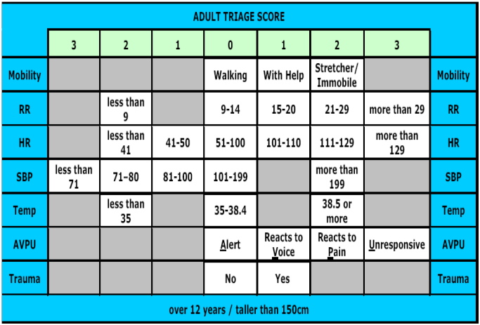
Figure 1.1. Triage Early Warning Score
RR, respiration rate; HR, heart rate; SBP, systolic blood pressure; Temp, temperature; AVPU, alert, voice, pain, unresponsive
TEWS | ESI
≥ 7 | Red
 | Orange
 | Yellow
 | Green
Table 1.1. Correlation of Triage Early Warning Score (TEWS) with Emergency Severity Inde
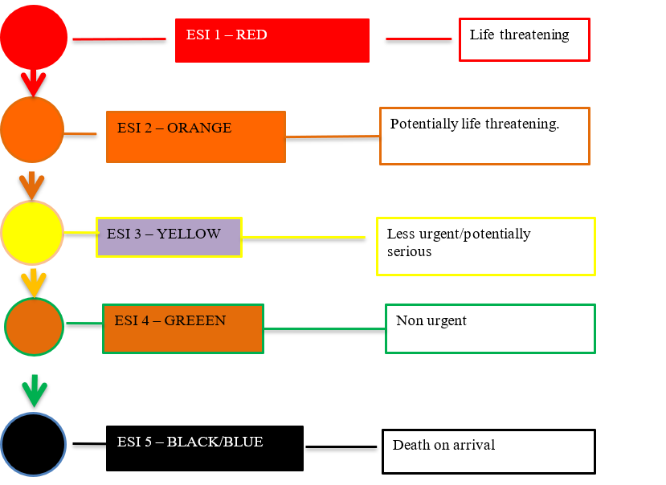
Figure 1.3. Triage priority levels and target times to be seen within
Priority Color | Target Time | Management
RED Tag: First priority  Patients who need immediate care and these patients first and transport. | Immediate | Airway and breathing priorities  Uncontrolled or severe bleeding  Decreased level of consciousness  Severe medical problem  Signs of shock  Severe burns
ORANGE Tag | <10 mins | Younger than 2 months crying/severe pain  More sleepy than normal  Poisoning or Overdose  Focal neurology acute  Severe mechanism of injury  Burns circumferential, electrical, chemical  Eye injury  Fracture – open or threatened limb
YELLOW Tag: Second priority (delayed). Patients whose treatment and transportation can be temporarily delayed | < 1 hour | Burn without airway problem  Major or multiple bone or joint injuries  Back injury with or without spinal cord damage
GREEN Tag: Third priority walking wounded patients.  Patients who do not require any treatment and transportation can be delayed until last. | < 4 hours | Minor fracture  Minor soft tissue injury
BLUE Tag: fourth priority | < 2 hours | Obvious death  Obviously non survival  Respiratory arrest (if limited resource)  Cardiac arrest
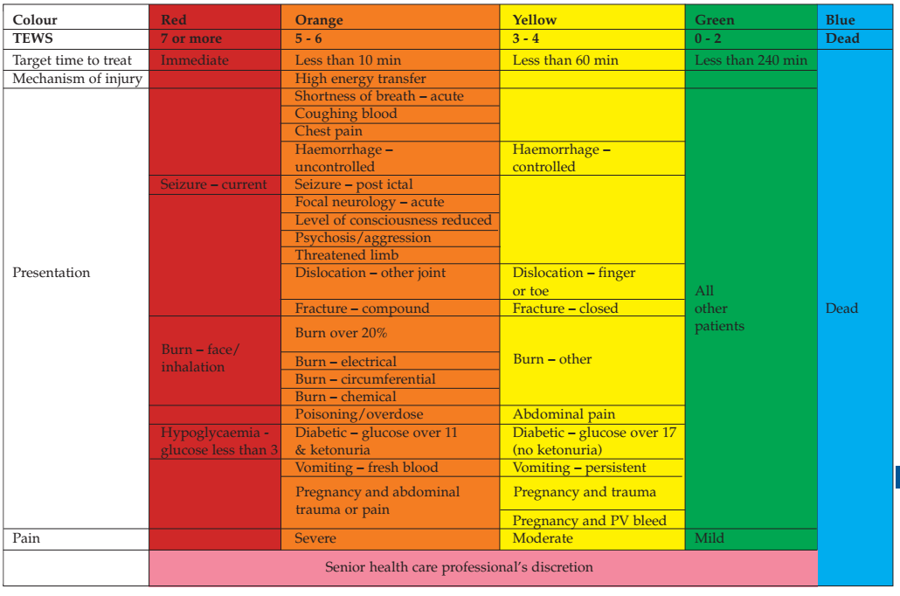
Figure 1.4. Clinical discriminator list

1.1.3. Clinical Activities of Triage
Quick looks for two or more patient’s conditions/presentations in the triage area
- All arriving patients receive a “quick look” to determine ABCD stability and whether they are “Sick.” Sick in this sense means patients have abnormalities in airway, breathing, circulation, and neurological function.
- Emergency patients go immediately to the treatment area.
- The rest are prioritized for a more thorough triage history and assessment.
- Use the simplest method to see the stability of ABC in primary survey by using the 30–2–CAN DO method:
- If an adult patient’s respiration is less than 30 (RR < 30)
- Knows their name and where they are (2)
- Follows verbal command (CAN DO)
- These indicate the patients may have adequate initial oxygenation and perfusion
Conduct the appropriate focused history (Hx) and physical examination (P/E).
- Triage physical assessment
- General appearance
- ABC stability (airway, breathing, circulation)
- Focused P/E
- Pain assessment
Triage history should include:
- Chief complaint
- Pain assessment
- Medications
- Allergies
- Past medical history
Investigations at triage
- Finger pricks random blood sugar (RBS)
Treatment
- Follow the triage protocol
- Secure iv line, start fluid, oxygen administration as indicated
- Medication administration as indicated
Communication for seriously injured/critically ill patient
- When communicating with the receiving area a brief verbal communication should be made with the treating team.
- Patient should be accompanied by triage officer to resuscitation area

Figure 1.5. Step wise approach to triage

1.1.4. Pediatric Emergency Triage
In many hospitals, children are not checked before a senior health worker examines them; as a result, some seriously ill patients must wait a very long time before they are seen and treated. Children are known to have died of a treatable condition while waiting in the queue for their turn. The idea of triage is to prevent this from happening.
Triage is the process of rapidly examining all sick children when they first arrive in hospital to place them in one of the following three categories:
- Those with EMERGENCY SIGNS (E) – require immediate emergency treatment:
- Start to give appropriate emergency treatment. ¬
- Call a senior health worker and other health workers to help. ¬
- Carry out emergency laboratory investigations.
- Those with PRIORITY SIGNS (P) – should be given priority in the queue (rapidly assessed)
- Those who have no emergency or priority signs assigned as QUEUE (Q) – wait their turn in the queue for assessment and treatment.

Triage categories | Action required
Emergency cases | Need immediate emergency treatment
Priority Cases | Need Assessment and rapid attention
Queue cases | Can wait their turn in the que
Table 1.1. Pediatric emergency triage categories
The ABCDO concept
Triage of patients involves looking for signs of serious illness or injury. These emergency signs relate Airway, Breathing, Circulation/Consciousness, Dehydration/Disability, and Other Emergencies, which are easily remembered as “ABCDO.”
Each letter refers to an emergency sign which, when positive, should alert you to a patient who is seriously ill and needs immediate assessment and treatment.
A and B: To assess if the child has airway or breathing problems you need to know: ¬
- Is the child breathing?
- Is the airway obstructed?
- Is the child blue (centrally cyanosed)?
- Look, listen. and feel for air movement. Obstructed breathing can be due to blockage by the tongue, a foreign body, a swelling around the upper airway (retropharyngeal abscess), or severe croup, which may present with abnormal sounds, such as stridor.
- Does the child have severe respiratory distress?
- Are children having trouble catching their breath so that it is difficult to talk, eat, or breastfeed? Are they breathing fast and getting tired, do they have severe chest in drawing or are they using auxiliary respiratory muscles?
C: To assess if the child has circulation problems you need to know: ¬
- Does the child have warm hands? ¬
- If not, is the capillary refill time ≥ 3 seconds? ¬
- And is the pulse weak and fast?

In the older child the radial pulse may be used; however, in infants, the brachial or femoral pulses may need to be felt.
To assess for coma:
- Conduct a rapid assessment of conscious level by assigning the patient to one of the AVPU categories:
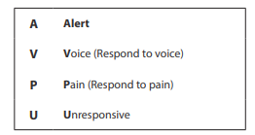
D: To assess for dehydration, you need to know:
- Is the child lethargic or unconscious? ¬
- Does the child have sunken eyes? ¬
- Does a skin pinch go back very slowly? ¬
- Is the child being unable to drink?
To assess for any disability (Ds) for a child with major trauma ¬
- Can the child move their extremities?
O: To assess for other emergency signs, you need to know: ¬
- If the child has active bleeding ¬
- If the child was brought within an hour of ingestion of poison ¬
- If the child has an open fracture
Emergency signs include:
- Obstructed or absent breathing
- Severe respiratory distress
- Central cyanosis¬ signs of shock (cold hands, capillary refill time longer than 3 seconds, weak and fast pulse)
- Coma (or seriously reduced level of consciousness)
- Convulsions
- Signs of severe dehydration in a child with diarrhea
- Disabilities like motor deficit (paraplegia/paresis, hemiplegia/paresis, facial palsy, etc.)
- Other emergency signs (bleeding child, immediate poisoning, major trauma)
- Bleeding child:
- Bleeding due to trauma
- Spontaneous bleeding (epistaxis, hematemesis, rectal bleeding, umbilical bleeding, etc.)
- Immediate poisoning:
- Acute eye or skin poisoning
- Ingested poison within one hour
- Major trauma:
- Compound (open) fracture
- When ABCDO has been completed and there are no emergency signs, continue to assess the priority.
Priority signs
Children with no emergency signs need prompt assessment (no waiting in the queue) to determine what further treatment is needed. These signs can be remembered with the symbols 3 TPR–MOB:
- Tiny baby: any sick child aged less than two months ¬
- Temperature: child is very hot or very cold ¬
- Trauma or other urgent surgical condition ¬
- Pallor (severe) ¬
- Poisoning (other than those who require emergency care) ¬
- Pain (severe) ¬
- Respiratory distress ¬
- Restless, continuously irritable, or lethargic ¬
- Referral (urgent) ¬
- Malnutrition: Visible severe wasting ¬
- Oedema of both feet ¬
- Burns
Triage all sick children. When a child with emergency signs is identified, take them to the emergency room or treatment area and start the appropriate emergency treatments immediately. Do not proceed to the next step before treatment is begun for a positive sign.
If the child has no emergency signs, check for priority signs. After the examination for priority signs has been completed, assign the child to one of two categories:
- Priority (P): if the child has priority signs, the child should be put at the front of the queue
- Queue (Q): if the child has no emergency or priority signs, they should wait their turn in the queue

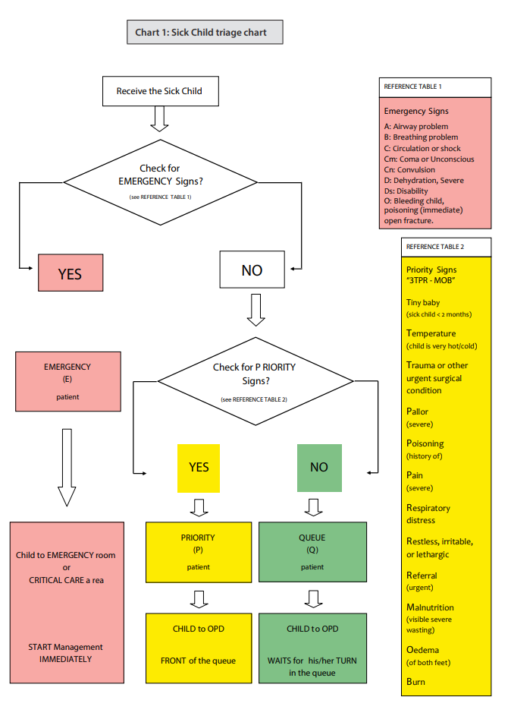

Figure 1.6. Triage chart for sick children

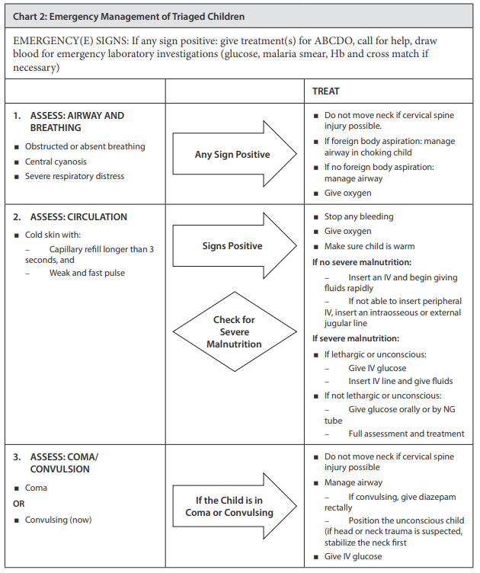
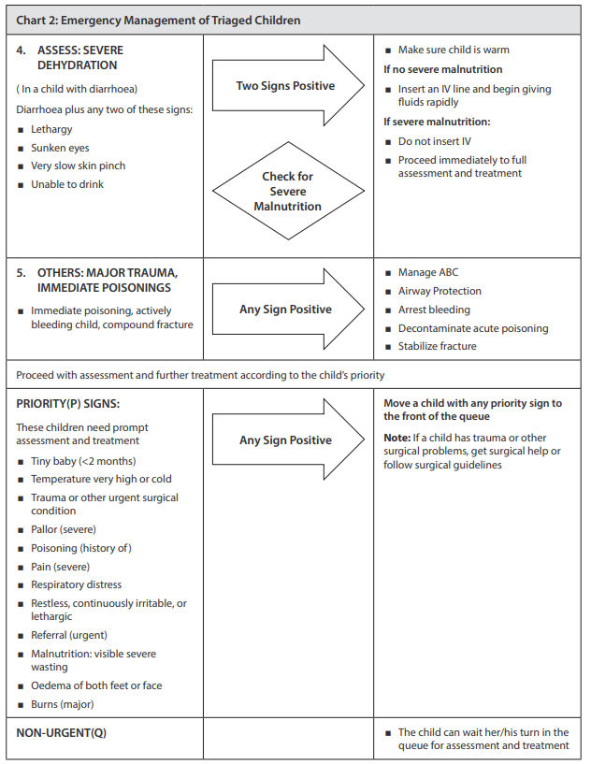
Figure 1.7. Emergency management of triaged children
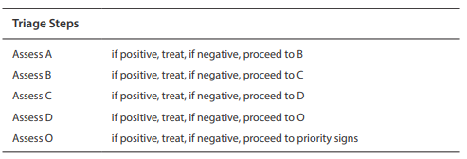
Table 1.2. ABCDO triage steps for children

1.1.5. Triage Early Warning Score in Pediatrics
The TEWS is a composite score representing physiological parameters at triage. There are different age-appropriate versions: the younger child TEWS is for patients smaller than 95 cm or younger than 3 years. The older child TEWS is for patients 96 cm to 150 cm or 3 years to around 12 years, and the adult TEWS is for patients older than 12 years or taller than 150 cm.
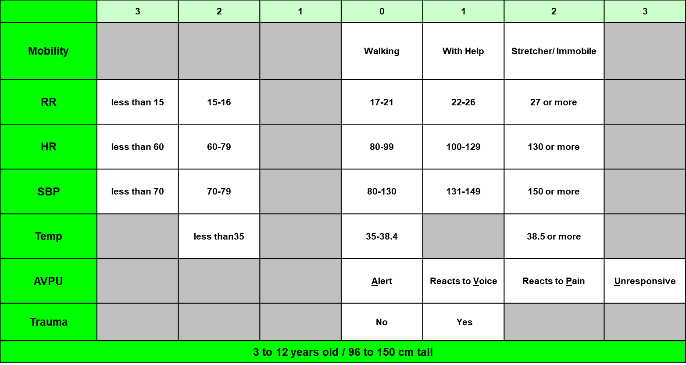
Figure 1.8. Triage early warning score for older children (3 years to 12 years)
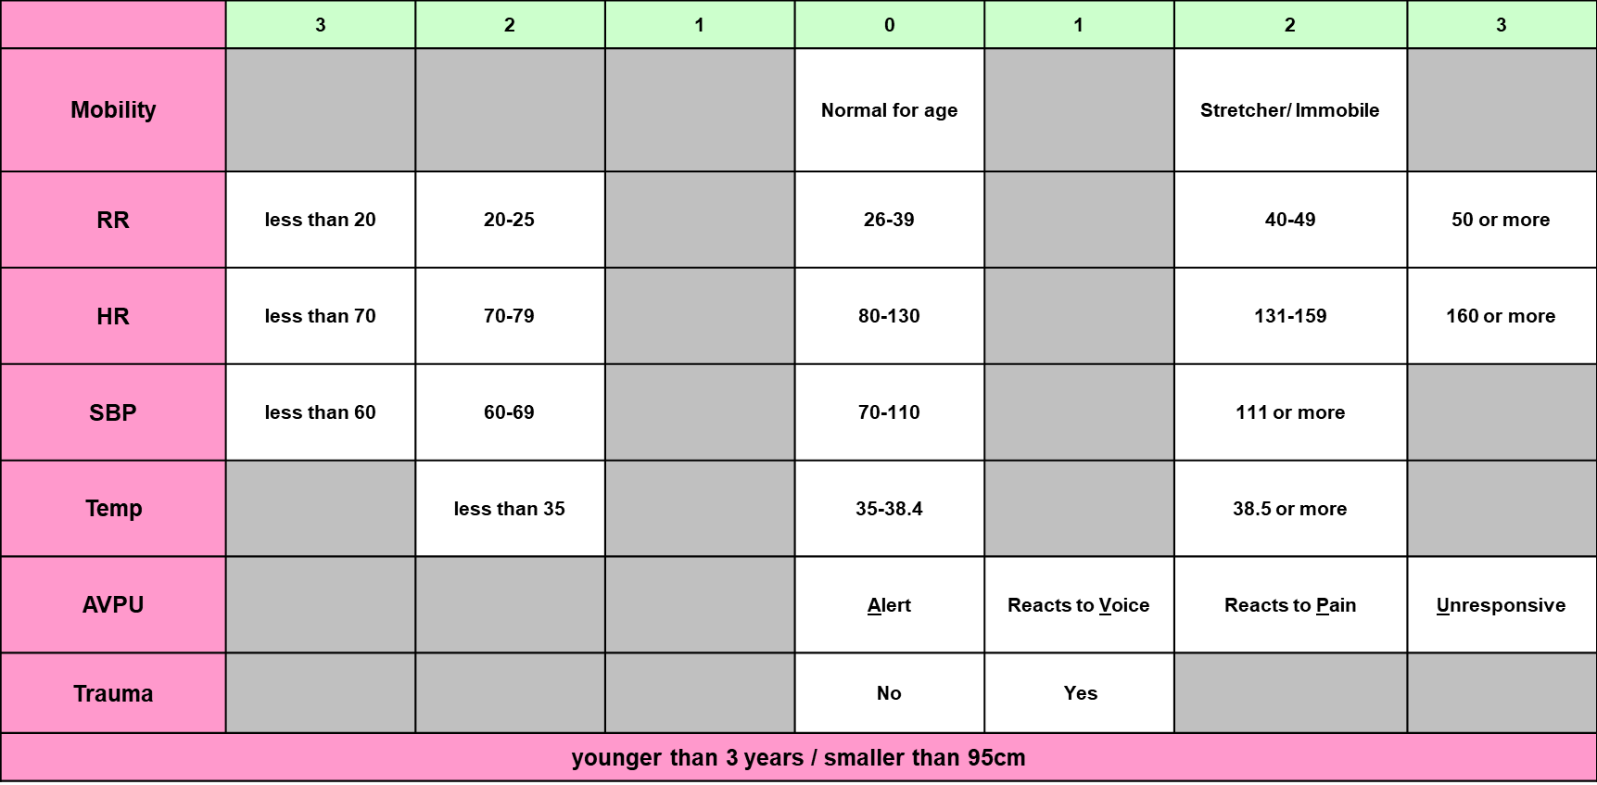
Figure 1.9. Triage early warning score for younger children (younger than 3 years)

1.2. Initial Assessment of the Acutely Ill Patient
Our approach to a critically ill patient needs to be systematic to ensure that life-threatening conditions are recognized promptly and the most critical interventions are done first. The ABCDE (airway, breathing, circulation, disability, and exposure) approach should be followed by a rapid history using the SAMPLE method (sign and symptom, allergies, medications, past medical history, last meal, events). Using these standards ensures that different providers can easily communicate and manage acutely ill patients.

1.2.1. Introduction
Safety considerations
A critical part of the approach to managing any ill or injured patient is keeping providers and others safe as an ill or injured provider will be unable to help anyone. Safety considerations involve checking for:
- Scene hazards:
- Is there a fire, electrical wire or chemical spill that could injure providers or bystanders?
- At a road traffic crash, is the scene closed to oncoming traffic?
- If a building has collapsed, is it safe to enter?
- At the scene of an explosion, always consider the possibility of further explosions. Remember that delayed building collapse may follow explosions, fires, and earthquakes.
- Violence:
- Is there a chance that providers may be harmed by the patient or by others?
- For patients who are aggressive or agitated, request help as needed from security personnel or police before beginning your assessment.
Use of personal protective equipment
- Use appropriate personal protective equipment (PPE) (gloves, eye protection, gown, and mask) every time you approach a patient.
- Always protect yourself from any exposure to bodily fluids.
- Always be sure that you are up to date on current local recommendations.
Cleaning and decontamination
- Infectious disease exposure is a significant risk.
- Use PPE and wash your hands or use alcohol gel cleanser before and after every patient contact.
- Carry an alcohol gel cleanser if hand washing will not be immediately possible.
- In between patients, clean and disinfect all facility and vehicle surfaces and all reusable equipment.
- Decontamination may be required after exposure to pesticides or other chemicals (dry or wet) and depending on the chemical, may include washing or brushing to remove the substance.
Call or ask for help.
- If multiple people are injured or ill, call for help or send someone to call for help.
- If advanced care is needed, begin deciding as early as possible about consultations or transfers.

1.2.2. Elements of the ABCDE Approach
The ABCDE approach is to rapidly identify life-threatening conditions, ensure that the healthcare provider picks up deadly conditions in order of priority and addresses them immediately before moving on to the next step in the first 5 minutes and repeated whenever a patient’s condition changes or worsens.
A – Airway: check for and correct any obstruction to movement of air into the lungs
B – Breathing: ensure adequate movement of air into the lungs
C – Circulation: evaluate whether there is adequate perfusion to deliver oxygen to the tissues; check for signs of life-threatening bleeding
D – Disability: assess and protect brain and spine functions
E – Exposure: identify all injuries and any environmental threats and avoid hypothermia

1.2.3. The ABCDE Assessment and Management


Airway assessment
- Can the patient talk normally?
- If yes, the airway is open
- If the patient cannot talk normally:
- Look to see if the chest wall is moving.
- Look for foreign body or abnormal swelling around the airway.
- Look and listen for fluid (such as blood, vomit) in the airway.
- Listen to see if there is air movement from the mouth or nose, listen for abnormal sounds (stridor, grunting, or snoring) or a hoarse or raspy voice that indicates a partially obstructed airway.
- Stridor plus swelling and/or hives suggest a severe allergic reaction (anaphylaxis).
- Check if the patient can swallow saliva or is drooling.
Principles of management
- NO TRAUMA: open the airway using the head-tilt and chin-lift maneuver.
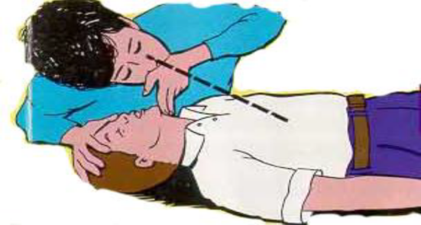
Head-tilt, chin-lift maneuver
- CONCERN FOR TRAUMA: maintain cervical spine immobilization and open the airway using the jaw thrust maneuver.
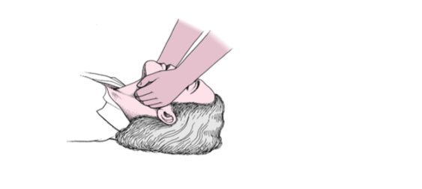
Jaw thrust
NO TRAUMA: infant and children
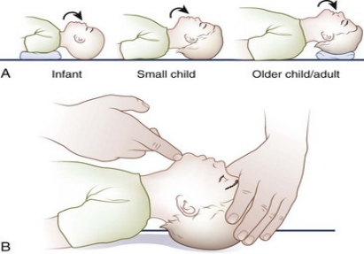
Maintaining the airway
- After opening the airway make sure to place an oropharyngeal airway (OPA) or nasopharyngeal airway (NPA), which are available in different sizes—pediatric and adult—to maintain the airway.
- OPA insertion
- Used in patients who are at a risk of developing airway obstruction from the tongue or relaxed upper airway muscles.
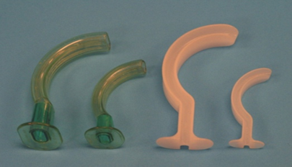
Oropharengeal airway
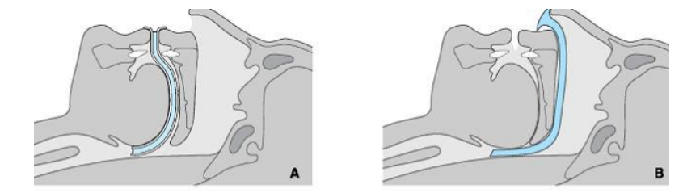
Oropharengeal airway placement
Select the appropriate size, measure from mouth to mandible (1). Insert the OPA convex side up using a tongue depressor or insert the airway upside down (concave side up) until the tip reaches the soft palate (2). Rotate through 180°and slide back over the tongue (3).
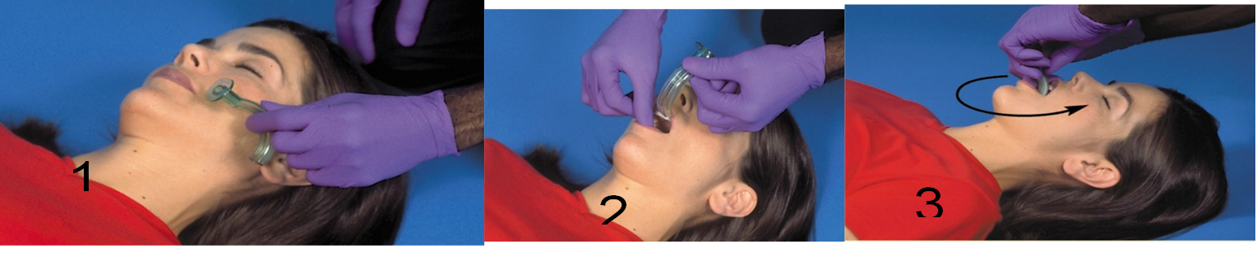
Nasopharyngeal airway insertion
- Used both in conscious and unconscious patients to facilitate deep suctioning.
- It should be avoided in patients with a mid-facial injury, coagulation disorder.
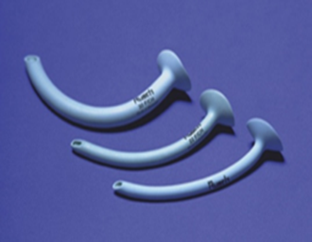
Nasopharyngeal airway
Nasopharyngeal airway placement
- Size: measure from nostril to tragus
- Make sure you have chosen appropriate size of tubes and lubricate with water- soluble jell before insertion.
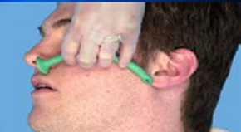
Measure for appropriate size for nasopharyngeal airway
- If foreign bodies are suspected:
- If the object is visible, remove it, be careful not to push the object deeper.
- If the patient can cough, keep the patient calm and encourage coughing.
- If the patient is choking (unable to cough, not making sounds) use age-appropriate chest thrusts/abdominal thrusts/back slaps.
- Heimlich maneuver technique for adults—abdominal thrust
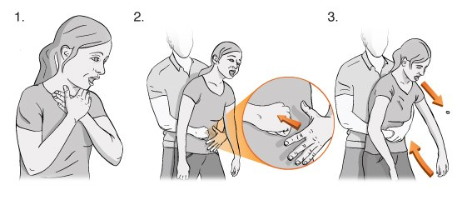
Heimlich maneuver technique for pregnant women—chest thrust
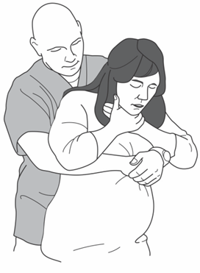
Pediatric chest thrust maneuver for chocking
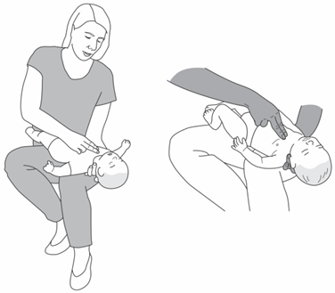
Pediatric back slap maneuver for chocking
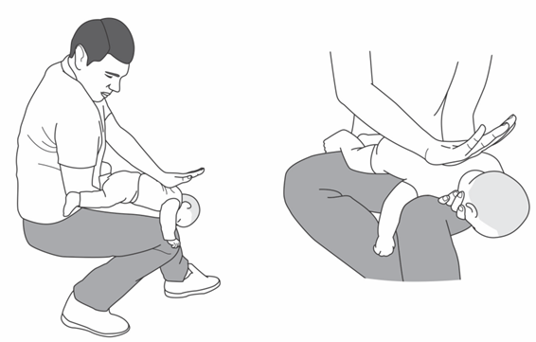
- If the patient becomes unconscious while choking, follow relevant cardiopulmonary resuscitation (CPR) protocols.
- If secretions or vomit are present, suction when available, or wipe clean. Consider placing patient in the recovery position if the rest of the ABCDE is normal and no trauma is suspected.
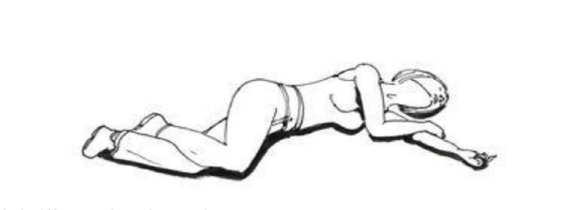

Recovery position
- If the patient has swelling, hives or stridor, consider severe allergic reaction (anaphylaxis), and give intramuscular adrenaline.
- Allow the patient to stay in a position of comfort and prepare for rapid handover/transfer to a center capable of advanced airway management, if needed.



Breathing assessment
- Look, listen, and feel like seeing if the patient is breathing.
- Assess if breathing is very fast, very slow, or very shallow.
- Look for signs of increased breathing (accessory muscle use, chest in drawing/ retractions, nasal flaring) or abnormal chest wall movement.
- Listen for abnormal breath sounds such as wheezing or crackling.
- Listen to if breath sounds are equal on both sides.
- If there are no breath sounds on one side, and hypotension, check for distended neck veins or a shifted trachea (consider tension pneumothorax).
- Check for the absence of breath sounds and dull sounds with percussion on one side (large pleural effusion or hemothorax)
- Check oxygen saturation with a pulse oximeter when available.
Principles of management
- If unconscious with abnormal breathing, start bag-valve-mask ventilation and follow relevant CPR protocols.
- If not breathing adequately (too slow for age or too shallow), begin bag-valve-mask ventilation preferably with oxsygen.
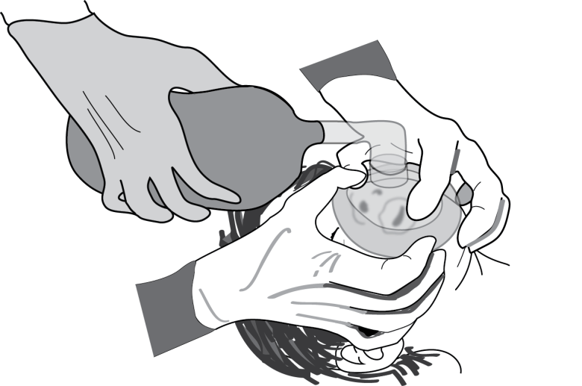
Bag-valve-mask ventilation
- If oxygen not immediately available, DO NOT DELAY ventilation. Start ventilation while oxygen is being prepared.
- If breathing fast or hypoxic, give oxygen.
- If bilateral wheezing, give salbutamol and repeat as needed.
- If concern for severe allergic reaction (anaphylaxis), give intramuscular adrenaline.
- If concern for tension pneumothorax, perform needle decompression immediately and give IV fluids and oxygen.
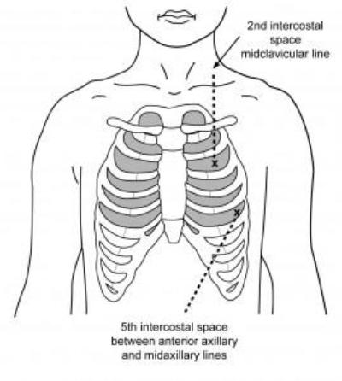
Needle decompression sites
- If concern for large pleural effusion or hemothorax, give oxygen or plan for chest tube insertion or plan for rapid handover/transfer based on the cause and facility’s capability.
- If cause unknown, remember the possibility of trauma.


Circulation assessment
- Look and feel for signs of poor perfusion:
- Cool and moist extremities
- Delayed capillary refill, greater than 3 seconds
- Low blood pressure
- Tachypnea
- Tachycardia
- Absent pulses
- Look for both external and internal bleeding, potential sites for internal bleeding include:
- Chest cavity
- Heart (pericardium)
- Abdomen
- Pelvic
- Long bones like femur fracture
- Look for hypotension, distended neck veins and muffled heart sounds that might indicate pericardial tamponade.
Principles of management
- No pulse or cardiopulmonary arrest, follow CPR protocols.
- If signs of poor perfusion, give IV fluids and oxygen.
- For external bleeding, apply direct pressure, elevate the arm, or use tourniquet in uncontrolled bleeding.
- If internal bleeding or pericardial tamponade are suspected, refer rapidly to a center with surgical capabilities.
- If cause unknown
- Bind pelvic fractures and splint femur fractures or any fracture with compromised blood flow.
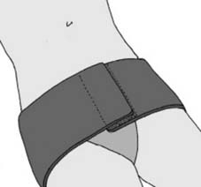
Pelvic binding



Disability assessment
- Assess level of consciousness with the AVPU (alert, voice, pain, unresponsive) or Glasgow Coma Scale (GCS)
- Always check blood glucose level in the confused or unconscious patient.
- Check for pupil size, whether the pupils are equal, and if pupils are reactive to light.
- Check movement and sensation in all four limbs.
- Look for abnormal repetitive movements or shaking on one or both sides of the body (seizure/convulsion).
Principles of management
- If mental status altered and no evidence of trauma, place in recovery position.
- If glucose low (< 3.5 mmol/L) or glucose test not available and patient has altered mental status, give glucose.
- For active seizures, give benzodiazepine.
- If pregnant and having seizures, give magnesium sulphate.
- If pupils are small and breathing slow, consider opioid overdose and give naloxone.
- If pupils are not equal, consider increased intracranial pressure on the brain and raise head of bed 30 degrees.
- If no concern for spinal injury. Plan for rapid transfer to an advanced provider or facility with neurosurgical care.
- If cause unknown, remember possibility of trauma: immobilize the cervical spine.


Exposure assessment
- Examine the entire body for hidden injuries, rashes, bites, or other lesions.
- Rashes, such as hives, can indicate allergic reaction and other rashes can indicate serious infection.
Principles of management
- If snakebite is suspected, immobilize the affected limb.
- Remove constricting clothing and all jewelry.
- Cover the patient as soon as possible to prevent hypothermia.
- Acutely ill patients have difficulty regulating body temperature.
- Remove any wet clothes and dry patient thoroughly.
- Respect the patient and protect modesty during exposure.
- If cause unknown, remember the possibility of trauma: log roll if suspected spinal injury.

1.3. Airway Assessment and Management
The goal of airway assessment is to identify patients who may have difficult airways. It is always necessary to be prepared to manage an unanticipated difficult airway.

1.3.1. The Difficult Airway
An airway is considered difficult when oxygenation and ventilation cannot be achieved in the desired manner.
- A difficult airway, as defined by the American Society of Anesthesiologists, is a situation where a trained healthcare provider has difficulty with a bad-valve-mask, difficulty with tracheal intubation, or both. Other characteristics of the difficult airway include:
- More than two attempts at intubation with the same laryngoscope blade
- Need for a change in blade or use of intubation stylet
- Need for an alternative intubation technique or rescue

1.3.2. Difficult Airway Assessment
General history
- SAMPLE history (sign and symptoms, allergies, medications, past medical history, last meal, events)
- Exercise capacity
- Smoker
Airway compromise
- Upper airway obstruction symptoms: stridor, hoarse voice, orthopnea, drooling, dysphagia
- Risk factors: suspected airway burn, neck trauma or neck surgery
Risk factors for difficult airway management include
- Infections of oropharynx and neck
- Previous surgery or radiotherapy to neck
- Problems with mouth opening, e.g., trauma, soft tissue disorders
- Problems with neck mobility, e.g. cervical spine disruption, rheumatoid arthritis, cervical fusion (e.g., operative, ankylosing spondylitis, scleroderma)
- Obesity, obstructive sleep apnea
- Oropharyngeal or neck masses
- Difficult dentition
- Pregnancy
- Recent intubation (swelling, trauma), angioedema
- Craniofacial syndromes
- Burns
- Airway trauma, blunt or penetrating
- Airway obstruction
Examination
General
- Level of consciousness and co-operation
- Body mass index (BMI)
Face
- Beard
- Craniofacial deformity
Mouth
- Mallampati grade I to IV
- Mouth opening—inter-incisor distance (> 3 cm = good, < 3 cm = bad)
- Shape of palate
- Jaw protrusion
Teeth
- Edentulous
- Teeth prominence (upper incisors) and condition
- Relation of maxillary to mandibular incisors during normal jaw closure
- Dentures/caps/crowns/loose teeth
Neck
- Range of motion of head and neck
- Thyro-mental distance (<6cm- bad, >6cm –good)
- Neck length and circumference/ thickness
- Compliance of mandibular space
- Sternomental distance
Mallampati score
- Used to assess the degree to which the tongue obstructs the visualization of the posterior pharynx and is associated with the ability to visualize the glottis
- Class I: Soft palate, uvula, fauces, pillars visible
- Class II: Soft palate, uvula, fauces visible
- Class III: Soft palate, base of uvula visible
- Class IV: Only hard palate visible
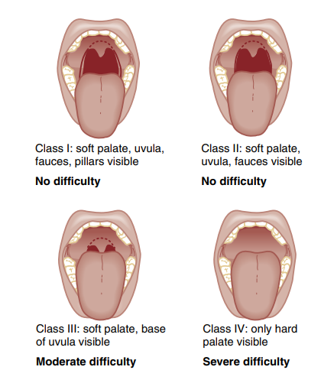

Useful mnemonics

Difficult intubation = LEMON
- Look externally
- Evaluate 3-3-2 rule
- Mallampati score
- Obstruction
- Neck mobility

Difficult BVM = BONES
- Beard
- Obese
- No teeth
- Elderly
- Sleep apnea/snoring
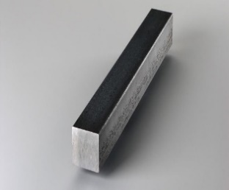
Difficult laryngeal mask airway (LMA) = RODS
- Restricted mouth opening
- Obstruction
- Distorted airway
- Stiff lungs or cervical spine
Difficult surgical airway = SHORT
- Surgery
- Hematoma
- Obesity
- Radiation distortion or other deformity
- Tumor

1.3.3. Rapid-Sequence Intubation Technique and Organization
Rapid-sequence intubation (RSI) is an airway management technique that produces immediate unresponsiveness (induction agent) and muscular relaxation (neuromuscular blocking agent) and is the fastest and most effective means of controlling the emergency airway.
RSI is particularly useful in the patient with an intact gag reflex, a “full” stomach, and a life-threatening injury or illness requiring immediate airway control.
Indications:
- Lack of airway protection despite patency (swallow, gag, cough, positioning, and tone) hypoxia
- Hypoventilation
- Need for neuroprotection (e.g., target PaCO2 35–40 mmHg)
- Impending obstruction (e.g., airway burn, penetrating neck injury)
- Major trauma requiring multiple interventions
- Cervical spine injury (diaphragmatic paralysis)
- Contraindication
Suspected of a difficult airway
- Airway assessment class III–IV
- Morbidity
- Obesity
- Short neck,
- Facial and neck trauma

Remembered as the 9Ps:
- Plan
- Preparation (drugs, equipment, people, place)
- Protect the cervical spine
- Positioning (some do this after paralysis and induction)
- Pre-oxygenation
- Pre-treatment (optional, e.g., atropine, fentanyl, and lignocaine)
- Paralysis and induction
- Placement with proof
- Post-intubation management
Some add a 10th P for (cricoid) pressure after pre-treatment, but this procedure is optional and has many drawbacks.
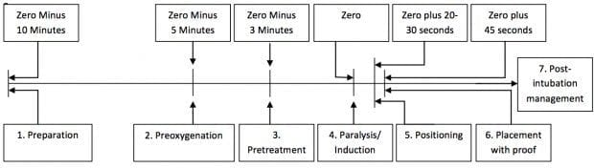
Figure 1.10. Rapid-sequence intubation
Equipment
Make sure you have the following equipment, use the mnemonic for SOAPME and O2 MARBLES:
SOAPME
- Suction – at least one working suction, place it between mattress and bed
- Oxygen – non-rebreather mask and bag-valve-mask (BVM) attached to 15 liters per minute (LPM) of O2, preferably with nasal prongs for apneic oxygenation.
- Airways
- 7.5 endotracheal tube with stylet fits most adults, 7.0 for smaller females, 8.0 for larger males; test balloon by filling with 10 cc of air with a syringe.
- Stylet – placed inside endotracheal tube for rigidity, bend it 30 degrees starting at proximal end of cuff (i.e., straight to cuff, then 30 degree bend)
- Blade – Mac 3 or 4 for adults – curved blade
- Miller 3 or 4 for adults – straight blade
- Handle – attach blade and make sure light source works —
- Backups – ALWAYS have a surgical cric-kit (for cricothyrotomy) available
- Video laryngoscope, LMA, and bougie at bedside
- Pre-oxygenate – 15 LPM non-rebreather mask
- Monitoring equipment/medications
- Cardiac monitor, pulse ox, BP cuff opposite arm with IV —
- Medications drawn up and ready to be given
- End-tidal CO2
O2 MARBLES is an alternative for the equipment and planning:
- Oxygen
- Masks (NP, NRB, BVM); monitoring
- Airway adjuncts (e.g., OPA, NPA, LMA); ask for help and difficult airway trolley
- RSI drugs; resuscitation drugs
- BVM; bougie
- Laryngoscopes; LMA
- Endotracheal tubes (ETTs); end-tidal CO2
- Suction; state plan
Pre-oxygenation
Attach oxygen via nasal prongs. Turn up to MAXIMUM if patient is unconscious or after sedation. Keep this for the entire intubation process.
Spontaneously breathing patient: Position patient as below and allow at least 5 minutes of spontaneous breathing with a tight-fitting non-rebreather mask at MAXIMUM and continue until the patient stops breathing after sedation/paralysis. Avoid positive pressure ventilation if possible.
Patient not breathing or not breathing adequately: Use a BVM with a reservoir and O2 at 15 liters per minute (L/min) to provide one breath every 6 seconds (synchronized to the patient’s breaths) until you can achieve and sustain the highest possible oxygen saturation (SpO2).
Position the patient
- Ensure you have 360-degree access to the patient
- HoP up – Head of patient up to Head of Bed
- HoB up – Head of Bed up 30 degrees,
Reverse Trendelenburg in high BMI, late pregnancy, spinal immobilization

Drug dosages for RSI
- Regarding doses given below:
- Doses shown are for intravenous (IV) administration
- Ideal body weight (IBW), total body weight (TBW)
- Doses may need to be adjusted in the hypotensive or shocked patient
Induction agents:
- Ketamine 1.5–2 mg/kg TBW
- Etomidate 0.3–0.4 mg/kg TBW
- Fentanyl 2–10 mcg/kg TBW
- Midazolam 0.1–0.3 mg/kg TBW
- Propofol 1–2.5 mg/kg IBW + (0.4 x TBW) (others simply use 1.5 mg/kg x TBW as the general guide)
- Thiopental 3–5 mg/kg TBW
Neuromuscular blockers:
- Suxamethonium 1–2 mg/kg TBW
- Rocuronium 0.6–1.2 mg/kg IBW
- Vecuronium 0.15–0.25 mg/kg IBW
Induction agents
Ketamine
- Dose: 1.5 mg/kg IV (4mg/kg IM)
- Onset: 60–90 sec
- Duration: 10–20 min
- Use: any RSI, especially if hemodynamically unstable (OK in traumatic brain injury [TBI], does not increase intracranial pressure [ICP] despite traditional dogma) or if reactive airways disease (causes bronchodilation)
Drawbacks: increased secretions, caution in cardiovascular disease (hypertension, tachycardia), laryngospasm (rare), raised intra-ocular pressure
Thiopental
- Dose: 3–5 mg/kg IV TBW
- Onset: 30–45 sec
- Duration: 5–10 min
- Use: any RSI if hemodynamically stable, status epilepticus
Drawbacks: histamine release, myocardial depression, vasodilation, hypotension, must NOT be injected intra-arterially due to risk of distal ischemia, contraindicated in porphyria
Propofol
- Dose: 1–2.5 mg/kg IBW + (0.4 x TBW) (others simply use 1.5–2.5 mg/kg x TBW as the general guide)
- Onset: 15–45 seconds
- Duration: 5–10 minutes
- Use: hemodynamically stable patients, reactive airways disease, status epilepticus
Drawbacks: hypotension, myocardial depression, reduced cerebral perfusion, pain on injection, variable response, very short acting
Fentanyl
- Dose: IV 2–10 mcg/kg TBW
- Onset: < 60 seconds (maximal at ~5 min)
- Duration: dose dependent (30 minutes for 1–2 mcg/kg, 6h for 100 mcg/kg)
- Use: may be used in a low dose as a sympatholytic premedication (e.g., TBI, subarachnoid hemorrhage [SAH], vascular emergencies)
Drawbacks: respiratory depression, apnea, hypotension, slow onset, nausea and vomiting, muscular rigidity in high induction doses, bradycardia, tissue saturation at high doses
Midazolam
- Dose: 0.3mg/kg IV TBW
- Onset: 60–90 sec
- Duration: 15–30 min
- Use: not usually recommended for RSI, some practitioners use low doses of midazolam and fentanyl for RSI of shocked patients
Drawbacks: respiratory depression, apnea, hypotension, paradoxical agitation, slow onset, variable response
Etomidate
- 0.3mg/kg IV
- Onset: 10–15 seconds
- Use: suitable for most situations including hemodynamically unstable, other than sepsis or seizures
Drawbacks: adrenal suppression, myoclonus, pain on injection
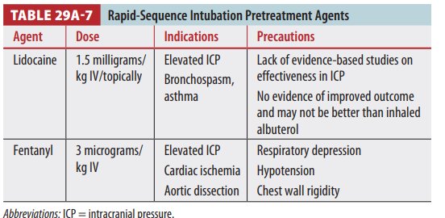
Table 1.3. Rapid-sequence intubation pre-treatment agents
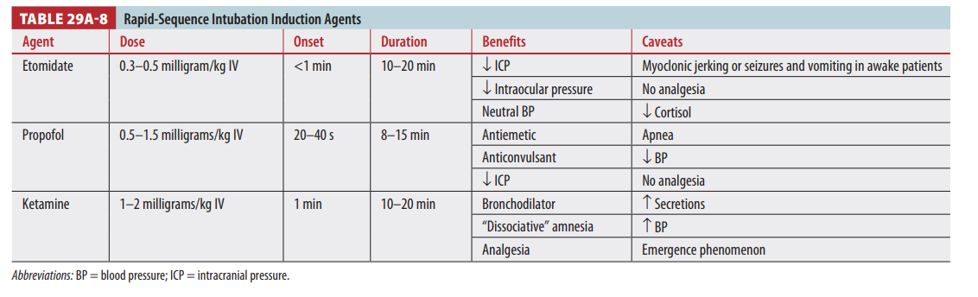
Table 1.4. Rapid-sequence intubation induction agents
Paralytic agents
Suxamethonium (aka succinylcholine)
- Dose: 1.5 mg/kg IV (2 mg/kg IV if myasthenia gravis) and 4 mg/kg IM (in extremis)
- Onset: 45–60 seconds
- Duration: 6–10 minutes
- Use: widely used unless contraindicated; ideal if need to intubate rapidly following an elective procedure or to assess neurology in an intubated patient
- Contra-indications: hyperkalemia, malignant hyperthermia, > 5d after burns/ crush injury/ neuromuscular disorder, bradycardia, elevated intra-ocular pressure
Rocuronium
- Dose: 1.2 mg/kg IV IBW
- Onset: 60 seconds
- Use: can be used for any RSI unless contraindication or require rapid recovery for extubation after elective procedure or neurological assessment
Drawbacks: allergy (rare)
Vecuronium
- Dose: 0.15 mg/kg IV (may be preceded by a 0.01 mg/kg IV priming dose 3 minutes earlier)
- Onset: 120-180 seconds
- Duration: 45-60 minutes
- Use: not recommended for RSI, unless no Suxamethonium or rocuronium cannot be used – can be reversed by sugammadex
Drawbacks: allergy (rare), slow onset, long duration
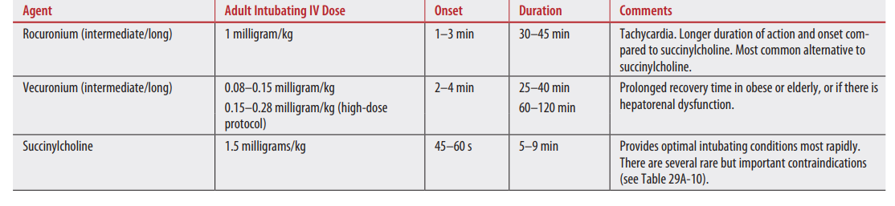
Table 1.5. Rapid-sequence intubation paralytic (neuromuscular blocking) agents
Post-intubation care
Check for proper placement of the tube by direct visualization of the cords during ETT insertion, observation of clouding of the tube, auscultation of the chest, and, if possible, with end-tidal CO2 measurement after insuring the proper placement of the tube, secure tube properly with tape and bandage.
Pass the tube
- Limit the attempt to < 30 seconds.
Proof of intubation
- Point auscultation: epigastrium, bilateral axillae, bilateral lung bases
- Waveform capnography: maintain Co2 level at 35–45 mmHg
- Secure the tube at depth of 3 x ETT size at the teeth/gums
Post-intubation care
Initiate post-intubation analgesia and sedation
- Morphine 0.1–0.4 mg/kg/hr
- Ketamine (analgesic and sedative) 0.05– 0.4mg/kg/hr
- Midazolam 0.02–0.1mg/kg/hr
- Obtain CXR to confirm depth of ETT not the location
Overview in pediatrics
- RSI is used to secure the airway quickly with an endotracheal tube and to prevent chance of regurgitation and aspiration
- The basic approach is similar to that in adults
- Note that pre-treatment with atropine, while traditionally given prior to intubation in children, is generally not necessary
Procedure
Pre-oxygenation
- 4 vital capacity breaths or until ETO2 is concentration > 90%
- This may be difficult with an uncooperative child, a cautious dose of fentanyl 0.25mcg/kg IV provides a slightly sedated, more compliant child; however, caution needs to be taken as airway protection must be maintained, not normally a problem for small children, but older ones may kick up a fuss
- Suction prepared and under pillow
- Apneic oxygenation via nasal prongs
- Induction with thiopental 3–6mg/kg IV if patient’s hemodynamics will tolerate this dose
- Choice of induction age and dose may be modified according to clinical context (e.g., propofol, etomidate)
- Cricoid pressure applied by skilled assistance (optional)
- Suxamethonium 1–2mg/kg IV (2mg/kg for neonates, and 1mg/kg children) OR rocuronium 1.2mg/kg IV
- Once patient fasciculated/paralyzed perform rapid laryngoscopy with placement of an endotracheal tube
- ETT size = age/4 + 4
- Traditionally uncuffed until age 8, then cuffed (a “one-size smaller” cuffed tube can be used in children < 8 years)
- Leak should occur at 20cmH2O if un-cuffed
- Check endotracheal tube placement by:
- Observing tube fogging, chest rising and falling, auscultation of in both axillae, and observing end-tidal CO2
- If child is > 2 years old then endotracheal tube should be at lips by formula age/2 + 12cm
- Once endotracheal tube is satisfactory position cricoid pressure can be released
- If a nasogastric tube is in situ, leave in place during the procedure as it will help decompress stomach if bag-mask ventilation required, remove post procedure if indicated

1.3.4. Airway Obstruction
Introduction
Airway obstruction is divided into upper and lower obstruction and, depending on the magnitude of obstruction, it could be partial or complete. It affects people of all ages and sex and almost 99% is acquired.
Upper airway obstruction
The upper airway consists of the nasal cavity, pharynx, and larynx. The most common site of upper airway obstruction in adults is the larynx.
Causes
The causes include the tongue, surrounding soft tissues are falling back, secretions in patients with altered consciousness and in patients who are not fully recovered from anesthesia, foreign body, infections (viral or bacterial), airway edema or spasm following anaphylaxis, chemical inhalation, tumor compressing the airway tract, and trauma to the face and neck.

Partial upper airway obstruction
Patients may have different degree of breathing difficulty or maintain their spontaneous breathing, but they are still at high risk to develop complete obstruction if left untreated.
Causes
- Obstruction of the pharynx by the tongue, secretions, and foreign body in the unconscious patient, usually with GCS < 8/15
- Foreign bodies in the oropharynx, trachea, or esophagus (commonly large pieces of meat or food)
- Allergic swelling of upper airway structures (angioedema)
- Chemical burns, inhalation injuries
- Infectious causes: -epiglottitis and retropharyngeal or peri- tonsillar abscess.
- Trauma of face, neck, upper tracheal, or laryngeal injury
Signs and symptoms of airway obstruction
- Snoring – is a sound heard during inspiration and expiration, main causes are secretions, tongue falling to the back of oropharynx
- Stridor – is a sound heard most of the time during inspiration and it is audible accompanied with use of respiratory accessory muscles, caused by obstruction at or above the laryngeal level, due to spasms or edema of the larynx
- Expiratory wheeze – caused by obstruction of lower airways
Different degree of respiratory distress: shallow, fast, labored breathing with respiratory muscle retractions
- Central nervous system manifestations– Irritability, agitation, convulsion, and coma due to hypoxia and/or hypercarbia
- “Tripod positioning” – is a patient positioning preference towards easing breathing exercise (standing up or seating and leaning forward position for maximal air passage to the lung)
Workup
Note: Every investigation done outside the emergency suite should be considered only after stabilization of patient’s life-threatening condition

General approach and disposition
- Triage and ABCD evaluation to determine the severity
- Patient with severe sign of hypoxia: saturation is low, tachycardia, tachypnea, irritable or lethargic, dispose to resuscitation area
Action
- Put on monitor and strict follow-up
- Open IV lines
- Encourage patient to cough forcefully and close observation if the suspicion is foreign body aspiration or chocking
- Place patient in position of comfort, avoid upper airway stimulation for suspicion of infection of the epiglottis
- Administer O2, 10–15liters/min via face mask
- Nebulization with steroids, epinephrine, anti-histamine to reduce airway edema
- If available, Helix—a helium–oxygen gas mixture—is effective in reducing the work of breathing by decreasing airway resistance for conditions such as post-intubation laryngeal edema, tracheal stenosis or extrinsic compression, and angioedema
- Consult airway expert if patients signs and symptoms are worsening
- Consult respective department for definitive management
Complete upper airway obstruction
Complete airway obstruction is defined as severe difficulty of breathing or no breathing, lethargy or loss of consciousness and may end with cardiac arrest due to severe hypoxia and hypercarbia.
Action/treatment
- Shout for help
- Dispose to resuscitation area
- Open the mouth with head-tilt, chin-lift maneuver for non-trauma or jaw-thrust if trauma is suspected, suction secretions, look for foreign body and remove if it is visible and accessible with Magill forceps.
- Insert oropharyngeal (OPA) or nasopharyngeal airway (NPA) if the cause of obstruction is loss of consciousness or the tongue is obstructing the pathway; assess the breathing pattern.
- If patient has regained adequate spontaneous breathing, administer oxygen using appropriate oxygen delivery device, using facemask: 15 L/min or nasal prong 1–5 L/min.
- If breathing effort is inadequate, apply assist breathing with BVM (ambu-bag) with 100% oxygen. Consider oral airway if the chest is not expanding well during BVM assistance. For adults, ventilate once every 5–6 seconds (10–12 times per minute), and monitor with pulse oximeter and capnogram.
- If there is difficulty in ventilating the patient or chest is not expanding with an BVM, try to insert laryngeal mask airway (LMA) OR Combitube and ventilate.
- Activate experienced team for definitive airway management using intubations or surgical methods such as crico-thyroidotomy or tracheostomy.
- Before intubation, attempting rapid airway evaluation/assessment is mandatory.
- According to airway assessment, avoid rapid-sequence inductions if difficult airway is suspected, such as airway assessment of Mallampati score III–IV, trauma on the face and neck, obesity, deformity of the face, inadequate mouth opening, severe hypoxia not resolving with high flow of oxygen.
- Indications for RSI includes: all emergency and trauma patients, pregnant women, diabetic patients, patients with signs and symptoms of gastric and bowel obstruction. For the technique of RSI see annex.
- Following intubations confirm for proper position of the Endotracheal Tube (ETT), secure the tube properly, and continue ventilation manually using Ambu bag and 100% of oxygen and transfer to ICU for mechanical ventilation support after stabilization of the condition.
- The need for an immediate surgical airway (crico-thyroidotomy) must be evaluated considering the potential difficulties associated with emergency intubation in cases of laryngotracheal trauma, foreign body lodged in the pharyngolaryngeal area, or severe anatomic deformity caused by trauma or congenital deformity.
- Determine and manage patient's hemodynamic symptoms.
- Monitor and record vital signs and respond. Continually reassess level of consciousness, ABCs, and vital signs. If cardiac arrest is diagnosed, use CPR protocol.
- Obtain appropriate history related to event, recent infectious history (fever, cough, etc.) or exposure to allergens while managing the airway or ABCD evaluation.
- Consult appropriate specialty for definitive management.
Specific airway problems
Unconscious patients
Unconscious with adequate breathing GCS > 8/15
- Dispose to orange or temporary keeping room.
- Put on continuous cardiac monitoring.
- ABCD evaluation and vital signs (VS).
- Remember cervical spine precaution if patient has history of trauma.
- Put them on recovery/left lateral position.
- Consider supplemental oxygen to maintain O2 saturation > 93%.
- Give oxygen via nasal cannula at 2– to 5 liter per minute, OR use facemask at 10–15 liters per minute according to patient’s needs.
- Insert nasopharyngeal airway to facilitate suctioning and to support the airway patency.
- Insert nasogastric tube for gastric content drainage or feeding.
- Monitor continuously with pulse oximeter and capnometer to measure oxygen saturation and end-tidal CO2, vital sign, GCS, temperature, input output.
Record and act accordingly.
- Consult immediate senior if patient’s GCS is going down.
- Care: suction the ETT and/or the oropharynx at least every 2hrs or according to need, protect eyes from drying, nasogastric feeding as recommended, positioning every 2hrs, confirm the ETT appropriate position with bilateral chest auscultation.
- Consult respective department for further management.
Unconscious with inadequate breathing
Patients with a reduced conscious level with GCS of 8/15 or below are often considered unable to maintain their airway patency and clear their secretions due to suppressed airway reflexes (gag reflex, swallowing reflex, and cough reflexes). They are at risk of aspiration and alveolar hypoventilation, with development of hypercarbia and respiratory acidosis.
- Dispose to red or orange area.
- Put on continuous cardiac monitoring.
- ABCD evaluation and vital signs.
- Open airway—use head-tilt, chin-lift for none trauma patients and jaw thrust for trauma patients.
- Remember all cervical-spine precaution if patient has history of trauma.
- Consider placement of OPA.
- Supplemental oxygen based on pulse oximeter reading or signs and symptoms of hypoxia (10–15 liter per minute with Facemask OR 2-5 Lit/min with nasal prong)
- BVM (Ambu bag) with 100% oxygen if the breathing effort is not adequate. Consider oral airway if the chest is not expanding well during BVM assistance. For adults, ventilate once every 5–6 seconds (10–12 breaths per minute).
- If signs of airway obstruction present (no chest movement) reassess the patient for possible presence of foreign body or tongue is falling back.
- Suction if there is excessive secretion, check for any foreign body and remove if it is accessible, proceed to use oral air way, get an assistant and using both hands for jaw trust and ventilate with Ambu bag. If above 92% continue bagging till definitive airway management is ready.
- If you could not ventilate and oxygenate, use laryngeal mask airway (LMA) OR Combi tube.
- Prepare for definitive airway management using ETT intubation.
- Use RSI and intubation method if there are no signs of difficult airway and ventilate with BVM or mechanical ventilator
- Monitoring: Use pulse oximeter and capnogram to measure oxygen saturation and CO2 tension, vital signs, GCS, input output.
Record readings and act accordingly.
- Care: suction the ETT and/or the oropharynx at least every 2hrs or according the need, protect eyes from drying, nasogastric feeding as recommended, positioning every 2hrs, confirm the ETT appropriate position with bilateral chest auscultation.
- Consult respective department for further definitive management.
Obstruction due to a foreign body
To treat a choking patient, it is important to recognize the patient’s condition. Try to ascertain what material is causing the obstruction.

Signs and symptoms
- Choking has a sudden onset.
- Patient will be obviously distressed and agitated.
- The face is likely to be congested (red).
- The patient may be holding their throat (universal sign).
- The patient may be standing up and leaning forward.
- Difficulty in breathing and/or speaking.
- Cyanosis (late sign, blueness around the lips).
- Unconsciousness (late and pre-arrest sign).
Treatment
- Conscious /partial obstruction
- Reassure the patient
- Encourage patient to cough, forcefully and provide close observation.
- Do not give anything per mouth
- If the patient is not improving and has developed signs of complete obstruction, use the management measures for complete airway obstruction,
Conscious with complete obstruction
- Stand to the side and slightly behind the patient.
- Support the chest with one hand; lean the patient forward so that if the object becomes dislodged it will not go further down to the windpipe but be ejected.
- Give FIVE firm blows with the heel of the palm of the hand between the shoulder blades.
- If this fails, abdominal trusts should be used. Stand behind the patient and place both arms around the upper part of the abdomen, just below the ribcage.
- Hold one fist within the other hand and pull sharply inwards and upward up to FIVE times. And observe the foreign body is dislodged and still patient is conscious.
- If unsuccessful, return to five back blows and alternate with abdominal thrusts until the obstruction is removed or patient becomes unconscious.
Unconscious with complete obstruction
- If patient loses consciousness, position carefully on their back and attempt to conduct abdominal thrust five times. See if the object is in the mouth, remove if visible, and proceed to give two rescue breaths. Continue rescue breathing until the foreign body is dislodged and patient resumes spontaneous breathing.
- Loss of consciousness will lead to a relaxation of the muscles in the throat and may allow some air to pass beyond the obstruction and into the lungs, therefore give two rescues breathing using BVM.
- If cardiac arrest is eminent, conduct CPR according to the adult CPR guideline.
Burn or smoke inhalation
- In the case of burns or history of smoke inhalation, adopt a high index of suspicion for airway injury.
- Signs such as carbonaceous sputum, dust around the face and mouth, and burned hair around the face warrant urgent airway intervention.
- Dispose to resuscitation room
- Put patient on monitor and strictly monitor progress of symptoms.
- Secure IV lines, and hydrate accordingly.
- Administer O2 with appropriate device.
- An anesthesia professional or senior emergency physician must always assess these patients early, as these are dynamic situations that may rapidly progress from one of stability to one of a threatened and compromised airway.
- Early intubation should be undertaken in high-risk groups.
- Monitoring: Use pulse oximeter and capnogram to measure oxygen saturation and CO2 tension, vital signs, GCS, input and output,
- Record readings and act accordingly
- Care: suction the ETT or and the oropharynx at least every 2hrs or according the need, protect eyes from drying, nasogastric feeding as recommended, positioning every 2hrs, confirm the ETT appropriate position with bilateral chest auscultation, Temperature, wound care, hydration, IP
- Consult respective department for further definitive management
Trauma and compression on the face and neck
- External compression from an adjacent pathology—e.g. trauma on the face and neck, goiter, lymphadenopathy, tumor, and hematoma—may be dangerous or rapid in onset; therefore, early identification of patients at risk is vital.
- Such patients may present with no remarkable signs of airway obstruction immediately but they may develop to severe stage within short time due to progressive edema.
- Dispose such patients to resuscitation area even if they look stable and watch carefully.
- Put patient on monitor and strictly monitor for signs of deterioration
- Administer O2 accordingly.
- Secure large-bore IV lines.
- Maintain their comfort position.
- Prepare for definitive airway management (intubation or surgical)—personnel, equipment. and drugs.
- Consult respective department (surgery; ear nose and throat; orthodontal) for definitive management.
Airway problem due to tracheostomy tube obstruction
In a patient with a tracheostomy tube, obstruction may develop due to:
- Dry secretions, crust, or hematoma if the tube insertion is fresh
- Dislodged from the site of insertion and the opening is covered by tissue
Prevention
- Regular suctioning to prevent blockage
- Administering humidified gas to prevent drying
- Pain management
- The skin should be inspected for irritation such as erythema, the skin has to be dry and frequent dressing is applied as needed
- Stoma has to be suctioned every 4–8hrs, or more frequent as needed
- Tracheostomy ties should be replaced as needed
- Adequate hydration is necessary to keep secretions thin and mobile
- For effective coughing, patient should be in semi-seating position
Action for blockage
- Wipe neck opening with gauze
- Attempt to suction tracheostomy tube with saline
- If the tracheostomy tube is plastic and has cuff, deflate the cuff
- If patient is in distress and the tracheostomy is with inner tube the inner tube has to be removed, cleaned, and re-inserted
- Suction has to be confirmed—the suction tube is passing beyond the tube end and patient’s condition evaluated
- If still in distress, deflate cuff and mask ventilation with subsequent intubation; after patient is stabilized re-insert the tube.
- Once the tracheostomy is corrected and patent, give oxygen as necessary and reassess and monitor as required and care for tracheostomy as the above.

1.4 Oxygen Therapy

1.4.1. Introduction and Principles of Oxygen Therapy
Oxygen therapy is a medical intervention used to deliver oxygen to individuals with compromised oxygen levels in the blood. It is usually defined as the administration of oxygen at concentrations greater than those found in ambient air. The primary goal is to maintain adequate oxygenation of tissues and organs, ensuring sufficient oxygen delivery to meet metabolic demands.

1.4.2. Recommended Management
Assessment: evaluate the patient's oxygenation status using pulse oximetry and arterial blood gases (ABGs) test if necessary.
Oxygen delivery devices:
- Nasal cannula: for mild hypoxemia; delivers 1–6 L/min, providing 24–40% FiO2 (fraction of inspired oxygen).
- Simple face mask: for moderate hypoxemia; delivers 6–10 L/min, providing 40–60% FiO2.
- Venturi mask: for precise oxygen delivery; provides specific FiO2 levels (24–50%) by varying the oxygen flow rate.
- Non-rebreather mask: for severe hypoxemia; delivers 10–15 L/min, providing up to 100% FiO2.
- High-flow nasal cannula: For patients requiring higher oxygen concentrations and flow rates.
- Mechanical ventilation: For patients who cannot maintain adequate oxygenation with non-invasive methods.
Special considerations
- Chronic obstructive pulmonary disease (COPD) patients: careful titration to avoid hypercapnia due to hypoxic drive dependency.
- Hyperbaric oxygen therapy: for conditions like carbon monoxide poisoning, decompression sickness, and certain wound healings.
Indications for oxygen therapy
- Hypoxemia: SpO2 < 90% or partial pressure of oxygen (PaO2) < 60 mmHg
- Acute respiratory conditions: pneumonia, acute respiratory distress syndrome, asthma exacerbations
- Chronic respiratory conditions: COPD, interstitial lung disease, cystic fibrosis
- Cardiac conditions: congestive heart failure, myocardial infarction
- Perioperative support: during and post-surgery for patients with compromised respiratory function
- Severe anemia: when oxygen carrying capacity is significantly reduced
- Shock: septic, hypovolemic, or cardiogenic shock to improve tissue oxygenation

Figure 1.11. Oxygen delivery devices
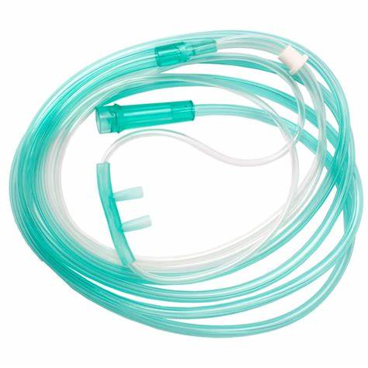
Nasal cannula
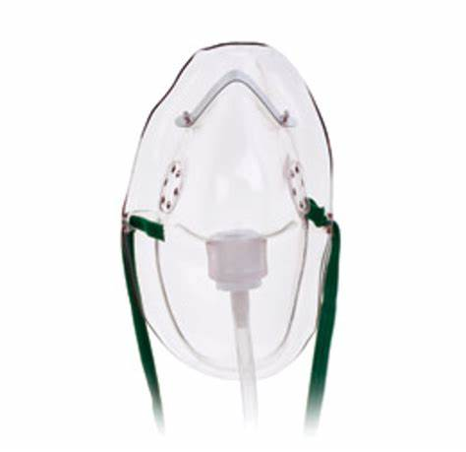
Simple face mask

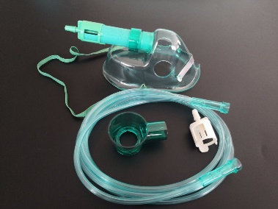
Venturi mask
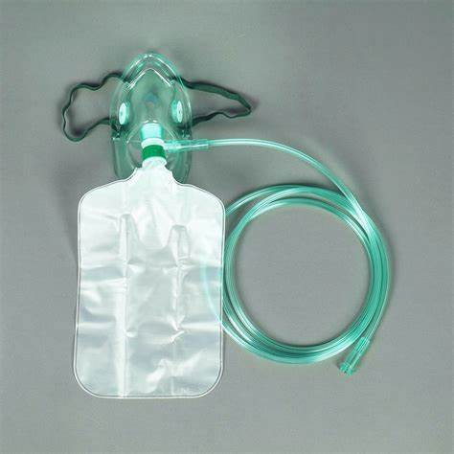
Non-rebreather mask

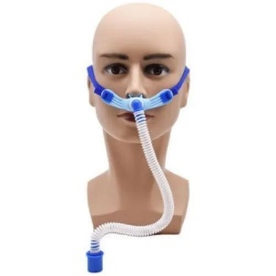
High-flow nasal cannula
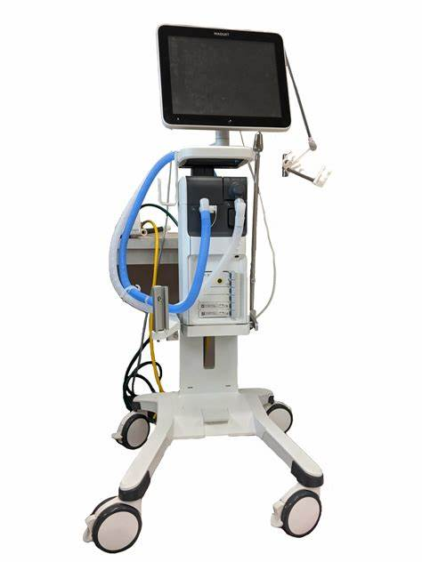
Mechanical ventilator

1.4.3. Management of Complications
- Oxygen toxicity: prolonged exposure to high FiO2 can cause lung damage. Monitor and adjust oxygen levels to the minimum required to achieve target saturation (SpO2 92–96% for most patients).
- Hypercapnia: particularly in COPD patients; monitor ABGs and adjust oxygen delivery accordingly
- Absorption atelectasis: high FiO2 can lead to alveolar collapse; use the lowest effective oxygen concentration

1.4.4. Monitoring Oxygen Administration
- Vital Signs: regularly check heart rate, respiratory rate, blood pressure, and temperature.
- Oxygen Saturation: continuously monitor SpO2 using a pulse oximeter.
- Clinical Status: observe for signs of respiratory distress, changes in mental status, and overall clinical improvement or deterioration.
- Laboratory Investigations: perform ABGs as required to assess oxygenation and ventilation status.
- Pulse oximetry should be available in all clinical situations in which oxygen is used
- ABG measurement should be considered in the following situations:
- Critically ill patients with cardiorespiratory or metabolic dysfunction
- Patients with an SpO2 <92% in whom hypoxemia may be present
- Deteriorating oxygen saturation requiring increased FiO2
- Patients at risk of hypercapnia
- Breathless patients in whom a reliable oximetry signal cannot be obtained.
Target oxygen saturation
- General Target: SpO2 of 92-96% for most patients.
- COPD and chronic respiratory failure: SpO2 of 88-92% to avoid suppressing the hypoxic drive.
- Critically ill patients: maintain SpO2 of 94-98% unless specified otherwise based on individual needs.
Escalation and de-escalation of therapy
When to escalate:
- Persistent hypoxemia: despite initial oxygen therapy, if SpO2 remains below target, escalate to a higher flow or more efficient delivery device (e.g., from nasal cannula to non-rebreather mask).
- Increased work of breathing: signs include tachypnea, use of accessory muscles, and retractions.
- Clinical deterioration: worsening mental status, cyanosis, or signs of respiratory fatigue.
When to de-escalate:
- Stabilization: once the patient maintains target SpO2 with improved clinical signs.
- Weaning protocol: gradual reduction in oxygen flow while monitoring SpO2 and clinical status.
- Room air trial: if SpO2 remains within target range on low-flow oxygen, consider a trial off supplemental oxygen with close monitoring.

1.4.5. Disposition
- Stable Patients: Transition to lower levels of oxygen support or discontinue therapy as appropriate, ensuring follow-up care.
- Unstable Patients: Intensify monitoring and consider higher levels of care (e.g., ICU) if there is no improvement or if complications arise.

1.5. Trauma, Burns, and Poisoning

1.5.1. Trauma
Trauma is the most common cause of youth mortality, morbidity, and the loss of years of useful life. With an emphasis on timing, injured patients should receive prompt initial examination and primary care, beginning at the scene of the accident and continuing through first evaluation, lifesaving intervention, reevaluation, stabilization, and, if necessary, transfer to a trauma center with use of a systematic approach: initial assessment.
The following constitute a component of the initial assessment:
- Preparation
- Triage
- Primary survey (ABCDEs) with immediate resuscitation of patients with life-threatening injuries
- Adjuncts to the primary survey and resuscitation
- Consideration of the need for patient transfer
- Secondary survey (head-to-toe evaluation and patient history)
- Adjuncts to the secondary survey
- Continued post-resuscitation monitoring and reevaluation
- Definitive care
Primary survey (ABCDEs) with immediate resuscitation
Primary survey encompasses the trauma care ABCDEs and detects conditions that pose a danger to life (completed in < 10 mins).
A = Airway maintenance with restriction of cervical spine motion
Assess the airway to ascertain patency.
See Chapter 1.3 Airway Management for further details.
While assessing and managing a patient’s airway, take great care to prevent excessive movement of the cervical spine and apply a cervical collar. When airway management is necessary, the cervical collar is opened and a team member manually restricts the motion of the neck (Figure 1.12).
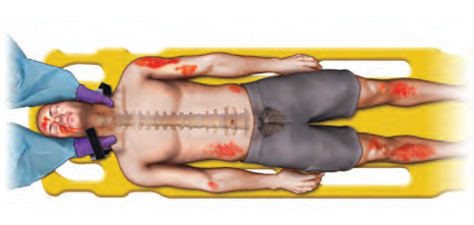
Figure 1.12. Cervical spine motion restriction technique
B = Breathing and ventilation
- Check chapter on breathing assessment and management.
- Injuries that significantly impair ventilation in the short term include: tension pneumothorax, massive hemothorax, open pneumothorax, and tracheal or bronchial injuries.
- For patients with tension pneumothorax, give oxygen, perform wide-bore needle decompression at the 2nd ipsi-lateral intercostal space at the mid-clavicular line immediately, secure IV line, and then insert a chest tube as fast as possible.
- For patients with open pneumothorax or sucking chest wounds, give oxygen, place a three-sided dressing that allows air to leave with exhalation but prevents air from entering during inhalation, secure IV line, and insert a chest tube as fast as possible.
- For patients with massive hemothorax, give oxygen, secure IV line, and insert a chest tube then consider early surgical consultation if thoracotomy is indicated.
- For patients with tracheobronchial injuries give oxygen and early surgical consultation.
Indications for thoracotomy:
Output more than 1,500 mL from chest tube placement or more than 200 mL/hour during the first 2–4 hours; in case of suspected tracheobronchial injury or heart or great vessel injuries.
C = Circulation with hemorrhage control
The first actions in assessing and managing patients with hemorrhage should be to rapidly identify them, limit exsanguination, and start resuscitation.
Assess the following during circulation:
- Look and feel for signs of poor perfusion (cool, moist extremities, delayed capillary refill greater than 3 seconds, tachycardia, low blood pressure < 90/60mmHg, tachypnea, absent/feeble pulses).
- Look for both external and internal bleeding, including bleeding into the chest, abdomen, pelvic or femur fracture, and bleeding wounds.
- Look for hypotension, distended neck veins, and muffled heart sounds that might indicate pericardial tamponade.
- Sources of bleeding during trauma: chest, abdomen, pelvis, long bones, and external bleeding.
- Immediate management may include pressure dressing, tourniquet application, application of a pelvic stabilizing device, and/or extremity splints.
- Establish vascular access: place two large-bore peripheral venous catheters to administer fluid and blood products and take samples for blood type and cross-match.
- When peripheral sites cannot be accessed, intraosseous line, central venous access, or venous cut-down may be used depending on the patient’s injuries and the clinician’s skill level.
- IV solutions crystalloid should be warmed either by storage in a warm environment (i.e., 37° C to 40° C, or 98.6° F to 104° F) or administered through fluid-warming devices.
- The infusion of greater than 1.5 L of crystalloid has been shown to be associated with increased mortality in trauma. For this reason, the early use of blood products is advocated, and there is no place for the infusion of large volumes of crystalloid fluid in trauma patients.
- Early resuscitation with blood and blood products in low ratios (1:1:1) is recommended in patients with evidence of Class III and IV hemorrhage.
- Massive transfusion should be utilized if needed and is defined as the transfusion of more than 10 units of blood in 24 hours or more than four units of blood in one hour.
- Pregnancy test for all females of childbearing age.
- Tranexamic acid can be administered within 3 hours of injury in severely injured patients at a loading dose of 1 g IV over 10 minutes, followed by 1 g infused over 8 hours.
- Definitive management may require surgical or interventional radiologic treatment and pelvic and long-bone stabilization. Initiate surgical consultation or transfer procedures early in these patients.
D= Disability (neurologic evaluation) and dextrose
- The GCS is a quick, simple, and objective method of determining the level of consciousness.
- A decrease in a patient’s level of consciousness may indicate decreased cerebral oxygenation and/or perfusion or it may be caused by direct cerebral injury.
- Prevention of secondary brain injury by maintaining adequate oxygenation and perfusion are the main goals of initial management
- Patients with evidence of brain injury should be treated at a facility that has the personnel and resources to anticipate and manage the needs of these patients. Consult a neurosurgeon once a brain injury is recognized.
- Blood sugar level should be checked and managed, accordingly.
E= Exposure and environmental control
- Completely undress the patient, usually by cutting off his or her garments to facilitate a thorough examination and assessment including hidden areas (back, perineum).
- Do a log roll maneuver to examine the back (Figure 1.13).

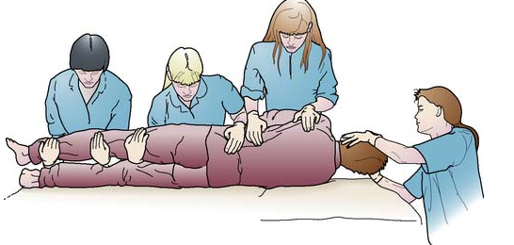
Figure 1.13. Log roll technique
- After completing the assessment, cover the patient with warm blankets or use an external warming device to maintain a warm environment and prevent hypothermia.
Adjuncts of the primary survey
- Physiologic parameters such as pulse rate, blood pressure, pulse pressure, respiratory rate, body temperature, and urinary output are assessable measures that reflect the adequacy of resuscitation.
- Values for these parameters should be obtained as soon as it is practical during or after completing the primary survey and reevaluated periodically.
- Insert a urinary catheter after ruling out a urethral injury or place a supra-pubic catheter if otherwise.
- Signs of urethral injury: bleeding or clot per meatus, overriding/displaced prostate and distended bladder.
- Insert nasogastric tube to decompress distention and assess for evidence of blood. When there is facial trauma or evidence of basilar skull fracture, insert the gastric tube through the mouth rather than the nose.
- Other helpful tests include x-ray examinations (e.g., chest, cervical, and pelvis) and focused assessment with sonography for trauma (FAST)/extended FAST (eFAST)
Note: Repeat the primary survey frequently to identify any deterioration in the patient’s status that indicates the need for additional intervention.
Secondary survey
- The secondary survey is a rapid but thorough head-to-toe examination for injuries.
- Obtain a thorough patient history including AMPLE (Allergies, Medications, Past medical history, Last oral intake, Events leading to the current medical condition) medical history.
- Perform a full physical examination.
- Order or perform relevant diagnostic tests as guided by clinical assessment.
- Begin critical targeted treatments and ensure adequate supportive care.
- Obtain consults as needed.
- Do not start the secondary survey until basic functions have been corrected in conjunction with the primary survey (ABCDE—airway, breathing, circulation, disability, exposure) and resuscitation has been initiated.
Note: If any deterioration occurs while doing the secondary survey, return to the primary survey.
Disposition
- Possible dispositions include transfer to the operating room, admission to the surgical service or ICU, limited observation in the emergency department, or transfer to another hospitals.
- The level of care and monitoring established in the emergency department should be maintained throughout patient transfer.

1.5.2 Traumatic Brain Injury
Traumatic brain injury is a temporary or permanent impairment in brain function and/or structure due to a transfer of a force of impact to the skull.
Classification
- Based on types of injury
- Primary brain injury (concussion, contusion, laceration, diffuse axonal injury)
- Secondary brain injury (hypoxia, hypovolemia, hyperglycemia, seizure, hyperthermia, hemorrhage)
- Based on post-resuscitation or prior-to-sedation assessment of level of consciousness (GCS) for severity scoring
- Mild TBI – GCS of 14 or 15
- Moderate TBI – GCS of 9 to 13
- Severe TBI –GCS of 3 to 8
- Based on site of injury and fracture
- Scalp injury
- Skull vault fracture
- Basal skull fracture
Diagnosis
Thorough Hx and P/E
Investigation
Baselines (complete blood count [CBC], blood group/Rh), C-spine x-ray (depressed GCS, focal deficits, midline cervical tenderness, alcohol intoxication, distracting pain)
Brain computed tomography (CT) (non-contrast)—if more than one episode of vomiting, failure to attain a GCS of 15 within 2 hours, suspected open or depressed skull fracture, retrograde amnesia > 30 min, dangerous mechanisms of injuries, old age.
Principles of management
- Start primary survey (ABCDE) with simultaneous neuroprotective measures.
- Measure GCS and pupillary response.
- Classify TBI by severity based on GCS.
- Look for other life-threatening injuries.
Recommended management
- Oxygenation (keep oxygen saturation > 90%) and airway protection if GCS < 8
- Secure IV line and put on maintenance fluid (ensure mean arterial pressure [MAP] > 80)
- Elevate the bed to 30 – 45 degrees (head and neck in a neutral position without neck flexion)
- Nasogastric or Oro-gastric (suspected basal skull fracture) tube
- Adequate analgesia
- Sedation (based on assessment)
- Seizure prophylaxis for patients with GCS < 10, penetrating injuries, depressed skull fractures, or abnormal CT scan findings
- Phenytoin 20mg/kg by mouth (PO) loading and then 100mg PO 3 times a day (TID)
- GI prophylaxis (moderate to severe TBI).
- Accompany patients to CT or transfer center if intubated or high-risk patients and protect the C- spine if C-spine injury cannot be ruled out.
Management of complications
- Acute seizure treatment with IV diazepam, if seizure continues treat as status epilepticus.
- Management of increased ICP— check chapter on the management of raised ICP
- Scalp lacerations can bleed profusely and hence bleeding should be controlled.
- Basal skull fractures involving the air sinus may need prophylactic antibiotics.
Monitoring
- Follow up with a neuro-sign chart
- Frequent monitoring of blood glucose and serum electrolyte levels as needed
- Monitoring of pain
- Sedation: use standardized scales to assess agitation and level of sedation (e.g., RASS)
Disposition
- Mild TBI: discharge after 24 hours of observations if no deterioration or need for other intervention.
- Moderate to severe TBI: admit (based on admission criteria) for finding-based intervention, monitoring, or referral to a better facility.
- Patients who can be managed in general hospitals are those with:
- Mild TBI
- Superficial scalp lacerations
- Unstable vital signs explained by other injuries
- Patients who need transfer to hospitals with neurosurgical facilities or ICU are those with:
- Moderate and severe TBI
- Skull fractures (depressed, basal)
- Penetrating head injuries
- Patients with severe signs, such as raised ICP, seizure, deteriorating GCS or vital signs
TBI in pediatric patients
In addition to the basic primary survey approaches, when evaluating children and infants with TBI, a number of special issues must be observed.
Causes
- Falls (most common)
- The possibility of child abuse must always be considered.
Clinical features: especially bulging anterior fontanelle (increasing ICP)
Diagnosis: cranial CT without contrast
- Identify patients with significant TBI but avoid unnecessary radiographic testing
- CT recommended for signs of skull fractures, increasing ICP, major neurologic symptoms (e.g., impaired consciousness, seizures), suspected child abuse
- Consider CT: if less severe symptoms (e.g., changes in behavior, self-limited vomiting) are present
Recommended management
- See the ABCDE in trauma and general management of TBI
- Inpatient observation indications:
- Skull fracture > 3 mm separation or depressed
- Evidence of TBI on imaging (e.g.., intracranial hemorrhage)
- Signs of increasing ICP (e.g., headache, altered mental status)
- Suspected physical abuse
- Caregivers who are unreliable or unable to return if neurological deficits develop within 24 hours after release
- Release and at-home observation for 24 hours
- Patients without neurological deficits and non-depressed linear skull fracture < 3 mm separation
- Patients have a caregiver who can reliably recognize new clinical neurological deficits and return the patient to the hospital if such manifestations arise

1.5.3. Neck Injury
The presence of major airway and food conduit, vascular structures and cervical spine make neck injury one of the most important parts that need adequate and thorough evaluation.
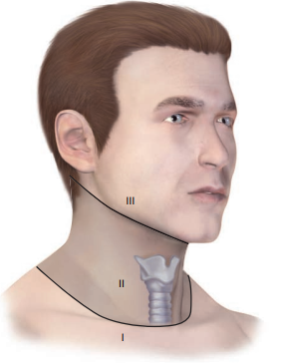
Classification

Figure 1.14: Zones of neck injuries

- Based on type of injury
- Blunt injury
- Penetrating injury when platysma is breached
Based on the regions (zones) (Figure 1.14), especially for the purpose of evaluating penetrating injuries
- Zone I
- Zone II
- Zone III

Diagnosis
- Hx: duration and mechanism of injury
- P/E: assess for patient’s stability
- Look for hard and soft signs
Hard signs: the presence of any of the following increases the likelihood of life-threatening injury requiring surgical intervention often bypassing CT imaging:
Airway or esophageal injury
- Airway compromise
- Wound bubbling
- Extensive subcutaneous emphysema
- Hoarseness and/or stridor
Vascular injury
- Hemorrhagic shock
- Pulsatile bleeding
- Expanding hematoma
- Carotid bruit
- Unilateral pulse deficit
- Signs of stroke
Soft signs: the presence of any of the following increases the likelihood of serious injury and often requires a computed tomography angiography (CTA) of the neck for further evaluation:
Airway or esophageal injury
- Hemoptysis and/or hematemesis
- Dysphonia
- Dysphagia
- Mild subcutaneous emphysema
Vascular injury
- Minor bleeding
- Nonexpanding hematoma
- Proximity wound
Investigation
- Baselines (CBC, blood group/Rh)
- C- spine x-ray or a CT scan (all with depressed GCS, awake patients with focal deficits, midline cervical tenderness, significant mechanism)
- For symptomatic zone I and zone III injuries but hemodynamically stable patients, an accurate preoperative diagnosis is preferred due to technical challenges with injury exposure and different operational techniques (CT angiography, esophagram, and bronchoscopy).
Principles of management
- ABCDEs
- Urgent surgical repair is typically indicated for vascular, laryngotracheal, and esophageal injuries
- Esophageal perforation typically requires broad-spectrum antibiotics and NPO (nothing by mouth) status
Recommended management
- Oxygenation (keep oxygen saturation > 90%)
- Prepare for difficult airway management (see air way assessment and management chapter for details [Chapter 1.3])
- Intubation via direct laryngoscopy or video-laryngoscopy using a smaller-sized endotracheal tube can be attempted initially if anatomy is preserved
- Awake fiber-optic intubation is preferred for distorted anatomy
- Prepare for emergency surgical airway as a backup
- Secure IV line and resuscitate while controlling hemorrhage
- Adequate analgesia.
- Accompany patients to CT, operating room, or transfer center if intubated or high-risk patients and protect the C-spine if C-spine injury cannot be ruled out.
Management of complications
- Spinal cord injuries should be addressed quickly, even though significant neurologic recovery is rare in complete spinal cord injuries.
- Patients with high spinal cord disruption are at risk for shock due to physiologic disruption of sympathetic fibers.
- IV fluid, vasopressors and/or atropine
- Bowel and bladder care
- Prevention of pressure sore
Monitoring
- Vital signs
- Neurological assessment (the ASIA [American Spinal Injury Association] guide should be completed documenting sensory and motor levels)
Disposition
- Unstable patient with hard signs needs an immediate transfer to operating theater.
- Unstable vertebral bone fracture or spinal cord compressive symptoms need neurosurgical or spinal specialist’s consultation.
- Follow the algorithm in Figure 1.15 for further disposition

Blunt neck injury

Patent Airway

Compromised Airway

Assess
- Aero-digestive
- Vascular

Monitor closely

- ABCDEs
- Secure airway ASAP
- Anesthesiologist, ENT, radiology, surgeons

Involve MDT for further evaluation

Operating room intubation preferred over emergency room intubation
Figure 1.15. Algorithm for disposition of patients with blunt neck injury
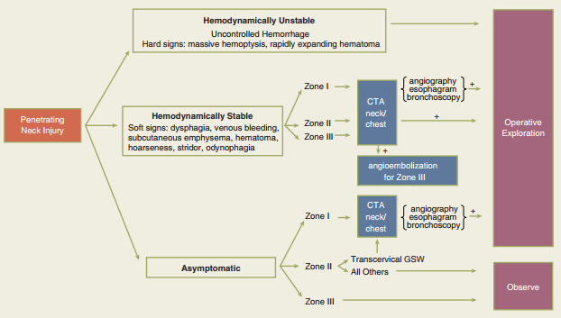
Figure 1.16. Algorithm for management of penetrating neck injury

1.5.4. Chest Trauma
Life-threatening tension pneumothorax, massive hemothorax, open pneumothorax, and flail chest resulting from blunt or penetrating chest injuries should be suspected, diagnosed, and treated during the primary survey.
Tension pneumothorax
Tension pneumothorax is a life-threatening condition involving air collection in between the parietal and viscera pleurae resulting in lung collapse with mediastina shift and hypotension.
Diagnosis
- Diagnosis should be made clinically and prolonged diagnostic studies should be avoided in favor of initiating immediate treatment.
- Distended neck veins, diminished breathe sounds, subcutaneous emphysema, and tracheal deviation to the contralateral side (one or more of these elements may be absent).
- Veins may remain flat in the presence of hypovolemia.
Investigations
- eFAST
- CXR after stabilization
Principles of management
- ABCDEs
Recommended management
- Oxygenation (target SpO2 ≥ 96–100%)
- Immediate needle decompression
- Once the tension pneumothorax is decompressed the patient's perfusion often improves immediately
- Needle decompression should be followed promptly by insertion of chest tube on the side of the tension pneumothorax at the triangle of safety
- Secure IV line and resuscitate
- Adequate analgesia

Management of complications
- If the patient fails to improve following decompression, other causes of shock, such as cardiac tamponade, should be immediately considered.
Monitoring
- Vital signs
- Chest tube functionality and output monitoring
Disposition
- Patients requiring a chest tube typically require hospital admission
Massive hem thorax
- Massive hem thorax is the presence of hemorrhagic shock, chest tube output ≥ 1500 mL immediately upon placement or chest tube output ≥ 200 mL/hour for 2–4 hour.
Diagnosis
- Clinical signs and symptoms:
- Decreased or absent breath sounds on the affected hemi thorax
- No chest movement with respiratory effort
- Dullness with percussion on the affected side
Investigations
- CXR
- As an alternative to chest radiography, in the unstable patient, bedside ultrasonography can be used.
Principles of management
- ABCDEs
Recommended management
- Oxygenation (target SpO2 ≥ 96–100%)
- Operative management (thoracotomy) is indicated if:
- Evacuation of > 1500 mL of blood for blunt injury and >1000 ml for penetrating injury immediately after tube thoracotomy
- or
- 200 mL of blood per hour for 3 consecutive hours in an non-coagulopathy patient
- Even in patients not meeting the above criteria, evidence of ongoing hemorrhage may warrant consideration of operative intervention.
- Secure IV line and resuscitate
- Adequate analgesia
- Chest physiotherapy
Management of complications
- Presence ongoing bleeding, persistent air leak, or caked hem thorax needs cardiothoracic consultation.
Monitoring
- Vital signs
- Chest tube functionality and output monitoring.
Disposition
- Patients with significant chest tube output fulfilling thoracotomy criteria needs admission (operating room then ward/high-dependency unit (HDU)/ICU) or referral to better center.
Open pneumothorax
A chest wall defect larger than 2/3 of the trachea's width results in an open pneumothorax (sometimes referred to as "sucking chest wound"), which leads to a positive intrapleural pressure and a collapsed lung on the affected side.
Diagnosis
- Clinical signs and symptoms
- Obvious violation of the outer chest wall and communication with the pleural space
- Audible gush of air through defect
- Respiratory distress, air entry, and breath sounds are often diminished on the affected side
Investigations
- Do CXR after an occlusive dressing and or tube thoracostomy.
Principles of management
- ABCDEs
Recommended management
- Oxygenation (target SpO2 ≥ 96–100%)
- Cover the wound with a three-sided with 4x4 cm gauze dressing.
- Care should be taken to avoid complete occlusion, which may convert the injury into a tension pneumothorax.
- Three-sided dressing is a temporary measure only and should be followed promptly by the insertion of chest tube to areas other than the wound. (pic)
- Secure IV line and resuscitate.
- Broad-spectrum antibiotics
- Adequate analgesia
- Tetanus antitoxin (TAT) prophylaxis
- Chest physiotherapy
Management of complications
- The defect needs to be closed (if possible) under aseptic technique.
- Wound care, accordingly.
Monitoring
- Vital signs
- Chest tube functionality and output monitoring
Disposition
- Admit patients for inpatient follow-up
Flail chest
Flail chest is segmental fracture of more than two adjacent ribs in two or more locations of the same ribs (anteriorly or laterally) often resulting in an unstable chest wall.
Diagnosis
- Clinical signs and symptoms
- History of trauma with paradoxical inward movement of the involved portion of the chest wall during inspiration and outward movement during expiration.
- Respiratory distress, air entry, and breath sounds are often diminished on the affected side because of concomitant underlying lung contusion.
Investigations
- CXR/CT chest showing segmental fractures
Principles of management
- ABCDEs
Recommended management
- Adequate oxygenation (target SpO2 ≥ 96–100%)
- Non-invasive ventilation (when possible)
- If SpO2 remains < 90% despite supplemental oxygen and adequate pain control, ventilatory support should be provided
- Shock, severe head injury, comorbid pulmonary disease, fracture of eight or more ribs, other associated injuries, and old age are other indications for ventilatory support
- Secure IV line and resuscitate
- Adequate analgesia (may include nerve blocks or epidural anesthesia)
- Chest physiotherapy (includes excellent pulmonary toilet)
- Surgical stabilization may be considered in patients:
- Getting a thoracotomy for other reasons
- Who fail to wean off a ventilator or whose respiratory status continues to decline despite other treatments
Management of complications
- Prevent atelectasis
- Postural drainage, suctioning, chest physiotherapy, incentive spirometry, encouraging coughing and deep breathing, and positive pressure ventilation using continuous positive airway pressure (CPAP) or bilevel positive airway pressure (BiPAP) may be used.
- Prevent complications of pulmonary contusion (respiratory insufficiency or failure) through adequate supportive care mentioned above.

Monitoring
- Vital signs
- Chest condition
Disposition
- Patients with mild to moderate flail chest and little or no underlying pulmonary contusion or associated injuries can often be managed at ward level.
- Those with severe injury and underlying significant contusion require HDU or ICU admission (see intubation criteria above).

1.5.5. Abdominal and Pelvic Trauma
It is crucial to promptly recognize and treat hemorrhage and sepsis, the two main effects of abdominal-pelvic injuries.
Abdominal injuries
Classification
- Blunt abdominal injury
- Penetrating abdominal injury
Diagnosis
- Hx: duration and mechanism of injury
- P/E: general status, systematic sequence abdominal examination followed by examination of the pelvis and buttocks, as well as urethral, perineal, and, if indicated, rectal and vaginal exams
Investigation:
- CXR, eFAST/abdomino-pelvic ultrasound (U/S)
- CT scan (indications for CT scan in hemodynamically stable patients include the inability to reliably evaluate the abdomen with P/E and the presence of abdominal pain, abdominal tenderness, or both).
Principles of management
- ABCDEs
Recommended management
- Blunt abdominal injury
- Oxygenation
- Secure IV line and resuscitate (refer trauma resuscitation)
- Prepare cross-matched blood
- Adequate analgesia
- Exploratory laparotomy is needed for blunt abdominal trauma with hypotension, with a positive FAST or clinical evidence of intraperitoneal bleeding or without another source of bleeding
- Others requiring exploratory laparotomy:
- Features of peritonitis
- Free air, retroperitoneal air, or rupture of the hemidiaphragm
- Contrast-enhanced CT that demonstrates ruptured gastrointestinal tract, intraperitoneal bladder injury, renal pedicle injury, or severe visceral parenchymal injuries
Penetrating abdominal injury
As described under blunt abdominal injury and the following patient with penetrating injury demands exploratory laparotomy:
- Hypotension with an abdominal wound that penetrates the anterior fascia
- Gunshot wounds that traverse the peritoneal cavity
- Evisceration
- Bleeding from the stomach, rectum, or genitourinary tract following penetrating trauma
Pelvic trauma
As mentioned above
- Hemorrhage control through mechanical stabilization of the pelvic ring and external counter pressure if there is a suspicion pelvic ring fracture
- A sheet, pelvic binder, or other device can produce sufficient temporary fixation for the unstable pelvis when applied at the level of the greater trochanters of the femur
Management of complications
Prevention of hypotension and hypothermia are important to reduce the chance of the lethal triads of the “blood vicious cycle” (hypothermia, acidosis, and coagulopathy).
Monitoring
- Follow up with close vital signs monitoring
- Frequent and serial abdominal examination
Disposition
- Once the patient’s vital functions have been restored, evaluation and management vary.
- Early consultation with surgeons (trauma, general and/or orthopedic surgeons) is necessary for a patient with possible intra-abdominal and pelvic injuries.

1.5.6. Musculoskeletal Trauma
Patients with trauma often have musculoskeletal injuries. Life-threatening hemorrhage or limb loss may occur if these injuries are not recognized and treated promptly.
Diagnosis
- Hx: Duration and mechanism of injury
- P/E: Neurovascular assessment
Investigation:
- Trauma series: C-spine x-ray, CXR, pelvic x-ray and extremity x-ray
Principles of management
- ABCDEs
Recommended management
- Oxygenation (severe trauma)
- Secure IV line and resuscitate
- Appropriate reduction, immobilization and splinting of fractures and joint dislocations
- If the fracture is open, apply a sterile pressure dressing
- If an open fracture is present, pull the exposed bone back into the wound—open fractures require surgical debridement.
- Remove gross contamination and particulate matter from the wound and administer weight-based dosing of antibiotics as early as possible in patients with open fractures.
- If a closed reduction successfully relocates the joint (check reduction techniques and maneuvers), immobilize it in the anatomic position with prefabricated splints, pillows, or plaster to maintain the extremity in its reduced position.
- If reduction is unsuccessful, splint the joint in the position in which it was found.
- Tetanus antitoxin prophylaxis for open fractures
- Adequate analgesia
Management of complications
- Rhabdomyolysis: refer to “Management of rhabdomyolysis.”
- Compartment syndrome: refer management of compartment syndrome (Part 1, Chapter 7)
Monitoring
- Monitor vital signs closely
- Assess the neurovascular status of the extremity before and after manipulation and splinting
Disposition
- Once the patient’s vital functions and fracture/dislocation have been stabilized, evaluation and management should be tailored according to the need for further intervention.

1.5.2. Burns
The severity of a burn is determined by temperature and length of exposure to the heat source.
Classification
Based on etiology
- Thermal injury (flame, scald, inhalational)
- Electrical burn
- Chemical burn
Based on the depth of burn
- First degree burn
- Second-degree burn (superficial and deep second degree)
- Third degree burn
- Fourth degree burn
Diagnosis
- Hx and P/E:
- Duration, causes, and history of confinement in a closed space environment
- History of burn in a closed space, presence of facial burns and/or oral carbon deposits
- Unconsciousness
Investigation
- Blood gas analysis
- Serum electrolytes: hyperkalemia and hyponatremia in the acute phase and hypernatremia in the post-acute phase
- BUN/creatinine
- Hemoglobin, hematocrit
- Serum protein and albumin levels
- ABG analysis
Principles of management
- ABCDEs
Recommended management
Minor burns
- Management of the burn area
- Remove clothing, dirt, and debris
- Cool with room-temperature or cool running water
Wound care
- Irrigation: cleaning the wound with mild soap and water
- Topical moisturizers (e.g., calamine lotion, aloe vera-based gels) symptom relief for 1st degree burns
- Consider antiseptic ointments (e.g., silver sulfadiazine) or topical antibiotics (e.g., bacitracin) for 2nd degree burns.
- Wound dressing: indicated in 2nd degree burns
- Types of dressings (e.g., paraffin-impregnated gauze, hydrocolloid dressings, biosynthetic dressings)
- Wet-to-dry dressing: for infected wounds or wounds with devitalized tissue
- Pain management: oral NSAIDs, acetaminophen
- Prophylaxis: tetanus vaccination
Moderate and major burns
Initial management
- Prioritize the ABCDE approach for immediate management of moderate and major burns
Airway
- Intubation is indicated if an inhalation injury is suspected or if burns involve > 30% total body surface area (TBSA) (Figures 1.17, 1.18).
- Do not delay intubation if needed, as fluid resuscitation can increase laryngeal swelling.
- Breathing
- Administer 100% oxygen if carbon monoxide poisoning is suspected.
- Escharotomy is indicated in circumferential burns of the trunk and neck (Figure 1.19)
- Circulation: Fluid resuscitation with crystalloids is indicated to ensure sufficient perfusion in patients with major burns.
- Lactated ringer solution (LR) is preferred over hypertonic saline (HTS) because HTS may cause hyperchloremic metabolic acidosis.
- The volume for 24 hours of initial fluid therapy with LR is calculated using the Parkland formula: 4 mL x (% of TBSA affected by 2nd and 3rd degree burns] x weight (in kg).
- Because of the risk of serious complications from over-resuscitation (e.g., pleural effusion and compartment syndrome), current guidelines recommend adjusting the Parkland formula as follows:
- Individuals ≥ 14 years of age: half the volume calculated using the Parkland formula
- Individuals < 14 years of age who are ≥ 30 kg: initial fluid therapy with LR for a 24hour period using 3 mL x (% of TBSA affected by 2nd and 3rd degree burns) × weight (in kg)
- Children < 30kg: 24 hours of initial fluid therapy followed by 24 hours of maintenance fluid therapy with a glucose-containing (5% dextrose) solution
- Half of the recommended fluid volume should be administered within the first 8 hours and the remaining half over the course of the next 16 hours.
- After initial stabilization, patients who require aggressive fluid resuscitation should undergo urethral catheterization to monitor urine output and adjust fluids accordingly.
Cool the burned area with room-temperature or cool running water or saline-soaked gauze, and cover the wound with a sterile dressing.
- Core body temperature should be monitored for hypothermia; if body temperature is < 35°C, warm IV fluids can be given.
- Cool with caution or not at all in patients with burns > 10% TBSA because of the high risk of hypothermia.
Wound care
- Early debridement of necrotic tissue
Nutritional support
- Enteral feeding via a nasogastric or nasoduodenal feeding tube is preferred over parenteral.
Pain management: NSAIDs, opioids
Anxiety management: benzodiazepines
Prophylaxis
- Proton pump inhibitors or H2 antagonists: curling ulcer prophylaxis
- Vaccination: tetanus prophylaxis
- Antibiotic therapy: Routine prophylactic systemic antibiotic therapy is not recommended.
- If infection or sepsis occur, treat empirically (e.g., with vancomycin) until methicillin-resistant Staphylococcus aureus (MRSA) can be ruled out.
- Treat for Pseudomonas (e.g., with cefepime) if suspected.
Supportive measures: physical therapy
Management of complications
- Shock, sepsis, and respiratory failure
- Common causative organisms of sepsis include Staphylococcus aureus (including MRSA), Enterococcus (including vancomycin-resistant Enterococcus), and Pseudomonas.
- Circumferential burns should be addressed promptly.
Monitoring
- Close monitoring of vital signs
- Renal status monitoring
- For high-voltage electrical burns or deep tissue burns (high risk for myoglobin-induced acute tubular necrosis), the urine output should be maintained at 2 mg/kg/hr
- Adult respiratory distress syndrome and/or systemic inflammatory response syndrome (SIRS) should be anticipated
- ECG monitoring for electrical burn
- Monitor blood glucose level
Disposition
- Excision and grafting of burn wounds demand consultation of plastic or general surgeons.
- Admission criteria to a burn center or impatient management includes;
- Greater than 15% TBSA for 10 to 40 years old patients, deep second-degree or deeper burns
- Greater than 10% for younger than 10 years or older than 40 years
- Burns involving the face, hands, feet and/or perineum.
- Circumferential burns.
- Electrical burns
- Suspected abuse
- Inhalational injuries
Figure 1.17. Adult burn total body surface area (TBSA) estimation | Figure 1.18. Pediatric TBSA estimation
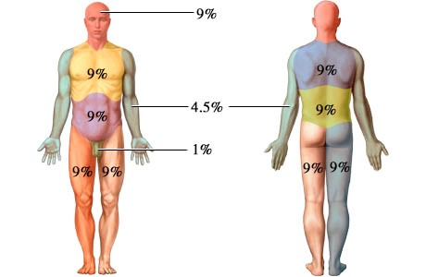 | 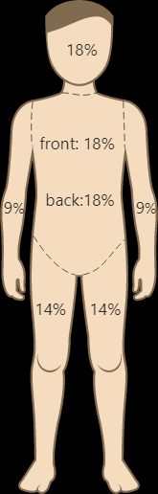

Figure 1.19. Escharotomy for circumferential burn
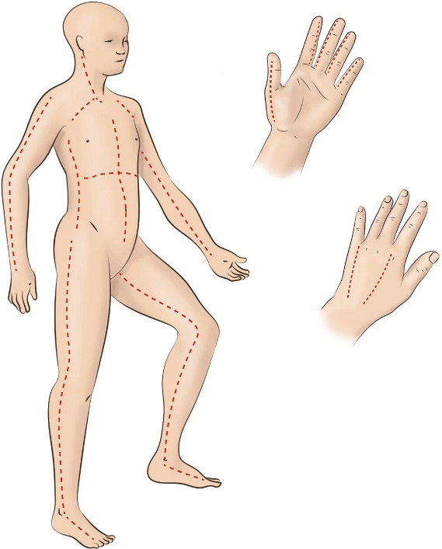

1.6. Approach to Acute Abdomen and Peritonitis

1.6.1. Approach to Acute Abdomen
Acute abdomen represents the rapid onset (usually less than 01 weeks) of severe symptoms that may indicate potentially life-threatening intra-abdominal pathology that requires urgent surgical intervention. 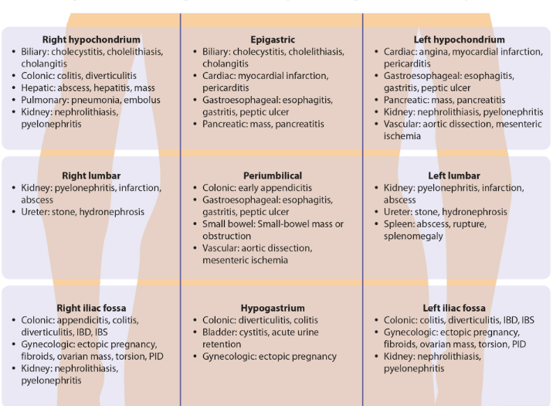Figure 1.20. Differential diagnosis of acute abdomen based on the site of pain felt
Diagnosis
Diagnosis requires higher index of suspicion of serious pathology, consideration of special population groups (pediatrics, pregnancy, and elderly)
History: duration character of pain, location, associated symptoms, etc.
- Identify pertinent past medical illness (diabetes, heart disease, hypertension, liver disease, renal disease, immunocompromising)
- Previous abdominal surgeries or any recent trauma.
- Menstrual history and pregnancies (deliveries, abortions, ectopic)
P/E: tenderness, rigidity, distension, peristalsis, bowel sounds, etc.
Investigations:
- CBC, serum glucose
- Coagulation studies (e.g., INR, PT)
- Liver function test (LFT), renal function test (RFT)
- Lipase, amylase
- ESR/C-reactive protein
- Urinalysis
- β-hCG urine test
- Erect CXR, plain abdominal X-ray
- Abdominal U/S
- CT abdomen
Principles of management
- ABCDEs
Recommended management
- Definitive treatment of abdominal pain is cause-specific
- Oxygenation (for critical patients)
- Secure IV line and resuscitate
- Consider nasogastric (NG) tube if severe vomiting occurs, there are signs of intestinal obstruction, or the patient is extremely unwell and there is danger of aspiration
- Antiemetic: avoid using this as a symptomatic treatment without considering a diagnosis in a community setting
- Broad-spectrum antibiotics: if systemic sepsis or peritonitis
- Adequate analgesia
- Etiology based surgical or medical interventions
Monitoring
- Close monitoring of vital signs and progress of the etiology
Disposition
- Arrange urgent surgical/gynecological consultation, as appropriate.
- Admit to ward/ICU if the patient is unstable.
- Patients with an unclear diagnosis at discharge, even if the CT scan is negative (or for whom response to treatment is a concern), should be asked to return to the ED for reevaluation within 12 hours.

1.6.2. Peritonitis
Peritonitis is infection and/or inflammation of the peritoneum.
Classification
Primary
- Is found without clear gastrointestinal risk factor or no features of violation of gastrointestinal tract integrity.
Secondary
- Occurs due to complications of acute abdomen (such as appendicitis, salpingitis, cholecystitis, perforated discus like typhoid fever, etc.) with clear violation of GIT integrity
- Is usually a mixed infection, and gram-negative bacilli (E. coli, Klebsiella, Pseudomonas, Proteus, etc.), gram-positive cocci (like pneumococcus), and gastrointestinal anaerobe (like Bacteroides fragilis) are the most important organisms involved?
Tertiary
- Recurrent intra-abdominal infection that occurs 48 hours after a well-succeeded control of a secondary peritonitis
- Fungal and multidrug-resistant pathogens should be entertained
Diagnosis
- Diagnosis is clinical with underlying conditions mostly clear.
- Hx: fever, abdominal pain
- P/E: guarding, tenderness, rebound tenderness, complications (localized or generalized), abscess, sepsis /septic shock, Hippocratic face, etc.
- Investigations: those mentioned for acute abdomen
Principles of management
- ABCDEs
Recommended management
- As mentioned under acute abdomen (see section 1.6.1)
- Medical management for primary peritonitis
Monitoring
- Close monitoring of vital signs
- Renal status monitoring
Disposition
- Arrange urgent surgical/gynecological or medical consultation, as appropriate.
- Admit to ICU if the patient is unstable.

1.7. Musculoskeletal Emergency

1.7.1. Compartment Syndrome
Compartment syndrome develops when increased pressure within a musculofascial compartment causes ischemia and subsequent necrosis. Common areas for compartment syndrome include the lower leg, forearm, foot, hand, gluteal region, and thigh.
Diagnosis
- Hx: Compartment syndrome is a clinical diagnosis.
- Early diagnosis is the key to successful treatment of acute compartment syndrome, especially if the patient has an altered sensorium and is unable to respond appropriately to pain.
- Clinical diagnosis is based on the history of injury and physical signs, coupled with a high index of suspicion (6 Ps: pain (disproportionate and on passive stretch), pulselessness, paresthesia, poikilothermia, pallor, paralysis)
Investigation:
- CBC, blood group/Rh
- Limb x-ray
Principles of management
- ABCDEs
- Fasciotomy within 4–6 hours to prevent irreversible tissue necrosis
Recommended management
- Oxygenation (for associated severe injury or sepsis)
- Secure IV line and put on maintenance/resuscitative fluid.
- Adequate analgesia.
- Promptly release all constrictive dressings, casts, and splints applied over the affected extremity and immediately obtain a surgical consultation.
- If fasciotomy is required, debride all dead muscle and leave wounds open
- Repeat irrigation and debridement 48–72 hours later
- Possible delayed primary wound closure or split-thickness skin grafting at a later time
Management of complications
- Myoglobinuria, which may cause decreased renal function.
- Adequate fluid resuscitation with a target urine output of 2ml/kg/hr
- Rebound compartment syndrome
- Onset: occurs 6–12 hours after surgical reperfusion
Monitoring
- Close monitoring of vital signs and status of the limb
- Renal status monitoring
Disposition
Admission for impatient management of wound or associated underlying injury is necessary.

1.7.2. Acute Limb Ischemia
Acute limb ischemia is characterized by a rapid or abrupt reduction in limb perfusion, which frequently poses a threat to limb viability (Table 1.6).
Classification:
Based on the vessel occluded
- Arterial occlusion (most common)
- Arterial embolism (30%), arterial thrombosis due to plaque progression and complication (40%), thrombosis of a popliteal aneurysm (5%), trauma (5%) or graft thrombosis (20%)
- Venous occlusion (i.e., phlegmasia), which is rare
Diagnosis:
- Hx: duration, presence of intermittent claudication to severe resting pain
- P/E: presence of skin color change, paresthesia, muscle weakness, paralysis and even necrosis, gangrene, and limb loss.
Investigation
- Baselines (CBC, blood group/Rh), coagulation profile
- Duplex ultrasound, followed by CTA and magnetic resonance angiography (MRA)
- Echocardiogram (if indicated)
Principles of management
- Prompt identification and treatment of the causes
- Look for other life-threatening comorbidities
Recommended management
Acute limb ischemia due to thromboembolism
- Systemic anticoagulation with an IV heparin bolus followed by continuous infusion unless a contraindication is present
- Further management depends on the severity of acute limb ischemia
Viable, non-threatened limb
- Urgent angiography to localize the site of the occlusion
- Revascularization procedure (open or catheter-directed thrombectomy or thrombolysis) within 6–24 hours
Threatened limb: emergent revascularization procedure within 6 hours
- First-line: catheter-directed thrombolysis and/or percutaneous mechanical thromboembolectomy (e.g., balloon catheter embolectomy)
- Second-line: open thromboembolectomy
- Non-viable limb: limb amputation
Acute limb ischemia due to compartment syndrome: fasciotomy (see compartment syndrome)
Acute limb ischemia due to a dissecting aneurysm: stenting and/or surgical repair
Management of complications
- Wet gangrene: needs debridement or amputation and antibiotics coverage

Monitoring
- Close monitoring of vital signs and limb status
- Monitoring of coagulation profile
- Monitoring of cardiac and renal condition (if indicated)
Disposition
- Early consultation of vascular surgeons or interventional therapists is necessary
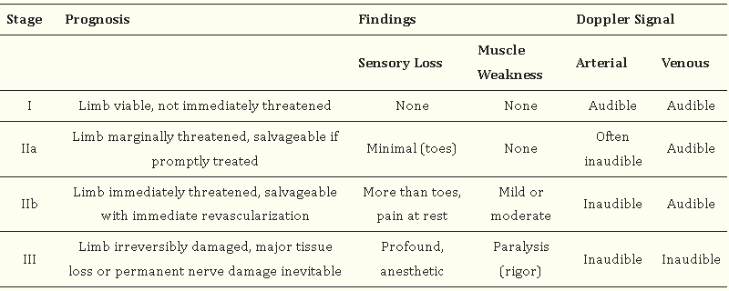
Table 1.6. Stages of acute limb ischemia according to the Rutherford classification

1.7.3. Acute Osteomyelitis
Osteomyelitis is defined as an inflammation of the bone caused by an infecting organism. Osteomyelitis can be classified as acute, sub-acute, or chronic, depending on the duration of symptoms.
Classification:
Based on the mechanism of infection
- Exogenous (caused by open fractures, surgery [iatrogenic], or contiguous spread from infected local tissue)
- Hematogenous (results from bacteremia)
Based on host response to the disease
- Pyogenic
- Nonpyogenic
Diagnosis:
- Hx: duration, fever and chills, malaise, irritability, pain, swelling, a limp or an inability to bear weight
- An infant with upper extremity involvement may exhibit pseudoparalysis; older children and adults with upper extremity involvement complain of pain on movement or use of the extremity
- P/E: tenderness with localized warmth and swelling
- In children it is generally in the metaphyseal region
- It is also important to evaluate the adjoining joint for evidence of septic arthritis, which can occur as an extension of the adjoining osteomyelitis.
Investigation
- Baselines (CBC, blood group/Rh), C-reactive protein and erythrocyte sedimentation rate (ESR)
- Blood, bone, or joint aspirate cultures
- Standard limb radiographs
- As radiographic signs are late findings; their absence does not exclude a diagnosis of acute osteomyelitis
- Ultrasonography and MRI (with and without IV gadolinium: most sensitive study)
Principles of management
Signs of sepsis present: start management of sepsis without waiting for diagnostic test results
Recommended management
- Maintenance fluid
- Appropriate parenteral antibiotics
- Surgical removal of avascular tissues or abscesses or surgical decompression of marrow space
- Surgery should be minimal and should not damage the already ischemic bone and soft tissue
- The two main indications for surgery in acute osteomyelitis are;
- The presence of an abscess requiring drainage
- Failure of the patient to improve despite appropriate intravenous antibiotic treatment
- Adequate analgesia
- Comfortable positioning of the affected limb (point of pressure [POP] splint or skin traction if indicated)
Management of complications
Surgical decompression of acute septic arthritis should be considered, if indicated
Monitoring
- Close monitoring of vital signs
- C-reactive protein value should be checked every 2 to 3 days
- Limb status (local inflammatory signs)
Disposition
- Early consultation with orthopedic surgeons is necessary
- Admit to ward for a course of parental antibiotics
1.7.4. Septic Arthritis
Septic arthritis is an infection-related inflammation of the joint space, which is an orthopedic emergency.
Diagnosis
- Hx: duration, joint pain, fever, irritability, decreased appetite, swelling, limited range and a reluctance or refusal to move the affected joint
- P/E: knee is the most common joint involved in septic arthritis, followed by the hip, shoulder, and ankle
- Effusions are common on examination.
- The range of motion is limited and palpation may be associated with pain.
Investigation
- Baselines (CBC, blood group/Rh), C-reactive protein and ESR
- Blood cultures
- Synovial fluid analysis
- Standard limb radiographs
- May reveal widened joint spaces, bulging of the soft tissues, or subchondral bony changes (late finding)
- A normal plain radiograph does not rule out septic arthritis
- Ultrasonography is useful in identifying and quantifying the joint effusion as well as aiding in needle aspiration of the joint.
- MRI is useful for early detection of joint fluid and may reveal abnormalities in surrounding soft tissue and bone
Principles of management
Prompt identification and initiation of parental antibiotics and joint fluid drainage underlies the management of septic arthritis.
Recommended management
- Maintenance fluid
- Appropriate parenteral antibiotics
- Anti-staphylococcal coverage (nafcillin, oxacillin, or vancomycin) for all age and risk categories.
- Nongonococcal septic arthritis usually involves the use of intravenous vancomycin directed against gram-positive organisms especially if there is a suspicion of MRSA
- If the patient is immunocompromised, abuses intravenous drugs, or the gram stain is negative, then a third-generation cephalosporin is required
- Blood and synovial fluid cultures and sensitivities should direct prolonged antimicrobial treatment.
- Joint fluid drainage (arthrotomy, arthroscopy, or daily needle aspiration)
- Adequate analgesia
- Comfortable positioning of the affected limb (POP splint or skin traction if indicated).
Management of complications
Osteomyelitis, chronic pain, osteonecrosis, leg length discrepancies/joint fusion, and sepsis should be sought and addressed accordingly.
Monitoring
- Close monitoring of vital signs
- C-reactive protein value should be checked every 2 to 3 days
- Joint status (local inflammatory signs)
Disposition
- Early involvement by an orthopedic surgeon is essential.
- The procedure used to drain joint fluid depends on multiple factors and is determined by the orthopedic surgeon.

1.7.5. Pyomyositis
Pyomyositis is a bacterial infection of skeletal muscle that classically leads to abscess formation.
Diagnosis
- Hx: cramps and aches in the affected muscle, low-grade fever (early stage)
- Fever and chills, pain in the affected muscle, mobility issues (stage two)
- P/E: tenderness, firm lump under your skin (the muscle abscess)
- Presence of life-threatening conditions like septic shock and organ damage or failure (stage three)
Investigation
- Baselines (CBC, blood group/Rh)
- Blood cultures
- Standard limb radiographs: presence or absence of bony/joint involvement
- Ultrasonography
- MRI
Principles of management
Prompt identification and initiation of parental antibiotics and surgical drainage is important.
Recommended management
- Maintenance fluid
- Appropriate parenteral antibiotics
- Surgical drainage and debridement
- Wound care
- Adequate analgesia
- Comfortable positioning of the affected limb (POP splint or skin traction if indicated)
- Management of complications
- Osteomyelitis, chronic pain, and sepsis should be sought and addressed accordingly.

Monitoring
- Close monitoring of vital signs
- Limb status (local inflammatory signs)
Disposition
- Early involvement by general/orthopedic surgeon is essential.

1.7.6. Necrotizing Fasciitis
Necrotizing fasciitis is an aggressive skin and soft tissue infections that cause necrosis of the muscle, fascia, and subcutaneous tissues and moves along the fascial plane.
Diagnosis:
- Hx: excruciating pain out of proportion to presenting symptoms
- The infection can spread rapidly within hours; hence suspicion should be high for necrotizing fasciitis in the presence of intense pain.
- P/E: tenderness to palpation beyond the erythematous border, crepitus, and cellulitis
- The presence of bullae, ecchymosis, and dysesthesia/paresthesia
- Subcutaneous emphysema and crepitus are almost always present
- Anesthesia may also be present in some areas due to injury to the nerve fibers.
Investigation:
- Laboratory risk indicator for necrotizing infection (LRINEC) score (Table 1.7)
- A score of six has a positive predictive value of 92% and a negative predictive value of 96%. A score of eight or more represents a 75% risk of necrotizing infection.
- CT
- The use of B-mode color Doppler ultrasound can help in the early diagnosis of necrotizing fasciitis at the bedside

S# | Laboratory test | Values | score
1 | C-reactive protein, mg/L | Less than 150 | 0
1 | C-reactive protein, mg/L | More than 150 | 4
2 | Total white cell count (WBC), cells/mm | Less than 15 | 0
2 | Total white cell count (WBC), cells/mm | 15 to 25 | 1
2 | Total white cell count (WBC), cells/mm | More than 25 | 2
3 | Hemoglobin, g/dl | More than 13.5 | 0
3 | Hemoglobin, g/dl | 11 to 13.5 | 1
3 | Hemoglobin, g/dl | Less than 11 | 2
4 | Sodium, mmol/L | 135 or greater | 0
4 | Sodium, mmol/L | Less than 135 | 2
5 | Creatinine, mg/dL | 1.6 or less | 0
5 | Creatinine, mg/dL | More than 1.6 | 2
6 | Glucose, mg/dL | 180 or less | 0
6 | Glucose, mg/dL | More than 180 | 1
Table 1.7. Laboratory risk indicator for necrotizing infection score
Principles of management
- ABCDEs
Recommended management
- Secure IV line and resuscitate
- Appropriate broad-spectrum parenteral antibiotics
- Identification of infection-causing pathogens and applicable adjustment of antimicrobial coverage
- Radical surgical debridement with limiting incision, wound should be left open
- Wound care
- Adequate analgesia
- Soft tissue reconstruction (later)
- Management of complications
- Multi-organ failure, septic shock, loss of extremity, severe scarring, and toxic shock should be sought and addressed accordingly.
Monitoring
- Close monitoring of vital signs
- Wound status (there may be a need for re-debridement)
Disposition
- Early involvement by general surgeon is essential.
- These patients are best managed in the ICU until patient is stabilized.

1.8. Ear, Nose, and Throat Emergencies

1.8.1 Acute Otitis Media and Mastoiditis
Introduction and principles of management
Acute otitis media (AOM) is a common infection of the middle ear, predominantly affecting children. It is characterized by the rapid onset of signs and symptoms of middle ear inflammation (fever, ear discharge, ear pain).
The primary goals in managing AOM are to relieve symptoms, eradicate infection, and prevent complications.
Diagnosis
Typically based on clinical findings, including otoscopic examination

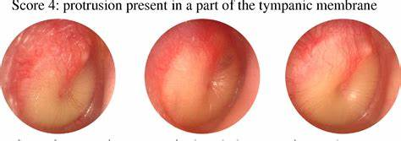
Figure 1.21. Bulging tympanic membrane on otoscopic examination
Recommended management
Initial management:
- Pain management: administer analgesics such as acetaminophen or ibuprofen.
- Observation vs. antibiotics
- Observation: for mild cases or in older children with mild symptom.
- Antibiotics: for severe symptoms, children under 6 months or when there is a bilateral infection in children under 2 years
- First-line antibiotics: amoxicillin is the preferred initial antibiotic. For penicillin-allergic patients, use alternatives such as cefdinir, cefuroxime, or azithromycin.
- Second-line antibiotics: amoxicillin-clavulanate or ceftriaxone for cases unresponsive to initial treatment
- Drugs and Doses
Analgesics:
- Acetaminophen:
- Pediatric: 10-15 mg/kg per dose every 4-6 hours as needed.
- Adult: 500-1000 mg every 4-6 hours as needed (maximum 4 g/day).
- Ibuprofen:
- Pediatric: 5-10 mg/kg per dose every 6-8 hours as needed.
- Adult: 200-400 mg every 4-6 hours as needed (maximum 3200 mg/day).
Antibiotics:
- Amoxicillin:
- Pediatric: 80-90 mg/kg/day divided into two doses.
- Adult: 500 mg every 8 hours or 875 mg every 12 hours.
- Amoxicillin-Clavulanate:
- Pediatric: 90 mg/kg/day of amoxicillin component, divided into two doses.
- Adult: 500 mg every 8 hours or 875 mg every 12 hours.
- Cefdinir:
- Pediatric: 14 mg/kg/day divided into one or two doses.
- Adult: 300 mg every 12 hours.
- Cefuroxime:
- Pediatric: 30 mg/kg/day divided into two doses.
- Adult: 250-500 mg every 12 hours.
- Azithromycin:
- Pediatric: 10 mg/kg on day 1, then 5 mg/kg on days 2-5.
- Adult: 500 mg on day 1, then 250 mg on days 2-5.
- Ceftriaxone:
- Pediatric: 50 mg/kg IM/IV once daily for 1-3 days.
- Adult: 1-2 g IM/IV once daily.
Special considerations
- Recurrent AOM (three episodes in six months or four in a year): consider prophylactic antibiotics and referring to ear, nose, and throat (ENT) specialist for tympanostomy tube placement.
- Patients with tympanostomy tubes: topical antibiotic drops may be preferred over systemic antibiotics for otorrhea.
Management of complications
- Tympanic membrane perforation: monitor healing and provide follow-up care
- Chronic otitis media: consider ENT referral for recurrent or persistent cases
- Mastoiditis: Requires prompt evaluation and possible surgical intervention (e.g., mastoidectomy) in severe cases
Disposition
- Outpatient management: most cases managed at home with antibiotics and symptomatic care.
- Hospitalization criteria: consider in severe cases, young infants, or when complications are suspected.

1.8.2. Acute Mastoiditis
Introduction and principles of management
Mastoiditis is an infection of the mastoid air cells in the temporal bone, characterized by postauricular pain, swelling, erythema, fever, and otorrhea, often occurring as a complication of AOM. It can lead to severe complications if not promptly diagnosed and treated.
The primary goals in managing mastoiditis are to eradicate the infection, relieve symptoms, and prevent further complications.
Diagnosis
Based on clinical findings and imaging studies (particularly CT scan of the sinuses).
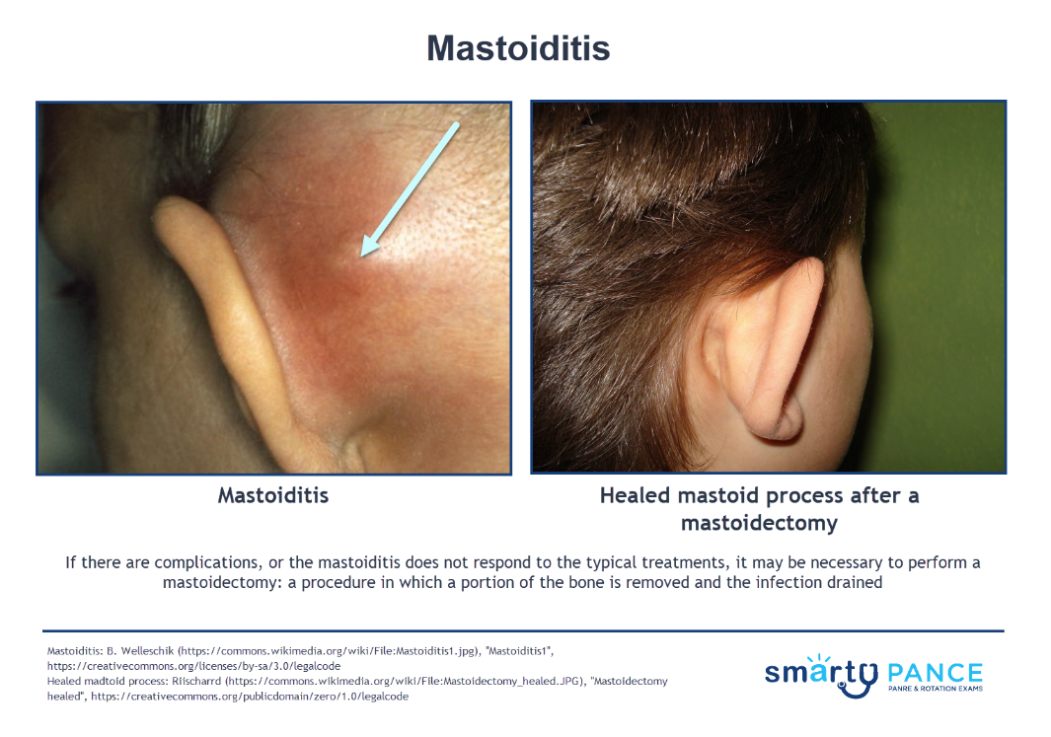
Figure 1.22. Mastoiditis of the left ear
Recommended management
Initial management
- Hospitalization: most patients with mastoiditis require inpatient care.
- Intravenous antibiotics: start with broad-spectrum antibiotics targeting common pathogens (Streptococcus pneumonia, Haemophilus influenzae, and Staphylococcus aureus).
- First-line antibiotics: ceftriaxone or cefotaxime, combined with clindamycin or vancomycin if MRSA is suspected.
- If no recurrent AOM or no recent antibiotic use (3 to 6 months),
- Vancomycin (15 mg/kg intravenously [IV] every 6 hours; maximum 1 g per dose)
- If recurrent AOM (most recent episode within six months) or recent antibiotic administration,
- Vancomycin PLUS Ceftazidime/cefepime 50 mg/kg per dose IV every 8 hours (maximum 2 g per dose)
- Duration of antimicrobial therapy:
- Totally four weeks IV treatment may be continued for 7 to 10 days or IV to PO conversion should be done approximately after a clinical improvement.
- Pain management: administer analgesics such as acetaminophen or ibuprofen.
- Myringotomy: consider for drainage and culture of middle ear fluid.
Surgical intervention
Mastoidectomy: indicated for cases unresponsive to medical therapy, presence of subperiosteal abscess, or intracranial complications.
Special considerations
- Immunocompromised patients: higher risk of complications and may require more aggressive treatment and monitoring
- Pediatric considerations: children are more susceptible to complications and may present with more subtle signs
Management of complications
- Subperiosteal abscess: requires surgical drainage and continued antibiotic therapy
- Intracranial complications: such as meningitis, brain abscess, or lateral sinus thrombosis. These require aggressive treatment with intravenous antibiotics and possible neurosurgical intervention.
- Hearing loss: monitor for any signs of conductive or sensorineural hearing loss and refer to an audiologist if needed.
Monitoring
- Vital signs: continuous monitoring of temperature, heart rate, and blood pressure
- Neurological assessment: evaluate for signs of neurological deficits, including cranial nerve examination
Disposition
- Hospitalization: typically required for intravenous antibiotic therapy and close monitoring.
- Outpatient follow-up: arrange for follow-up with ENT specialist for ongoing management and resolution assessment.
Reference
Evidence-based guidelines from organizations such as the American Academy of Pediatrics (AAP) and relevant clinical studies on AOM and mastoiditis management.

1.8.3 Epistaxis
Introduction and principles of management
Epistaxis, or nosebleed, is a common condition that can range from a minor bleed to a life-threatening emergency. It can be classified into anterior and posterior epistaxis, with anterior being more common and generally less severe (Figure 1.23).
The primary goals in managing epistaxis are to control bleeding, identify the underlying cause, and prevent recurrence.
Diagnosis
- Based on clinical findings and, if necessary, further investigations to identify any underlying pathology

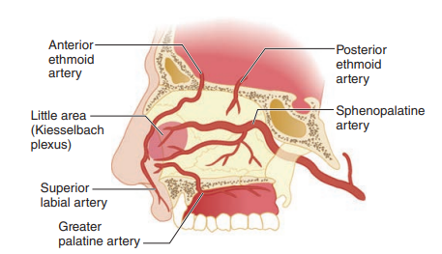
Figure 1.23. Anatomy and classification of epistaxis
Recommended management
Immediate management
- Positioning: sit the patient upright and lean slightly forward to prevent blood from entering the pharynx
- Direct pressure: pinch the soft part of the nose for 10-15 minutes
- Topical vasoconstrictors: apply oxymetazoline or phenylephrine nasal spray
- Anterior nasal packing: use gauze (Figure 1.24) or a nasal tampon if direct pressure and vasoconstrictors are ineffective (Figure 1.25)
- Cauterization: chemical (silver nitrate) or electrical cautery for visible bleeding sites after local anesthesia
- Procedure protocol: silver nitrate cauterization for epistaxis
Indication
- Anterior nosebleed from the Kiesselbach’s plexus area
- Procedure
- The silver nitrate should be applied with firm pressure for 5 to10 seconds (Figure 1.26)
- After the successful procedure is complete, the patient is instructed to use antibiotic ointment in the nose twice a day for 1 week; if possible, the patient should not use aspirin or NSAIDs products for this duration of time.

Figure 1.24. Process of anterior nasal packing | Figure 1.25. A dual balloon epistaxis catheter providing anterior and posterior compression
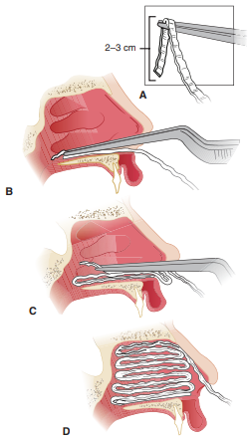 | 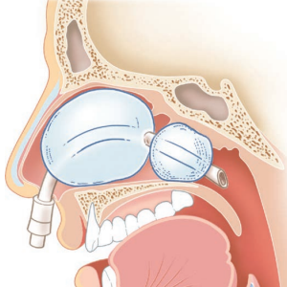


Figure 1.25. Silver nitrate sticks

Further management for posterior epistaxis:
- Posterior nasal packing: use a balloon catheter or gauze pack if anterior measures fail (Figure 1.25)
- Hospitalization: consider for posterior packing due to the risk of complications
Systemic treatment:
- Antibiotics: prophylactic antibiotics for patients with nasal packing to prevent toxic shock syndrome
- Hemostatic agents: tranexamic acid may be considered in persistent or severe cases
Drugs and doses
- Topical vasoconstrictors
- Oxymetazoline:
- Pediatric and Adult: 2-3 sprays in each nostril every 10-12 hours as needed.
- Phenylephrine:
- Pediatric and Adult: 2-3 sprays in each nostril every 4 hours as needed.
- Systemic Hemostatic Agents:
- Tranexamic Acid:
- Pediatric: 10-15 mg/kg IV every 8-12 hours.
- Adult: 1 g IV every 8-12 hours.
- Prophylactic Antibiotics:
- Amoxicillin-Clavulanate:
- Pediatric: 20-40 mg/kg/day of amoxicillin component divided into three doses.
- Adult: 500-875 mg every 12 hours.
Special considerations
- Underlying conditions: manage any contributing factors such as hypertension, coagulopathies, or anticoagulant therapy.
- Children and elderly: pay particular attention to these populations due to increased risk of complications and recurrence.
Management of complications
- Recurrent epistaxis: investigate for underlying causes such as nasal tumors, coagulopathies, or systemic diseases
- Infection: monitor for signs of sinusitis or toxic shock syndrome, especially in patients with nasal packing
Monitoring
- Vital signs: continuous monitoring for hemodynamic stability
- Bleeding status: regular assessment of nasal packing and bleeding control
- Laboratory tests: check hemoglobin, hematocrit, coagulation profile, and blood type and cross-match if significant bleeding is present
Disposition
- Stable patients: most patients can be managed on an outpatient basis with follow-up care
- Hospitalization: required for severe, recurrent, or posterior epistaxis, or if there are signs of significant blood loss or hemodynamic instability
Referral: refer to an otolaryngologist for recurrent epistaxis, complications, or if specialized procedures (e.g., arterial ligation, embolization) are needed

1.8.4. Nasal Bone Fracture
Introduction and principles of management
Nasal bone fractures are the most common type of facial fractures, often resulting from blunt trauma (Figure 1.27).
The primary goals in managing nasal bone fractures are to ensure airway patency, control bleeding, reduce the fracture, and prevent cosmetic deformity.
Diagnosis
Typically based on clinical examination and may be confirmed with imaging studies.

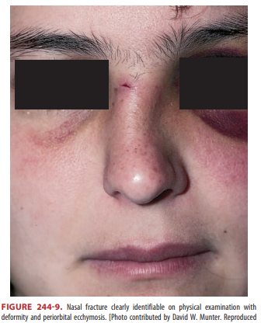
Figure 1.27. Nasal bone fracture
Recommended management
- Assess the airway first (go through ABCDE)
- Immediate nasal bleeding after a blow to the nose means nasal bone fracture (90% probability)
- X- ray of the nose are optional
- The best way to evaluate nasal fracture is by waiting for swelling to subside for a week and comparing with a pre-injury photo
- At the time of injury, always check for septal hematoma (Figure 1.28)
- A hematoma causes the septum to appear defected to both sides of nose at the same place
- If a hematoma is missed and infection occurs, the top of the nose will collapse (saddle nose)
- Consideration in other facial trauma, check for:
- Numbness (floor of orbit fracture)
- Diplopia (ocular muscle trapped in fracture)
- Trismus (mandibular fracture)
Management of complications
Septal hematoma: prompt drainage to prevent septal cartilage necrosis.
The procedure for incision and drainage of a nasal septal hematoma is:
- Place patient in “sniffing position,” and be prepared to perform adequate anterior rhinoscopy with a nasal speculum, light source, suction, irrigation, and packing materials.
- Properly anesthetize the nasal mucosa by placing three cotton pledgets soaked in a 1:1 mixture of 4% topical lidocaine and epinephrine 1:1000 solution for 5 minutes, followed by infiltrative anesthesia if required.
- Although sterile technique cannot be fully achieved in the nasal cavity, use sterile instruments and keep the operative area as clean as possible with irrigation of foreign debris.
- While obtaining adequate visualization of the hematoma with the nasal speculum, make a small horizontal incision superficially through the mucosa, making sure you do not incise the cartilaginous septum.
- Evacuate the clot with Frazier suction or with forceps.
- Perform bilateral anterior nasal packing with nasal tampons coated in topical antibiotic ointment to prevent re-accumulation of the clot and keep the septum midline.
- Discharge with 24-hour ENT or ED follow-up.
Some recommend the use of prophylactic antibiotics for patients with packing in place, but this is not necessary if the packing will be removed in 24 to 36 hours.
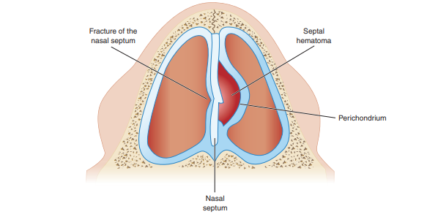
Figure 1.28. Nasal septal hematoma
Nasal septal deviation: address during fracture reduction to prevent functional impairment
Cosmetic deformity: consider aesthetic outcomes during fracture management
Disposition
- Outpatient management: majority managed as outpatients with instructions for wound care, splint management, and follow-up
- Hospitalization criteria: consider for complex fractures requiring surgical intervention or close monitoring
- Patient education: provide instructions on postoperative care, signs of infection, and follow-up appointments.
Reference
Clinical guidelines from organizations such as the American Academy of Otolaryngology-Head and Neck Surgery (AAO-HNS), relevant studies on nasal fractures, and fracture management protocols.

1.8.5. Acute Tonsillopharyngitis
Introduction and principles of management
Acute tonsillopharyngitis is an infection and inflammation of the tonsils and pharynx. It is commonly caused by viruses or bacteria, with Group A Streptococcus being the most significant bacterial pathogen.
The primary goals in managing acute tonsillopharyngitis are to relieve signs (erythema, tonsillar exudates, and tender anterior cervical lymphadenopathy) and symptoms, eradicate the infection, and prevent complications.
Diagnosis
Based on clinical findings and, if necessary, rapid antigen detection tests or throat cultures
Recommended management
Initial management:
- Symptomatic Treatment:
- Analgesics and antipyretics: acetaminophen or ibuprofen for pain and fever relief
- Hydration and rest: encourage fluid intake and adequate rest
- Antibiotic therapy:
- First-line antibiotics: for confirmed or highly suspected streptococcal infection
- Penicillin V: preferred due to narrow spectrum and effectiveness
- Amoxicillin: alternative with similar efficacy
- Penicillin allergy: use alternatives such as cephalexin (if not anaphylactic), clindamycin, or azithromycin
Drugs and doses
- Antibiotics
- Penicillin V:
- Pediatric: 250 mg 2-3 times daily for 10 days
- Adult: 500 mg 2-3 times daily for 10 days
- Amoxicillin:
- Pediatric: 50 mg/kg once daily (maximum 1000 mg) for 10 days
- Adult: 500 mg twice daily or 1000 mg once daily for 10 days
- Cephalexin (for non-anaphylactic penicillin allergy):
- Pediatric: 25-50 mg/kg/day in divided doses
- Adult: 500 mg every 12 hours for 10 days
- Clindamycin:
- Pediatric: 7 mg/kg every 8 hours
- Adult: 300 mg every 8 hours for 10 days
- Azithromycin (for severe penicillin allergy):
- Pediatric: 12 mg/kg once daily for 5 days
- Adult: 500 mg on day 1, then 250 mg once daily for 4 more days

- Analgesics and Antipyretics:
- Acetaminophen:
- Pediatric: 10-15 mg/kg per dose every 4-6 hours as needed
- Adult: 500-1000 mg every 4-6 hours as needed (maximum 4 g/day)
- Ibuprofen:
- Pediatric: 5-10 mg/kg per dose every 6-8 hours as needed
- Adult: 200-400 mg every 4-6 hours as needed (maximum 3200 mg/day)
Special considerations
- Recurrent tonsillopharyngitis: evaluate for possible chronic carriers and consider tonsillectomy in selected cases
- Viral etiology: most cases are viral and antibiotics are not indicated. Supportive care is the mainstay.
Management of complications
Peritonsillar abscess (quinsy): characterized by severe throat pain, trismus, and a "hot potato" voice (Figure 1.29)
Requires needle aspiration or incision and drainage along with antibiotic therapy
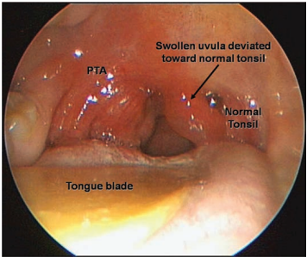
Figure 1.29. Peritonsillar abscess
- Rheumatic fever: prevented by appropriate antibiotic treatment of streptococcal infections
- Poststreptococcal glomerulonephritis: manage symptoms and provide supportive care
Monitoring
- Follow-up visits: re-evaluate within a few days if symptoms do not improve with initial treatment
- Complication monitoring: watch for signs of peritonsillar abscess, systemic involvement, or worsening condition
Disposition
- Stable Patients: most patients can be managed on an outpatient basis with follow-up care.
- Hospitalization: required for severe cases, complications, or patients unable to maintain oral intake

1.9. Monitoring, Admitting, and Discharging Patients and Medico-Legal Cases

1.9.1. Monitoring
- Monitoring ensures rapid detection of changes in the clinical status.
- Monitoring allows for accurate assessment of progress and response to therapy.
- When clinical signs and monitored parameters disagree, assume that clinical assessment is correct.
- Trends are more important than a single reading; make assessment based on trends.
- Use non-invasive techniques when possible.
- Alarms are crucial for patient safety and should be checked frequently.
- Results should be observed and interpreted in the context of the patient and treatment.

Minimal non-invasive parameters
Respiratory rate (RR), oxygen saturation (SpO2), temperature (T), heart rate (HR), blood pressure (BP, MAP), level of consciousness (alert, verbal, pain, unresponsive [AVPU]), urine output
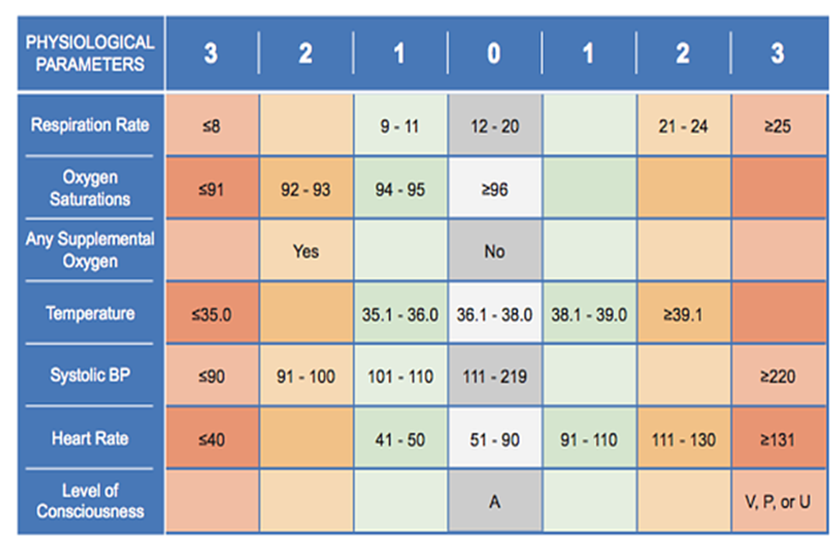
Frequency of monitoring
During the early resuscitation phase, monitoring multiple parameters (not just one) is necessary to titrate interventions and guide actions.

Parameter | Frequency of monitoring | Limitations
RR, HR, SpO₂ | Measure continuously using a non-invasive monitor  Normal value is 98–100% (at sea level) goal in adults is more than 90% | Requires a pulsatile signal – challenging with motion or poor perfusion  Does not measure ventilation (pCO₂)  False readings can be seen with abnormal Hb or CO poisoning  Remember to remove nail polish if present!
Parameter | Frequency of monitoring | Limitations
RR, HR, SpO₂ | Measure continuously using a non-invasive monitor  Normal value is 98–100% (at sea level) goal in adults is more than 90% | Requires a pulsatile signal – challenging with motion or poor perfusion  Does not measure ventilation (pCO₂)  False readings can be seen with abnormal Hb or CO poisoning  Remember to remove nail polish if present!
Parameter | Frequency of monitoring | Limitations
RR, HR, SpO₂ | Measure continuously using a non-invasive monitor  Normal value is 98–100% (at sea level) goal in adults is more than 90% | Requires a pulsatile signal – challenging with motion or poor perfusion  Does not measure ventilation (pCO₂)  False readings can be seen with abnormal Hb or CO poisoning  Remember to remove nail polish if present!
BP (SBP, DBP, MAP) | Measure every 5–15 minutes during initial resuscitation of patients with shock. Once stabilized, can reduce to every 30–60 minutes.  Consider invasive continuous monitor if refractory shock to fluids or need frequent arterial sample | Technically difficult to obtain in shock states  Use appropriate cuff size  Invasive blood pressure monitoring  Benefits:  Directly measures arterial pressure  More accurate  More reproducible  Continuous
Mental status | Monitor hourly
GCS or four scale | If patient is receiving sedation, analgesia, or mechanical ventilation, monitor sedation and pain with standardized scales every hour (RASS, etc.)
Temperature | Measure at least every 3 hours
Urine output | Measure hourly
Physical examination | Focused examination of cardiovascular and respiratory system should be assessed every 30–60 minutes during the resuscitation phases of shock. Once patient is stabilized, can reduce to every 2–4 hours.
Laboratory tests | As often as needed when managing shock and metabolic abnormalities (i.e., CBC, creatinine, electrolytes, glucose, and lactate). Avoid routine laboratory testing.
Ultrasound | If possible, on daily basis and as indicated in ventilated patients.

Transport of unstable patient from emergency department
- A trained physician or nurses with intubation skills, and basic life support (BLS)/advanced cardiovascular life support should be available during transportation
- Before moving the patient, communications with the receiving department or hospital should be confirmed and maintained.
- Referral notes should be completed clearly and the purpose of transfer included.
- High speed journeys must be avoided except when clinically necessary.
- Fully sedate and paralyze all ventilated patients before transport.
- The safety profile of the transport for a critically ill patient should be similar to conditions in an ICU.
- The transport should include:
- Drugs for paralysis and sedation, in addition to emergency drugs, should be available as syringes for bolus administration.
- Infusions, other than vasopressors, should be closed, as much as possible.
- Syringe drivers or volumetric pumps are only allowed for essential drugs, e.g. inotropes.
- Monitoring equipment for pulse rate, SpO2, ECG plus portable monitor
- Oxygen log plus two O2-tank used for ventilation of transported patients.
- AMBU bag for manual ventilation and essential drugs/equipment.
- Check that request forms and essential x-rays are available.
- A nurse should accompany all patients.
- A doctor should accompany all unstable and critical patients and should have airways skills.
- Ensure appropriate emergency treatments have been given and patient is stable and ready for transport.
- Ensure appropriate documentation and handover of care to next responsible clinicians.
Admitting and discharging patients as decided by the emergency physician
Procedure
Emergency Room area is a resuscitative and first aid area where patients walk in/come in their own vehicles or are brought in an ambulance, after being referred from other hospitals
The Emergency Medicine is for resuscitation, first aid of patients, urgent therapy for stabilization of patients, therefore patients will be cared for in the department for the above purpose. Patient will be registered under Emergency Medicine. It has an area demarcated for resuscitation/first aid/urgent therapy for stabilization of patients with beds designated for such purpose. The department includes:
- Resuscitation area with a mobile trolley/bed, spot light, emergency drugs, defibrillator, multi-parameter monitor, piped O2, and suction ports (vacuum)
- An emergency physician and nurse who check the vitals and, if required, connects patients to monitors. They will:
- Start emergency treatment, such as oxygen, IV fluids
- Perform resuscitation if required
- A brief history and physical examination is done for all patients and the initial assessment form is documented.
- Investigation orders are raised if required
- Patients are assessed for admission or discharge to home, based on the observation of the medical team and investigations results, if any, and as per specialist’s recommendations. The patient may be discharged to home or will be admitted to inpatient wards, intensive care/high-dependency unit, or shifted to operation theater
- In case of transfer of patients to wards, patient handing over and taking over is done between staff nurses in the ED and admitting ward.
- A Medico-Legal Case will be registered in all cases of road traffic accidents, poisoning, and where there is suspicion of foul play leading to a medical/surgical condition.
- In case admission of the patient is necessary, the consultant on duty makes the decision for admission and authorize it. The emergency physician admits the patient under the specialty consultant on duty (during peak hours) and on-call basis (during non-peak hours).
- The ED nurse is informed if the patient is to be admitted.
- The ED nurse communicates with the nurse in charge of the floor and confirms the availability of the bed and initiates the transfer of the patient to the floor admitted.
- Patient is transferred to the floor by transport by the housekeeping staff as per patient's acuteness. Monitored patients are transferred with a nurse and a doctor. All documents and reports of the patient are transferred to the floor along with the patient.
- Exceptions occur in cases of life and death emergencies. The patient will be transferred to the ICU directly from the ED and registration and documentation may be postponed and done after the initial stabilization of the patient

1.9.2. Documentation and Handling Of Medico-Legal Cases
Medico-legal case examination and reporting is one of the legal responsibilities of all doctors working in the hospital.
Introduction
A medico-legal case is a case of injury/illness where the attending doctor, after eliciting history and examining the patient, thinks that some investigation by law enforcement agencies is essential to establish and fix responsibility for the case in accordance with the law of the Ethiopia.
Cases that are to be treated as medico-legal case
The following cases should be considered as a medico-legal case and, as such, the medical officer is duty-bound to report to the police regarding such cases:
- All cases of injuries (irrespective of suspicion of foul play)
- All vehicular, factory, or other unnatural accident cases
- Firearm or gunshot injury
- Bomb blast injury
- Dead body
- Snake bite (in the State of Karnataka)
- Electrocution
- Cases of suspected or evident sexual assault
- All cases of suspected or evident poisoning or intoxication
- Cases referred from court or otherwise for age estimation
- Dead bodies with improper history creating suspicion of an offence
- Cases of suspected self-infliction of injuries or attempted suicide
- Any other case not falling under the above categories but that has legal implications.
Policy
- In all the above-mentioned cases, the doctor shall enter the patient’s details in the medico-legal register.
- Police intimation form shall be written and sent to the respective police station.
- In the outpatient department folder, the history sheet shall contain the medico-legal case seal.
- In murder/assault cases:
- The patient’s clothing and any weapon found shall be preserved
- Assault patients and attenders shall be advised not to wash their clothes, to dry them under the sunlight, and preserve for police investigation
- In poising cases:
- All the evidences like stomach wash content and clothes shall be preserved.
- In rape and sexual assault cases:
- If the patient is brought by the police, then they must bring the letter of incident
- If the patient is brought by anyone other than police, the intimation shall be sent from the hospital
- Details of such incident shall be written in the medico-legal case register and in the history sheet
- Blood samples for HIV, HbsAg for hepatitis B infection, and for sexually transmitted infections shall be collected
- Urine pregnancy test shall be done
- Immediate reference to obstetrics/gynecology shall be given
- Scalp hair, nail clippings, pubic hair and gauze with blood, high and low vaginal smear and swabs shall be collected
- Patient’s clothing shall be preserved
- All the above shall be handed over to the Department of Forensic Medicine
- Medico-legal case in case of an unknown patient:
- If a victim is brought to ER by police and if the victim’s name, age, address is not known, then they shall be identified as “unknown”
- The details of the person who brings the patient shall be documented
- Patient admitted under medico-legal case dies during the course of treatment
- Police shall be notified regarding the same
- Dead body shall be handed over to the police. If there is delay in arrival of the police, dead body shall be kept in cold storage
- Trauma cases:
- Details of all cases of trauma cases should be entered in the accident register.
- Details of non-traumatic cases like poisoning should also be entered in the accident register.
- Extreme care should be exercised in recording the details.
- If the victim is unconscious, the information is to be obtained from the accompanying person. The name, address and relationship of such person should also be recorded.
- If the victim states the circumstances as to the causation of injury and if the doctor is convinced that they do not come within the ambit of Section 39 of Criminal Procedure Code (non-medico-legal case, e.g., domestic accident), police need not be notified.
- If the history given by the relatives, and if the trauma victim is unconscious, police should be notified.
- If a non-police case, such as a domestic accident victim admitted in the hospital dies, the death comes under the category of unnatural deaths and hence the police should be notified.
- In case of a patient is brought in dead:
- If a patient is brought dead to the ED, a written police intimation shall be sent, and it shall be recorded in the brought dead register.
- The body shall be handed over to the police after receiving a written consent from the police for the release of the body with their number and signature.

1.10. Infection Prevention and Control in Emergency Department
Infection prevention and control (IPC) is a practical, evidence-based approach preventing patients and health workers from being harmed by avoidable infections.

1.10.1. Core Practice
Leadership support
- Ascertain that the company or healthcare facility's governing body bears responsibility for the accomplishment of IPC initiatives.
- Provide adequate financial and human resources for the prevention of infections.
- Assign one or more competent people who have received IPC training.
- To guarantee the efficacy of the program, empower and uphold the authority of individuals in charge of the IPC initiative.
Education and training of healthcare personnel on infection prevention
- Provide all healthcare workers with task-specific IPC education and training.
- Require training before people are permitted to carry out their responsibilities and once a year as a refresher.
- Create procedures to guarantee that all healthcare workers comprehend IPC guidelines and are capable of following them while carrying out their duties.
- Provide written IPC policies and procedures that are up to date, readily available, and grounded in guidelines supported by evidence (e.g., U.S. Centers for Disease Control, the Ministry of Health).
Patient, family, and caregiver education
Provide appropriate IPC education to patients, families, visitors, etc.
- Provide information about how infections spread
- How to prevent infections
- The signs and symptoms that should prompt reevaluation and notification of the patient's healthcare provider
Performance monitoring and feedback
- Identify and monitor IPC practices and compliance with IPC requirements.
- Provide prompt and regular feedback to medical staff and facility managers on compliance and related outcomes.
- Train performance monitoring staff to use standardized tools and definitions.
- Monitor outbreaks of infectious diseases that may be associated with care provided at the facility.
Standard precautions
Standard Precautions include:
- Hand hygiene
- Environmental cleaning and disinfection
- Injection and medication safety
- Risk assessment with use of appropriate PPE (e.g., gloves, gowns, face masks) based on activities being performed
- Minimizing potential exposures (e.g. respiratory hygiene and cough etiquette)
- Reprocessing of reusable medical equipment between each patient or when soiled.
Hand hygiene
- Hand hygiene should be performed as recommended by the U.S. Centers for Disease Control and Prevention.
- For the following indications, use an alcohol-based hand sanitizer or wash with soap and water:
- Immediately before touching the patient
- Before performing sterile work (e.g., placing an indwelling device) or handling invasive medical devices
- Working from a contaminated area to a clean area of ​​the patient's body
- After touching the patient or their surroundings
- After contact with blood, body fluids, or contaminated surfaces
- Immediately after removing gloves
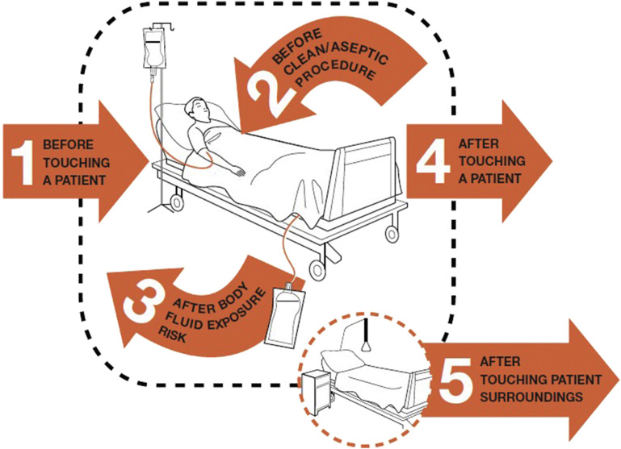
Figure 1.10. The five indications for hand hygiene

Steps for proper hand hygiene using soap and water (Figure 1.31):
- Wet your hands with clean, running water (warm or cold), turn off the tap, and apply soap.
- Lather your hands by rubbing them together with the soap. Be sure to lather the backs of your hands, between your fingers, and under your nails.
- Scrub your hands for at least 20 seconds. Hum the "Happy Birthday" song from beginning to end twice to make sure you spend enough time scrubbing.
- Rinse your hands well under clean, running water.
- Dry your hands using a clean towel or air-dry them.
Steps for proper hand hygiene for hand sanitizer:
- Apply the recommended amount of hand sanitizer, usually about a dime-sized amount, to the palm of one hand.
- Rub your hands together, covering all surfaces of your hands and fingers, until your hands are dry. This should take around 20 seconds.
Key points:
- Wash your hands frequently, especially before eating, after using the restroom, and after coughing/sneezing.
- Use soap and water whenever your hands are visibly dirty.
- Alcohol-based hand sanitizers can be used when soap and water are not available, but they are less effective on dirty hands.
- Scrubbing for at least 20 seconds is important to remove germs effectively.
- Dry hands thoroughly, as moisture can harbor bacteria.
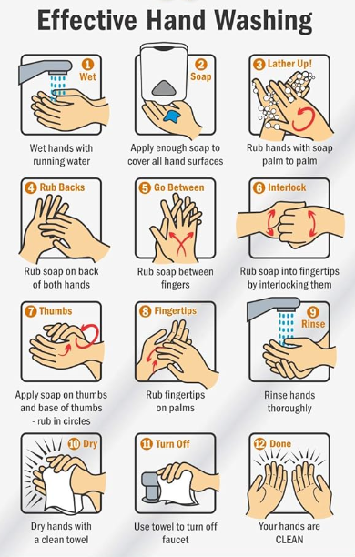
Figure 1.31. Effective hand hygiene steps
Injection and medication safety
- Prepare medications in a designated clean medication preparation area that is isolated from potential sources of contamination, such as sinks and other water sources.
- Use aseptic technique when preparing and administering medications.
- Disinfect the drug bottle’s access membrane before inserting the device into the vial.
- Use needles and syringes on only one of patient (this includes cartridge devices such as manufactured prefilled syringes and insulin pens).
- Use a new needle and syringe to fill the medication container, even if you are providing additional doses for the same patient.
- Single-dose or single-use vials, ampoules, bags or bottles of parenteral solutions should only be used for one patient.
- Use the infusion or administration set (such as intravenous tubing) on one patient only.
- Reserve multiple-dose vials for a single patient whenever possible.
- Wear a face mask when placing catheters or injecting substances into the epidural or subdural space (e.g., during myelography, epidural anesthesia, or spinal anesthesia).
Risk assessment with appropriate use of PPE
- Ensure that PPE is appropriately selected and used based on:
- Nature of patient interaction
- Potential for blood exposure
- Body fluids and/or infectious materials:
- Wear gloves, if possible, blood or other potentially infectious materials contact may occur, such as:
- Mucous membranes
- Intact skin
- Potentially contaminated skin or contaminated equipment.
- Wear a gown appropriate for the job to protect your skin and prevent staining your clothing.
- Wear safety glasses and a mask or face shield to protect the mucous membranes of the eyes, nose, and mouth during procedures or activities that may involve splashing of blood, body fluids, secretions, or excretion.
- Select masks, goggles, face shields, and combinations thereof depending on the anticipated needs of the task being performed.
- After completing the task, remove and discard (other than respirators) before leaving the patient's room or care area.
- If a ventilator is used, it should be removed and disposed of (or reprocessed if reusable) after leaving the patient room or care area and closing the door.
NB: Do not use the same gown or gloves for multiple patient care.
- Disposable gloves should be removed and discarded after completing a task or if they become soiled during the care process.
- Do not wash and reuse gloves.
Minimizing potential exposures
- Develop and implement systems for early detection and management (e.g., use of appropriate IPC measures, including isolation precautions, PPE) of potentially infectious persons at initial points of patient encounter in outpatient settings.
- Use respiratory hygiene and cough etiquette to reduce the transmission of respiratory infections within the facility.
- Prompt patients and visitors with symptoms of respiratory infection to contain their respiratory secretions and perform hand hygiene after contact with respiratory secretions by providing tissues, masks, hand hygiene supplies, and instructional signage or handouts at points of entry and throughout the facility.
- When space permits, separate patients with respiratory symptoms from others as soon as possible (e.g., during triage or upon entry into the facility).
- During periods of higher levels of community respiratory virus transmission, facilities should consider having everyone mask upon entry to the facility.
Reprocessing of reusable medical equipment
NB: Follow the manufacturer's instructions for the proper use of cleaning and disinfection products (e.g., dilution, contact time, material compatibility, storage, expiration date, safe use and disposal).
Cleaning:
The first and most important step to thoroughly clean the equipment is to remove all visible soil, debris, and organic matter. This is typically done using water, detergents, and mechanical action (e.g., brushing, flushing).
Kinds of reusable medical equipment
- Surgical instruments (e.g., scalpels, forceps, clamps)
- Endoscopes (e.g., gastroscopes, colonoscopes, bronchoscopes)
- Respiratory equipment (e.g., breathing circuits, nebulizers, tracheostomy tubes)
- Surgical equipment (e.g., suction devices, irrigation systems)
- Ultrasound probes
Disinfection
After cleaning, reusable medical equipment undergoes disinfection to kill pathogenic microorganisms. Common disinfectants used include:
- Liquid chemical disinfectants (e.g., glutaraldehyde, hydrogen peroxide, peracetic acid)
- High-level disinfectants (e.g., ortho-phthalaldehyde, peracetic acid)
- Thermal disinfection (e.g., pasteurization, boiling)

Kinds of reusable equipment:
- Endoscopes
- Dialysis equipment (e.g., tubing, filters)
- Respiratory equipment (e.g., anesthesia masks, ventilator parts)
- Some surgical instruments (e.g., non-critical items)
- Tourniquets
- Hydrotherapy equipment
Sterilization
For critical medical devices that enter sterile body sites, sterilization is required to kill all microorganisms, including spores. Common sterilization methods include:
- Steam sterilization (autoclaving)
- Ethylene oxide gas sterilization
- Hydrogen peroxide gas plasma sterilization
- Radiation sterilization (e.g., gamma, electron beam)
Kind of medical equipment to be sterilized:
- Surgical instruments (e.g., scalpels, forceps, clamps)
- Implantable devices (e.g., prosthetic joints, pacemakers)
- Surgical equipment (e.g., sutures, staples, clamps)
- Endoscopes
- Respiratory equipment (e.g., breathing tubes, ventilator parts)
- Hemodialysis equipment
Packaging and storage:
All types of reusable medical equipment that have been cleaned, disinfected, or sterilized, including the examples mentioned above.

1.10.2. Occupational Health
Ensure healthcare workers are vaccinated or have proof of vaccination.
Follow permitted procedures and guidelines for patients that encourage healthcare workers to intervene when they see signs or symptoms of serious infectious diseases (such as fever, cough, diarrhea, vomiting, or skin contamination) to prevent the spread of infection to patients and other medical personnel.
Establish a process for healthcare personnel to report to a supervisor or healthcare provider signs, symptoms, and diagnoses that may pose a risk to patients and colleagues.

1.11. Breaking Bad News
Breaking bad news refers to the process of informing a patient (or their family) about a serious, life-altering, or potentially life-threatening diagnosis, prognosis, or other difficult information. This can be one of the most challenging tasks for healthcare providers, as it requires empathy, clear communication, and sensitivity.
The SPIKES Protocol:
The SPIKES protocol is a widely recognized approach for breaking bad news effectively. It consists of 6 steps:
- Setting up the interview:
- Ensure privacy and arrange a quiet, comfortable environment.
- Involve the right people (e.g., patient, family members).
- Allocate sufficient uninterrupted time.
- Assessing the patient's Perception:
- Determine what the patient already knows or suspects about their condition.
- Clarify the patient's understanding before providing new information.
- Obtaining the patient's Invitation:
- Ask the patient how much information they would like to receive.
- Gauge their readiness to hear the bad news.
- Giving Knowledge and information to the patient:
- Use clear, simple language to deliver the bad news.
- Avoid medical jargon and be direct but compassionate.
- Provide information in small, manageable chunks.
- Addressing the patient's Emotions with empathetic responses:
- Recognize and validate the patient's emotional reactions.
- Use empathetic statements to show you understand their feelings.
- Provide emotional support and allow the patient to express emotions.
- Strategy and summary:
- Collaborate with the patient to develop a plan for next steps.
- Summarize the key points and ensure the patient's understanding.
- Provide resources and schedule a follow-up appointment.
- Ask for understanding: “This may be a bit confusing, are you roughly following what I say?”
Regularly reinforce information and clarify.
Ask for understanding: “This may be a bit confusing, are you roughly following what I say?”
"Can you just tell me the general content of what I said, to check whether I have explained it clearly?
Listen to the patient. What are their concerns, for example, patients may be more worried about hair loss due to chemotherapy than the risk of the underlying disease.
Invite them to ask any questions.
Breaking bad news in children
Breaking bad news to children requires a sensitive and age-appropriate approach. By following these steps, healthcare providers can help the child and their family cope with the difficult information, while also fostering trust, understanding, and a sense of partnership in the child's care.
Steps for Breaking Bad News to Children:
- Prepare yourself:
- Gather all the necessary information about the child's condition.
- Anticipate the child's potential reactions and prepare appropriate responses.
- Consult with other healthcare providers, such as child life specialists, to get guidance.
- Set the stage:
- Choose a private, comfortable, and child-friendly environment.
- Involve the child's parents or caregivers, if appropriate.
- Ensure that you have enough time and are not rushed.
- Assess the child's understanding:
- Determine what the child already knows or suspects about their condition.
- Gauge the child's emotional state and readiness to receive the news.
- Deliver the news gently and honestly:
- Use simple, age-appropriate language that the child can understand.
- Be direct, but also compassionate and empathetic.
- Provide information in small, manageable chunks, allowing the child to process it.
- Respond to the child's emotions:
- Recognize and validate the child's emotional reactions, such as fear, anger, or sadness.
- Provide emotional support and encouragement.
- Encourage the child to express their feelings and concerns.
- Involve the child in the plan:
- Collaborate with the child and their family to develop a plan for next steps.
- Explain the plan in a way that the child can understand.
- Provide resources and schedule follow-up appointments.
- Offer ongoing support:
- Check in with the child regularly to address any new concerns or questions.
- Provide a safe space for the child to express their emotions.
- Coordinate with other healthcare providers and the child's support system.

1.12. Blood Transfusion

1.12.1. Types of Blood Transfusions:
- Red blood cell (RBC) transfusion: The most common type, used to replace lost red blood cells and improve oxygen delivery.
- Platelet transfusion: Used to prevent or treat bleeding in patients with thrombocytopenia or platelet dysfunction.
- Plasma transfusion: Provides clotting factors and may be used to treat coagulopathies or replace lost plasma.
- Whole blood transfusion: Less common, but may be used in cases of massive blood loss or in certain pediatric patients.

1.12.2. Indications for Blood Transfusion in Ethiopia:
- Acute blood loss: Blood transfusions are often required to replace significant blood loss due to trauma, postpartum hemorrhage, gastrointestinal bleeding, or surgical procedures.
- Severe anemia: Patients with severe anemia, such as those with chronic diseases, malnutrition, or hematological disorders, may need blood transfusions to improve oxygen delivery and prevent complications.
- Sickle cell disease: Individuals with sickle cell disease may require regular blood transfusions to prevent or manage complications like acute chest syndrome, stroke, and acute pain crises.
- Obstetric emergencies: Pregnant women with severe bleeding or placental complications may need blood transfusions to prevent life-threatening complications.
- Pediatric conditions: Children with severe anemia, malaria, or other conditions that cause significant blood loss may require blood transfusions.

1.12.3. Transfusion-Related Complications
- Mild itching, chills, and urticarial (hives) to high fever
- Severe shortness of breath, jaundice, hypotension, or hemoglobinuria.
NB: Severe reactions can lead to death.
Common transfusion reactions
Acute hemolytic reactions:
- Clinical presentation: fever, chills, back pain, chest pain, dyspnea, hypotension, and dark-colored urine.
- Diagnosis: rapidly falling hemoglobin, elevated bilirubin, and positive direct antiglobulin (Coombs) test.
- Management:
- Immediately stop the transfusion and safely disconnect the patient from the blood product.
- Administer IV fluids to maintain blood pressure and urine output.
- Provide supplemental oxygen and respiratory support as needed.
- Administer IV methylprednisolone or hydrocortisone to reduce inflammation and hemolysis.
- Consider administering loop diuretics (e.g., furosemide) to promote urine output and prevent acute kidney injury.
- Provide vasopressor support (e.g., norepinephrine) if the patient develops hypotension.
- Notify the blood bank for further investigation and management.
Febrile non-hemolytic reactions:
- Clinical Presentation: fever, chills, and sometimes nausea or vomiting during or shortly after the transfusion.
- Diagnosis: Rule out other causes of fever, such as infection.
- Management:
- Slow or stop the transfusion, if the fever or other symptoms are significant.
- Administer antipyretic medications, such as acetaminophen or ibuprofen, to manage the fever.
- Provide supportive care, such as IV fluids and monitoring.
- Consider premedication with acetaminophen or hydrocortisone before future transfusions.
Allergic reactions:
- Clinical presentation: urticaria, pruritus, angioedema, bronchospasm, and in severe cases, hypotension and anaphylaxis.
- Diagnosis: based on clinical symptoms, with possible laboratory testing for specific IgE antibodies.
- Management:
- Immediately stop the transfusion and safely disconnect the patient from the blood product.
- Administer antihistamines (e.g., diphenhydramine) to manage the allergic symptoms.
- For severe reactions, administer corticosteroids (e.g., methylprednisolone) and epinephrine if the patient develops anaphylaxis.
- Provide supplemental oxygen and respiratory support as needed.
- Maintain IV access and administer IV fluids to support blood pressure.
Transfusion-related acute lung injury:
- Clinical Presentation: Acute onset of respiratory distress, hypoxemia, and bilateral pulmonary edema within 6 hours of transfusion.
- Diagnosis: clinical presentation, chest imaging, and exclusion of other causes of acute lung injury.
- Management:
- Immediately stop the transfusion and safely disconnect the patient from the blood product.
- Provide supplemental oxygen and mechanical ventilation, if needed, to manage respiratory distress and hypoxemia.
- Administer diuretics (e.g., furosemide) to reduce pulmonary edema.
- Consider the use of corticosteroids to reduce inflammation.
- Provide supportive care, including hemodynamic support with IV fluids and vasopressors, if the patient develops hypotension.

Fluid overload:
- Clinical presentation: shortness of breath, cough, elevated blood pressure, and signs of pulmonary edema.
- Diagnosis: clinical presentation, radiographic findings, and laboratory tests (elevated brain natriuretic peptide).
- Management:
- Slow or stop the transfusion and safely disconnect the patient from the blood product.
- Administer diuretics (e.g., furosemide) to promote urine output and reduce fluid overload.
- Provide supplemental oxygen and mechanical ventilation, if needed, to manage respiratory distress.
- Consider the use of vasodilators (e.g., nitrates) to reduce preload and afterload

Part 2. Adult Emergency

2.1. Respiratory Emergencies

2.1.1. Acute Severe Asthma
Introduction
Asthma is a recurrent airway disease affecting the bronchus with reversible airflow obstruction. It is due to hyper-responsiveness of airways, broncho-constriction, and inflammation.
Parameter | Mild Asthma | Moderate Asthma | Severe Asthma | Life-threatening Asthma
Breathless | Walking  Can lie down | Talking  Prefers to sit up | At rest  Hunched forward
Talks in | Sentences | Phrases | Words | Unable to speak
Alertness | Not agitated | Not agitated | Always agitated | Drowsy or confused
Respiratory rate | Increased | Increased | >30 breaths per min | >30 breaths per min
Accessory muscles | Not used | Usually, | Used | Paradoxical thoracic and abdominal movements
Wheeze | Moderate, often only end-expiratory | Loud | Usually, loud | Absence of wheeze; silent chest
Pulse rate | 100 | 100–120 | >120 | Bradycardia
Oxygen saturation | 95%–90% | >90% | <90% | <90%
Peak expiratory flow (PEF) | >50% of predicted personal best | >50% of predicted personal best | ≤ 50% of predicted or personal best | Impossible to measure
Table 2.1. Classification of severity of an asthma attack

Principles of management
- Assessment of the severity of asthma attack and initiation of treatment accordingly.
- Treatment of the precipitating factor for the acute attack.
- Optimizing maintenance therapy for discharge.
Recommended management of mild to moderate asthma
Medication:
- Salbutamol: Administer 4–10 puffs usually by pressurized metered-dose inhaler (pMDI) and spaced every 20 minutes for the first hour.
- Oral prednisolone: Start with 40–60 mg PO per day which may not be given in mild attack.
- Controlled oxygen: Titrate with target saturation of 93–95%.
- Assess and address any modifiable precipitant for the acute exacerbation.
Monitoring
The patient is monitored for improvement with vital signs and assessment of chest condition. The following are signs of clinical improvement:
Good response:
- No distress
- Oxygen saturation >95% at room air
- Normal vital signs and chest examination
- Decreased need or no need for reliever
- PEF >60–80% of personal best or predicted
- Response sustained for at least 1 hour after last treatment
Incomplete response:
- Mild to moderate symptoms despite standardized treatment
- PEF >50% of personal best or predicted
Poor response
- Severe features despite standardized treatment
- PEF <50% of personal best or predicted

Disposition
If Good response:
- Patient can be discharged to continue treatment at home.
- Reliever should be continued as needed.
- Controller should be started or stepped up with inhaled corticosteroids (ICS) and long-acting beta-agonist (LABA) combination if available, or ICS alone with assessment of inhaler technique and adherence.
- Oral corticosteroids should be continued for 5–7 days.
- Education should be provided on how to take medications during exacerbations and adherence to treatment (routine use).
- Appropriate continuum of care should be established, with follow-up within 2–7 days.
- An action plan should be discussed to recognize early signs and home self-management of asthma exacerbations.
If Incomplete response:
- Individualize admission decision.
If Poor response:
- Admit to ICU or medical high dependency unit (HDU), if available, to manage as severe case.
Recommended management of severe asthma
- These patients should be kept at the RED side in the ER. Treatment should be started urgently with ABC evaluation until transfer to acute care unit (ICU or medical HDU if available) if present or referral from primary care health institution.
- Oxygen administration: Titrate with target saturation 93–95%.
Medication
- High-dose salbutamol: Administer 6–0 puffs every 20 minutes in the first hour, then every 1 hour for 6 hours, then every 2 hours for 6 hours, then every 4 hours for 24 hours, and then every 6 hours.
- Salbutamol: 2.5–5 mg by a nebulizer, with oxygen every 20 minutes. Continue 5 mg every 1–4 hours until recovery.
- Ipratropium bromide-Anticholinergic: 0.5 mg inhalation/MDI can be given together if available.
OR
- Adrenaline: 0.5 cc IM/SC, repeat after 20 minutes if no improvement, for anaphylactic asthma and severe cases.
- Systemic steroid:
- Hydrocortisone IV: 200 mg loading then 100 mg should be given every 4–6 hours, change to PO when possible.
- Methylprednisolone IV: 60–80 mg TID/QID for 48 hours, then 30–40 mg/day.
- Adjunct therapy (if the response is poor to the above regimen):
- Magnesium sulfate: 1–2 gm IV over 30 minutes can used. Nebulized magnesium can also be used. Dose can be repeated once if necessary.
- Aminophylline: 5 mg IV bolus over 30 minutes if not taken PO theophylline in the last 24 hours with a continuous infusion of 1 mg/kg per hour
- Caution—used as a last resort for refractory asthma.
- Ketamine: 0.3 mg/kg IV bolus followed by infusion of 0.4–0.5mg/kg over 30 minutes can be considered.
- Antibiotics: Should only be started if there is evidence of pneumonia demonstrated by fever, leukocytosis, raised Erythrocyte Sedimentation Rate (ESR), C-reactive protein (CRP), evidence of pneumonia on chest imaging.
- Noninvasive Positive Pressure Ventilation (NIPPV) like CPAP is provided when there is failure to achieve target saturation with facemask oxygen.
Mechanical ventilation (MV)
Indication for NIPPV ventilation:
- Severe to life-threatening asthma
- Excessive use of accessory muscles of respiration with fatigue and somnolence
Arterial blood gas analysis indications:
- pH less than 7.2,
- Carbon dioxide pressure (PaCO2) increasing by more than 5 mmHg/h or greater than 55–70 mmHg, or
- Oxygen pressure less than 60 mmHg on 100% oxygen delivered through face mask.
- Forced expiratory volume over 1 second (FEV1) and peak expiratory flow rate (PEFR) <50% predicted despite treatment
Indication for invasive ventilation:
- Used as a last resort
- Failure of noninvasive mechanical ventilation (NIV) to improve oxygenation
- Deteriorating mental status or coma
- Respiratory or cardiac arrest
- Excessive respiratory secretions and repeated vomiting that creates difficulty to put on NIV
- Facial abnormalities that impede use of NIV
Special conditions in ventilator support of severe asthma:
- Experienced personnel should intubate using larger endotracheal tube
- Ketamine is the good choice for intubation
- Initial setting for asthma includes: normal tidal volume (6–8 ml/kg), lower respirator rate, lower inspiratory time, low positive end-expiratory pressure (PEEP), higher inspiratory flow rate, and prolonged expiratory time
Test the inhaler: shake well and release one puff into the air
Breathe out gently and place the mouth piece in the mouth and close lips around it
Tilt head slightly backwards, breathe in slowly, and press down the canister to release one dose
Remove the inhaler, hold breath for 10 seconds, and breathe out slowly
Table 2.2. Technique of using inhaler drugs

2.1.2. Acute Exacerbation of Chronic Obstructive Pulmonary Disease
Introduction
An exacerbation of chronic obstructive pulmonary disease (ECOPD) is defined as an event characterized by increased dyspnea and/or cough and sputum that worsens in <14 days which may be accompanied by tachypnea and/or tachycardia and is often associated with increased local and systemic inflammation caused by infection, pollution, or other insult to the airways.
Classification
Exacerbations are classified after the event has occurred as described in the table below.
 | Mild | Moderate | Severe
Dyspnea visual analogue scale (VAS) | <5 | ≥5 | ≥5
Respiratory rate | <24 breaths/min | ≥24 breaths/min | ≥24 breaths/min
Heart rate | <95 | ≥95 bpm/min | ≥95 bpm/min
Saturation | ≥92% | <92 % | <92%
CRP | <10 mg/dl | ≥10 mg/dl | ≥10 mg/dl
PaO₂ | >60 mmHg | ≤60 mmHg | ≤60 mmHg
PCO₂ |  | >45 mmHg with no acidosis | >45 mmHg with acidosis (pH <7.35)
Table 2.3. Classifications of acute ECOPD post-event
Principles of management
- To minimize the negative impact of the current exacerbation
- To prevent the development of subsequent events
- To treat precipitating factors
Recommended management
- Assess ABC of life
- Oxygenation
- Oxygen support if hypoxemic with a target of 88–92%
- High-flow nasal therapy (HFNT) at a rate of maximum 60 L/min usually should be preceded by a trial of NIV
- Medication
- Bronchodilators
- Inhaled short-acting bronchodilators
- Using MDI inhaler 1–2 puffs every 1 hour for 2 or 3 doses, and then every 2–4 hours based on the patient’s response. If a nebulizer is chosen to deliver the bronchodilator agent, air-driven bronchodilator nebulization is preferable to oxygen.
- Inhaled long-acting bronchodilators
- Beta2-agonist in combinations with or without ICS, or
- Anti-cholinergic in combinations with or without ICS during an exacerbation (should be continued or started as soon as possible before hospital discharge)
- Intravenous methylxanthines
- Theophylline or aminophylline are not recommended to use in these patients due to significant side effects.
- Glucocorticoids
- Therapy with oral prednisolone is equally effective to intravenous administration
- Nebulized budesonide alone may be a suitable alternative for treatment of exacerbations in some patients and provides similar benefits to IV methylprednisolone
- Antibiotics
- Antibiotics should be given to patients with exacerbations of COPD who have three cardinal symptoms:
- Increase in dyspnea, sputum volume, and sputum purulence
- If any of the two the cardinal symptoms, start empirical treatment: Aminopenicillin with clavulanic acid, macrolide, tetracycline or, in selected patients, quinolone
- Adjunct therapies
- Depending on the clinical condition of the patient, other supportive treatments are done:
- An appropriate fluid balance
- Use of diuretics when clinically indicated
- Anticoagulants
- Treatment of comorbidities (e.g., heart failure, PTE, and arrhythmia) and nutritional aspects should be considered
- Deep vein thrombosis (DVT) and pulmonary thromboembolism (PTE) prophylaxis
- Enforce the need for smoking cessation
- Indications for medical ICU admission
- Severe dyspnea that responds to initial emergency therapy
- Changes in mental status (coma, confusion)
- Hemodynamic instability
- Need for invasive MV
- Persistent or worsening hypoxemia (PaO2 <40 mmHg) and/or worsening respiratory acidosis (pH <7.25) despite supplemental oxygen and NIV
Ventilator support
- Ventilator support in an exacerbation can be provided by either noninvasive (nasal or facial mask) or invasive (Oro-tracheal tube or tracheostomy) ventilation
- The use of noninvasive mechanical ventilation (NIV) is preferred over invasive ventilation (intubation and positive pressure ventilation) as the initial mode of ventilation to treat acute respiratory failure in patients hospitalized for acute exacerbations of COPD
- Once patients improve and can tolerate at least 4 hours of unassisted breathing, NIV can be directly discontinued without any need for a “weaning” period
Indications for NIV
- Respiratory acidosis (PaCO2 >45 mmHg and arterial pH ≤7.35)
- Severe dyspnea with clinical signs suggestive of respiratory muscle fatigue, increased work of breathing (use of accessory muscle, paradoxical motion of abdomen or retraction of the intercostal spaces)
- Persistent hypoxemia despite supplemental oxygenation
Indications for Invasive Ventilation
- Unable to tolerate Non-Intensive Ventilation (NIV)
- Status post respiratory or cardiac arrest
- Massive aspiration or persistent vomiting
- Diminished consciousness
- Persistent inability to remove respiratory secretions
- Severe hemodynamic instability without response to fluids ad vasoactive drugs
- Severe ventricular or supraventricular arrhythmia
- Life-threatening hypoxemia I patients unable to tolerate NIV
Monitoring
- Vital sign assessment
- Arterial blood gas (ABG) should be checked frequently, or as clinically indicated, to ensure satisfactory oxygenation without carbon dioxide retention and/or worsening acidosis
- High-flow nasal therapy at rates up to 60 L/min in adults with COPD experiencing episodes of either acute or chronic hypercapnic respiratory failure
- Ventilator support: Some patients need immediate admission to the respiratory care or intensive care unit
- Ventilator support in an exacerbation can be provided by either noninvasive (nasal or facial mask) or invasive (Oro-tracheal tube)

2.1.3. Pulmonary Thromboembolism
Introduction
Pulmonary thromboembolism (PE) is occlusion of pulmonary arteries by embolus dislodged from thrombus at a distant site, mostly deep vein of the lower limb.
Diagnosis
The diagnosis of PE starts from:
- Clinical symptoms and sings: Dyspnea (73%), dizziness or syncope (10%), chest pain, hemoptysis (13%), sudden cardiac arrest (8%), hypoxemia, tachypnea (54%), tachycardia and DVT (70%). Silent PE.
- Investigations
Confirmatory investigations:
- D-dimer levels if available
- Spiral CT is diagnostic in 98% of patients with PE
- CT angiography is diagnostic in 90% of patients with PE
Supportive investigations:
- Echocardiography: specificity is 80–90% and sensitivity 50–60%
- Direct signs for PE: Clot in transit
- Indirect signs: Signs of right ventricular (RV) strain and dysfunction
- Cardiac biomarkers: elevated troponin
- ECG: Sinus tachycardia, nonspecific ST and T wave changes in (V1–V4), S1Q3T3 pattern, and incomplete or complete right bundle branch block (RBB)
- Chest X-ray (CXR): rare PE pathognomonic signs like unilateral basilar atelectasis, pleural based opacity (Hampton’s hump), dilated pulmonary artery (Pala’s sign), and unilateral lung oligemia (Westermarck’s sign)
- Coagulation profile
- CBC
Risk assessment for PE
Patients with the above clinical manifestations should be assessed for the presence of risk for development of PE using Wells criteria (Table 2.4 below) and classifications per international guidelines (Table 2.5) and worked up using diagnostic algorithm in Figure 2.1.
High risk of PE:
- Hemodynamically unstable: Echo for RV dysfunction, do computed tomography pulmonary angiogram (CTPA)
- Hemodynamic stable: do CTPA
- If no CTPA, treat as PE
Intermediate risk of PE:
- First do D-dimer level if available; if elevated, order CTPA
- If no D-dimer, do Echo, ECG; if positive, do CTPA
Low risk of PE:
- First do D-dimer level; if elevated, order CTPA
- If no D-dimer; do Echo, ECG, if positive, do CTPA

Clinical symptoms of DVT (leg swelling, pain with palpation) | 3.0
Other diagnosis less likely than pulmonary embolism | 3.0
Heart rate >100 | 1.5
Immobilization (≥3 days) or surgery in the previous 4 weeks | 1.5
Previous DVT/PE | 1.5
Hemoptysis | 1.0
Malignancy | 1.0
Probability | Score
Traditional clinical probability assessment (Wells criteria)
High | >6.0
Moderate | 2.0– 6.0
Low | <2.0
Simplified clinical probability assessment (Modified Wells criteria)
PE likely | >4.0
PE unlikely | ≤4.0
Table 2.4. Wells criteria and modified Wells criteria: clinical assessment for PE
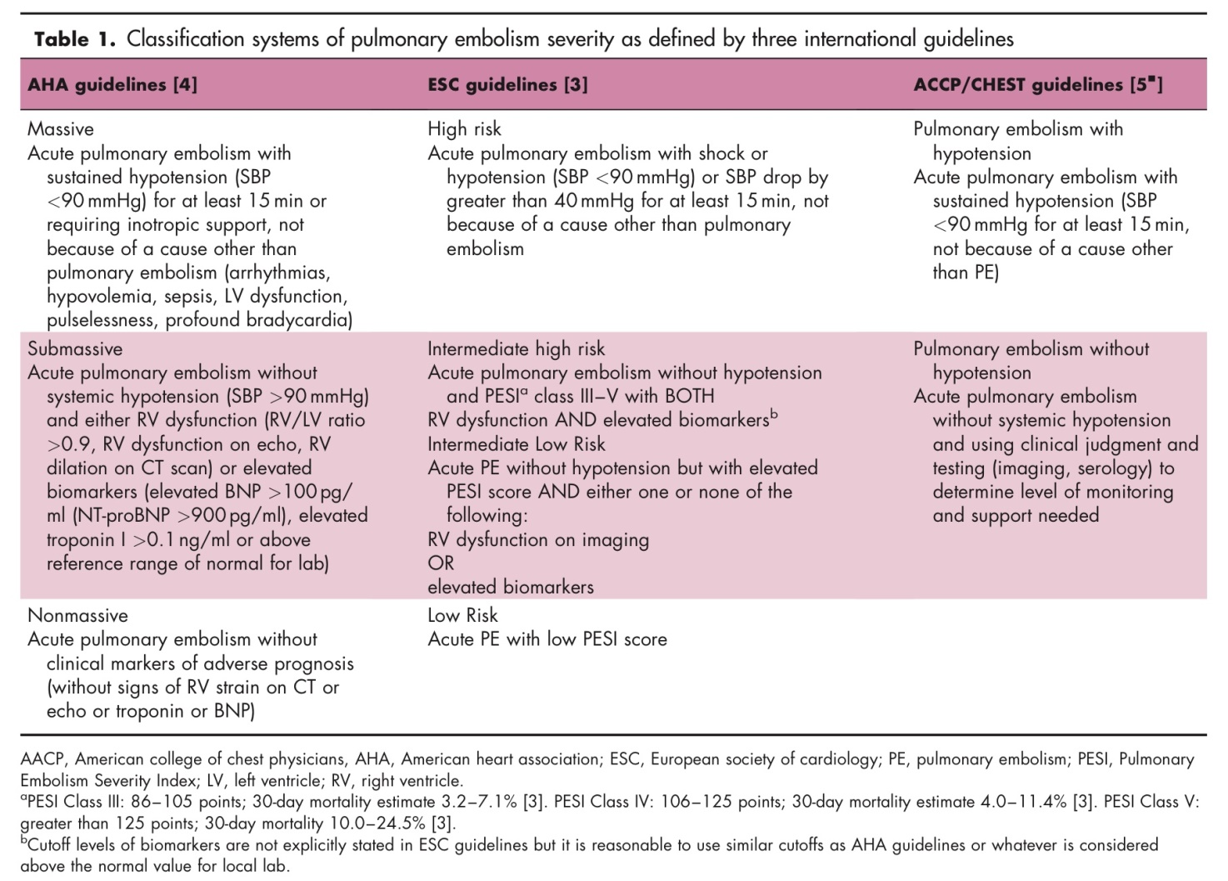
Table 2.5. Classification of pulmonary embolism
Principles of management
Assessment and maintenance of hemodynamic stability.
Assessment of PE-related early mortality risk used for the decision of early thrombolysis that includes prompt initiation of treatment
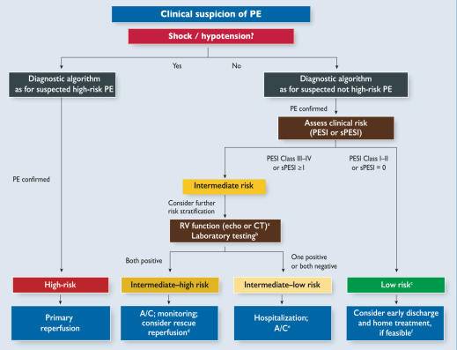
Figure 2.1. Management of clinical suspicion of pulmonary embolism
Recommended management of acute phase of PE
- ABC approach to assess hemodynamic stability and respiratory support
- Risk stratification for early PE-related 30 days mortality risk for decision on need of thrombolysis using:
- Clinical features
- PESI clinical 30-day mortality score (See Table 2.6 below)
- Biomarkers reflecting RV dysfunction
- Biomarkers reflecting myocardial injury
- Risk of further events

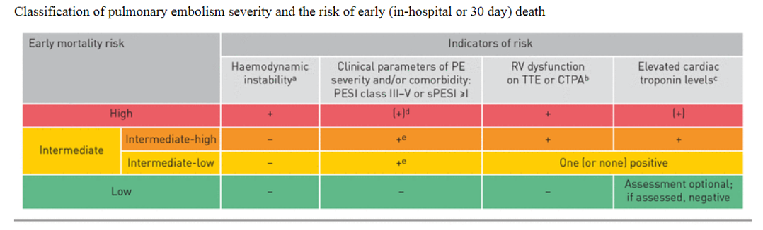
Table 2.6. Classification of PE severity and risk of early death
High-risk massive pulmonary embolism (MPE)
- Hemodynamic support
- Employ fluid-conservative strategy: Avoid fluid boluses unless the patient has frank clinical evidence of volume loss (e.g., watery diarrhea) or a small inferior vena cava (IVC) with respiratory collapsibility of >70% is seen.
- Vasopressor-aggressive strategy: To achieve mean arterial pressure (MAP) >60–65 mmHg, start on vasopressor with least pulmonary vasoconstriction effect like norepinephrine, epinephrine, and vasopressin
- Optimize oxygenation
- Administer oxygen for hypoxemia
- Avoid intubation; but if inevitable, it should be done by an experienced operator following measures are taken to reduce the risk of cardiac arrest:
- Correct hypotension with target higher systolic blood pressure (SBP) in the range of 130–140 mmHg
- Pre-oxygenation
- Correct acidosis and hypercarbia
- Use cardio stable sedatives (e.g., ketamine)
- Employ apneic oxygenation
- Avoid over-vigorous bag ventilation after intubation
- Set for the lowest PEEP, tidal volume of <6 ml/kg lean body weight to keep the end-inspiratory plateau pressure <30 cm H₂O
- Correct hypercarbia and acidosis
- Nitroglycerin (1mg/ml), inhale 5 mg over 15 minutes
- Epoprostenol at 0.05 mcg/kg/min.
- Nitric Oxide at 20 ppm
- Milrinone (1mg/ml), inhale 5 mg over 15 minutes
- Thrombolytic therapy
- Crashing MPE
- If absolute contraindication, percutaneous catheter directed clot removal or surgical embolectomy
- If relative or no contraindication, thrombolytic therapy can be given
- Non-crashing MPE
- If absolute contraindication, percutaneous catheter directed clot removal or surgical embolectomy
- If relative contraindication, thrombolytic therapy can be given with reduced dose
- If no contraindication, thrombolytic therapy can be given
High-risk submissive PE
- Optimize oxygenation
- Administer oxygen for hypoxemia
- Hemodynamic support
- RV dysfunction: Achieve MAP >60–65 mmHg
- Thrombolytic therapy
- If absolute contraindication, anticoagulation alone with or without percutaneous catheter directed clot removal
- If relative contraindication, thrombolytic therapy can be given with reduced dose via peripheral IV or catheter directed thrombolysis
- If no contraindication, thrombolytic therapy can be given
Low-risk submissive PE
- Optimize oxygenation ad hemodynamic support
- Anticoagulation therapy.
Low-risk PE
- Anticoagulation therapy
See Table 2.7 below for summary of risk vs. benefit of thrombolytic therapy, and Tables 2.8 and 2.9 for thrombolytic and anticoagulation medication, respectively.
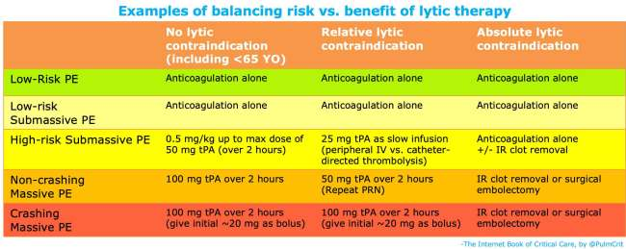Table 2.7. Summary of thrombolytic therapy
DRUG NAME | LOADING DOSE | INFUSION DOSE | ADMINISTRATION TIME
Streptokinase | 250000 IU, 30 min | 100000 IU/h | 24 h
Urokinase | 4400 IU, 10 min | 4400 IU/kg/h | 12 h
Alteplase (rt-PA) | Not needed | 50 mg/h* | 2 h
Reteplase | Not needed | 10 U IV bolus, twice with 30-minute interval
Tenecteplase | Not needed | 10000 U bolus single dose in 5–10 seconds*
Table 2.8. Thrombolytic medication

Drug | Dose | Special Considerations
Unfractionated heparin (UFH) | 80 unit/kg IV bolus, followed by an 18-unit/kg/h infusion  5000 IU IV bolus, followed by a 1300 units/h infusion  250 units/kg SC, followed by 250 units/kg q12hr | Preferred in patients with renal failure
Enoxaparin | 1 mg/kg SC BID | Preferred in patients with malignancy
Warfarin | Start with 2–5 mg po  Overlap warfarin on Day 1 or 2 of LMWH or UFH therapy until desired INR | Preferred in patients with renal failure
Rivaroxaban | 15 mg po twice daily x 3 weeks, then 20 mg once daily x at least 6 months | Take with food to improve absorption
Fondaparinux | <50 kg: 5 mg SC daily  50–100 mg: 7.5 mg SC daily  >100 kg: 10 mg SC daily | Initiate warfarin within 72 hours and give concomitantly for at least 5 days
Edoxaban | 60 mg po once daily; 30 mg once daily if body weight ≤60 kg | Not used if CrCl <95 mL/min  Dose after 5 to 10 days of initial therapy with a parenteral anticoagulant
Apixaban | 10 mg po twice daily for 7 days, followed by 5 mg twice daily
Dabigatran | 150 mg po BID  110 mg BID for patients ≥80 years | Dose after 5 to 10 days of initial therapy with a parenteral anticoagulant  Reduce dose to 110 mg BID for patients ≥80 years or ≥75 years with at least one bleeding risk factor
Dalteparin | 200 IU/kg/day SC for 1 month, followed by 150 IU/kg/day subcutaneously for months | Maximum of 18,000 IU per day
Table 2.9. Anticoagulation medication
Special population: pregnant women
- An effort should be made to reduce radiation exposure by shielding and limiting testing where possible.
- Warfarin is better avoided during pregnancy.
- UFH and low molecular weight heparin (LMWH) are safe during pregnancy, and can be started in suspected patients
Monitoring
- Follow vital signs with monitor, RV status.
- Closely monitor for risk of developing high-risk MPE for those with intermediate risk.
- If treatment is started with UFH infusion, check PTT 1 hour after bolus of heparin and every 6 hours, if difficult at least once a day to achieve a target PTT of 1.5 to 2 times the patient’s baseline.
- If on warfarin, monitor the international normalized ratio (INR) for a target of 2.0–3.0.
- Monitor for signs of over anticoagulation.
Disposition
- Patient should be admitted to the ICU or ward based on the severity of symptoms.

2.1.4. Fat Embolism
Introduction
Fat embolism (FE) and fat embolism syndrome (FES) are clinical phenomena that are characterized by systemic dissemination of fat emboli within the system circulation.
Diagnosis
A diagnostic criterion is used to diagnose FE in at-risk patients. See Annex at the end

Recommended management
- Maintenance of adequate oxygenation and ventilation with open lung strategies such as the use of airway pressure release ventilation (APRV)
- Maintenance of hemodynamic stability
- Administration of blood products as clinically indicated
- Hydration
- Prophylaxis of DVT and stress-related gastrointestinal bleeding
- Nutrition

2.1.5. Amniotic Fluid Embolism
Introduction
Amniotic fluid embolism (AFE) is a critical obstetric emergency marked by sudden cardiorespiratory collapse and disseminated intravascular coagulation (DIC).
Diagnosis
The criteria used for diagnosing AFE stipulate the presence of the following conditions:
- Sudden cardiopulmonary collapse or hypotension (SBP <90 mmHg) with hypoxia (SpO2 <90%).
- Severe hemorrhage or DIC according to the ISTH definition.
- Symptomatology occurs either during labor or placental delivery (or up to 30 minutes later).
- Absence of fever or other explanations for the observed findings.
Recommended management
- Admit the patient with AFE into the ICU.
- Administer oxygen to maintain normal saturation. Intubate as indicated.
- Initiate CPR if the patient arrests. If she does not respond to resuscitation, perform a peri-mortem cesarean delivery.
If hemodynamically unstable:
- IV fluids—use crystalloids. Avoid excessive fluid administration to avoid over distention of the RV and blood products.
- Vasopressors—Nor ephrepheline (NE) as necessary with a goal MAP >65 mmHg, a cardiac index >2 L per meter squared, an adequate urine output of 40–50 mL/hr, and a PaO2/FiO2 ratio >250. Dobutamine and milrinone, as inotropes can be used.
- Pulmonary artery catheterization in patients who are pregnant. Continuously monitor the fetus. Deliver immediately following cardiac arrest if gestational age is ≥23 weeks.
- Hemodialysis with plasmapheresis and ECMO with intra-aortic balloon counter pulsation have been described in case reports with successful outcomes in treating AFE patients with cardiovascular collapse.
Coagulopathy
- Fresh frozen plasma (FFP) for a prolonged aPTT, cryoprecipitate for a fibrinogen level less than 100 mg/dL, and transfuse platelets for platelet counts less than 20,000/µL.
Obstetrical management
- Prioritize the rapid evacuation of the fetus when gestation age >28 weeks, usually by cesarean section with ongoing resuscitation of the patient during delivery.
- Following fetal delivery, manage hemorrhage, uterine atony, and the resulting coagulopathy (DIC) with empiric administration of packed red blood cells (PRBCs), FFP, and platelets in a 1:1:1 ratio.

2.1.6. Air Embolism
An intravascular air embolism (VAE) is a rare, preventable, but serious complication of endovascular procedures resulting in significant morbidity and mortality.
Diagnosis
Clinical manifestations with risk of air embolism.
Management
- ABC, CPR if necessary.
Oxygenation
- Administer 100% oxygen by a non-rebreathe mask. If the patient is intubated, the Fi02 should be set to 100%.
- Place the patient in the left lateral decubitus and Trendelenburg position (Durant’s maneuver).
- Position the patients in the flat supine position as the head-down position may worsen cerebral edema.
- Patients should be transferred to an ICU for careful monitoring and management.
- Hyperbaric oxygen therapy (HBOT) is the gold standard for treatment.
- Advanced treatments including extracorporeal membrane oxygenation (ECMO).
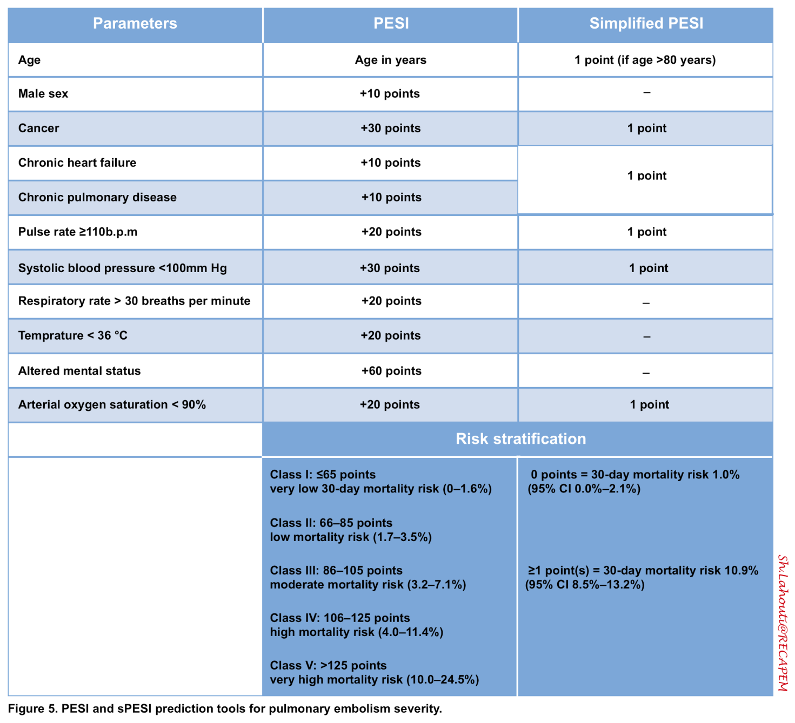
Table 2.10. PESI and sPESI prediction tools for pulmonary embolism severity
Absolute contraindications | Relative contraindications
- Prior intracranial hemorrhage  - Known structural cerebral vascular lesion  - Known malignant intracranial neoplasm  - Ischemic stroke within 3 months  - Active bleeding (excluding menses)  - Significant closed-head trauma or facial trauma within 3 months | - Severe uncontrolled hypertension on presentation (SBP>180 mmHg or DBP >110 mmHg)  - History of ischemic stroke more than 3 months before  - Major surgery less than 3 weeks before  - Recent (within 2–4 weeks) internal bleeding  - Non-compressible vascular punctures  - Current use of an anticoagulant that produced an elevated INR >1.7 or PT >15 seconds  - Pregnancy  - Recent invasive procedure  - Active peptic ulcer  - Pericarditis or pericardial fluid  - Age >75 years  - Diabetic retinopathy
Table 2.11. Contraindications for thrombolytic therapy in PTE

2.1.7. Pneumonia
Introduction
Pneumonia is an acute infection of the pulmonary parenchyma that is associated symptoms and signs of acute infection and acute infiltrates on a chest radiograph.
Classification
- Community-acquired pneumonia: Acute pulmonary infection in a patient who is not hospitalized or residing in a long-term care facility for 14 or more days before presentation.
- Hospital-acquired pneumonia: New infection occurring 48 or more hours after hospital admission.
- Ventilator-acquired pneumonia: New infection occurring 48 or more hours after endotracheal intubation.
Diagnosis
Laboratory: CBC, CXR, ESR, CRP, organ function tests, serum electrolytes (in critical patients); for admitted patients: Gram stain and culture (tracheal aspirate for intubated patients), pretreatment sputum analysis (culture and Gram stain), and blood culture.
- For para-pneumonic effusion: do pleural fluid analysis including cells with differential count, glucose, protein, LDH, Gram stain, acid-fast bacilli, and cytology.
Recommended management
- Inpatient admission of patients is decided using different criteria; here, CURBS-65 is used.
- The CURB-65 criteria:
- Confusion, Urea>7mmol/L, Respiratory rate >30, Blood pressure <90/60, and Age >65
- For all patients, the CURB-65 score should be interpreted in conjunction with clinical judgment.
- Patients with a CURB-65 score of >2 should be admitted.
Treatment of severe pneumonia
- Inpatient therapy of ICU patients with severe pneumonia:
- Maintain SaO2 94% and above
- Resuscitate with crystalloids if there is fluid deficit
- Antipyretics/analgesics if needed
- Intubation: if respiratory failure
- Drugs: Combination therapy with ceftriaxone 1gm IV BID, ampicillin1sulbactam 1.5–3g every 6h, cefotaxime 1–2g every 8h if available for 7–14 days + azithromycin 500 mg PO/day for 3 days
- Inpatient therapy for non-ICU patients with community-acquired pneumonia:
- Drugs: ceftriaxone 1 gm IV BID + azithromycin 500 mg PO per day
- Supportive management: oxygen, antipyretics, analgesia, IV fluids
- Inpatient therapy for non-ICU and ICU patients with methicillin-resistant Staphylococcus aureus (MRSA) or pseudomonas risk:
- Risk: Prolonged hospital or long-term care facility stay, structural disease of lung (e.g., heart failure, bronchiectasis), steroid treatment (>10 mg prednisone/day), broad-spectrum antibiotics for >7 days in the past 1 month, AIDS especially CD4 <50/ml, neutropenia (ANC <500/dL)
- Drugs: Vancomycin 1 gm IV BID for MRSA
- Meropenem/ceftazidime/cefepime 1 gm IV TID + ciprofloxacin 400 mg IV TID for pseudomonas
- Inpatient therapy for aspiration pneumonia
- Drugs: Ceftriaxone 1gm IV BID + metronidazole 500 mg IV TID OR
- clindamycin 600mg PO/IV TID
- Supportive management: oxygen, antipyretics, analgesia, IV fluids
Monitoring
- Follow the vital signs of the patient
- Assess mental status and oxygen saturation
- Assess fluid status with urine output and input
Disposition
- Indication for ICU admission (admission is considered if ≥3 of the criteria below are fulfilled):
- Septic shock
- Respiratory failure
- Adult Respiratory Distress Syndrome (ARDS)
- Coma
- Acidosis and significant electrolyte disturbance
- Multilobar infiltrates
- uremia
- Leucopenia, thrombocytopenia
- Hypothermia, hyponatremia
- CURB-65 >3
- If patient does not need ICU admission, admit to wards.
- Early involvement of internist and pulmonologist is recommended.

2.1.8. Acute Respiratory Distress Syndrome
Introduction
Acute Respiratory Distress Syndrome (ARDS) is defined by the presence within 7 days of a known clinical insult, a new or worsening respiratory symptom of a combination profound acute hypoxemia of PaO2/FiO₂ ≤300 mmHg, PEEP of at least 5 cmH₂O in ventilated patient, and bilateral pulmonary opacities on radiography not explained by cardiac failure or fluid overload. If there is no PaO2 measurement saturation to Fios ratio less than 315.
ARDS severity scoring
The Berlin definition uses the PaO₂/FiO₂ ratio to distinguish:
- Mild ARDS: 200 <PaO₂/FiO₂ ≤ 300 mmHg
- Moderate ARDS: 100 <PaO₂/FiO₂ ≤200 mmHg
- Severe ARDS: PaO₂/FiO₂ ≤100 mmHg
There is no gold standard diagnostic investigation for ARDS.
Principles of management
- NIV or MV using low tidal volumes
- Treatment of the underlying condition
- Supportive care
- Adjunctive therapies
- Preventing complications associated with prolonged MV and ICU stay
Recommended management
- Assess ABC and assess for need of respiratory support.
- Use noninvasive ventilation and high-flow nasal cannula.
- High-flow nasal delivers oxygen at flows of up to 50–60 L/min.
- Mechanical ventilation:
- The goals of MV in ARDS are to maintain oxygenation while avoiding oxygen toxicity and the complications of MV.
- Maintain PO2 in the range of 85–90%, reducing FiO2 <65% within the first 24–48 hours.
- Use lung protective ventilation strategy:
- Tidal volume of 4–6 mL/kg predicted body weight of lower tidal;
- Inspiratory plateau pressure ≤30 cm water;
- PEEP of moderate to high;
- delta P (plateau pressure minus PEEP) of low level should be achieved with low tidal volume ad higher PEEP;
- Increase the ventilator rate and administer bicarbonate as needed to maintain the pH at a near normal level.
- Set at I:E ratio of 1.1 to 1.3, PEEP ≥5 cm H2O, higher PEEP >12 mmHg, RR ≤35 breaths/mi, TV 4–6 ml/Kg with goal of pH of 7.3–7.45.
- If oxygenation is still a problem, inverse I:E ratio ventilation may be beneficial, ratios as high as 7:1 have been used. Pressure-controlled ventilation, using lower peak pressures, may also be beneficial in patients with bronco-pleural fistulae, facilitating closure of the fistula.
- Prone positioning:
- Recommended in moderate-to-severe ARDS that results in reduction of FiO2.
- Recruitment of dependent lung zones, increased functional residual capacity, improved diaphragmatic excursion, increased cardiac output, and improved ventilation-perfusion matching.
- Fluid management:
- Conservative fluid strategy to maintain a low-normal intravascular volume.
- Supportive management: DVT prophylaxis, prevent pressure sores, and nutritional support.
Monitoring
- Put patient on monitor and follow vital sings, PO2 of 88–95%.
- Monitor the arterial pH 7.3–7.45, PAO2 55–80 mmHg.
- Re-evaluate ventilation parameters and therapeutic measures every 24 hours.
- Early spontaneous breathing trials and weaning protocols.

2.2. Cardiovascular Emergencies

2.2.1. Acute Heart Failure
Introduction
Acute heart failure (AHF) is the acute clinical syndrome of new or worsening signs and symptoms of heart failure (HF) that result from any structural or functional impairment of ventricular filling or ejection of blood that results in the inability of the heart to supply adequate oxygen and meet the demands of the body’s metabolizing tissues.
Cardiogenic pulmonary edema is manifested by severe respiratory distress and fatigue; endotracheal intubation and MV is necessary.
Cardiogenic shock is characterized by a reduction in cardiac output manifested by end-organ dysfunction.
Classification
Using left ventricular ejection fraction:
- Heart failure with reduced ejection fraction (HFrEF) is HF with a LVEF ≤40%.
- Heart failure with preserved ejection fraction (HFpEF) is HF with a LVEF >40%.
Staging of heart failure:
- Stages of HF that include from A–D, which emphasize the development and progression of disease (see Annex 1 at the end).
New York Heart Association (NYHA) classification:
- NYHA classification (I–IV) characterizes symptoms and functional capacity of patients with symptomatic (Stage C) and advanced (Stage D) HF (see Annex 1).
Diagnosis
- Diagnostic: ECG, echocardiography, B-type natriuretic peptide (BNP), and NT-proBNP levels.
- Workup for comorbidities and precipitating factors: CBC, urinalysis, serum electrolytes, blood urea nitrogen, serum creatinine, glucose, fasting lipid profile, liver function tests, and thyroid-stimulating hormone levels.

Principles of management
- Provision of symptomatic relief
- Improving of oxygenation, maintaining of cardiac output and perfusion of vital organs
- Reduction of excess extracellular fluid
- Treatment of the precipitating factor for the HF
- Starting or optimization of guideline directed medical therapy
General management
- Evaluate for ABC, put on cardiac monitor, place in semi-sitting position, administer oxygen and open IV line
- Identify if patient is unstable or not using the following important clues:
- BP <90/60 (hypotension)
- RR >35 and other signs of respiratory distress, O2 sat <90%
- Severe increasing work of breathing, sweating
Recommended management of AHF with cardiogenic pulmonary edema
Treatment:
Oxygen:
- Administer oxygen with appropriate system as needed to achieve oxygen saturation of more than 94%.
Diuretics:
- Furosemide (Lasix)
- IV bolus 40 mg–80 mg, or <0.5mg/kg, and escalate the dose of furosemide every 1 hour with 40 mg increment or doubling the dose, depending on response.
- Note: there is no standing dose of furosemide that is universal for every patient and decision on frequency and dosage must be individualized depending on renal status, BP and response.
- The maximum recommended dose of furosemide as a single IV bolus is 160–200.
- IV infusion at a rate of 10–40 mg per hour till a maximum dose of 80–160 mg/hr.

Vasodilators:
- Nitroglycerine 0.3 mg–0.6 mg sublingual 3 doses every 5 minutes or isosorbide dinitrate 10 mg, repeat every 5-minute based on response.
- If pulmonary edema persists and no evidence of shock, IV nitroglycerin 5–10 microgram/min infusion, can be titrated to 100 microgram/min.
Morphine:
- 2–4mg IV boluses can be used in anxious patients and can also aid for reduction of preload and anxiety.
- Noninvasive positive pressure ventilation/invasive ventilation.
- Indications for NIV
- Respiratory distress despite supplemental oxygen
- Acidosis or hypoxia despite supplemental oxygen
- Any modality (BiPAP or CPAP) can be used
- Recommended initial settings of 10 cm of water pressure for CPAP (12/6) and 10/4 cm water pressure (inspiratory positive airway pressure/expiratory positive airway pressure) for BiPAP with 100% oxygen
- Contraindications for NIV
- Hypotension, possible pneumothorax, vomiting, altered level of consciousness or noncompliance
- Invasive ventilation
- If patient has contraindications for NIV
- If despite noninvasive ventilation, there is persistent hypercapnia, hypoxemia or acidosis
- Settings at high PEEP of 10–15 cm of water pressure
Monitoring
- Clinical symptoms and chest condition should be evaluated frequently
- Follow the decrement in the level of crepitation to see for resolution of lung congestion
- Spo2, BP, and RR should be monitored frequently
- Urine output and balance should be measured every 1 hour
- Follow serum electrolytes and renal function test (RFT)
- Patient should be on continuous ECG monitoring
Disposition
- If adequate urinary output (UOP), oxygen requirement declines to 5–7 liters, stabilization of BP and PR, admit to wards for optimization of guideline directed therapy
- If worsening with treatment, need for respiratory support, admit to ICU
Recommended management of acute heart failure with cardiogenic shock
Diagnosis of cardiogenic shock is considered when there are both low systolic BP and hypo perfusion depending on the clinical shock criteria below.
- Low BP as follows:
- SBP <90 mmHg for 30 min
- Mean BP <60 mmHg for 30 min
- Vasopressor requirement to maintain systolic BP ≥90 mmHg or mean BP ≥60 mmHg
- Hypo perfusion defined by any of the following:
- Decreased mentation
- Cold extremities
- Livedo reticularis
- UOP <30 ml/hr
- Lactate >2 mmo/L
Treatment
Stabilize the patient by addressing the ABC and put on cardiac monitor.
Oxygen:
- Administer oxygen with appropriate system as needed to achieve oxygen saturation of more than 94%.
Vasopressors/inotropes:
- The goal means arterial BP required for adequate splanchnic and renal perfusion is 60 or 65 mmHg, and is based on clinical indices of organ function.
SBP 80 or below:
- Noradrenaline is the drug of choice 0.2–1.5 mcg/Kg/min, or
- Adrenaline 2–20 mcg/min (0.1–1 μg/kg/min), or
- Dopamine 2–20 mcg/Kg/min can be used; at dosages >10 mcg/Kg/min, there is high risk of arrhythmia.
SBP 80–90 with low ejection fraction:
- Dobutamine 2.5–15mcg/kg/min alone or in combination with other vasopressors.
- Titrate dose of the vasopressors depending on BP and urine output with a goal SBP >90 mmHg.
- Diuresis with furosemide 20–40mg IV bolus after inotropic support if there are signs and symptoms of pulmonary edema when BP is elevated to low-normal.
- Look for treatable causes.
- If patient had tachyarrhythmia or acute myocardial infarction (AMI), see the respective management section.
- Admit to ICU or medical HDU for continued management.
Monitoring
- Spo2, BP, and RR should be monitored frequently.
- Urine output and balance should be measured every 1 hour.
- Patient should be on continuous ECG monitoring.
- Clinical symptoms and chest condition should be evaluated frequently.
- Precipitating factors should be identified and treated accordingly These are summarized using the mnemonic device “HEART FAILES”:
- Hypertension
- Endocarditis
- Arrhythmia
- Rheumatic fever/Myocarditis
- Thyrotoxicosis and pregnancy
- Fever (infection)
- Anemia
- Infarction
- Lack of compliance
- Embolism (Pulmonary)
- Stress (emotional, dietary, fluid excess, physical)
Disposition
Admit to ICU or medical HDU for continued management and monitoring

2.2.2 Acute Coronary Syndrome
Introduction
Acute coronary syndrome (ACS) is a sudden onset of coronary insufficiency, commonly as a result of thrombotic occlusion of one or more coronary arteries.
Classification
- Angina pectoris: Partial thrombotic coronary occlusion: fixed thrombus with coronary stenosis, symptoms of inefficiency occur during high demand states
- Unstable angina: Partial thrombotic coronary occlusion: dynamic thrombus, transient complete occlusion with spontaneous revascularization
- Non-ST-segment elevation myocardial infarction (NSTEMI): Partial thrombotic coronary occlusion, transient complete occlusion with spontaneous revascularization.
- Elevated cardiac biomarkers, No ECG changes
- ST-segment elevation myocardial infarction (STEMI): Complete, sustained thrombotic occlusion
Elevated cardiac biomarkers with ischemic ECG changes
Diagnosis
The diagnosis of ACS includes the triads: typical clinical features, ECG findings, and cardiac biomarkers
Clinical features:
- Severe left sided chest pain lasting for more than 20 minutes, radiating to the arms, neck or jaw or epigastric pain
- Associated with nausea, sweating or diaphoresis, shortness of breath, fatigue
- Atypical symptoms are common in diabetic patients, elderly and women
- Risk factors are age >55 for female, age >45 for male, male sex, smoking, family history, diabetes, hypertension, hypercholesterolemia
ECG findings:
- ECG done at presentation (standard door-to-ECG time is 10 minutes)
- UA/NSTEMI
- Transient ST changes ≥0.5 mm (ST depression especially horizontal or downsloping)
- Symmetrical precordial T wave inversion (≥2 mm /0.2 mV)
- STEMI
- New ST elevation ≥ 0.1 mV in at least 2 contiguous precordial leads or 2 adjacent limb leads
- New left bundle branch block (LBBB)
- Posterior MI (ST elevation in posterior chest leads V7 to V9)
- ECG must also be analyzed for arrhythmias. Sinus tachycardia is the most fatal arrhythmia in the first 24 hours.
Cardiac biomarkers
At presentation and 6–12 hours after symptom onset
- Cardiac troponins (T&I) = rise 20 X ULN in acute MI; rise 4–8 hour after injury; may remain elevated for 7–10 days; more specific and sensitive than CK-MB.
- Creatinine kinase (CK) = rises in 4–8 hours; normalize by 48–72 hours; incorporate on classification.
Echocardiography
New regional wall motion abnormality (the echocardiographic changes of MI come prior to the ECG changes)
- CXR: look for pulmonary edema
- RBS, lipid profiles
Triage
At Emergency Department (ED), if ACS is considered in those patients with any of the above clinical manifestation, the following should be done within 10 minutes of ED arrival:
- 12-lead ECG should be performed for all patients
- If the initial ECG is not diagnostic but the patient remains symptomatic and there is a high clinical suspicion for ACS:
- Serial ECGs at 5- to 10-minute intervals during the first hour should be performed to detect ischemic changes, or
- Continuous 12-lead ECG, for those at intermediate/high risk of ACS
- Supplemental ECG leads with V7 to V9
- Right-sided ECG leads should be obtained to screen for ST elevation suggestive of RV infarction, in patients with inferior STEMI
- Serial cardiac troponin I or T levels should be done for all patients within 3–6 hours after symptom onset
- Do troponin after 6 hours if normal troponin levels in patients with ECG change on serial examination and/or if clinical presentation confer an intermediate or high index of suspicion for ACS
- B-type natriuretic peptide or N-terminal pro–B-type natriuretic peptide may be considered to assess risk in patients with suspected ACS
Principles of management
Stabilization of the patient’s condition
- Prevent major adverse cardiac events (MACE): death, nonfatal MI, and need for urgent revascularization
- Treat acute, life-threatening complications of ACS, such as ventricular fibrillation, pulseless ventricular tachycardia (VT), unstable tachycardia, and symptomatic bradycardia
- Reduce the amount of myocardial necrosis that occurs in patients with AMI
Recommended management of MI
The management of patients diagnosed with MI focuses on the decision for the need for early reperfusion strategy versus early ischemic strategy and continued pharmacologic management.
Reperfusion in STEMI
After diagnosis, a reperfusion strategy should be employed depending on timeliness, feasibility, and contraindications to the treatment.
- Invasive reperfusion
- Referral to a facility capable of performing cardiac catheterization and rapid revascularization service with (percutaneous coronary intervention [PCI] or coronary artery bypass graft surgery [CABG]) should be decided
- If it can be performed within 90 minutes and as late as 3 hours
- If patient is in cardiogenic shock and age <75 years, invasive reperfusion should be done within 18 hours of shock onset
- Pharmacological reperfusion
STEMI patients should undergo pharmacologic reperfusion with fibrinolysis if:
- Presenting to a facility without the capability for expert, prompt invasive reperfusion intervention
- Inability to refer to one within 90 minutes of first medical contact
- If fibrinolytic therapy can do within 30 minutes of hospital presentation
- Patients should have low risk of bleeding
- Patients should have no contraindications
- Contraindications:
- Asymptomatic patients whose initial symptoms of STEMI began more than 24 hours earlier
- 12-lead ECG shows only ST-segment depression
Reperfusion in NSTEMI
Invasive reperfusion
- After diagnosis, an invasive strategy by doing diagnostic angiography with intent to perform revascularization if appropriate based on coronary anatomy is considered in patients with the following indications:
Indications:
- Early invasive strategy within 24 hours of admission
- Refractory angina
- Hemodynamic or electrical instability
- Initially stabilized patients who have been stratified as high-risk with risk stratification model
- A delayed invasive strategy within 25–72 hours
- Initially stabilized patients who have been stratified as intermediate risk with risk stratification model
Contraindications:
- Extensive comorbidities (e.g., hepatic, renal, pulmonary failure, cancer)
- Acute chest pain and a low likelihood of ACS who are troponin-negative, especially women
Pharmacological reperfusion
- A pharmacologic reperfusion with fibrinolytic therapy is not indicated in patients with NSTE-ACS
Ischemia-guided strategy
- In STEMI
- This strategy is used if cannot perform reperfusion treatment due to:
- Contraindications to the procedure.
- The institution does not have the capability to perform the procedure.
- Unable to refer to a center capable of performing reperfusion.
- In NSTEMI
- The decision to implement an ischemia-guided strategy in initially stabilized patients depends on:
- If patients have contraindications to reperfusion.
- If patients have no indications to reperfusion.
The components of ischemia-guided treatment are described immediately below.
General management
- Oxygen
- Administer to patients with arterial oxygen desaturation (SaO2 <90%)
- Administer to all patients with uncomplicated STEMI during the first 6 hours
- Routine administration of oxygen is not recommended
- Goal is oxygen saturation of SaO2 >94%
- Bed rest and sedation with diazepam 5mg po BID
- Venous thromboembolism prophylaxis
- Intravenous fluid (e.g., for inferior MI)
- Put on continuous ECG monitoring for arrhythmia and ST changes
- NPO except for fluid diet until stable
Medical management
- Nitroglycerin
- Sublingual nitroglycerin: 0.4 mg every 5 minutes for a total of 3 doses, for patients with ongoing ischemic discomfort
- Caution in inferior wall MI since risk of concomitant RV infarction
- Intravenous nitroglycerin is continued for relief of ongoing ischemic discomfort, control of hypertension, or management of pulmonary congestion.
- Contraindications
- SBP <90 mmHg or ≥30 mmHg below baseline
- Severe bradycardia <50 bpm
- Tachycardia >100 bpm
- Suspected RV infarction
- In patients who have received a phosphodiesterase inhibitor for erectile dysfunction within the last 24 hours (48 hours for tadalafil)
Analgesia
- Morphine sulfate 2–4 mg IV with increments of 2–8 mg IV repeated at 5- to 15-minute intervals
- Morphine induced hypotension is corrected by fluid infusion; vasopressor agents should never be used
Aspirin
- Load with 162–325 mg chewed immediately, then 75–162 mg
- Although some trials have used enteric-coated aspirin for initial dosing, more rapid buccal absorption occurs with non-enteric-coated aspirin formulations
- If patient has severe vomiting or nausea or GI disorder, use ASA 300 mg suppository
- Discontinue or do not start other non-selective NSAID as well as Cox 2-selective agents
Clopidogrel
- Load with 300mg PO, then 75 mg/d for at least 1 year (but ASA lifelong)
Beta-blockers
- Oral beta-blocker therapy should be administered promptly to those patients without a contraindication, irrespective of concomitant fibrinolytic therapy or performance of primary PCI
- Metoprolol: 25–50 mg PO q 6 h, target HR=60–80/min should be started within the first 24 hours; if HTN, ongoing pain, tachycardia: give IV over 1–2 min by 5mg increments) or Atenolol 25–50mg PO
Contraindication: Hypotension, CHF, bradycardia (<60 pm), 2nd and 3rd degree heart block, severe COPD, asthma, severe PAD
- IV beta-blockers promptly to STEMI patients without contraindications, especially if a tachyarrhythmia or hypertension is present
Aldosterone system
- Oral angiotensin-converting enzyme (ACE) inhibitor should be administered within the first 24 hours
- Start low dose in the first 24 hours after onset of symptoms in STEMI patients

E.g., Enalapril/Lisinopril 2.5–5 mg PO/day OR captopril 6.25–12.5mg TID; then escalate gradually to clinically effective dose
- Indication: STEMI with pulmonary congestion or LVEF <40%
- Contraindication: Hypotension (SBP <100 mmHg or ≥30 mmHg below baseline), CR >2.5mg/dl, bilateral renal artery stenosis or known contraindications to that Class of medications
Anticoagulant: should be started immediately which include:
- Unfractionated heparin: Bolus 60–70 U/kg (max 5000 U) IV then infusion of 12–15 U/kg/ h (initial maximum 1000 U/h) titrated to aPTT 50–70s; if no perfuser, 12,500 IU SC BID is possible
    - Recommended for STEMI patients
- LMWH (Enoxaparin):1 mg/kg SC Q 12 h, if GFR< 30, 1mg/kg once daily Recommended for unstable angina and NSTEMI, but if patient cannot afford LMWH, UFH can be used
Statins
- Atorvastatin 80mg PO per day is preferred; others options are pravastatin/ simvastatin/lovastatin 40mg PO per day
Glycemic control
- Goal RBS of 140–180mg/dl
Monitoring
- Put patient on continuous ECG monitoring.
- Follow up on vital signs frequently every 15–30 minutes to 1 hour until stable, then every 2–4 hours and as needed.
- Blood sugar should be determined, followed every 6 hours and preferably maintained in range of 140–180mg/dl.
- Watch for mechanical complications like heart failure, myocardial wall rapture, papillary wall rapture, septum rupture, ventricular aneurysm, post myocardial infarction pericarditis and Dressler’s syndrome, and manage accordingly.
Complications
Early complications
- Common anticipated early complications are decompensated heart failure, cardiogenic shock. (For management refer to the AHF and shock section).
- Arrhythmias can occur in the first 24 hours; mainly ventricular fibrillation can occur within the first 4 hours. (For management, refer to the Arrhythmia section).
Mechanical complications
- Acute MR, ventricular septal rupture, ventricular free wall rupture or aneurysm may occur; management includes referral to a center that has the capability to manage it.
Disposition
- Cardiologist, if available, and internist should be involved the minute the patient arrives to the ER.
- Patients with symptoms consistent with ACS without objective evidence of myocardial ischemia (non-ischemic initial ECG and normal cardiac troponin) but have intermediate risk for ACS:
- Should be observed with serial ECGs and cardiac troponin at 3- to 6-hour intervals.
- Should have a treadmill, or stress myocardial perfusion imaging, or stress echocardiography, before discharge or within 72 hours after discharge.
- Perform coronary CT angiography to assess coronary artery anatomy or rest myocardial perfusion imaging with a technetium-99m radiopharmaceutical to exclude myocardial ischemia if available.
- If the patients have low risk for ACS:
- Start on daily aspirin, short-acting nitroglycerin, and other medication if appropriate (e.g., beta-blockers), with:
- Instructions about activity level,
- Need for clinician follow-up, and
- Discharge with OPD appointment for internist or cardiologist follow-up or refer to one.
- All suspected patients with ACS should be kept at ER for resuscitation.
- Patients with STEMI should be assessed for eligibility and transferred to a facility where reperfusion therapy can be provided as soon as possible.
- Patients with unstable angina or NSTEMI with persistent symptoms and complications should be considered for PCI in coronary care unit.
- All patients with diagnosed ACS should be admitted ICU at least for the first 48–72 hours.

2.2.3. Hypertensive Crisis
Classification
- Hypertensive urgency (severe asymptomatic hypertension) is defined as BP measurement ≥180/120 mmHg without any evidence of end-organ damage.
- Hypertensive emergency: BP ≥180/120 mmHg with evidence of end-organ damage. It must be noted that in some patients with newly diagnosed hypertension, end-organ damage can even be present at DBP as low as 100 mmHg.
- End-organ damages in hypertensive emergency: These are complications of severe hypertension such as acute left ventricular failure, dissecting aneurysm, ACS, hypertensive encephalopathy, subarachnoid hemorrhage, hemorrhagic stroke, acute renal failure, and eclampsia.
Diagnosis
- Clinical evaluation: Look for any evidence of end-organ damage and causes of secondary hypertension.
- Work up:
- Urinalysis, BUN and Creatinine, ECG and CXR.
- When stroke is suspected, get CT of the brain.
- Further investigations to look for secondary causes.
Recommended management
Hypertensive emergency
The initial goal is to reduce the BP relatively quickly, by about 25% in the first 2–3 hours or to a level around 160/100 mmHg. This gives time for healing of necrotizing vascular lesions in the end organs without increasing the risk of ischemic events.
Choice of drug:
- An ideal drug to achieve this is parenteral, rapid onset, and short-acting to help adjust the dose based on response (see table below).
- Oral antihypertensive are NOT preferred due to their slower onset and longer action and difficulty to monitor response minute to minute.
- Oral or sublingual drugs with rapid onset of action can result in an uncontrolled drop in BP leading to stroke, myocardial ischemia.
- Once the blood pressure is controlled, oral therapy can be initiated with a goal to gradually reduce the diastolic BP to 85–90 mmHg over weeks to months.
- Patient should be educated on the problem, the medications, compliance, and lifestyle modification before discharge.
Drug | Dose | Onset/  Duration | Remarks
Labetalol | 50 mg over 1 min  Repeat every 5 min if necessary to a max of 200 mg then 2 mg/min | 5 min/  3–6 hours | Add drug of choice for specific cases  See # comment below
Hydralazine | 5–10 mg IV, repeat after 20–30 mins if needed,  Maintenance infusion also can be given 50–150 µ/ min | 20–30 min/  3–8 hours | Caution in acute coronary syndromes, cerebrovascular accidents and dissecting aneurysm *Available in Ethiopia
Sodium nitroprusside | 0.25–10 µ/kg/min | 1 min/  1–5 min | Ideal drug in hypertensive urgency
Nitroglycerine | 5–100 µ/min | 2–5 min/  3–5mins | Preferred in acute coronary syndromes and acute pulmonary edema
Esmolol | IV bolus 250–500 µ/kg over 1 min  IV 50–200 µ/kg/min for 4 min; May repeat sequence | 1–2 min/  3–10 min | Used in peri-operative situations and tachyarrhythmia
Table 2.12. List of antihypertensive drugs and dosage
# In pregnancy, 200 mg labetalol in 50 ml normal saline and start infusion at 4 ml/hour.
* In pregnancy, the initial dose is 25 mg/min IV infusion (25 mg in 500 ml NS at 30 ml/hour).
Hypertensive urgency (severe asymptomatic hypertension)
- Goal is to reduce the BP to <160/100 mmHg over hours to days.
- There is no benefit of rapidly reducing the blood pressure in asymptomatic severe hypertension or hypertensive urgencies as it may precipitate ischemic events.
- Counsel on adherence and restart initial antihypertensive if noncompliant.
- Add another drug if difficult to control with one drug and enroll to OP clinic.
- Newly diagnosed: Initiate oral antihypertensive and enroll to OP clinic.
- The patient should be observed for a few hours to ascertain that BP is improving. They can then be enrolled into OP clinic.
Monitoring
- Vital signs should be monitored every 20 minutes.
- Patient can be put on continuous monitoring.
Disposition
- If achieve BP goal is achieved, the patient can be discharged with oral anti-hypertensive with linkage to follow-up clinic.
- If failed to achieve BP goal within 24 hours, the patient is admitted to the medical HDU or ICU if a hypertensive emergency, and to the ward if urgent.

2.3. Shock

2.3.1. Introduction
Shock is a physiologic state characterized by a significant reduction in systemic tissue perfusion, resulting in decreased oxygen delivery to the tissues, which creates an imbalance between oxygen delivery and oxygen consumption. In adults, it also defined as a clinical state of cardiovascular collapse characterized by acute reduction of blood volume which is:
- Systolic BP <90 mmHg, or
- MAP ≤60 mmHg
- Reduction of systolic BP >30 mmHg from the patient’s baseline
Generally, shock has the following three stages:
- Pre-shock or compensated shock: This stage is characterized by compensatory mechanisms to counter the decrease in tissue perfusion, including tachycardia, peripheral vasoconstriction, and changes in systemic BP.
- Shock: During this stage, most of the classic signs and symptoms of shock appear due to early organ dysfunction, resulting from the progression of the pre-shock stage as the compensatory mechanisms become insufficient.
- End-organ dysfunction: This is the final stage, leading to irreversible organ dysfunction, multiorgan failure, and death.

2.3.2 Types of Shock
Hypovolemic shock
- Hypovolemic shock is characterized by decreased intravascular volume and increased systemic venous assistance (compensatory the mechanism to maintain perfusion in the early stages of shock).
- In the later stages of shock, due to progressive volume depletion cardiac output also decreases and manifest as hypotension.
- Hypovolemic shock divides into two broad subtypes:
Hemorrhagic hypovolemic shock. Common causes include:
- Gastrointestinal bleed: both upper and lower gastrointestinal bleed (e.g., variceal bleed, portal hypertensive gastropathy bleed, peptic ulcer, diverticulosis, trauma)
- Vascular etiologies (e.g., aortoenteric fistula, ruptured abdominal aortic aneurysm, tumor eroding into a major blood vessel)
- Spontaneous bleeding in the setting of anticoagulant use (in the setting of supra-therapeutic INR from drug interactions)
Non-hemorrhagic hypovolemic shock. Common causes include:
- GI losses: the setting of vomiting, diarrhea, NG suction, or drain.
- Renal losses: medication-induced diuresis, endocrine disorders such as hypoaldosteronism
- Skin losses/insensible losses: burns, Stevens-Johnson syndrome, Toxic epidermal necrosis, heatstroke, and pyrexia
- Third-space loss: in the setting of pancreatitis, cirrhosis, intestinal obstruction, trauma
Clinical features of hypovolemic shock include:
- Hypotension orthostatic hypotension, tachycardia, tachypnea
- Flattened jugular venous pulsations, decreased skin turgor, dry skin, dry axillae, tongue/buccal mucosa, postural hypotension, decreased JVP
- Obtundation, or abnormal mental status, cold, clammy extremities, mottled skin
- Oliguria, metabolic acidosis, and hyperlactatemia
- Features pertaining to the underlying cause of the shock: Pallor if its secondary to hemorrhage or have sequela of chronic liver disease (in case of variceal bleeding)
Cardiogenic shock
Due to intra-cardiac causes leading to decreased cardiac output and systemic hypo perfusion. Different subtypes of etiologies contributing to cardiogenic shock include:
- Cardiomyopathies: include acute myocardial infarction (AMI) affecting more than 40% of the left ventricle, acute myocardial infarction in the setting of multi-vessel coronary artery disease, RV myocardial infarction, fulminant dilated cardiomyopathy, cardiac arrest (due to myocardial stunning), myocarditis.
- Arrhythmias: both tachy- and Brady arrhythmia
- Mechanical: severe aortic insufficiency, severe mitral insufficiency, ruptures of papillary muscles, or chordae tendinea trauma rupture of ventricular free wall aneurysm.
- Clinical findings: chest pain suggestive of cardiac origin, narrow pulse pressure, elevated jugular venous pulsations or lung crackles, and significant arrhythmias on EKG and diffuse crackles on lung.
Obstructive shock
Mostly due to extra cardiac causes, leading to a decrease in the left ventricular cardiac output.
- Pulmonary vascular: due to impaired blood flow from the right heart to the left heart. Examples include hemodynamic ally significant pulmonary embolism, severe pulmonary hypertension.
- Mechanical: impaired filling of right heart or due to decreased venous return to the right heart due to extrinsic compression. Examples include tension pneumothorax, pericardial tapenade, restrictive cardiomyopathy, constrictive pericarditis.
- Clinical findings depend on the cause of the obstruction. For example, if it is tension pneumothorax, signs include tachypnea, unilateral pleuritic chest pain, absent or diminished breath sounds, tracheal deviation to the normal side, distended neck veins and also has pertinent risk factors for tension pneumothorax such as recent trauma, MV, underlying cystic lung disease.

Distributive shock
Distributive shock is a type of shock that is characterized by peripheral vasodilatation. It has different subtypes, namely:
Septic shock:
- Sepsis is defined as life-threatening organ dysfunction resulting from deregulated host response to infection.
- Septic shock is a subset of sepsis with severe circulatory, cellular, and metabolic abnormalities resulting in tissue hypo perfusion manifested as hypotension which requires vasopressor therapy and elevated lactate levels (more than 2 mmol/L).
- Clinical findings may be suggestive of the source of infection.
Systemic inflammatory response syndrome:
- Systemic inflammatory response syndrome (SIRS) is a clinical syndrome of the vigorous inflammatory response caused by either infectious or noninfectious causes.
- Infectious causes include pathogens such as gram-positive (most common) and gram-negative bacteria, fungi, viral infections (e.g., respiratory viruses), parasitic (e.g., malaria), rickettsia infections.
- Noninfectious causes of SIRS are not limited to pancreatitis, burns, FE, air embolism and AFE.
Anaphylactic shock
- A clinical syndrome of severe hypersensitivity reaction mediated by immunoglobulin E (Ig-E), resulting in cardiovascular collapse and respiratory distress due to bronchospasm.
- The immediate hypersensitivity reactions can occur within seconds to minutes after the presentation of the inciting antigen.
- Common allergens include drugs (e.g., antibiotics, NSAIDs), food, insect stings, and latex.
- Clinical findings include: hypotension, flushing, urticaria, tachypnea, hoarseness of voice, oral and facial edema, hives, wheeze, inspiratory stridor, and history of exposure to common allergens such as medications or food items the patient is allergic to or insect stings.
Neurogenic shock
- Neurogenic shock can occur in the setting of trauma to the spinal cord or the brain.
- The underlying mechanism is the disruption of the autonomic pathway resulting in decreased vascular resistance and changes in vagal tone.

2.3.3. Laboratory/Diagnosis
- To identify the cause and early organ failure
- Especially performed early in undifferentiated shock
- CBC, Basic chemistry—Na, K, Cl, serum bicarbonate, BUN, creatinine, liver function tests (LFTs), amylase, lipase, PT, INR, PTT, fibrinogen, ABG, Type and cross-match, CXR, abdominal x-ray, CT/MRI
Empiric criteria for diagnosis of circulatory shock:
- Ill appearance or altered mental status (AMS)
- HR >100 beats/minute
- RR >22bpm, or PaCO2 <32 mmHg
- Arterial base deficit <-5 mEq/L or lactate >4 mM/L
- Urine output <0.5 mL/kg/hr
- Hypotension >20 minutes duration
Regardless of the cause, four of the criteria above should be met.

2.3.4. Management of Shock
Hemorrhagic shock
- Ensure adequate ventilation/oxygenation
- Provide immediate control of hemorrhage, when possible (e.g., traction for long bone fracture, direct pressure)
- Initiate judicious infusion of NS or Lactated Ringer’s solution (10–20ml/kg)
- With evidence of poor organ perfusion and 30-minutes anticipated delay to hemorrhage control, begin PRBC infusion (5–10 ml/kg)
- Adjunctive therapy:
- Rewarming techniques (e.g., warm fluids, blankets, radiant lamps, head covers), as hypothermia is a common consequence of massive blood transfusion that can contribute to cardiac dysfunction and coagulation abnormalities.
- Antibiotics: when open dirty or contaminated wounds are present to prevent and treat bacterial infections.
Cardiogenic shock
- Put the patient on cardiac and pulse oximetry monitoring.
- Ameliorate increased work of breathing: provide oxygen, pain control (e.g., morphine for acute MI; PEEP for pulmonary edema).
- Preload augmentation: give fluid: 250ml of NS.
- Begin inotropic support: dobutamine (5 micro gm/kg/min) is common empiric agent for a border line BP (SBP between 90–100 mmHg), dopamine/norepinephrine are choices for significantly reduced BP (SBP <80 mmHg). If no option, epinephrine can be considered. The most important part is titration of the dose of inotropes and vasopressors based on patient’s response.
- Diuresis after inotropic support if there are signs and symptoms of pulmonary edema.
Reverse the underlying pathology (e.g., treatment of arrhythmias, MI).
Septic shock
- Sepsis is defined as life-threatening organ dysfunction caused by a dysregulated host response to infection. The consensus document describes organ dysfunction as an acute increase in total Sequential Organ Failure.
- Septic shock is a subset of sepsis in which underlying circulatory and cellular/metabolic abnormalities are profound enough to substantially increase mortality. Septic shock is defined as lactate levels rising above 2 mmol L−1 without hypervolemia and initiation of vasopressor treatment to keep MAP >65 mmHg.
- Organ dysfunction is defined as an increase of two or more in the Sequential Organ Failure Assessment (SOFA) scoring system, and it was determined that this caused a more than 10% increase in hospital mortality.
- SOFA scores two points consequently to the infection.
- The quick Sequential Organ Failure Assessment (qSOFA) scoring system should create a suspicion of sepsis and organ dysfunction. (See Figure below).

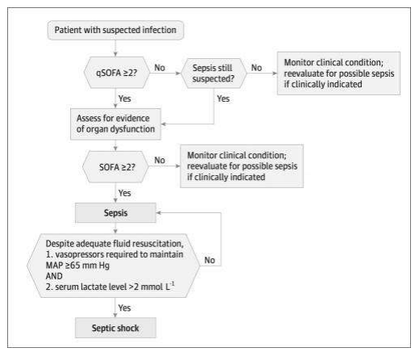
Figure 2.2. Flow chart of assessment of patient with sepsis
Management
- ABC of life: airway stabilization-secure airway if indicated for air way protection, optimization of oxygenation and ventilation.
- Remove work of breathing: Ensure adequate oxygenation by giving oxygen via face mask, if possible or through nasal catheter or nasal prongs.
- Administer 30 ml/kg of IV crystalloid as bolus within first 3 hours, and titrate infusion to adequate urine output, up to 5–6 liters, until you see evidence of lung congestion, and consider the MAP of ≥65 mmHg.
- Initiate broad-spectrum antibiotic therapy early within one hour, usually based the possible focus of infection/septic focus.
- Source control intervention or surgical drainage/debridement of an abscess or dead and necrotized tissue.
- If volume restoration fails to improve organ perfusion, begin vasopressor support.
- Corticosteroid administration for refractory vasopressor-dependent shock.
- Blood transfusion only when hemoglobin concentration decreases to less than 7g/dl or if HCT is <30% to keep adequate O2 saturation.
- MV using target tidal volume of 6ml/kg predicted body weight
- Maintain plateau pressure less than 30cm H2O.
- Glucose control: maintain glucose ≤180mg/dl.
Update Hour-1 bundle:
- Measure lactate level, re-measure if initial lactate >2 mmol/L.
- Obtain blood cultures prior to administration of antibiotics.
- Administer broad-spectrum antibiotic.
- Begin rapid administration of 30 ml/kg crystalloid for hypotension or lactate ≥4 mmol/L.
- Apply vasopressors if patient is hypotension during or after resuscitation to maintain MAP ≥65 mmHg.
Vasopressors:
- Vasopressors are potent pharmacologic agents that are used to increase blood pressure and MAP by vasoconstriction, which in turn increase the systemic vascular resistance.
- They should be reserved for cases of persistent hypotension and tissue hypoperfusion after volume resuscitation has failed.
- Most vasopressors have multiple actions on the heart and vasculature and have a propensity to cause arrhythmias. Some vasopressors are also inotropes and are used to improve cardiac output, particularly in patients with left ventricular pump failure or cardiogenic shock.
- There are different vasopressors that we use for different purposes, below are the common vasopressor doses, effects and uses, the figure below shows us their dose range, which receptor they act on, cardiovascular effects.

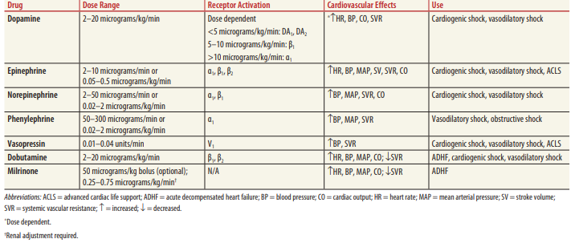
Table 2.13. List of vasopressors, their dose, and cardiovascular effects
Anaphylactic shock
- Control airway and ventilation.
- Put the patient on monitor and give oxygen via high pressured face mask.
- Consider early definitive airway control for those with evidence of significant airway edema or if you fail to correct oxygenation with face mask.
- Secure bilateral wide bore needle IV lines and administer 20 ml/kg of crystalloids as fast as possible.
- Administer epinephrine for control of acute symptoms.
- The dose is epinephrine, 0.3–0.5 milligram (0.3–0.5 mL of the 1:1000 dilution) IM repeated every 5–10 minutes according to response or relapse.
- If the patient is refractory to treatment despite repeated IM epinephrine, or with signs of cardiovascular compromise or collapse, then institute an IV infusion of epinephrine: Initially, epinephrine, 100 micrograms (0.1 milligram) IV, should be given as a 1: 100,000 dilutions.
- This can be done by placing epinephrine, 0.1 milligram (0.1 mL of the 1:1000 dilution), in 10 mL of NS solution and infusing it over 5–10 minutes (a rate of 1–2 mL/min).
- If the patient is refractory to the initial bolus, then an epinephrine infusion can be started by placing epinephrine, 1 milligram (1.0 mL of the 1:1000 dilution), in 500 mL of 5% dextrose in water or NS and administering at a rate of 1–4 micrograms/min (0.5–2 mL/min), titrating to effect.
- Administer 5–10 mg/kg of hydrocortisone or 1–2 mg/kg of methyl prednisolone for late control of symptoms for refractory vasopressor-dependent shock.
- Blood transfusion only when hemoglobin concentration decreases to <7 g/dl or if HCT is <30% to keep adequate O2 saturation.
- MV using target tidal volume of 6ml/kg predicted body weight. Maintain plateau pressure less than 30cm H2O.
- Glucose control: maintain glucose ≤180 mg/dl.
- Don’t have any role in the control of acute symptoms.
- H2 receptor blockers.

2.3.4. Disposition
- Early recognition, treatment, and subsequent transfer of critically ill patients to the intensive care unit improve patient outcomes and improves ED throughput.
- Communicate and document all ED resuscitative efforts to the critical care team.

2.4. Electrolyte Abnormalities

2.4.1 Hyponatremia
Introduction
Hyponatremia is generally defined as a serum level of <135 mEq/L (Normal range: 135–145 mol/L). Emphasis should be given to treatment of the underlying causes in an asymptomatic patient with chronic illnesses.
Diagnosis
Serum sodium level
- Mild: serum sodium = 130–135 mEq/L
- Moderate: serum sodium = 125–129 mEq/L
- Severe: serum sodium <125 mEq/L

Time of onset
- Acute hyponatremia: Hyponatremia that is documented to have occurred over <48 hours. This usually results in cerebral edema and significant symptoms.
- Chronic hyponatremia: Hyponatremia that is documented to have occurred over ≥48 hours.
- Unknown duration: When it cannot be classified by time of onset.
Serum tonicity
- Hypotonic hyponatremia: the most common
- Hypertonic hyponatremia: less common
- Isotonic hyponatremia: less common
Principles of treatment
- Correction of the level of serum sodium
- Treatment of underlying cause
- General issues to be addressed before specific treatment:
- Is it acute or chronic or unknown duration?
- Is it symptomatic or not?
- Optimal rate of correction?
- Fluid status?
Recommended treatment
Based on onset of hyponatremia
- Acute and symptomatic
- Calculate sodium deficit by
- Na deficit= TBW (Na desired-Na measured)
- Use 3% hypertonic saline (=513 meq/L of sodium) or table salt
- Aim to increase plasma Na+ by 1–2meq/hr to a total of 4–6meq/24 hrs which is enough to relieve acute symptoms (usually within 4hrs)
- Give usually over 4 hours
- After this, treatment as protocol of chronic hyponatremia applies
- Chronic
- Correct at a rate of <10–2 meq/24 hrs or <18meq/48 hrs
- Unknown duration
- Treatment should be dependent on the presence or absence of symptoms
- If patient is symptomatic, relieve symptoms with the acute treatment protocol above
- If patient is asymptomatic, treatment should rely on treatment of the causes (see below)
Treatment of underlying causes
Hypovolemic hyponatremia
- Use isotonic saline
Hypervolemic hyponatremia
- Treat causes of hypervolemia
- IV saline and resumption of normal diet for low solute intake
Hypokalemic patients
- Correction of K corrects Na
- Water restriction to <1 liter per day
Treatment based on volume of hyponatremia
Hypovolemic hyponatremia
- Isotonic intravenous fluids (e.g., normal saline 0.9% or a balanced solution such as Lactated Ringer solution) should be administered in 250–1000 mL boluses to maintain blood pressure
Hypervolemic or euvolemic hyponatremia
- All patients should be fluid restricted (including all oral and intravenous fluids) of 1 L/day
Rate and degree of correction
- Calculate Na Deficit (for men) = Wt. x 0.6 (target Na – current Na)
- Na Deficit (for women) = Wt. x 0.5 (target Na – current Na)
- Volume of Hypertonic Saline in ml = Na deficit/512 x 1000
- Infusion Rate (L/h) = Volume of hypertonic saline in ml/ target Na – current Na/desired correction rate
- In chronic hyponatremia, correction should not exceed 0.5 mmol/L/h in the first 24 hrs and 0.3mmol/L/h thereafter
- In acute hyponatremia, the ideal rate of correction is 1.5–2 mEq/h for 4 hrs then slow correction 12 mEq/L over 24 hours
- Plasma Na+ of 125–130 mmol/L is a reasonable target for initial correction of both acute and chronic states
- The rate of correction of serum Na should be kept to <8 meq/l/ day to prevent myelinolysis
- Attempts to achieve normo- or hypernatremia rapidly should be avoided
- Neurological complications (e.g., Central Pontine Myelinolysis) are related to the degree of correction and the rate; premenopausal women are more prone to these complications

2.4.2. Hypernatremia
Introduction
Hypernatremia is defined as when serum sodium is >145 meq/L. It results from water loss, hypothalamic lesions impairing thirst (osmoreceptor function) or sodium overload.
Administration of desmopressin increases urine osmolality by 50% in central diabetes insipidus (CDI) but no or little response in nephrogenic diabetes insipidus (NDI).
Treatment
- Calculate water deficit using the following formula:
- Water deficit = TBW x (Na measured - Na desired)/Na desired; plus, ongoing loss (insensible, others)
- Slowly correct over 48–72hrs by no more than 10 meq/day
- Rarely, Na can be corrected by 1 meq/hr in acute hypernatremia (<48 hours) due to Na loading
- Replace the deficit ideally orally
- D₅W IV can cause hyperglycemia which precipitates hypernatremia
- ¼ or ½ NS if hypotensive or low BP
- NS only if severe hyponatremia of frank hypotension
If CDI:
- Restrict salt: give loop diuretics (furosemide).
- Complete CDI: desmopressin (DDAVP) (10μg BD intra-nasally or 1–2μg BD IV)
- Partial CDI: desmopressin, but often responds to drugs that increase the rate of antidiuretic hormone (ADH) secretion or end-organ responsiveness to ADH (e.g., chlorpropamide, hydrochlorothiazide)
If NDI:
- Low salt diet and thiazides
- High-dose desmopressin may be effective
- Consider removal of causative agents (e.g., lithium, demeclocycline)

2.4.3 Hypokalemia (<3.5 meq/l)
Introduction
Hypokalemia is defined by serum potassium level less than 3.5 meq/L. The causes could be spurious (in vitro uptake by profound leukocytosis), inadequate intake, redistribution (from insulin, alkalosis, B₂ adrenergic agonists, theophylline, caffeine, hypokalemic paralysis with thyrotoxicosis), extrarenal losses, renal loss (diuretics, high doses of penicillin related antibiotics, steroids, theophylline, renal tubular toxins, DKA, Conn’s syndrome, Secondary hyperaldosteronism, Cushing’s syndrome, metabolic alkalosis, hypomagnesemia) and other causes like hypoaldosteronism, metabolic acidosis and hypomagnesemia.
Diagnosis
Clinical manifestations include respiratory muscle weakness, ileus, cardiac arrhythmias and ECG changes.
ECG: changes prolongation of the PR interval, T wave flattening and inversion, ST depression, Prominent U waves.
Recommended treatment
Calculate:
- Potassium deficit (100meq/L fall in total K+ for 0.27 meq/l decrease in plasma K+, this may not apply in redistributive causes)
- Potassium bicarbonate and its precursors—in metabolic acidosis and diarrhea
- Potassium phosphate—rarely used except in concomitant severe hypophosphatemia
- KCl in all other clinical situations:
- IV (via central line) with ECG monitoring when there is a clinically significant arrhythmia (20 mmol over 30 min, repeated according to levels)
- Slower intravenous replacement (20 mmol over 1 h) should be used where there are clinical features without arrhythmias
- Oral supplementation (a total of 80–120 mmol/day) where there are no clinical features
- HSeck Mg++ level as adequate Mg++ is necessary for correction
Treatment of mild to moderate hypokalemia (3–3.4 meq/l)
- Po supplementation (20–80 meq/d in 2–4 divided doses)
- Potassium sparing diuretics for renal wasting and primary aldosteronism
- Non-selective B agonists like propranolol for hypokalemia due to increased sympathetic activity
Treatment of severe (<2–3 meq/l) or symptomatic hypokalemia
Rapid administration of K (PO or IV)
PO KCl 40meq 3–4x/day or IV 20 meq every 2–3 hrs
Monitor serum level every 2–4 hrs
Treat as mild to moderate hypokalemia once K level is persistently >3–3.4 meq/l and asymptomatic
Prevent complications
- Pain and phlebitis occur at a rate greater than 10 meq/hr or concentration more than 3 meq/l
- If large infusions are needed for severe hyperkalemia, use central vein or multiple peripheral veins
- 1000 ml fluid, maximum 60 meq/l of K
- 100–200ml in peripheral vein, maximum 10 meq/l
- 100 ml in central vein, maximum 40 meq/l

2.4.4. Hyperkalemia (>5.5meq/L)
Introduction
Hyperkalemia is defined by serum level greater than 5.5 meq/L. The cause could be:
- Pseudohyperkalemia due to fast clenching during venipuncture, marked thrombocytosis, leukocytosis, and/or erythtrocytosis, cooling of blood after venipuncture
- Redistribution hyperkalemia due to acidosis, beta adrenergic blockers, digitalis overdose, hypertonic states, familial hyperkalemic periodic paralysis, fluoride, succinylcholine
- Impaired K excretion due to aldosterone deficiency or tubular non-responsiveness to aldosterone, renal failure (GFR <20%)
- Medications like ACEis, ARBs, renin inhibitors, cyclosporine, tacrolimus, NSAIDs, COX-2 inhibitors, K sparing diuretics
Diagnosis
Clinical features include arrhythmias, ECG changes, ascending paralysis, metabolic acidosis.
ECG: A tall peaked and symmetrical T wave is the first change seen on the ECG in a patient with hyperkalemia.
Recommended treatment
Treat reversible causes first:
- Stop medications that increase serum K
Antagonism of cardiac effects:
Calcium gluconate
- 10 ml of 10% (contains 90 mg of elemental calcium) or 3–4ml of 10% calcium chloride (10ml of 10% contains 270 mg of elemental calcium) IV over 3–4min without cardiac monitoring
- Onset is over 1–3min and lasts for 30–60 min
- Repeat dose if no ECG change or symptoms recur
- Same amount can be given in 100 ml of D₅W over 20–30 min to avoid acute hyperkalemia
Redistribution into cells:
10IU of regular insulin IV + 50 ml of 50% dextrose (25 g glucose)
- Onset in 10–20 min, peaks at 30–60 min and lasts for 4–6 hr
- Should be followed by infusion of 10% dextrose at 50–75ml/hr, but no need if glucose >200–25 omg/dl
- Frequent blood glucose monitoring
B2 agonists
- Albuterol 10–20 mg via nebulizer in 4 ml of NS over 10 min
- Onset in 30 min, peak at 90 min and lasts 2–6 hrs
Removal of potassium:
- Potassium exchange resins: -Sodium polystyrene sulfonate (SPS): 15–30g + 33% sorbitol
- Diuretics
Dialysis effective means of removal of potassium

2.5. Acute Kidney Injury and Other Renal Emergencies

2.5.1 Acute Kidney Injury
Acute kidney injury (AKI) is deterioration of renal function over hours or days, resulting in the accumulation of toxic wastes and the loss of internal homeostasis.
AKI Stage | RIFLE Category | Change in Creatinine/GFR Criteria | Urine Output Criteria
1 | Risk | Serum Cr increase ≥0.3 mg/dl  OR  increase ≥1.5 times to two-fold from baseline over <48 hrs | <0.5 ml/Kg/h for >6 hrs
2 | Injury | Serum Cr increase 2–3 times from baseline  OR  GFR decrease 50–75% | <0.5ml/Kg/h for >12 hrs
3 | Failure | Serum Cr increase > 3 times from baseline OR  ≥ 4mg/dl and acute increase >0.5 mg/dl | <0.3 ml/Kg/hr for 24 hrs, or  Anuria for 12 hrs
 | Loss | Complete loss of kidney function for >4 weeks
 | End-stage renal disease | Need for renal replacement therapy for >3 months
Table 2.14. Acute kidney injury categorization
Classification
Diagnosis/Laboratory
- Clinical evaluation: Look for:
- Symptoms pertaining to uremia: symptoms of azotemia like nausea, vomiting, drowsiness, fatigue, ad symptoms due to uremic complication of organ systems of the body.
- Cause of AKI
- Pre-renal (55–60%)
- Renal (35–40%)
- Ischemic AKI:
- Toxic AKI
- Glomerulonephritis
- Interstitial Nephritis
Post-renal AKI: symptoms of obstruction
- Laboratory work up: CBC, RFT, Serum electrolytes, urine analysis for protein, sediments, ultrasound for kidney size and obstruction
- Recommended management
Supportive management
- Care for ABCD as any emergency care
Diuretics: for treatment of fluid overload
- Furosemide stress test: administer 1 mg/Kg of furosemide in naive patients or 1.5 mg/Kg in those with prior exposure (Urine output <200ml over 2 hours predicts progression from AKIN 2 to 3)
- Antihypertensive: Use antihypertensive that is safe to use in renal derangement
- Calcium channel blockers, beta-blockers, centrally acting alpha lockers
HCO3 administration:
- 50ml, 50mq, 8.4meq/l in 30 min is needed only when other do not control acidosis fail and PH is 7.1
- For electrolyte imbalance hyperkalemia and hypernatremia
Preventing further renal injury:
- Avoid nephrotoxic drugs like aminoglycoside (unless it is mandatory)
- Avoid IV contrast for imaging in patients with GFR < 30 ml/min/1.73m2 and if it is mandatory GFR < 30 ml/min/1.73m² after nephrologist’s decision
- Follow fluid balance
- Treat pre-renal causes
Renal dose adjustments: Should be made for medication orders
Relieve urine outflow obstruction: Permanent loss of renal function develops over the course of 10–14 days complete obstruction
Indications for dialysis:
- Uremic symptoms: Pericarditis, encephalopathy, bleeding-coagulopathy, neuropathy
- Severe fluid overload: Not responsive to medical treatment and in association with persistent hypoxia
- Refractory electrolyte disorders: Hyperkalemia (K >6.5 mmol/L or rising), serum sodium <115 or >165 mEq/l refractory to medical treatment.
- Severe refractory acidosis: pH <7.2 despite normal or low PaCO₂ refractory to medical treatment
- Anuria/severe oliguria: No UOP for >6 hours or UOP <200 ml for >24 hrs, respectively; refractory to medical treatment
Specific etiology-directed treatment:
Pre-renal AKI
- Correct volume deficit with IV isotonic fluids
- Severe acute blood loss should be treated with packed red blood cells
- Optimization of cardiac function in the cardio renal syndrome (i.e., renal hypoperfusion from poor cardiac output) may require use of inotropic agents, preload- and afterload-reducing agents, and antiarrhythmic drugs
Post-renal AKI
- Transurethral or suprapubic bladder catheterization: For ureteric obstruction
- Nephrostomy: For ureteric obstruction of any cause after urology consultation
- Prompt recognition and relief of urinary tract obstruction
NB-Be aware of post-obstructive diuresis
- Rhabdomyolysis: Early and aggressive volume repletion is needed where the patients may require 10 L of fluid per day to achieve adequate diuresis
Monitoring
Monitor:
- Vital signs
- Input, output, and fluid balance

Disposition
ADMISSION CRITERIA | DISCHARGE
1. Electrolyte abnormality | 1. Improvement in symptoms
2. Fluid over load and AKI | 2. No vital sign derangement
3. Patient require renal replacement therapy | 3. No electrolyte abnormality
4. Correction of underlying cause | 4. Improvement in renal function
5. Workup for cause of AKI | 5. Appropriate outpatient follow-up arranged
6. Poor follow-up
Table 2.15. Admission and Discharge Criteria for Renal Cases
- Early nephrologist consultation if available or internist involvement within 48 hours of patient presentation is beneficial for patients with AKI.
- Mandatory involvement of nephrologist or referral to one is vital if:
- Inadequate response to supportive treatment;
- AKI without a clear cause;
- Stage 3 or higher AKI;
- Stage 4 or higher CKD; and
- Other situations requiring specialist expertise (e.g., renal transplant, glomerulonephritis, multiple myeloma, in intrinsic causes of AKI).
- Involvement of the internists and nephrologists is mandatory from the time the patient presents to the ER.

2.5.2. Other Renal Emergencies/Nephrolithiasis and Stones in Lower Urinary Tract
Introduction
Urinary tract stones are common, with a global prevalence of approximately 14%, which varies depending on age, sex, and ethnicity. The majority are found in the upper urinary tract and 5% are found within the bladder.

Classification
Urinary stones can be classified according to size, location, X-ray characteristics, etiology of formation, composition, and risk of recurrence
Stone size
- Stone size can be reported in a single, two or three dimensions. Linear measurement of cumulative stone diameter is used.
- Stones <5 mm, 5–10 mm, 10–20 mm, and >20 mm for use the below documents.
Stone location
- According to anatomical position:
- Upper, middle, or lower calyx
- Renal pelvis; upper, middle, or distal ureter
- Urinary bladder
X-ray characteristics of stones
- Plain X-ray appearance (kidney-ureter-bladder [KUB] radiography) uses mineral composition. (Refer to Table 2.16)
- Non-contrast-enhanced computed tomography (NCCT) uses density, inner structure, and composition
Radiopaque | Poor radiopacity | Radiolucent
Calcium oxalate dihydrate | Magnesium ammonium phosphate | Uric acid
Calcium oxalate monohydrate | Cysteine | Ammonium urate
Calcium phosphate |  | Xanthine
 |  | 2,8-Dihydroxyadenine
Table 2.16. X-ray characteristic of stones
Etiology of stones
Noninfectious
Calcium oxalate | Calcium phosphate | Uric acid  Ammonium urate
Infection Stones
Magnesium Ammonium Phosphate | Highly carbonated apatite | Ammonium urate
Genetic Causes
Cystine | Xanthine | 2,8-Dihydroxyadenine
Drug Stones
Table 2.17. Stones classified by etiology
Composition of stone
- Classification depends on type of composition of stone depicted in the Table 2.17.
Risk of recurrence of stone
- The risk of recurrence of stones in patients depend on the following risk factors:
- Genetic factors
- Diseases associated with stone formation
- Genetically determined stone formation
- Drug-induced stone formation
- Anatomical abnormalities associated with stone formation
- Environmental and professional factors
Diagnosis
Clinical manifestation
- Urolithiasis may present with loin pain, fever, nausea, and vomiting or with an incidental finding.
- Bladder stones present differently with lower urinary tract symptoms (LUTS) predominantly, but hematuria and suprapubic pain may also be present.
- Symptoms and signs consistent with the etiology of the stone and complication of the stone.
Diagnostic imaging workup
Renal and ureteric stones
Adults
- First Line: Non-contrast CT (NCCT) scan of abdomen
- Second Line: IV urography, utrasound, kidney-ureter-bladder radiopgraph (KUB), if CT is not available
- Functional imaging to assess residual kidney function, if available
- Third line: Uretroscopy
Children
- First Line: Ultrasound, KUB
- Second Line: V urography,
- Third Line: Low dose NCCT, MR urography
Pregnant women
- First Line: Ultrasound
- Second Line: MRI
- Last resort: Low dose NCCT
Bladder Stones
Adults
- First Line: Bladder ultrasound
- Second Line: NCCT
- Third Line: Cystoscopy, KUB X-ray: for confirmed stone for follow-up and plan of treatment
Children
- First Line: Bladder ultrasound
- No second line investigation studied if ultrasound is negative
- Pregnant woman
Diagnostic biochemical workup
- Hematology: CBC, CRP
- Biochemistry: Creatinine, urea, serum electrolyte (sodium, potassium, ionized calcium, phosphorous), uric acid
- Coagulation profile
- Urine: Urine dip stick (pH, nitrites, RBC, WBC), microcopy (infection)
- Stone analysis: for recurrent stone formers, intervention planned
- Workup: to identify cause, for complications of stone
Recommended management
Renal colic
Non-obstructive stone
- Pain relief
- NSAID are first line
- Opoids are second line
- Antiemetics: In conjuction with the anti-pain medications
- Analgesic refractory renal colic: Ureteroscopic stone removal or renal decompression
- Rehydration: If patient shows dehydration signs
- Antibiotic therapy
- If signs of urinary tract infection (UTI):
- Pyuria of 10 WBCs/hpf (or more WBCs than RBCs), bacteriuria, fever, or unexplained leukocytosis.
- Culture positive for UTI
Obstructive stone
Obstructive stones with all signs UTI and or anuria is a urologic emergency. Urgent consultation of urologist is required or refer to one.
- Urgent Decompression
There are two options for urgent decompression:
- Placement of an indwelling ureteral stent
- Percutaneous placement of a nephrostomy tube.
- Antibiotic therapy
- Urgent initiation of empiric antibiotics is mandatory which will be tailored after culture result
- Definitive stone removal: done after treatment of infection
- Antibiogram sensitivity testing: send both urine and blood samples
- Pain relief treatment as above
Stone removal
Non-obstructive stone
- Size <4mm
- Conservative treatment with spontaneous expulsion
- Size >5mm but <10 mm
- Refer to urologist
- Medical expulsive therapy with alpha blockers
- Oral chemolysis for uric acid stones… not frequently advised
- Size >10 mm
- Extra-corporal shock wave lithotripsy
- Transurethral/percutaneous cystolithotripsy
- Refer to urologist
Obstructive Stone
Urologist or general surgeon should be involved in the management of patients in ED
Monitoring
- Vital signs
- Pain scoring
- Signs of infection
- If stent is in place, follow up for output and vital signs
Disposition
- For simple uncomplicated, non-obstructive stone: appoint to urology clinic in consultation with urologist or general surgeon
- Admission is required if:
- Uncomplicated obstructive stone
- Complicated obstructive stone with sepsis, signs of renal failure and infection (pyelonephritis, pyonephrosis, cystitis)

2.6. Neurologic Emergencies

2.6.1. Stroke
Introduction
Stroke is a sudden focal neurological deficit attributable to a specific vascular territory secondary to obstruction or bleeding. It is characterized with rapidly developing signs of focal or global disturbance of cerebral functions lasting more than 24 hours.
Classification
- Transient Ischemic Attacks (TIA): a clinical syndrome characterized by an acute loss of focal cerebral or ocular function with symptoms lasting less than 24 hours.
- Ischemic stroke: Causes includes thrombosis from atherosclerosis or embolism may be from a cardiac source or artery to artery emboli accounts for 85% of strokes. Systemic hypo perfusion also may contribute.
- Cerebral hemorrhage: account for the remainder.
- Primary intracerebral hemorrhage (ICH): is associated with rupture of Charcot-Bouchard aneurysms in patients who usually have hypertension.
- Subarachnoid hemorrhage (SAH): hemorrhage from a cerebral blood vessel, aneurysm or vascular malformation into the subarachnoid space. It is characterized by sudden onset of headache, and vomiting, with or without loss of consciousness.
Diagnosis
Clinical
- Sudden neurologic manifestation with various degrees of mental status change, and focal neurologic deficit.
- Assessment for the localization of the likely cerebral area affected.
- Manifestation pertaining to the underlying cause like atrial fibrillation (AF)
Workup
- Diagnostic: non-contrast brain CT scan, brain MRI (with DWI-FLAIR)
- For underlying cause: ECG, echocardiography, carotid doppler, early noninvasive cerebral angiography (CTA/MRA within 48 hours of onset) should be considered where a macrovascular cause is likely to be identified
- For comorbidity: Lipid profile, RBS, FBS, HgA1c
- For complication: CBC, RFT, liver enzymes, serum electrolyte
Principles of management
- Stabilization of the patient condition.
- Supportive management for the neurologic manifestation and complication.
- Prevent further damage to the brain.
- Prevent stroke recurrence.
Triage
- Rapid assessment and stabilization of ABCD.
- Urgent brain imaging with non-contrast CT scan to evaluate for hemorrhage.
After the imaging, patient subsequent management is tailored depending on the diagnosis as ischemic stroke or hemorrhagic stroke; the patient should be kept at Red area.
Acute ischemic stroke
- Patients with acute ischemic stroke should be assessed for eligibility for IV thrombolysis with alteplase or Tenecteplase which are:
- Acute ischemic stroke within 4.5 hours of known onset
- Acute ischemic stroke with known onset between 4.5–9 hours, if there is evidence of the potential to salvage brain tissue on CT perfusion or MRI (DWI-FLAIR mismatch).
- Acute ischemic stroke eligible for mechanical thrombectomy.
- If eligible for IV thrombolysis, patients should be transferred or referred to an acute stroke center with the capability to perform the treatment within the specified time frame for each respectively.
- Patients eligible for mechanical thromboectomy (using ASPECTS score) are:
- Acute anterior circulation ischemic stroke between 6–24 hours of onset.
- Large artery occlusion between 6–24 hours of onset.
- Acute ischemic stroke in the posterior circulation within 12 hours of onset with confirmed intracranial vertebral or basilar artery occlusion.
- All eligible should receive prior IV thrombolysis as rapidly as possible (unless contraindicated).
- Patients with acute ischemic stroke not eligible for IV thrombolysis and/or mechanical thrombectomy should be started on the supportive managements as detailed in the management section.
Intracranial hemorrhage
- Patients with acute spontaneous intracerebral hemorrhage should be assessed for eligibility for surgical treatment (need neurosurgical consultation):
- For patients with cerebellar hemorrhage >3 cm
- For patients with ICH associated with a structural vascular lesion
- For young patients with lobar hemorrhage
- Patients with SAH should be considered for eligibility for surgical treatment like
- Clipping or coiling the ruptured berry aneurysm to prevent re-bleeding. Need neurosurgical consultation.
Recommended Management
General measures:
- Stabilization of ABCD, careful nursing care and early physiotherapy.
- Maintain good glycemic control.
- Hypoglycemia or hyperglycemia has to be managed accordingly. RBS should be between 140–180mg/dl.
- Manage intracranial pressure if there are a rise and anticonvulsant for seizure activity.
- Reduce pyrexia.
- Treatment of associated illnesses (e.g., pneumonia)
- DVT prophylaxis.
- Early physical and speech support.
- Check for swallowing in order to prevent aspiration.
- Admit patient to ICU or an acute stroke unit.
Nursing care:
- Coma care: nursing care to prevent bedsores, hypostatic pneumonia, contractures, exposure keratitis.
- Nutritional support to maintain adequate caloric intake.
- Patients should be mobilized as soon as possible.
- Change position at least every 2 hours for the prevention of bedsores.
- Bladder and bowel care: catheterize if patient is incontinent or unconscious.
- Feeding: insert nasogastric (NG) tube for patients who have swallowing problems or are at risk of aspiration (e.g., pseudobulbar palsy) and that unconscious.
Ischemic stroke
Specific treatment:
- Antihypertensive
- Do not lower BP unless it is very severe, like >220/120 or MAP ≥130 mmHg.
- Ischemic stroke with thrombolytic plan:
- BP should be reduced below 185/110mmHG.
- Ischemic stroke with hypertensive encephalopathy, IHD, aortic dissection:
- BP target is 140/90 but use short-acting drugs like esmolol.
- Lower BP by approximately 15–20% during the first 24 hours after stroke onset, restart antihypertensive medications at approximately 24 hours after stroke onset in patients with preexisting hypertension who are neurologically stable.
- Recommended antihypertensive drugs:
- Intravenous labetalol: 10–20 mg IV for 1–2 min is given, and may be repeated or doubled every 10 minutes to a maximum dose of 300 mg.
- IV esmolol: Loading dose 500–1,000 mcg/kg/min over 1 min followed by a 50 mcg/kg/min infusion.
- Antiplatelet and anti-thrombotic treatment:
- Aspirin: 300 mg PO enterally or suppository should be given as soon as possible after the onset of stroke symptoms once a diagnosis of primary hemorrhage has been excluded.
- Following thrombolysis it should be delayed for 24 hours.
- Early anticoagulation: May precipitate secondary hemorrhage; start anticoagulation only after 1–2 weeks in large artery territorial infarcts.
- Statin
- High-intensity statin therapy with atorvastatin 80 mg po/day is started for secondary prevention.
TIA and minor stroke
- Patients with acute focal neurological symptoms that resolve completely within 24 hours of onset (i.e., suspected TIA):
- Should be given aspirin 300 mg po immediately unless contraindicated.
- Should be kept and observed at least for 24 hours.
- Assessed within 24 hours by a stroke specialist clinician in a neurovascular clinic or an acute stroke unit.
- Brain imaging with MRI to detect the presence and/or distribution of brain ischemia and/or non-contrast CT to detect hemorrhage.
Receive treatment for secondary prevention as soon as the diagnosis is confirmed, including:
- Antiplatelet or anticoagulant therapy (see the ischemic part).
- High-intensity statin therapy and link to outpatient clinic.
Hemorrhage stroke
- Supportive care:
- ABC assessment and management.
- The head of the bed should be elevated 30° to ensure optimal venous drainage.
- If increased intracranial pressure (ICP) or herniation:
- Osmotic diuresis: IV mannitol.
- Antihypertensive therapy:
- A SBP of 150–220 mmHg should be considered for urgent treatment within 6 hours of symptom onset, aiming to achieve a goal SBP of 130–139 mmHg within 1 hour and sustained for at least 7 days.
- Early treatment may decrease hematoma enlargement and lead to better neurologic outcome.
- Cautiously lower BP by at least 15% to a MAP of <130 mmHg, but avoid excessive hypotension.
- IV nicardipine hydrochloride: can be used for reduction.
- IV labetalol: for titrated reduction in BP.
- Correct any identifiable coagulopathy with FFP, vitamin K, protamine, or platelet transfusions.
- Anticonvulsant with levetiracetam: Only if the patient has seizure due to lobar hemorrhage.

Subarachnoid hemorrhage (SAH)
- Admit to ICU for observation.
- Admit in a darkened, quiet room and given mild sedation if agitated to decrease risk of ICP.
- The head of the bed should be kept elevated at 30° to ensure optimal venous drainage.
- If increased ICP or herniation:
- Patient should be intubated and hyperventilated.
- Minute ventilation should be titrated to achieve a PCO₂ of 30–35 mmHg.
- Avoid excessive hyperventilation, which may potentiate vasospasm and ischemia.
- Osmotic agents (e.g., mannitol).
- Antihypertensive:
- Avoid excessive reduction of BP which can result in ischemia.
- Beta-blockers IV: MAP >130 mmHg and goal SBP of 130–140 mmHg.
- Hydralazine and calcium channel blockers: Angiotensin-converting enzyme inhibitors can be used.
- Prevent hyponatremia from possible cerebral salt wasting.
- Nimodipine: 60 mg PO every 4 hours to decrease risk of vasospasm and should be initiated within 96 hours, and
- Phenytoin: for seizure prophylaxis.
- Correct any identifiable coagulopathy with FFP, vitamin K or platelet transfusions.
Disposition
All stroke patients need admission for observation and supportive management either to HDU or ICU.

2.6.2 Guillain-Barré Syndrome
Introduction
Guillain-Barré syndrome (GBS) is a demyelinating neuropathy with a collection of clinical syndromes that manifests as an acute inflammatory polyradiculoneuropathy with resultant weakness and diminished reflexes.
Classification
- Acute inflammatory demyelinating polyneuropathy
- Acute motor axonal neuropathy
- Acute motor-sensory axonal neuropathy
- Miller-Fisher syndrome (5%): Classically presents as a triad of ataxia, areflexia and ophthalmoplegia
- Acute pan-autonomic neuropathy
- Involves the sympathetic and parasympathetic nervous systems
- Pure sensory GBS
- A rapid onset of sensory loss, sensory ataxia, and areflexia in a symmetrical and widespread pattern
- Pharyngeal-cervical-brachial variant of GBS
Diagnosis
Clinical: Signs and symptoms that present 2–4 weeks following a relatively benign respiratory or gastrointestinal illness with complaints of:
- Muscle weakness of the lower extremities that may progress over hours to days to involve the arms, truncal muscles, cranial nerves, and muscles of respiration.
- Cranial nerve involvement: Manifests with facial droop (may mimic Bell’s palsy), diplopia, dysarthria, dysphagia, ophthalmoplegia, and pupillary disturbances.
- Paresthesia: Pain, tingling, numbness, burning, prickling, or itching on the skin; can affect any part of the body with sensory or afferent nerve fibers, but is most common in the extremities, like hands and feet.
- Typical respiratory complaints: Include dyspnea on exertion, shortness of breath, difficulty swallowing, and slurred speech.
- Autonomic changes: Include tachycardia/bradycardia, facial flushing, paroxysmal hypertension, orthostatic hypotension, anhidrosis and/or diaphoresis, urinary retention.
Investigation: A basic peripheral neuropathy workup is recommended.
- Laboratory: Electrolyte levels, LFTs, creatine phosphokinase (CPK) levels, ESR, cerebrospinal fluid studies (elevated protein level, PM <10 or normal diagnostic).
- Needle electromyography and nerve conduction studies.

Recommended management
Supportive care
- Assess the ABC and administration of oxygen if hypoxic and IV access.
- Assisted ventilation may be indicated to the degree of intubation should be performed on patients who develop any degree of respiratory failure.
- Clinical indicators for intubation in the ED include the following:
- Hypoxia, rapidly declining respiratory function, poor or weak cough, suspected aspiration.
- Forced vital capacity <15 mL/kg. Declining negative inspiratory force (NIF) to -30 cmH₂O should cause concern and monitoring.
- Bowel and bladder dysfunction: Management should be directed toward safe evacuation and the prevention of overdistension.
Specific treatment
- Dysautonomia
- Tachycardia: Treatment is rarely needed for tachycardia.
- Symptomatic bradycardia: Atropine is recommended.
- Hypertension: Since it is labile, best treated with short-acting agents, such as a short-acting beta-blocker or nitroprusside.
- Hypotension: Usually responds to IV fluids and supine positioning.
- Second- and third-degree heart block: Temporary pacing may be required.
- Prophylaxis for prevention of DVT and PE: SC UFH or LMWH.
- GI prophylaxis.
- Immunomodulation: Intravenous immunoglobulin (IVIG).
- Plasmapheresis: Plasma exchange has proved equally effective.
Monitoring
- Close monitoring for changes in blood pressure, heart rate, and arrhythmias.
- Perform daily single breath count.
- Progression of weakness.
Disposition
- Patient should be admitted to medical HDU or ICU.
- Early involvement of internists and neurologists.

2.7. Endocrine Disease

2.7.1 Diabetic Ketoacidosis
Introduction
Diabetic ketoacidosis (DKA) is an acute, life-threatening complication of diabetes mellitus.
DKA occurs predominantly in patients with Type 1 diabetes mellitus, but 10–30% of cases occur in newly diagnosed Type 2 diabetes mellitus. The clinical manifestations of DKA are related directly to hyperglycemia, volume depletion, and acidosis.
Principles of management
- Correction of hypovolemia
- Correction of hyperglycemia
- Correction of electrolyte disturbances
- Correction of acid-base balance
- Treatment of precipitants
Recommended management
Fluid resuscitation
- Fluid management depends on patient presentation.
- Patients without extreme volume depletion can be managed safely with a more modest fluid replacement regimen such as 250–500 mL/h NS for 4 hours.
- The estimated fluid loss in patient with extreme fluid depletion is around 5–10 L and it should be replaced over 24 hours.
- In general, the first 2 L are administered rapidly over 0–2 hours, the next 2 L over 2–6 hours, and then an additional 2 L over 6–12 hours. This replaces approximately 50% of the total water deficit over the first 12 hours, with the remaining 50% water deficit to be replaced over the subsequent 12 hours depending on the degree of dehydration and central venous pressure readings (IVC size).
- When the patient becomes euvolemic, the physician may switch to half the isotonic sodium chloride solution, particularly if hypernatremia exists.
- When glucose approaches 250 (11 mmol/L), change IV to D5 0.5 NS.
- If the patient is in shock, refer to the shock management guidelines.

Correcting electrolyte disturbances
- If initial [K+] >5.2 do not administer potassium.
- If initial [K+] is >3.3 and <5.2 and the patient has adequate urine output, add 20 meq of K+ to each liter of fluid.
- If initial [K+] is <3.3 hold insulin drip and give K+ at 40 mEq/h in 500ml N/S through IJ/EJ vein access with rate of 20 meq/hr until [K+] is >3.3; then initiate insulin drip.
Glucose management
- Insulin should be started about an hour after IV fluid replacement is started.
- Administer insulin at a rate of 0.1–0.14 unit/kg/h with no insulin bolus once hypokalemia ([K+] <3.3 mEq/L) is excluded.
- Alternatively, if there is no infuser administer bolus of 10IU RI IV and IM the same dose; and 5IU RI IV every 1 hour.
- If blood glucose does not decrease by 10% (50–75 milligrams/dL/h) after 1 hour of insulin therapy, give 0.14 units/kg bolus then resume previous rate.
- If blood glucose decreasing faster than 50–75 milligrams/dL/h, decrease insulin drip. Check glucose hourly.
- When glucose approaches 250 (11 mmol/L), change IV to D5 0.5 NS and decrease insulin rate to 0.02–0.05 units/kg/hr.
- Maintain serum glucose 180–200 (10–11 mmol/L) and continue insulin drip for at least 12 hours or until DKA resolves.
- The goals of management are: glucose <200 (11 mmol/L), normal AG, pH >7.3 and HCO3 >15.
- Patient able to eat: give SC short- and long-acting insulin, feed patient, discontinue IV insulin 1–2 hours AFTER SC insulin.
Management of acidosis
- Sodium bicarbonate only is infused if decompensated acidosis starts to threaten the patient’s life, especially when associated with either sepsis or lactic acidosis.
- Give bicarbonate only if the initial pH is ≤6.9.
- Adults with a pH <6.9 can be given 100 mEq of sodium bicarbonate in 400 mL of water with 20 mEq KCl at 200 mL/h for 2 hours until the venous pH >7.0.

Management of precipitants
Treat infection (particularly sepsis), myocardial ischemia or infarction, medication noncompliance.
Management of complication
Cerebral edema: Remains the most common and feared cause of mortality.
- Deterioration of the level of consciousness in spite of improved metabolic state usually indicates the occurrence of cerebral edema.
- 0.5–1 g/kg intravenous mannitol may be given over the course of 20 minutes and repeated if no response is seen in 30–20 minutes; hypertonic saline (3%), 5–10 mL/kg over 30 minutes, may be an alternative to mannitol. Intubation and fluid restriction are generally necessary if patient GCS is worsening.
Monitoring
Parameters | VS (RR, PR, B/P, SPo2) | Mental status (GCS) | Serum glucose | Urinalysis  ketone | electrolyte | Blood gas | ECG | BUN/Cr
Frequency | Continuous monitoring | Continuous monitoring | Every 1 hr | Every 2 hrs | Every day | Every 6 hrs | Daily | Daily
Table 2.18. DKA follow-up chart

2.7.2. Myxedema Crisis
Introduction
Myxedema crisis is a state of metabolic and multiorgan decompensation characterized by uncorrected hypothyroidism, mental status changes or coma, and hypothermia usually <35.5°C /95.9°F. It is precipitated by a number of conditions, including: infection, anesthetic agents, cold exposure, trauma, myocardial infarction or congestive heart failure, cerebrovascular accident, GI hemorrhage, metabolic conditions, hypoxia, hypercapnia, hyponatremia, hypoglycemia, surgery, burns, medications (e.g., beta-blockers, sedatives, narcotics, phenothiazine, amiodarone), or thyroid medication noncompliance.

Diagnosis
Clinical features include bradycardia, hypotension, hypothermia, hypoventilation, and altered mental status or coma. Pleural effusions are frequently demonstrable. Other potential respiratory problems include upper airway obstruction from glottic edema, vocal cord edema, and macroglossia. Comatose patient, patient with symptomatic bradycardia and patient with airway problem should be admitted to the ICU.
Principles of management in ICU
- Supportive care
- Hormonal replacement therapy
- Treatment of complications
- Treatment of precipitants
Recommended management
Supportive care
- Airway, breathing, and circulation support: Ensure airway control, oxygen, IV access, and cardiac monitor.
- IV therapy: Dextrose for hypoglycemia; water restriction for hyponatremia.
- Vasopressors: If indicated (ineffective without thyroid hormone replacement).
- Hypothermia: Treated with passive rewarming.
- Steroids: Hydrocortisone (due to increased metabolic stress; 100–200 milligrams IV).
Thyroid replacement therapy
- IV thyroxine (levothyroxine) at 4 micrograms/kg (typically between 200–500 micrograms as initial dose).
- Followed in 24 hours by 100 micrograms IV, then 50 micrograms IV until oral medication is tolerated. Thyroxine is readily available and preferred in the elderly and those with cardiac disease.
- Starting dose in the elderly is 100 micrograms IV.
Stress dose steroid
- Hypothyroidism may associate with adrenal insufficiency, either due to pituitary disease or as a multifocal autoimmune disorder.
- Hydrocortisone 100 mg IV q8hr is the standard therapy here.
- Patients may be weaned off steroid fairly rapidly, once they are hemodynamically stable and improving.
Management of complications
Cardiovascular
- The cardiovascular complications include bradycardia, pericardial effusion and pleural effusions, and cardiogenic shock (late finding). (Refer to management in the respective section).
- Treat with thyroid hormone replacement and vasopressor.
Neurologic
- Manifest with delirium or coma and seizures can occur, including status epilepticus (potentially exacerbated by hyponatremia).
- Treat with thyroid hormone replacement, control active seizure (see Seizure management section) and correct hyponatremia with hypertonic fluid (see Hyponatremia management section).
Pulmonary
- Manifest with, pleural effusions may promote hypoxemia and edema of the tongue can complicate intubation.
- Put on mechanical ventilator for hypoventilation, which may result from central reduction in respiratory drive, as well as from muscular weakness.
- Therapeutic thoracentesis for massive pleural effusion.
- Intubation for airway obstruction.
Hyponatremia
- Replace sodium with 3% NS and restrict free fluid intake for severe hyponatremia.
- Mild hyponatremia will resolve with thyroid supplementation.
Management of precipitants

- Infections: Manage sepsis.
- Drugs: Discontinue sedatives, beta-blockers, antipsychotic, amiodarone (after discussion with senior physician).
- Congestive heart failure: Manage heart failure according to the guideline.
- Gastrointestinal hemorrhage: Correct coagulopathy and GI acid secretion.

Monitoring
Parameters | V/S, GCS | TFT (free T3/T4/TSH) | CBC | Electrolyte | RBS | ECG | Cr/BUN | S/E, occult blood | Bedside cardiac U/S
Frequency | Continuous | Daily | Daily | Daily | Every 6 hrs | Every 12 hrs | Daily | Once | Daily
Table 2.18. DKA follow-up chart

2.7.3. Thyroid Storm
Introduction
Thyroid storm is an acute, severe, life-threatening hyper metabolic state of thyrotoxicosis caused either by excessive release of thyroid hormones—causing adrenergic hyperactivity or altered peripheral response to thyroid hormone.
Diagnosis
The diagnosis depends on clinical signs and symptoms where diagnostic scoring parameters is used in thyrotoxicosis patients. (See table below for scoring).
Score more than 45 is thyroid storm; 25–45 is impending score; and <25 is unlikely.
for airway protection and ventilation, management of uncontrolled arrhythmia, heart failure and coma care.
Diagnostic Parameter | Scoring Points
Thermoregulatory dysfunction  Temperature ºC (ºF)  37.2–37.7 (99–99.9)  37.7–38.3 (100–100.9)  38.3–38.8 (101–101.9)  38.9–39.4 (102–102.9)  39.4–39.9 (103–103.9)  >40 (>104.0) | 5  10  15  20  25  30
Central nervous system effects  Absent  Mild (agitation)  Moderate (delirium, psychosis, extreme lethargy)  Severe (seizure, coma) | 0  10  20  30
GI-hepatic dysfunction  Absent  Moderate (diarrhea, nausea/vomiting, abdominal pain)  Severe (unexplained jaundice) | 0  10  20
CV dysfunction  Tachycardia (beats/min)  90–109  110–119  120–129  >140 | 5  10  15  25
Congestive heart failure  Absent  Mild (pedal edema)  Moderate (bibasilar rales)  Severe (pulmonary edema) | 0  5  10  15
Atrial fibrillation  Absent  Present | 0  10
Table 2.19. Burch and Wartofsky’s diagnostic parameters and scoring points for thyroid storm

Principles of management
- Supportive care
- Controlling of thyroid hormone synthesis or conversion
- Treatment of complications
- Treatment of precipitating factors
Recommended management
Supportive care
Patients need ICU admission.
- General: oxygen, put on cardiac monitoring.
- Fever: external cooling; acetaminophen 325–650 milligrams PO or PR every 4–6 hrs. (aspirin is contraindicated because it may increase free thyroid hormone).
- Dehydration: IV fluids, IV isotonic saline with 5% dextrose may be used to replace glycogen depletion if blood sugar is low.
- Nutrition: glucose, multivitamins, thiamine, including folate can be considered (deficient secondary to hypermetabolism).
- Cardiac decompensation (atrial fibrillation, congestive heart failure): rate control and inotropic agent, diuretics, sympatholytic as required.
Inhibition of new thyroid hormone synthesis with thionamides
Methimazole
- 40 mg given PO as loading dose and followed by 25 mg every 4 hr.
- Total daily dose should be given: 120 mg/d.
- If given PR, 40 mg should be crushed in aqueous solution.
- Avoid methimazole for pregnant women in first trimester as it can cause teratogenic effect.
OR
Propilthiouracyl (PTU)
- Loading dose of 600–1000 mg given PO and followed by 200–250 mg every 4 hrs. Total daily dose should be given: 1200–1500 mg/d.
Inhibition of thyroid hormone release (at least 1hr. after step 2)
Lugol solution
- 8–10 drops PO every 6–8 hr. potassium iodide (SSKI) five drops PO every 6 hrs.
Beta adrenergic receptor blockade
Propranolol
- IV in slow 1–2 mg boluses, which may be repeated every 10–15 min until the desired effect is achieved. For less toxic patient, PO dose of 20–mg per dose or 160–320 mg/d in divided doses (contraindicated in bronchospastic disease and congestive heart failure).
OR
Esmolol
- 500 micrograms/kg IV bolus, then 50–200 micrograms/kg/min maintenance.
Preventing peripheral conversion of thyroxine to triiodothyronine
- Hydrocortisone: 100 mg IV initially, then 100 mg 3 times per day until stable (also for adrenal replacement due to hyper metabolism);
OR
- Dexamethasone: 2 mg IV every 6 hrs.
Management of complications
Cardiovascular:
- Manage shock (either due to cardiogenic or distributive shock) and heart failure according to the guideline.
- If there is tachycardia (either sinus tachycardia or atrial fibrillation with rapid ventricular response), manage according to tachyarrhythmia guideline. Avoid beta-blocker in patients with heart failure.
Hyperthermia:
- Paracetamol 1gm every 6 hrs.
- Use of cooling blankets is recommended for high fever.
- Avoid salicylates or NSAIDs, since these may increase free thyroid hormone levels.
Agitation management
- Agitation may worsen hyperthermia and impede ability to provide care.
- Olanzapine is a drug of choice 2.5–5mg every 4 hrs. either by PO, IM, or IV routes.
Treat precipitating event
- Infection: Start broad-spectrum antibiotics
- Myocardial infarct: Manage AMI according to the guideline.
Monitoring
Parameters | V/S, GCS | TFT (free T3/T4/TSH) | CBC | Electrolyte | RBS | ECG | Cr/BUN | Liver function test
Frequency | Continuous | Daily | Daily | Daily | Every 6 hrs | Every 12 hrs | Daily | Once
Table 2.20. Monitoring of thyroid storm

2.8. Infectious Diseases

2.8.1. Severe Malaria
Introduction
Severe falciparum malaria is defined as one or more of the following clinical
manifestations, occurring in the absence of an identified alternative cause and in the
presence of P. falciparum asexual parasitemia:
- Impaired consciousness: A Glasgow coma score <11 in adults.
- Prostration: Generalized weakness so that the person is unable to sit, stand, or walk without assistance.
- Multiple convulsions: More than 2 episodes within 24 hrs.
- Acidosis: A base deficit of >8 mEq/L or, if not available, a plasma bicarbonate level of <15 mmol/L or venous plasma lactate ≥5 mmol/L. Severe acidosis manifests clinically as respiratory distress (rapid, deep, labored breathing).
- Hypoglycemia: Blood or plasma glucose <2.2 mmol/L (<40 mg/dL).
- Anemia: Hgb ≤5 g/dL or Hgb <7 g/dL and HCT <20% with parasite count >10,000/µL.
- Renal impairment: Plasma or serum creatinine >265 µmol/L (3 mg/dL) or blood urea >20 mmol/L.
- Jaundice: Plasma or serum bilirubin >50 µmol/L (3 mg/dL) with a parasite count >100,000/µL.
- Pulmonary edema: Radiologically confirmed or SPO₂ <92% on room air with a RR >30/min, often with chest retractions and crepitation on auscultation.
- Significant bleeding: Including recurrent or prolonged bleeding from the nose, gums or venipuncture sites; hematemesis or melena.
- Shock
- Hyperparasitemia: P. falciparum parasitemia >10%.
- Severe vivax malaria is defined as for falciparum malaria but with no parasite density thresholds.
- Severe knowlesi malaria is defined as for falciparum malaria but with two differences:
- P. knowlesi hyperparasitemia: parasite density >100,000/µL.
- Jaundice and parasite density >20,000/µL.
Diagnosis
In malaria-endemic areas:
- Any patient presenting with a history of fever or T ≥37.5° C and no other obvious cause.
In areas where malaria transmission is stable (or during high-transmission period of seasonal malaria; includes many parts of sub-Saharan Africa and some parts of Oceania):
- Any patient presenting with Hgb <8 g/dL.
In areas where the incidence of malaria is very low:
- Parasitological diagnosis should be sent for patients with fever or a history of fever with no other obvious cause and recent travel to a malaria-endemic area without protective measures.
Laboratory investigation:
- Blood film (thick and thin) with parasitic level: If it is negative in patients with manifestations compatible with severe malaria, a series of blood films should be examined at 6–12-hour intervals.
- Malaria rapid diagnostic test: Can be useful for patients who have received incomplete antimalarial treatment and in whom blood film is negative.
- CBC, RBS, RFT, liver enzymes with bilirubin levels, coagulation profiles, CXR if ARDS, ABG for acidosis, blood culture if septicemia, lumbar puncture for coma.
Recommended management of severe malaria
Supportive treatment
- Clear and maintain the airway and position semi-prone or on side.
- Make rapid clinical assessment for hypoglycemia, dehydration, and shock; and if any, treat referring the detailed management in their respective treatment section.
- Plan first 8 hours of intravenous fluids, including diluents for antimalarial drug, glucose therapy, and blood transfusion.
- Consider other infections and, if proved, treat concurrently.
- Consider need for anti-convulsing treatment in seizures.
- Parenteral antimalarial drugs:
Artesunate
- 2.4 mg/Kg/dose initially followed by 2.4 mg/Kg/dose at 12 hours, 24 hours, and 48 hours, additional 4 days may be required in severely ill patients.
- Transition to oral therapy at least 4 hours after the last dose of IV artesunate.
- The dosage of artemisinin derivatives does not have to be adjusted for patients with vital organ dysfunction.
Appropriate oral therapies:
- Doxycycline (in patients >8 years and non-pregnant adults), clindamycin, mefloquine.
Artemether
- mg/kg (loading dose) IM, followed by 1.6 mg/kg daily for 6 days. If the patient is able to swallow, the daily dose can be given orally.
Quinine
- Loading Dose: 20 mg/kg in 500 ml (10ml/kg) of isotonic saline or 5% dextrose over 3–4 hours.
- Maintenance dose: 10 mg/kg to be given 8 hourly diluted in 500 ml of isotonic saline or 5% dextrose over 3–4 hours should be given 8 hours after the loading dose.
- Oral dose of quinine 10 mg/kg every 8 hours when patient tolerates.
N.B: If IV infusion is not possible, quinine can be given IM.
If a patient with severe malaria has persistent AKI or there is no clinical improvement by 48 hours:
- Reduce the dose of quinine by one-third to 10 mg salt/kg body weight every 12 hours.
- N.B: However, quinine accumulates in severe vital organ dysfunction.
- Dosage adjustments are not necessary if patients are receiving either hemodialysis or hemofiltration.
- If parenteral administration is not possible suppositories may be given.
- Artemisinin suppositories: 40 mg/kg (loading dose), then 20 mg/kg 24, 48 and 72 hours later, followed by an oral antimalarial drug. Or
- Artesunate suppositories: 200 mg at 0, 12, 24, 36, 48, and 60 hrs.
- Coartem: 4 tabs two times daily for 3 days.
Chloroquine-resistant malaria or sensitivity not known:
Quinine:
- Loading dose: 20 mg dihydrochloride salt/kg of body weight (loading dose) diluted in 10 ml isotonic fluid /kg by IV infusion over 4 hours: then, give a
- Maintenance dose: 10 mg salt/ kg, over 4 hours, 8 hours after the start of the loading dose.
- Repeat every 8 hours, calculated from the beginning of the previous infusion.
When the patent can swallow,
- Quinine tablets: 10 mg salt/kg 8-hourly to complete a 7-day course of treatment, or
- Sulfadoxine and pyrimethamine: a single dose of 25 mg/kg and 1.25 mg/kg, respectively (maximum 1500 mg sulfadoxine – 75 mg pyrimethamine).
Specific treatment of severe complicated malaria (see table below).
MANIFESTATION OR COMPLICATION | IMMEDIATE MANAGEMENT
Coma (cerebral malaria) | Maintain airway, place patient on his or her side  Exclude other treatable causes of coma (e.g., hypoglycaemia, bacterial meningitis)  Avoid harmful ancillary treatments  Intubate if necessary
Hyperpyrexia | Administer tepid sponging and fanning  Cooling blanket  Paracetamol
Convulsions | Maintain airways  IV or rectal diazepam, lorazepam, midazolam or  IM paraldehyde
Hypoglycaemia | Glucose containing infusion
Severe anemia | Transfuse with screened fresh whole blood
Acute pulmonary edema | Prop patient up at an angle of 45º  Give oxygen and a diuretic  Stop IV fluids  Intubate and add positive end-expiratory pressure or continuous positive airway pressure in life-threatening hypoxemia
Acute kidney injury | Exclude pre-renal causes  Check fluid balance and urinary sodium  In established renal failure, add hemofiltration or hemodialysis, or, if not available, peritoneal dialysis
Spontaneous bleeding and coagulopathy | Transfuse with screened fresh whole blood (cryoprecipitate, fresh frozen plasma and platelets, if available)  Give vitamin K injection
Metabolic acidosis | Exclude or treat hypoglycemia, hypovolemia, and septicemia  If severe, add hemofiltration or hemodialysis
Shock | Give parenteral broad-spectrum antimicrobials  Correct hemodynamic disturbances  Suspect septicemia, take blood for cultures
Table 2.21. Management of malaria (in addition to the above detailed treatment)
Treatment of severe malaria during pregnancy: Women in the second and third trimesters of pregnancy are more likely to have severe malaria than other adults; in low-transmission settings, this is often complicated by pulmonary edema and hypoglycemia.
- Parenteral artesunate: The treatment of choice in all trimesters. Treatment must not be delayed.
- IM artemether: Should be given if artesunate is unavailable, and if this is unavailable then:
- Parenteral quinine: Should be started immediately until artesunate is obtained, if artemether is unavailable. Recurrent hypoglycemia should be expected.
- Additional management includes:
- Obstetric advice should be sought at an early stage.
- Pediatrician should be alerted and blood glucose checked frequently.
- Severe malaria may also present immediately after delivery.
- Postpartum bacterial infection is a common complication and should be managed appropriately.
Treatment of severe P. vivax malaria: Severe P. vivax malaria manifests with severe anemia, thrombocytopenia, acute pulmonary edema and, less commonly, cerebral malaria, pancytopenia, jaundice, splenic rupture, hemoglobinuria, acute renal failure and shock.
- Parenteral artesunate: Given the same protocol as for severe P. falciparum malaria.
- Oral artemisinin-based combination therapy (ACT) or chloroquine: Full course is given following IV treatment (in countries where chloroquine is the treatment of choice).
- Primaquine: A full course of radical treatment should be given after recovery.
Monitoring
- Measure and monitor urine output.
- Take blood for diagnostic smear, monitoring of blood sugar, and HCT.

2.8.2. Relapsing Fever
Introduction
Relapsing fever is an acute febrile illness caused by Borrelia recurrent is and is transmitted through human body lice. It presents with abrupt onset of severe headache and fever with chills, arthralgia myalgia, etc. There are notably two phases:
- A chill phase: Characterized by rigors, rising temperature, and hypermetabolism.
- A flush phase: Falling temperature, diaphoresis, and a decreased effective circulating blood volume.
Diagnosis
Diagnosis is by blood film showing Borrelia spp., a spiral organism.
Recommended management of relapsing fever
Antibiotics
- Doxycycline 100mg po ID,
- TTC 500 mg po QID,
- Erythromycin 500 mg po QID or
- Procaine penicillin (PPC) 600,000 IU IM (all single dose) then give other PO single dose agents.
- Antibiotics administration may cause Jarich Herxheeimer reaction, which occurs due to release of cell wall proteins and serious endotoxic shock which is characterized by:
- Chills/rigors phase and
- Flush phase characterized by diaphoresis and complicated by hypotension.
- If shock occurs, follow septic shock management guideline.
- Fever can be controlled by the use of paracetamol or a cooling blanket and ice packs and by sponging of the patient with tepid water and alcohol in severe condition.
Management of complications:
- Admit to ICU for monitoring.
- Bleeding abnormalities: manifest with petechial rush, ecchymosis, sub-conjunctiva hemorrhage, and jaundice.
- Platelet transfusion, FFP, and vitamin K can be given.
- Myocarditis and heart dysfunction: includes a third heart sound (S3), prolonged QT interval, elevated central venous pressure, arterial hypotension, and pulmonary congestion with crepitation on auscultation of the lung.
- Digoxin can be given to slow the heart rate.

2.8.3. Typhus
Introduction
Typhus is a rickettsia disease that causes an acute febrile illness characterized by an abrupt onset of high-grade fever, severe headache, and prostration, and is transmitted by the human body louse (Pedicels humanus corporis) commonly present in areas that are cold, impoverished, and have poor hygienic conditions. Brill-Zinsser disease is a recrudescent illness occurring years after acute epidemic typhus, probably as a result of waning immunity.
Diagnosis
A high index of suspicion based on typical clinical scenario and with an impoverished living condition like poverty, overcrowding, prison, etc. The clinical manifestation includes:
- Abrupt onset of fever rising rapidly to 38.8°–40.0°C, prostration, severe headache, severe myalgia, with a prominent cough in most patients.
- A rash that is macular at first then becomes maculopapular, petechial, and confluent, which begins on the upper trunk on the 5th day in untreated people with pale skin, and then becomes generalized, involving the entire body except the face, palms, and soles.
- Complications like central nervous system involvement with confusion, coma, encephalopathy, and neurological deficits and vasculitis with gangrene, skin necrosis, can be seen.
Laboratory:
- PCR testing of a skin biopsy from skin rash or lesions, or blood samples.
- Immunohistological staining of infected tissue (skin tissue, usually).
Recommended management of typhus
Antibiotic:
- Doxycycline 100 mg PO bid for 5–7 days or
- Azithromycin 500 mg single dose I mild typhus or
- Tetracycline 250 mg QID PO for 5–7 days
Supportive treatment if complication occurs

2.8.4. Typhoid Fever
Introduction
Typhoid fever is an acute febrile illness caused mainly by Salmonella typhi and the mode of transmission is via contaminated food or water.
Diagnosis
- Clinical feature: It is clinically characterized by a gradual increase in body temperature associated with headache, malaise, and chills; symptoms are usually nonspecific.
- Laboratory: Confirmed by positive culture of blood, bone marrow, stool, or urine for the bacillus.
- Serological examination, such as the Widal test less commonly indicated as validity of the test has been very low, so clinical suspicion is very important.
- Complications: Bacteremia with septic shock, intestinal hemorrhage, and intestinal perforation.
Recommended management of typhus
Symptomatic Treatment:
- Antipyretics (e.g., paracetamol) to control fever
Drug treatment
- Ciprofloxacin, 500 mg PO, twice daily for 7 days (IV in critical patients), or
- Azithromycin 1gm PO stat and then 500 mg per day for 6 days, or
- Ceftriaxone, 1g daily as a single dose or 2 divided doses IM or IV for 5–7 days
For severe cases:
- Admit at ER or wards and open IV line and start IV medications every 6 hours, until 48 hours after fever has settled followed by PO

2.8.5. Meningitis
Introduction
Meningitis is inflammation of meninges, the outer cover of the brain, due to infection by organisms (e.g., bacteria, viruses, mycobacterium tuberculosis fungus), which can cause brain damage. As a result, prompt treatment is needed.
Diagnosis
Clinical features: Triads of fever, headache, and nuchal rigidity or pain. Patients may have altered status of consciousness, nausea, and vomiting.
- If there is meningococcal sepsis (fulminant Meningococcemia), the course will be very rapid manifesting with shock, petechial rash, lung injury and hypoxemia, disseminated intravascular hemolysis, etc., which can kill patients within 12 hours.
Laboratory diagnoses: WBC with differential, osmotic fragility test (OFT), and lumbar puncture after ruling out contraindications to the procedure (see Annex).
- CSF analysis: For the number of WBC with differential, protein level, glucose level, Gram stain, culture can be done.
Complications: Brain abscess, hydrocephalus, raised ICP, deafness, etc.
Recommended management of meningitis
Supportive Measures
- Regular monitoring of vital signs and neurological state.
- Intubation for airway protection if severely depressed mentation.
- If shock, give crystalloid until euvolemia is achieved.
Drug treatment of bacterial meningitis
- Community-acquired bacterial meningitis
- In immuno-competent:
- Ceftriaxone: 2g IV every 12 hourly + vancomycin 1gm IV BID for 10 days
- In immunocompromised with RVI, malignancy, steroid therapy, pregnancy, and the elderly:
- The above medications + ampicillin: 3 gm IV QID is added for coverage for L. Monocytogenes
- In immunocompromised host and hospital-acquired infections:
- Ceftazidime (for pseudomonas coverage) or/and carbapenems (in critical patients)
- Adjunctive steroids:
- Dexamethasone: 0.15 mg/kg every 6 hours for 2–4 days
Drug treatment of viral meningitis
- Acyclovir IV: 10 mg/Kg IV every 8 hours, if IV not available, high-dose PO acyclovir
- Gancyclovir IV: An induction dosage of 5 mg/kg IV every 12 hours for 21 days and a maintenance dosage of 5 mg/kg every 24 hours for CMV meningitis in RVI
- Foscarnet: An induction dosage of 60 mg/kg IV every 8 hours for 21 days and a maintenance dosage of 90–120 mg/kg IV every 24 hours
Drug treatment of fungal meningitis
- Cryptococcal meningitis:
- Induction: Amphotericin B (0.7–1 mg/kg/day IV) for at least 2 weeks, with or without flucytosine (100 mg/kg orally), in four divided doses.
- Consolidation: Fluconazole 400 mg/day for 8 weeks OR Itraconazole is an alternative if fluconazole is not tolerated.
- Maintenance: Fluconazole 200 mg/day for 6–12 months is most effective in preventing relapse (superior to itraconazole and amphotericin B at 1 mg/kg weekly). The risk of relapse is high in patients with AIDS.
- Histoplasma capsulatum:
- Amphotericin B: 5 mg/kg/day IV for a total of 175 mg/kg given over 4–6 weeks, followed by oral itraconazole 200–300 mg 2 or 3 times daily for at least 1 year or until the resolution of cerebrospinal fluid abnormalities and Histoplasma antigen levels.
- Candida species:
- Amphotericin B (0.7 mg/kg/day) with Flucytosine (25 mg/kg every 6 hours) and adjusted to maintain serum levels of 40–60 µg/mL; azoles may be used for follow-up therapy or suppressive treatment. Continue with 4 weeks of treatment after symptom resolution.
Drug treatment of tuberculosis meningitis:
- Anti-tuberculosis medications: RHZE combination in initiation phase for 2 months then RH depending on the weight of the patient 9–12 months
- Steroid: Dexamethasone 60–80 mg/day tapered over 6 weeks
Drug treatment of syphilitic meningitis:
- Aqueous crystalline penicillin G: 2–4 million U/day IV every 4 hours for 10–14 days, followed with penicillin G benzathine: 2.4 million U IM, or
- Procaine penicillin G: 2.4 million U/day IM plus probenecid: 500 mg orally every 6 hours for 14 days, followed by benzathine penicillin G: 2.4 million U IM
Treatment of complications:
- ICP and hydrocephalus (see ICP section)
- Seizures: (see seizure management section)
- Sepsis and septic shock (see guideline for severe sepsis and septic shock)
- Brain abscess: long-term antibiotics for 6–8 weeks
- Hyponatremia: (see electrolyte management section)
- Stroke: (see stroke section)

2.8.6. Urinary Tract Infection: Pyelonephritis, cystitis, urethritis
Introduction
A UTI is an inflammation of the urinary tract, which includes the renal parenchyma (pyelonephritis), the bladder (cystitis), the prostate in males (prostatitis), and the urethra (urethritis). Escherichia coli cause approximately 75–80% of acute infections in patients without catheters, stone or other urologic abnormalities. With urologic abnormality, manipulations or hospital origin organisms like klebsiella, enterobacteria, proteus, serratia, and pseudomonas is more prevalent. Usually complication of structural defects, obstruction, or instrumentation such as cystoscopy or inserting urinary catheters.
Diagnosis
Clinical: Fever, flank pain, costovertebral angle tenderness, dysuria, frequency, and urgency of micturition in bladder, and urethral involvement.
Laboratory evidences in complicated and/or recurrent UTI imaging study, by ultrasound if necessary.

- U/A: urine has to be examined in the morning and the sample has to be clean catch (i.e., midstream).
- Abnormal findings with many WBC, WBC casts, RBC can be seen while urine culture shows growth organisms.
- Gram stain of the urine: Pyuria and bacteriuria.
- Urine culture and sensitivity: Bacterial colony count of 10⁵ organisms per milliliter or greater in urine indicates UTI.
- Specimen should be sent before antibiotics initiation.
Complications: Sepsis and septic shock, abscess, stone formation.
Recommended management
UTI in women
- Acute, complicated upper UTI (pyelonephritis) in women:
- Cephalosporines: Ceftriaxone 1gm IV BID should be given parentally until fever gets down for the first 48–72 hours. Then can be discharged with:
- Quinolones: Norfloxacin 400mg or ciprofloxacin 500mg PO BID or Sulfamethoxazole + trimethoprim: 800 mg/160 mg PO BID,
- Amoxicillin: 250–500 mg PO TID for 7–10 days
- Aminoglycosides: Gentamycin can be combined in severe infections when renal function is normal
- Acute, uncomplicated lower UTI in women:
- Quinolones (norfloxacin 400 mg, ciprofloxacin 500 mg PO BID) or Sulfamethoxazole + trimethoprim, 800 mg/160 mg PO BID. Amoxicillin 250–500 mg PO TID for 3–5 days.
UTI in men
- Cephalosporines: Ceftraxone 1 gm IV BID should be given parentally until fever gets down for the first 48–72 hours. Then can be discharged with:
- Quinolones: Norfloxacin 400 mg or ciprofloxacin 500 mg PO BID or
- Sulfamethoxazole+trimethoprim: 800 mg/160 mg PO BID,
- Amoxicillin: 250–500 mg PO TID for 10–14 days.
For recurrent and resistant cases of UTI: refer for urologic and nephrologic evaluation.
Structural lesions should be ruled out, and antibiotics based on clinical classification.

2.9. Gastrointestinal Emergencies

2.9.1. Gastrointestinal hemorrhage
Introduction
GI hemorrhage is divided into upper GI bleeding and lower GI bleeding.
- Acute upper gastrointestinal bleeding (UGIB): Bleeding from any site along the gastrointestinal tract (GIT) that is above the ligament of Treitz. Etiology:
- Peptic ulcer disease (75% are gastric, rather than duodenal)
- Varices (90% are esophageal, rather than gastric)
- Consider variceal bleeding in patients with: history of alcohol ingestion, chronic hepatitis (especially hepatitis B and C) and previous variceal bleeding, presence of stigmata for chronic liver disease (e.g., palmar erythema, spider naive), or portal hypertension (e.g., ascites, splenomegaly, caput medusa).
- Esophagitis
- Gastritis
- Duodenitis
- Mallory-Weiss tears
- Portal hypertensive gastropathy
- Arteriovenous malformation (AVM)
- Lower gastrointestinal bleeding (LGIB): Loss of blood from the GIT distal to the ligament of Treitz.
- Diverticular disease
- Angiodysplasia
- Colonic tumor/polyps
- Meckel’s diverticulum
- Inflammatory bowel diseases
- Arteriovenous malformations
- Hemorrhoids, etc.
Remember: brisk upper GI bleeding is a cause of lower GI bleeding!

Diagnosis
GI bleeding can vary in presentation, but most cases present in one or more of four ways as follows: coffee-ground emesis, hematemesis, melena, or hematochezia.
- Perform targeted history, physical exam including a rectal exam.
Note: Melena should not be confused with the dark stools that result from ingestion of iron or bismuth.
Investigations: CBC, blood grouping and cross-matching, coagulation profile, OFT, electrolytes, stool for occult blood and H. Pylori as appropriate, endoscopy (diagnostic and therapeutic)—performed within 24 hrs. in most patients, colonoscopy, sigmoidoscopy, etc.
Urgent endoscopy for UGIB is typically indicated for:
- Syncope (indicates hemodynamic instability)
- Hematemesis (indicates that the stomach is filling with blood)
- Hypotension
- Transfusion requirements more than 4 units of PRBCs over 12 hrs.
- Age over 60
- Multiple comorbidities
Management principles
- ABC resuscitation: For emergency cases, when patient presents with an ongoing blood loss, in shock, or unconscious.
- A-Clear airway: Suctioning in cases of hematemesis, left lateral position to prevent aspiration. Intubate if airway is at risk from massive hematemesis.
- B-Breathing: Oxygen therapy for patients in shock, for those who are confused, agitated, or elderly.
- C-Circulation: Establish one or more intravenous accesses with wide bore cannula, if bleeding is brisk and massive.
- Blood transfusion with fresh whole blood or packed RBC.
- Crystalloid until blood becomes ready (with target hemoglobin of 7–9mg/dl). Note: avoid circulatory overload.
- Initial hemoglobin or hematocrit level obtained in a patient with acute bleeding may not be reflective the degree of blood loss. This is due to hemoconcentration.
- Consider intubation for airway protection in severe uncontrollable bleeding, encephalopathy and inability to maintain oxygen saturation adequately and to prevent aspiration.
- Continuous hematemesis or persistent hypovolemia despite aggressive resuscitation suggest bleeding is still active. Passage of “fresh” melena, which is maroon colored, or passage of bright red visible clots suggest active bleeding.
- Consultation with a gastroenterologist and surgeon should be considered early for uncontrollable bleeding.
- Insert NG Tube if intubated or has recurrent vomiting uncontrolled by antiemetics.
Recommended management
- Early upper gastrointestinal endoscopy after resuscitation (within 12 to 24 hours) is the cornerstone of management of UGIB.
- High-dose intravenous proton pump inhibitors for UGIB (e.g., IV omeprazole 80 mg bolus followed by 8 mg/h for 72 h; use pantoprazole if patient is on clopidogrel) should be started for non-variceal bleeding.
- Interventional radiology (embolization therapy) or surgery should be considered when bleeding is unresponsive to endoscopic hemostasis or failure of endoscopic visualization of the bleeder due to profuse hemorrhage or inaccessibility.
- Surgical intervention may be indicated for:
- Diverticular disease;
- Unmanageable polyps and malignancies;
- Other lesions (e.g., AVMs or inflammatory bowel disease) that are not amenable to endoscopic management.
- In patients with variceal bleeding:
- Terlipressin is administered as IV injection of 2 mg bolus and 1 mg Q 4 to 6 hours for 48 hours. Alternatively, octreotide is administered as a bolus injection of 5 mcg followed by an infusion at a rate of 50 mcg per hour.
- Antibiotic prophylaxis in patients with cirrhosis (such as quinolones or third generation cephalosporines) should be given for 7 days.
- If endoscopy is unavailable, consider balloon tamponade with a Sengstaken- Blakemore tube and referral to the nearest tertiary center.
- When there is failure to control bleeding, consider repeating endoscopy, surgical intervention.
- FFP may be given if the prothrombin time is at least 1.5 times higher than the control value.
Monitoring
- Monitor vital signs every 15 min until stable, then hourly.
- Monitor urine output: Aim for >0.5 mL/Kg/hr.
- Level of consciousness.
- Severity (amount) of bleeding.
- Consider securing central venous pressure (CVP) monitoring in patients with profound shock or organ failure and in elderly patients with significant comorbidity.
Disposition
Patients with significant UGIB require intensive care unit admission and early endoscopy. Very-low-risk patients (<60 years old, no major comorbidities, no history of red hematemesis, no hematochezia or melena, negative nasogastric aspirate, positive nasogastric aspirate, hemodynamically stable at ED presentation, and normal laboratory studies) may be eligible for ED observation or be discharged home with adequate outpatient follow-up.

2.9.2. Acute Diarrhea
Introduction
Diarrhea refers to the passage of three or more loose or watery stools in 24 hours, or the passage of one or more bloody stools. Acute diarrhea refers to a usually self-limited illness not lasting longer than 14 days.
Etiology: Can be caused by viral, bacterial, or protozoan pathogens.
- Chronic diarrhea is usually associated with noninfectious causes and requires further testing to determine the etiology.
- Normally, the small and large bowels absorb 99% of gastrointestinal tract secretions.
- Any pathologic state that reduces water absorption by 1% can cause diarrhea.
Clinical features:
- Tachycardia, orthostatic hypotension, poor skin turgor/color, diaphoresis, and mental status changes are all characteristic of hypovolemia and hypoperfusion.
- Associated septic shock may contribute to the hypotension and general organ hypoperfusion, and diarrhea may be a manifestation of toxic shock syndrome.
- A diarrhea-associated acid-base disorder should be suspected in patients with Kussmaul respirations, a significant anion gap on basic metabolic panel reflecting a lactic acidosis from significant volume loss or a non–anion gap metabolic acidosis associated with massive bicarbonate loss.
- The physical examination should assess the patient’s overall health, toxicity, fever, volume status, signs of a surgical abdomen, and determine the presence of blood in the stool.
- Young healthy adults may maintain a normal blood pressure and heart rate even with significant dehydration.
- In patients who are taking antiarrhythmic or beta-blocker medications or have conduction disease or fixed-pace rhythms, heart rate may not be a reliable indicator of volume status.
- Signs of volume depletion and impending shock include dry mucosa, poor skin turgor, decreased urine output, and mental status changes.
- Children will present with sunken eyes, depression of the fontanel, decrease in urine output (number of wet diapers), and decrease in alertness and activity.
- Particular attention should be given to the abdominal examination.
- Focal abdominal pain with peritoneal findings may be due to an acute surgical abdomen with symptoms mimicking those of severe gastroenteritis.
- A rectal examination should be performed to detect fecal impaction, melena, or hematochezia.
Diagnosis
- History and physical exam.
- Investigations:
- Diagnostic testing is rarely immediately helpful in the ED, but it can be helpful at patient follow-up.
- Stool culture for bacteria may be warranted in patients who are febrile, toxic-appearing, immunocompromised, at the extremes of age, experiencing a prolonged course, or if no response to conventional treatment.
- Stool examination for ova and parasites.
- Urinalysis and urine pregnancy test should be obtained only when UTI is a possibility, a gastrointestinal origin for the symptoms is not clear, or pregnancy is suspected.
- Radiographic studies: Plain radiographs and contrast CT.
Management
- Initial management of any patient begins with the ABC of life.
- Rehydration of severely dehydrated patients should begin immediately after large-bore IV access is achieved.
- Unless the patient is comatose or severely dehydrated, oral rehydration with a glucose-based electrolyte solution should be initiated in patients without associated nausea or vomiting.
- The World Health Organization recommends that a solution with a higher sodium concentration is well suited to more severe dehydration.
- Mildly dehydrated patients should aim to drink 30–50 mL/kg over the next 4 hours. For moderate dehydration, patients should drink 100 mL/kg over the next 4 hours.
- Lactose and caffeine should be avoided.
- Encourage patients to attempt early solid food intake following the above restrictions to expedite recovery from diarrheal illnesses.
- Treatment is dictated by the differential diagnosis.
- Treatment hinges on treating or excluding the life-threatening causes of diarrhea.
- Avoid anti-motility agents in patients with dysentery or other evidence of invasive bacterial or protozoan diseases.
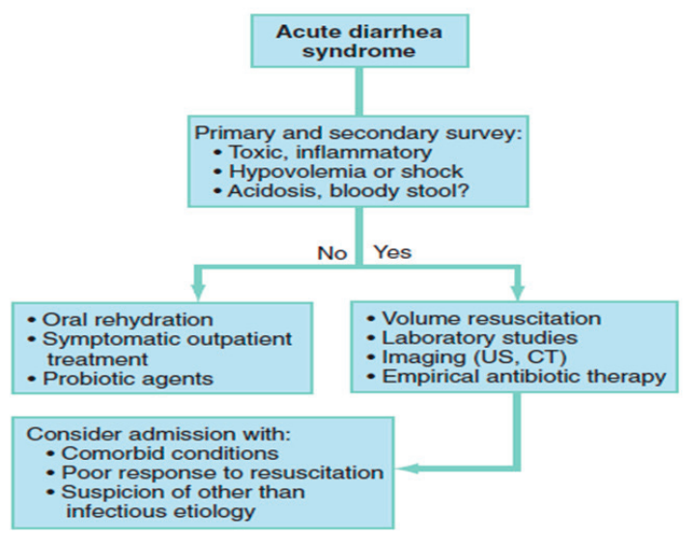
Figure 2.3. Algorithm for the approach and management of acute diarrhea syndrome

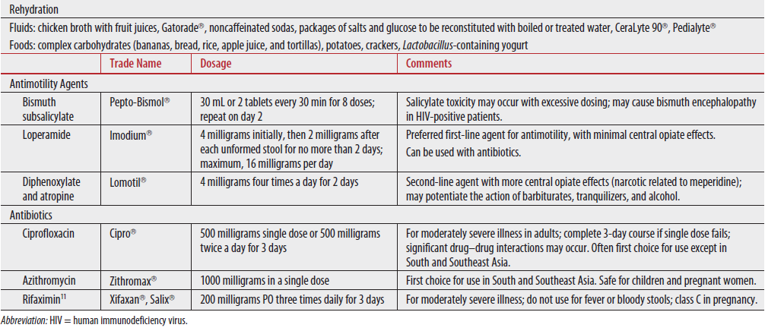
Table 2.22. Empiric treatment of traveler’s diarrhea in adults
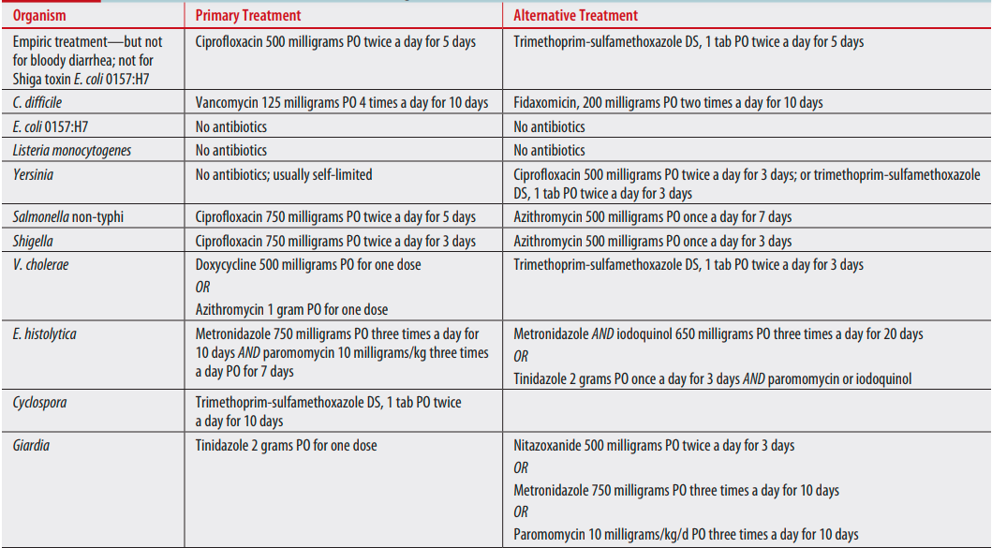
Table 2.23. Antimicrobial recommendations for infectious diarrheal pathogens in adults
Note: Length of treatment often varies with different sources

2.9.3. Vomiting
Introduction
Vomiting is the expulsion of gastric contents.
- The etiology of vomiting should be identified prior to treatment initiation.
- Symptoms may be the direct result of primary GI disorders or represent other pathologies like increased intracranial pressure, tumor, psychiatric conditions (bulimia nervosa, anxiety), endocrine or metabolic abnormalities (diabetic ketoacidosis, hyponatremia), or iatrogenic causes (medications, toxins).
- Might also occur as the result of severe pain, myocardial infarction, sepsis, or other systemic illnesses.
- A comprehensive history and physical examination, as well as the use of various diagnostic modalities, are needed to determine the cause and its complications.
- In young women, pregnancy is an important consideration.
Clinical features
History
- Identify the onset and duration of the symptoms.
- Chronic symptoms are defined as those symptoms present for >1 month.
- If the problem is chronic, asking the patient the results of tests that have already been performed will help narrow the diagnostic possibilities (if any).
- Frequency and interval between episodes, timing of the episodes, content of the vomitus, presence or absence of associated symptoms, and history of recent weight loss.
- Obtain a thorough past medical history and review the patient’s medication list.
Physical examination
- Should focus on determining whether a critical, life-threatening condition exists.
- Assess vital signs; observe skin turgor, mucous membrane hydration, and capillary refill.
- Abdominal examination is particularly important.
Diagnosis
- History and physical exam.
- Investigations:
- CBC, U/A, electrolytes, OFT, serum lipase, TFT, specific drug levels, ESR.
- Flat and upright abdominal films.
- CT with PO and IV contrast is superior to plain films to diagnose a mechanical obstruction.
- Abdominal ultrasound.
Management
- Stabilize the acutely ill, vomiting patient in a fashion similar to any patient with a potentially life-threatening illness.
- Attention should be paid to the ABCs: Intubate patients who are vomiting and unable to protect their airway.
- Dehydration:
- For mild to moderate dehydration: give ORS by mouth or NGT.
- If severe dehydration or shock, give a bolus of 20ml/kg NS with two more bolus based on response.
- Antiemetic (metoclopramide, prochlorperazine, promethazine, ondansetron).
- Once the patient has been stabilized, provide symptomatic relief.
- Definitive management will often require disease-specific treatment.
Monitoring
- Monitor vital signs, input-output, overall patient conditions, and response to therapy.
Disposition
- Admit the toxic patient and any patient who cannot comply with oral rehydration.
- Most patients with diarrhea can be discharged home, but be conservative in admitting those at extremes of age.

2.10. Ophthalmic Emergencies

2.10.1 Emergencies in Glaucoma
Acute angle closure glaucoma (AACG)
Acute angle closure glaucoma is a type of glaucoma that occurs when intraocular pressure (IOP) rises suddenly because of the blockage of the aqueous humor outflow. It is due to appositional attachment of the iris with the lens surface that, in turn causes peripheral appositional closure of the angel system. Risk factors include: age >40, females, eyes with shallow anterior chamber, and hyperopic eyes.
Symptoms:
- Sudden onset ocular pain
- Headache
- Blurred vision
- Rainbow-colored halos around lights
- Nausea and/or vomiting
- IOP is quite high, causing corneal edema and the other symptoms
Signs:
- Red eye
- Reduced visual acuity
- Corneal edema
- Mid-dilated and sluggish/ unreactive pupil
- Affected eyeball is hard or firm on digital palpation (through the eyelid) compared to the unaffected second eye
Examination:
- IOP measurement can be estimated by digital ballottement or using one of the tonometers, like Applanation, Tonopen, or Shiotz tonometer.
- The IOP is typically >30 mmHg (normal range: 10–20 mmHg).
- The eye can be grossly assessed using a handheld torch light and if available slit lump microscope for detailed examination of the eye.
Principles of treatment:
- Treatment focuses on lowering the IOP, breaking the obstruction, and controlling inflammation.
- Start with acetazolamide 500 mg PO stat then 250 mg PO TID or QID for 5 days unless contraindicated (e.g., sulphur allergy, renal pathology).
- Pilocarpine drops 1% or 2% to constrict the pupil. Administer 1 drop and repeat after 15 minutes. It is also advisable to give drop to the contralateral eye (for prophylaxis).
- Topical beta-blocker (e.g., Timolol 0.5%) eyedrop BID (caution with asthma or COPD patients).
- Steroid drops like Dexamethasone QID.
- The second eye is also at high risk of acute attack, if prophylactic peripheral iridotomy is not done.
- Refer urgently to a nearby eye center where there is an ophthalmologist(s).
Prognosis
- If AACG is not diagnosed as early as possible and not managed as an emergency, the affected eye could lose vision permanently.
- The untreated eye may further develop retinal vascular occlusion and neovascularization that will further complicate the eye to be not only blind, but also painful.
- Remember: Vision loss from glaucoma is not reversible.

Childhood glaucoma
Childhood glaucoma (CHG) refers to glaucoma that occurs during the first three years of life. It can be primary (the commonest type), developmental, or acquired. The primary CHG, often genetic in origin, is due to developmental abnormality of the anterior chamber angle, the site for the aqueous drainage system. Developmental glaucoma is associated with presence of other eye anomalies. Acquired or secondary childhood glaucoma is related to other causes like trauma, inflammation, tumor, or surgery.
Symptoms and signs:
- Tearing, blepharospasm (inability to open the eyelids) and photophobia are the three cardinal features of childhood glaucoma, big eyeball (buphthalmos), large and/or cloudy cornea.
- Elevated eye pressure, enlarged eyeball and cornea, corneal edema or opacification, and glaucomatous optic nerve head.
Principles of treatment:
- Because of its impact on visual development, all forms of congenital glaucoma need urgent intervention.
- The definitive treatment is surgery (trabeculotomy or goniotomy).
- Till the surgery, medical therapy is recommended (timolol 0.25% drops BID).
- CHG requires referral to a tertiary eye center as an emergency case.
Prognosis:
- CHG leads to lifelong blindness if not detected and managed early.
- The surgical management can be curative, if done successfully and in the first six months of age.
Phacomorphic glaucoma
Phacomorphic glaucoma is an acute form of secondary glaucoma resulting from blockage of the pupil by an anteriorly displaced swollen or intumescent cataracts lens. It occurs in eyes with mature or hyper mature cataract. Eyes with shallow anterior chamber are at more risk for the attack.

Clinical features:
Patients, who have had poor vision of the affected eye from cataract, present with pain, redness, and further reduction of vision.
Examination:
IOP, inflamed eye, edematous cornea, shallow anterior chamber, pupil blocked by cataractous lens, and either shallow or closed anterior chamber angle.
Principles of treatment:
- Reduction of IOP with medical treatment: Diamox 250–500 mg TID or QID; oral glycerol 1–2 g/kg; topical treatments include timolol, dorzolamide, or brimonidine.
- Control inflammation with topical steroid drops (dexamethasone or prednisolone drops) every 4 hours.
- Surgery: The definitive treatment is extraction of the cataract. If the angle is closed from delayed presentation, combined cataract extraction and glaucoma surgery is required.
- Start treatment with the aforementioned drugs and refer the patient to eye center as an emergency case for the surgical management.
Prognosis:
- Early presentation, diagnosis, and management can reverse and cure the condition.
- Delayed presentation, misdiagnosis and mismanagement lead to permanent vision loss.

2.10.2 The Acute Red Eye
Ophthalmia neonatorum
- Neonatal conjunctivitis (Ophthalmia neonatorum) is defined as conjunctival inflammation developing within the first month of life. It is the most common infection of any kind in neonates, occurring in up to 10%.
- Because of its association with serious local and systemic complications, it remains a significant cause of ocular morbidity, blindness, and even death in medically underserved areas around the world.
- Gonococcal conjunctivitis (caused by Neisseria gonorrhoeae) is by far the most common cause, and it is often the result of infection transmitted from mother to infant during delivery.
- Other causes include: herpes simplex infection, chlamydial infection, and chemical irritation.
Clinical features:
- Gonococcal and chlamydial neonatal conjunctivitis are characterized by mucopurulent/purulent discharge from one or both eyes with diffuse conjunctival injection.
- There may be associated eyelid swelling.
- The child may also have associated systemic features, like pneumonitis.
Treatment of gonococcal conjunctivitis:
- Copious saline irrigation of the conjunctival discharge.
- Give a stat dose of ceftriaxone 25–50 mg/kg IV/IM and refer to ophthalmic center.
Prognosis
- Early and appropriate treatment leads to excellent prognosis.
- Delay in treatment of bacterial conjunctivitis in neonates can lead to corneal involvement (with subsequent ulceration and endophthalmitis) and systemic spread.
Endophthalmitis
- Endophthalmitis is an infection of the contents of the eye.
- It is typically seen 2–5 days after an intraocular surgery (cataract, retinal detachment repair, etc.) or an intraocular injection.
- It also follows ocular trauma.
- It is usually painful and associated with a red eye and reduced vision.
- The inﬂammation is typically so severe that white cells precipitate in the lower portion of the anterior chamber giving rise to a hypopyon (pus in the anterior chamber). This is a very signiﬁcant sign.
- Endophthalmitis is the most feared complication of intraocular procedures and is potentially devastating (the eye can be lost). These cases need urgent referral.
- In cases where there is no history of recent surgery, or trauma, a hypopyon may be the result of severe uveitis (often HLA-B27-associated anterior uveitis). These cases should be referred on a routine basis to an ophthalmologist.
Uveitis
- Uveitis is inflammation primarily of the uveal tissue of the eye and may involve the anterior segment, posterior segment, or both.
- Patients may have history of prior episodes, with history of use of eye drops/ injections.
- On examination, patients typically have ciliary injection (redness around the limbus), photophobia, mildly reduced acuity, and an aching discomfort in and around the eye.
- These patients should be referred to an ophthalmologist as routine practice.
Subconjunctival hemorrhage
- It is conﬂuent bleed that obscures the conjunctival blood vessels.
- It will be patchy and less dense at its edges.
- Seen with trauma but may also occur with Valsalva maneuver, vomiting, and coughing.
- No treatment is needed unless the conjunctiva is bulging or prolapsing between the closed lids.
- If this is the case, then an eye ointment will prevent desiccation/ulceration (e.g., tetracycline QID).
- No referral needed if spontaneous.
Bacterial keratitis
- This condition presents as a painful red eye (usually with a foreign body sensation).
- Predisposing factors: Trauma associated with agricultural activity is by far most common risk factor in the developing world.
- Other predisposing factors include ocular surface diseases, like dry eye syndrome, trichiasis, blepharitis, etc.
- Local and systemic immune suppression and contact lens wear are other risk factors for bacterial keratitis.

Clinical features
- Patients present with pain, photophobia, red eye, and decreased vision.
- The characteristic ﬁnding is a small creamy-white spot on the surface of the cornea, usually only a millimeter or so in diameter. This “inﬁltrate” is a solitary colony of bacteria (like what we see on an agar plate). If patients present late, there may be a wider area of whitish cornea (ulceration or abscess formation).
Principles of treatment
- Start on topical antibiotic eye drops (e.g., 3% ciprofloxacin) using one drop every 15 minutes for the ﬁrst 2 hours then hourly until advised otherwise.
- Never give topical anesthetics or steroid eye drops to patients for use at home! Patients need immediate referral to ophthalmologist.
- Prognosis: Unless managed properly, bacterial keratitis can end up with corneal perforation or scarring.
Herpes simplex keratitis
- Is a recurrent condition that has a very characteristic appearance with ﬂuorescein staining.
- The eye will have sharp pain, often appear mildly injected, and visual acuity may be normal or slightly reduced.
- Corneal sensation will be reduced when compared to the fellow eye.
- The hallmark of this condition is a “dendritic ulcer:”
- A thin, linear, branching epithelial ulceration with club-shaped terminal bulbs at the end of each branch.
- Best appreciated using blue light after fluorescein stain.
Do not treat this with steroids as this will provoke rapid progression and a corneal melt! Never give topical anesthetic eye drops to patients for use at home!
Principles of treatment:
- Treat with 3% acyclovir ointment 5 times day or oral antiviral agents. Patients need routine referral.
Herpes zoster ophthalmicus (shingles):
- Dermatomal vesicular rash is characteristic.
- Start a suitable oral antiviral straight away.
- If the disease is bilateral or if a patient under 40 years is affected, then it may represent the ﬁrst manifestation of HIV.
- Patients need routine referral to check for signs of ocular involvement.
Scleritis
- Scleritis is an intensely painful inﬂammation of the sclera.
- The affected area is usually a brawny red and acutely tender to any pressure.
- Vision is usually impaired. Unlike episcleritis (which is not usually painful), there will be no blanching of the blood vessels in the affected area after topical phenylephrine 2.5%.
- 50% of patients have systemic disease (often a connective tissue disease).
- These patients need routine referral if needed.

2.10.3. Chemical Injuries
Introduction
Chemical injuries range in severity from superficial punctuates keratitis to corneal opacification with limbal ischemia. Acids and irritants can damage the cornea and conjunctiva. The most feared chemical insult to the cornea is an alkali burn, and these injuries should be managed with particular care.
Principles of treatment
A chemical burn is the only eye injury that requires emergency treatment without formal clinical assessment. Immediate treatment is as follows:
- Copious irrigation: minimize duration of contact with the chemical and normalize the pH in the conjunctival sac as soon as possible.
- The speed and efficacy of irrigation is the most important prognostic factor following chemical injury.
- Topical anesthetic should be instilled prior to irrigation, as this dramatically improves comfort and facilitates cooperation.
- Irrigate the eye for 15–30 minutes or until the measured pH is neutral.
- Double eversion of the upper eyelid should be performed so that any retained particulate matter trapped in the fornices is identified and removed.
- Debridement of necrotic areas of corneal epithelium should be performed at the slit lamp to promote re-epithelialization and remove associated chemical residue.
- Further management: Depending on the degree of the ocular injury, patients may need hospitalization and further medical management in ophthalmic center.

2.10.4. Orbital and Peri-Orbital Swelling
Introduction
The most common cause of orbital and peri-orbital swelling is cellulitis. An important distinction exists between infections arising in the orbit and infections that arise in the skin.
- Orbital cellulitis is more serious as it poses a risk of vision loss (through increased intra-orbital pressure) and of posterior spread (which can lead to meningitis and brain abscess formation). Orbital cellulitis usually occurs secondary to sinusitis with direct spread of infection to the orbit.
- Despite the differing severity, the two conditions can be very hard to discern clinically as conditions present with marked lid swelling (often unable to open the eye), redness, warmth of the affected tissues, and tenderness.
The key to differentiating the two is to look for signs of orbital disease:
- Reduced visual acuity
- Limited eye movements, which may give rise to binocular diplopia
- Proptosis
- A relative afferent pupillary defect
- Red desaturation (a red target appears darker or less saturated with the affected eye)
Principles of management
- CBC and culture prior to the administration of any antibiotics.
- CT scan of the orbits can detect the presence of sinus disease and identify whether or not an intra-orbital abscess is present.
Treatment
- IV antibiotics should be administered after sending blood samples for cultures.
- Ceftriaxone is a reasonable empiric choice based on the likely sinus pathogens.
- Patients need to be referred for further management and follow-up.

2.10.5. Eye Injuries
Eyelid trauma
- In all eye traumas, always consider the need for tetanus immunization if there is an open wound. Any sharp injury near the eye may also have involved the globe or even the brain.
- Indications for referral of patients with lid laceration include:
- Involvement of the lid margin.
- Extensive lid lacerations associated with tissue loss.
- Lacerations associated with orbital fat prolapse.
- Lacerations involving the punctum or canaliculi.
- Suspicion of associated globe/brain injury.
Ocular foreign bodies
Superﬁcial foreign body
- The history is usually diagnostic.
- Principles of treatment:
- Foreign bodies on the conjunctiva or in the fornix can usually be wiped away with a cotton-tipped applicator.
- A foreign body on the cornea is usually more adherent and usually requires removal under slit lamp using a 27G needle.
- Always ensure that there is not another foreign body in the other eye or hidden under an eyelid.
- In cases where the injury occurred when “metal hit metal” (e.g., hammer on chisel), must have plain x-rays of the orbits to look for an intraocular/intra-orbital foreign body.
- No referral if a superﬁcial foreign body is successfully removed.
- Prescribe an antibiotic eye ointment QID for 5 days.
Never give topical anesthetic eye drops to patients for use at home!
Subtarsal foreign bodies
- Foreign bodies that do not embed into the eye will usually end up beneath the upper eyelid.
- Causes pain on blinking and gives rise to a very characteristic pattern of ﬂuorescein staining.
Principles of treatment:
- Evert the upper lid.
- The foreign body will most likely be close to the margin of the eyelid (near the base of the lashes) and can usually be wiped away with a cotton-tipped applicator.
- Give an antibiotic ointment QID for 5 days.
Never give topical anesthetic eye drops to patients for use at home.
Suspected intraocular foreign body
You must do plain X-rays of the orbits to investigate the possibility.
Principles of treatment:
- Plain ﬁlms should include a PA and 2 laterals.
- The laterals should be taken in up and down gaze to look for signs of a foreign body inside the eye (an IOFB will move in the 2 lateral views whereas intra-orbital foreign bodies will stay still).
- CT of the orbits if the X-ray is suspicious.
- IOFBs warrant an emergent referral.
- Do not administer any topical medication; the patient must have an eye shield over the eye (to ensure that there is no pressure on the globe).
NB. If there is evidence of an open globe or there is suspicion that there may be an open globe, then do not apply any eye drops or ointment and cover the eye with a shield. This shield should ensure that nothing can place any pressure on the globe.
Ruptured globe
Clinical presentation:
- Decreased vision
- Sub-conjunctival hemorrhage
- Hyphemia
- Irregular shaped pupil
- A traumatic cataract and full-thickness scleral or corneal lesion may also be present
- The lens may become subdued and vitreous hemorrhage may also be present
Principles of management:
- TAT injection
- Protect the eye with eye shield.
- Start systemic antibiotics, analgesics.
- Avoid topical medications!
- If the patient has nausea, give antiemetics to prevent expulsive hemorrhage.
- Immediate referral to ophthalmologist if needed.
Orbital blow-out fracture
Traumatic blow-out fractures usually follow a direct trauma by a fist or by a material with a diameter larger than the orbital diameter.
Clinical presentation:
- Patients usually present with pain that increases upon vertical eye movement
- Binocular diplopia
- Crepitus after nose blowing
- Epistaxis
- Ecchymosis
- Enophthalmos may develop after the edema has resolved
Principles of treatment
- Nasal decongestant sprays
- Broad-spectrum oral antibiotics
- Ice packs
- Surgical repair is emergent within 24 hours if CT shows entrapped muscle or tissue with signs of diplopia and gastrointestinal symptoms (nausea/vomiting) or cardiovascular symptoms (heart block, bradycardia, or syncope), or if the patient is a child.
- All patients with suspected blow-out fractures should be immediately referred to ophthalmologist if needed.
Retrobulbar hemorrhage
- Bleeding in the orbit behind the globe (intraconal space).
- It is a sight–threatening condition unless managed immediately.
- Common following fall accidents, trauma to the head, or periocular region or it could occur as iatrogenic orbital pain.
- Tight eyelids (especially lower eyelid with subconjunctival hemorrhage and proptosis), resisting retropulsion following trauma are the hallmarks.
- Decreased vision, eyelid ecchymosis, limited extraocular motility, and increased IOP may also be present.
Principles of treatment
- Intervention comes before further investigations.
- If vision is threatened, do canthotomy.
- 5mm long lateral incision of the lateral canthus deep to the orbital rim.
- Cantholysis (Cutting the lateral attachment of the lower lid)
- Success is achieved when the lower eyelid is relaxed and moving freely.
Do not repair the wound after problem is relieved. Refer patient to ophthalmologist for further investigation and management if needed.

2.10.6. Pediatric considerations
In addition to the ocular disorders mentioned above, children with the following conditions warrant urgent referral for ophthalmologist evaluation and management.
Lecocoria
- A condition in which there is a whitish reflex through the pupil of the eye.
- More noticeable at night—could be a sign of a grave condition like a retinoblastoma congenital cataract.
- Retinoblastoma can be treated if the condition is detected early enough, but it can quickly spread to brain and other organs if there is any delay in treatment.
Parents should be counseled for urgent treatment!
Squint
- Squinting eyes could be a sign of a serious ocular problem or neurologic disorder.
- These eyes are also at risk of developing amblyopia.
They should urgently be referred, if needed.

2.11. Dermatological Emergencies

2.11.1. Stevens-Johnson Syndrome/Toxic Epidermal Necrolysis
Introduction
Stevens-Johnson syndrome (SJS)/toxic epidermal necrolysis (TEN) are life-threatening severe mucocutaneous hypersensitivity reactions, usually caused by a drug.
- If BSA (Body Surface Area) <10%: Stevens-Johnson Syndrome,
- If BSA = 10–30%: Stevens-Johnsons Syndrome/Toxic epidermal necrosis overlap syndrome
- If BSA > 30%: Toxic epidermal necrosis.
Recommended management
- Supportive care
- Wound care
- Fluid and electrolyte management
- Nutritional support
- Temperature management
- Ocular care
- Pain control
- Pulmonary toilet
- Monitoring and treatment of super-infections
Therapies
- No established therapies
- IVIg
- Systemic corticosteroids

2.11.2. Staphylococcal Scalded Skin Syndrome
Introduction
Staphylococcal scalded skin syndrome (SSSS), also called Ritter’s disease, is a superficial skin blistering disorder caused by toxin mediated exfoliative disease, occurring commonly in neonates and young children.
- Adults are less commonly affected and tend to have significant comorbidities such as renal failure, immunosuppression, alcoholism, malignancy, or HIV infection.
Recommended management
- Intravenous (IV) fluids
- Should be administered in those with signs of dehydration or and/or sepsis.
- Emollients and non-adherent dressings
- Should be applied to the skin and denuded areas to promote healing and reduce heat loss.
Antibiotics covering staphylococcus
- Should be administered early and include cefazolin, nafcillin or oxacillin for methicillin-sensitive Staphylococcus aureus (MSSA).
- Vancomycin should be administered if MRSA is suspected.

2.11.3. Necrotizing Fasciitis
Introduction
Necrotizing fasciitis is a severe, insidiously advancing soft-tissue infection characterized by wide spread fascial necrosis. The three most important causes are as follows:
- Type I: Polymicrobial
- Type II: Group A streptococcal
- Type III: Gas gangrene or clostridial myonecrosis
Recommended management
- Early diagnosis, aggressive resuscitation, surgical debridement, antibiotic therapy, and supportive intensive care
- Goal-directed therapy targets for hemodynamic resuscitation in patients with sepsis
- Serial debridement to remove the source of infection, toxins, and infarcted tissue
- A broad-spectrum agent Tazocin (piperacillin and tazobactam) or a carbapenem (such as meropenem), combined with clindamycin
Monitoring
- Monitor vital sign, ABG
- Follow septic patient according to sepsis management protocol
Disposition
- Dispose unstable patient/patient in shock to ICU
- Keep patient in isolation room and provide critical care if possible

2.12. Psychiatric Emergencies in Emergency Settings

2.12.1. Overview
Introduction
Any psychiatric condition can result in emergency presentation. The common ones are mania, acute psychotic state, suicide, catatonia, panic attacks, delirium, and delirium tremens. It is very important to rule out non-psychiatric medical conditions as they can present in a similar condition. The emergency health care provider must have a high index of suspicion for organic etiology in cases of:
- Very acute onset of symptoms
- Fluctuating levels of consciousness
- Disorientation to time and place, short-term memory difficulties
- Concurrent medical illness with physical findings
- History free of previous psychiatric episodes
Clinical presentation
Different behavioral and psychic conditions lead to emergency presentation. The following are a few examples:
- Aggression and violence
- Suicidal behavior
- Restlessness, hyperactivity
- Mute, not eating and drinking
- Sever anxiety like panic attack
- Confusion state
- Intoxication or withdrawal and others
Principles of management in emergency setting
- Safety issues to patient, staff, and other people
- Talking down the patient
- Restraint mainly through chemical restraint; physical restraint as a last resort
- Consider and R/o underlining emergency medical conditions, diagnostic investigation
- Admission decision, mostly involuntary. Based on psychiatric assessment, decision is made as to whether to admit or discharge patient:
DISCHARGE: Patient is deemed both medically and psychiatrically safe to be discharged to home setting. Follow-up with outpatient psychiatry appointment.
ADMIT: Patient is deemed unsafe or too impaired by current mental health condition to cope in home setting. The following decisions need to be made with regards to admission:
- Does the patient need stabilization in ER?
- What ward will the patient be eventually admitted to?
- Will the patient be a voluntary or involuntary admission?
Mechanical Restraints: Avoid the use of mechanical restraints whenever possible. If restraints are used, least-restraint policy should be initiated. The least amount and duration of restraints should be utilized. If physically restrained, the patient needs to be assessed by attending physician within 30 minutes and frequently assessed for removal of restraints.

2.12.2. Aggressive and Violent Behavior
Many different factors result in aggressive and violent behavior. The most common implicated disorders are:
- Mental health and behavioral disorders such as:
- Schizophrenia
- Post-convulsion confusion in epilepsy
- Manic states when frustrated
- Catatonic excitement
- Acute organic syndrome, especially:
- Alcohol intoxication
- Drug intoxication
- Delirium
- Drug withdrawal
- Substance abuse, drug side effects
- Worsening of underlying medical conditions
Recommended treatment
- Never take patients by surprise; explain all the procedures you are going to do.
- Quickly organize intervention to avoid injury to self and others.
- Put the patient in a quiet room and remove potentially dangerous objects.
- Understand why a patient is aggressive before resorting to restraining methods.
- Use minimum restraint when necessary and discontinue when it is no longer necessary.
- Never approach an aggressive mental patient alone.
Status | Treatment
Young and healthy | Antipsychotic treatments:  - Haloperidol 2–5 mg PO/IM every hour as needed up to a max of 15mg/24h  - Risperidone 1–2 mg PO every hour as needed up to a max of 6–8 mg/24h  - Olanzapine 10 mg PO every hour as needed up to a max of 20mg/24h  Benzodiazepine treatment:  - Diazepam 5–10 mg every 1–2 hours as needed up to a max 40mg/24h  - Extrapyramidal side-effect treatment:  - Trihexiphenidyl (artane/benzhexol) 2–5mg PO 2–4 times daily up to a maximum of 20 mg/24h
Elderly, frail, or neuroleptic naive | Antipsychotic treatments:  - Haloperidol 0.5–2mg PO/IM/IV every hour as needed up to a max of 5mg/24h  - Risperidone 0.25–0.5mg PO every hour as needed up to a max of 2mg/24h  - Olanzapine 2.5–5mg PO every hour as needed up to a max of 20mg/24h  Benzodiazepine treatment:  - Diazepam 5–10 mg every 1–2 hours as needed up to a max 20mg/24h  Extrapyramidal side-effect treatment:  - Trihexyphenidyl (Artane/benzhexol) 2–5mg PO 2–4 times daily up to a maximum of 10 mg/24h
Table 2.24. Pharmacological treatment of psychiatric emergencies
- In case of organic brain syndrome, identify the physical cause and manage it accordingly.
Pharmacological Treatment: Standing medications should be initiated based on medication reconciliation. Use oral agents when possible. Typical as needed (PRN) medication for agitation, aggression, and violence are listed in the table below.
N.B. Evaluate heart-rate corrected QT (QTc) interval before administration of antipsychotic agents to avoid the development of arrhythmia.

2.12.3. Suicide
Introduction
Suicide is an intentional self-inflicted death. It is a way out of a crisis that causes intense suffering (psychological pain, financial loss, illness, etc.). It is associated with unfulfilled needs, feelings of hopelessness and helplessness, ambivalent conflicts between survival and unbearable stress, a narrowing of perceived options, and a need for escape.
Diagnosis
History of current or past psychiatric disorder can be a very important risk factor.
The SAD PERSON acronym is of a fairly good suicide risk assessment tool:
- Sex (male sex)
- Age (the very young and old)
- Depression or any psychiatric diagnosis
- Previous suicidal attempt
- Ethanol abuse
- Loss of rational thought
- Lack of social supports
- Organized plan (Having a clear plan or means for suicide increases risk)
- No spouse
- Sickness
Other factors that also increase suicide risk are:
- Available means/weapons
- Recent life-altering events
- Acute psychosocial stressor (e.g., public humiliation, command hallucinations, religious preoccupation, and persistent hostile environment)
The following are factors identified to deter suicidal behaviors:
- Children in the home
- Sense of responsibility to family
- Pregnancy
- Religiosity
- Life satisfaction
- Reality testing ability
- Positive coping skills
- Positive problem-solving skills
- Positive social support
- Positive therapeutic relationship
Asking about suicide: Has there been a period where you:
- Have had trouble sleeping?
- Have felt depressed, sad, or lost interest in things?
- Have felt worthless, simple or guilty?
- Have had any thought of death, wish to go to sleep and never to wake up?
- Sometimes people think of committing suicide, did it ever cross your mind?
- Any plan or preparation? Access to the means?
When the person presents after a suicidal attempt:
- ABC of life
- Patient may be defensive, feel shame or anger (there may also a negative reaction by medical personnel and the public toward the act)
- Start by asking physical symptoms
- Then ask “What and how did it happen?” and “Why”
- Intent, lethality and patient’s understanding of lethality
- Reaction to being rescued and any future plan
Documentation: the screening and any other conversation about suicide with a patient should be clearly documented.
Recommended treatment
- Avoid thinking of the behavior in a derogatory way (e.g., that the patient is being “manipulative” or has made a “suicidal gesture”).
- Inpatient vs. outpatient: for any moderate-to-severe suicidal risk, inpatient management should be seriously considered.
- Before sending the person home, imagine the place and situation that the individual will be returning to after the evaluation—availability and adequacy of social support? Impulsive behavior? Suicidal plans?
- Remove or treat risk factors:
- Underlying medical and psychiatric problems
- Physical (in unpredictable and impulsive patients) and/or chemical restraint (anxiolytics, antidepressants, neuroleptics)
- Psychotherapy (supportive, family therapies)
- Electroconvulsive therapy (ECT)
- REFER the patient where he/she can be best helped for follow-up

2.12.4. Delirium
Introduction
Delirium is a syndrome characterized by a disturbance of consciousness and a change in cognition that develops over a short time. It is almost always caused by one or more systemic or cerebral derangements that affect brain function.
Clinical features:
- Disorganization of thought processes
- Perceptual disturbances
- Psychomotor hyperactivity and hypo activity
- Disruption of the sleep-wake cycle
- Mood alteration
- Altered neurological function

Risk Factors:
- Advanced age (major risk factor)
- Preexisting brain damage
- History of delirium
- Alcohol dependence
- Medical conditions like diabetes and cancer
- Sensory impairment and malnutrition
Recommended treatment
Management focuses on ensuring safety from behavioral disturbances while simultaneously assessing for a probable etiology and definitive treatment. Primary goal in treatment of delirium is to treat the underlying cause. Safety can best be addressed by combining environmental, behavioral, and pharmacologic means:
- Environmental support: Patients with delirium should be neither sensory deprived nor overly stimulated by the environment. They are usually helped by having a friend or relative in the room or by the presence of a regular sitter. Regular orientations to person, place, and time help make patients with delirium comfortable.
- Pharmacotherapy: The two major symptoms of delirium that may require pharmacological treatment are psychosis and insomnia.
- A well-studied and commonly used drug for psychosis is haloperidol (Haldol). Depending on a patient’s age, weight, and physical condition, the initial dose may range from 2–6 mg intramuscularly, repeated in an hour if the patient remains agitated.
- As soon as the patient is calm, oral medication should begin. Two daily oral doses should suffice, with two-thirds of the dose being given at bedtime.
- Phenothiazines (e.g., chlorpromazine): should be avoided in delirious patients because these drugs are associated with significant anticholinergic activity.
- Second-generation antipsychotics like risperidone (Risperdal), clozapine, olanzapine (Zyprexa): have limited data supporting it.
- Benzodiazepines: Except for particular indications (e.g., alcohol withdrawal delirium, delirium related to seizures) continues to be a recommendation

2.13. Obstetric and Gynecologic Emergencies

2.13.1 Hypertensive Disorder During Pregnancy
Introduction
Hypertension (HTN): Systolic blood pressure (SBP) ≥140 mmHg and/or diastolic blood pressure (DBP) ≥90 mmHg on two occasions at least 4 hours apart and within one week; Or a single record of BP >160/110 mmHg.
Proteinuria: Two urine dipstick measurements of at least 1+ (30 mg per dL) taken 6 hours apart or single dipstick ≥++; at least 300 mg of protein in a 24-hour urine sample; or a urinary protein/creatinine ratio ≥ 0.3.
Classification
- Gestational hypertension: Hypertension without proteinuria (or other signs of
pre-eclampsia) developing after 20 weeks of gestation in a previously normotensive woman
- Can be classified as mild and severe (BP ≥160/110 mmHg—managed as pre-eclampsia with severity feature)
Pre-eclampsia/eclampsia syndrome:
Pre-eclampsia
New onset of hypertension and proteinuria after 20 weeks of gestation in a previously normotensive woman
Classified into two types:
- Pre-eclamsia without severity feature
- Pre-eclamsia with severity feature
- Headache, blurred vision, oliguria (<400 ml/24 hours), epigastric pain or pain in right upper quadrant, difficulty breathing (pulmonary edema)
- Low platelet count (<100,000/µl)
- Elevated liver enzymes more than twice the upper limit of normal
- Serum creatinine >1.1mg/dl
Eclampsia
- Grandmal seizure or coma in a woman with pre-eclampsia
- Important causes of convulsion or coma, like cerebral malaria, meningitis, hypoglycemia, previous seizure disorder, head injury or intracranial space occupying lesions have to be ruled out
- Eclampsia may present with normal blood pressure
Chronic hypertension: Hypertension that antedates pregnancy; is present before 20 weeks of gestation; or persists after 12 weeks postpartum
Superimposed pre-eclampsia: When a chronic hypertensive woman develops one of the following:
- New-onset/worsening proteinuria
- Severe exacerbation in hypertension
- Development of symptoms of pre-eclampsia with severity or organ function derangement
As a group, they are one member of the deadly triad—along with hemorrhage and infection.
Management principles
- Anticonvulsant
- Blood pressure control
- Delivery
- Managing complications (AKI, pulmonary edema, DIC, etc.)
Recommended management
Gestational hypertension:
- Close outpatient follow-up for development of pre-eclampsia with severity feature
- If BP remains <160/110 mmHg and no other complication, delivery is at term
- No need for anticonvulsant
Pre-eclampsia without severity feature:
- Link her to obstetric side for close outpatient follow-up for development of pre-eclampsia with severity feature
- Delivery is at term
- Give anticonvulsant intrapartum

Chronic hypertension:
- Link her to obstetric side for close outpatient follow-up for development of superimposed pre-eclampsia
- If the patient was on antihypertensive, continue same medication (if the drug is contraindicated during pregnancy, change to safe drugs)
- Start antihypertensive if BP ≥140/90 mmHg in the initial contact
- Delivery at term (some cases can be pushed to full term)
- No need of anticonvulsant unless severe hypertension
Pre-eclampsia with severity feature and superimposed pre-eclampsia:
- General measures of management (see below)
- Prevent convulsion
- Control hypertension
- Delivery/expectant management in selected cases
General measures:
- Admit the patient urgently, preferably to the labor ward
- Manage in left lateral position
- Setup IV line and infuse maintenance fluids (if there is loss)
- Monitor urine output and maintain urine output at >30 ml/hr
- Maintain a strict fluid balance chart
- Prepare equipment for convulsion management at bed side (airway, suction equipment, mask and bag, oxygen)
- Never leave the patient alone
- Monitor vital signs, FHB, and reflexes
- Auscultate the lung bases for fine crepitation; if they occur, withhold fluids and administer a diuretic (furosemide 40 mg IV stat)
Anticonvulsant therapy (seizure prophylaxis):
Give magnesium sulfate as shown in Box 2.1 below.
In all severe preeclamptic/superimposed pre-eclampsia mothers during admission and continued during period of evaluation and observation for 24 hours.
Diazepam: may be used as alternative, if MgSO4 is not available (as shown in Box 2.2 below).
Control hypertension:
- Antihypertensive should be started if the systolic BP is 160 mmHg or higher and/or diastolic BP is 110 mmHg or higher.
- Hydralazine or labetalol is the drug of choice for acute control.
NOTE: Goal of therapy is to reduce blood pressures to a level that provides a margin of maternal safety (i.e., 140–150 mmHg systolic and 90–100 mmHg diastolic) without compromising adequate uterine perfusion.
Hydralazine:
- Give 5 mg IV slowly every 20 minutes until BP is lowered (to DBP <110 mmHg). The maximum dose is 25 mg per 24 hours.
Labetalol:
- Oral treatment: Administer 200 mg; repeat dose after one hour until the treatment goal is achieved. The maximum dose is 1200 mg in 24 hours.
- Intravenous treatment: Administer 10 mg IV. If response is inadequate after 10 minutes, administer 20 mg IV. The dose can be doubled to 40 mg and then 80 mg with 10-minute intervals until blood pressure is lowered below threshold. The maximum total dose is 300 mg; then switch to oral treatment.
Nifedipine:
- As alternative for acute therapy, administer 10 mg orally. Repeat dose after 30 minutes if response is inadequate until optimal blood pressure is reached.
- The maximum total dose is 30 mg in the acute treatment setting. For maintenance therapy10–20 mg PO bid is given.
Alpha methyldopa:
- Administer 250–1000 mg every 6–8 hours. The maximum dose is 3000 mg per 24 hours.
Planning Delivery:
Gestational age <28 weeks: Termination of pregnancy (expectant management is not recommended).
Gestational age ≥28 weeks and <34 weeks: Expectant management is recommended, provided that there is no indication for delivery. For expectant management:
- Transfer to maternity ward
- Follow vital signs every 4 hours
- CBC every other day
- Liver enzymes and creatinine twice weekly
- Fetal kick count daily
- Fetal surveillance twice weekly
- Administer dexamethasone 6 mg IM every 12 hours for 2 days or betamethasone 12 mg daily for 2 days
Indications for delivery are:
- Failure to control hypertension with two antihypertensive drugs with a maximum dose in 48 hours
- Persistent maternal severity symptoms (severe headache, visual changes and abdominal and/or epigastric pain with elevated liver enzymes) despite treatment
- HEELP Syndrome
- Eclampsia
- Pulmonary edema or left ventricular failure
- Placental abruption
- IUFD
- DIC
Gestation 34–37 weeks: In women with superimposed pre-eclampsia/pre-eclampsia with severity feature and a viable fetus that is between 34–37 weeks of gestation, expectant management may be recommended, provided that:
- Maternal hypertension is controlled
- Symptoms improved with magnesium sulfate, analgesics, and antacid
- Fetal condition is reassuring
- Laboratories are normal
Gestation after 37 completed weeks: For women with pre-eclampsia at term (≥37 weeks), regardless of severity features, delivery is recommended.
Mode of Delivery: Mode of delivery depends on gestational age, fetal condition, presentation, cervical condition, and maternal condition.
Eclampsia
- Treatment of eclampsia consists of: (see also Figure 2.4 below)
- General measures
- Control of convulsions (to stop ongoing convulsion and prevent subsequent convulsion)
- Blood pressure control, stabilization of the condition of the mother and fetus
- Fluid balance
- Delivery and intrapartum/postpartum care
General measures:
- Set up IV line and maintain intravascular volume and replace ongoing losses; avoid
overload (if not done already)
- Position the patient on her side (left lateral) position to reduce risk of aspiration of secretions, vomitus or blood
- Aspirate (suction) the mouth and throat as necessary and ensure open airway
- Give oxygen by mask as necessary
- Place an indwelling catheter to monitor urine output
- Observe vital signs, FHB, and reflexes frequently, and auscultate the lung bases hourly for crepitation indicating pulmonary edema; if pulmonary edema occurs, withhold fluids and administer a diuretic (e.g., furosemide 40 mg IV stat)
- Keep the patient in a quiet room, with an attendant must always present beside her
- Administration of broad-spectrum IV antibiotics is recommended
Anticonvulsant therapy:
- Administer anticonvulsant drugs to stop the ongoing convulsion and prevent subsequent attacks.
- Magnesium sulfate:
- MgSO4 is the drug of choice (see box below for dosing).
- Monitor and withhold or delay drug if respiratory rate falls below 12 per minute, patellar reflexes are absent or UOP falls <30 mL per hour or <100 ml over preceding 4 hours.
- Keep antidote ready in case of respiratory arrest.
- If respiratory arrest occurs, assist ventilation (mask and bag, anesthesia apparatus,
intubation) and administer calcium gluconate 1g (10 mL of 10% solution) IV slowly.
Box 2.1. Magnesium sulfate administration protocol for pre-eclampsia with severity, superimposed pre-eclampsia, and eclampsia
Loading dose:
• Magnesium sulfate 20% solution, 4g IV over 5 minutes.
• Follow promptly with 10 gm of 50% magnesium sulfate solution, 5 gm in each buttock as deep IM injection with 1mL of 2% lidocaine in the same syringe. Ensure that aseptic technique is practiced when giving magnesium sulfate deep IM injection. Warn the woman that a feeling of warmth will be felt when magnesium sulfate is given.
• If convulsion recurs after 15 minutes, give 2 gm magnesium sulfate (20% solution) IV over 5 minutes.
Maintenance dose:
• 5 gm magnesium sulfate (50% solution) + 1 mL lidocaine 2% IM every 4 hours into
alternate buttocks.
• Continue treatment with magnesium sulfate for 24 hours after delivery or the last
convulsion, whichever occurs last.

Diazepam: Diazepam is an alternative, but increases the risk of respiratory depression and newborn apnea, in babies who may already be suffering from the effects of utero placental ischemia and preterm birth. The effect may last several days. (See box below for dosing).
Box 2.2. Diazepam administration protocol for pre-eclampsia with severity, superimposed pre-eclampsia and eclampsia
Loading dose:
- 10 mg IV slowly over 2 minutes.
- If convulsion reoccurs, repeat same dose.
Maintenance dose:
- 40 mg in 500 ml IV fluid (N/S or RL) number of drops titrated to keep the woman sedated but arousable

Fluid balance:
- Keeping strict input and output records is essential and determines serum electrolytes.
- For unconscious patient, 5% DW and Ringer’s lactate solution are infused for maintenance of nutrition and fluid balance during 24 hrs.
- Replace extra fluid loss through vomiting, diarrhea, sweating, or blood loss.
- Nothing by mouth is allowed (if unconscious); when the patient becomes conscious and can drink, oral feeding of fluid is started.
Delivery:
- Delivery should take place within 12 hours of the onset of convulsions.
- Delivery should take place as soon as the woman’s condition has stabilized (ABC of life, administration of seizure prophylaxis, controlled BP, necessary investigations), regardless of gestational age.
Algorithm for management of pregnant woman presenting with convulsion







SHOUT for HELP

Check airway:
- Clear air way, Check breathing Rapidly evaluate Vital signs
- Insert airway, or
- Intubate as required

Not breathing Breathing

Assist ventilation Give O₂6L per Open IV line
using bag and face min by Mask or and run IV fluid
mask Nasal catheter at 80 ml/hr

Manage as Eclampsia and investigate for other cause

If eclampsia is diagnosed or if the cause of convulsion is not Treat other causes according determined to the diagnosis
Give antihypertensive if DBP≥110mmHg or SBP ≥160 mmHg  - Hydralazine 5mg IV slowly every 20 min maximum 20mg/24 hrs.  OR  - Labetalol  - Oral 200 mg, repeat after one hour as needed. – The maximum dose is 1200 mg in 24 hours. OR  - Intravenous treatment:  - Administer 10 mg IV.  - If response is inadequate after 10 minutes, administer 20 mg.  - The maximum total dose is 300 mg |  | Give MgSO4  Loading dose  - MgSO4 20% solution, 4gm IV over 5 min followed by 10gm of 50% MgSO4 solution,5 gm in each buttock as deep IM with 1ml of 2% Lidocaine in the same syringe .  - If convulsions recur after 15 min, give 2gm MgSO4 20% solution IV over 5 min.  Maintenance dose  - MgSO4 50% solution 5gm +1ml Lidocaine 2% IM every 4 hrs into alternative buttock for 24 hrs after delivery or the last convulsion whichever occurs last. Before repeat administration, ensure RR≥12 per min, Patellar reflex present, Urine output ≥30ml per Hr.  - Keep antidote ready ( Calcium gluconate 1gm of 10ml of 10% solution )
- Deliver after stabilizing her
- Protect the woman from injury at all times and place her on left lateral
Figure 2.4. Algorithm for management of pregnant woman presenting with convulsion

Evaluation for prompt delivery:
- Definitive management: delivery (preferably vaginal)
- Eclampsia is an absolute contraindication for expectant management
Monitoring
- Blood pressure measurement at least every 4 hours
- Watch for severity symptoms
- Follow for magnesium sulfate toxicity (RR, deep tendon reflex, UOP, etc.)
- Update investigations before discharge

2.13.2. Antepartum Hemorrhage
Introduction
Antepartum hemorrhage (APH) is vaginal bleeding from the 28th week of gestation until the fetus (the last fetus in case of multiple pregnancies) is delivered.
Causes
Placental causes:
- Abruptio placentae, also known as placental abruption:
- Defined as separation of the placenta—either partially or totally—from its normal implantation site before delivery of the fetus.
- Diagnosis: Placental abruption is primarily a clinical diagnosis supported by radiographic, laboratory, and pathologic studies. Any findings of vaginal bleeding, uterine contractions, abdominal pain/uterine tenderness, or trauma should prompt an investigation for potential placental abruption. The clinical presentation of abruption placenta mainly depends on the extent of placental separation, rate of separation, and flow of blood through the cervix (concealed/ revealed).
- Vaginal bleeding: menstrual-like (dark), totally concealed or the amount is less than the degree of the shock.
- NRFHRP or absent fetal heartbeat.
- Coagulation defect: frank bleeding (epistaxis, ecchymosis, petechiae).
- Placenta previa: Defined as the presence of placental tissue over or adjacent to the cervical.

Classifications:
- Placenta previa: Internal cervical os is covered partially or completely by placenta.
- Low-lying: Placenta lies within 2 cm of the cervical os but doesn’t cover it.
Diagnosis:
- Vaginal bleeding: Bright red, painless, and recurrent.
- Ultrasound (transabdominal/transvaginal): For placental location and fetal well-being assessment.
- Rare causes: Vasa previa and other placental abnormalities.
Non-placental causes:
- Heavy show
- Uterine rupture/dehiscence
- Local lesions of the cervix, vagina, and vulva
- Systemic bleeding disorders
Indeterminate:
- Causes of bleeding not identified even after delivery and examining the placenta
Precautions:
- Vaginal examination should be avoided till placenta previa ruled out
- Management should be at a site with operative and transfusion facility
Recommended Management for APH
- Resuscitate and stabilize on arrival, and admit the patient.
- Assess maternal and fetal wellbeing.
- Prepare cross matched blood (at least 2 units).
Expectant management: <37 weeks, patient in stable condition and reassuring fetal condition.
- Dexamethasone 6 mg IM BID for 48 hours.
- Anti D 300µg IM if Rh-negative and not sensitized.
- Closely monitor maternal and fetal conditions.
- Prevent and treat anemia.
- Immediate delivery: Gestational age is ≥37 weeks or estimated fetal weight is >2.5 Kg (if GA unknown), deranged vital signs, heavy bleeding, NRFHRP, IUFD, malformed fetus, established labor.
- Mode of delivery for placental abruption:
- Vaginal delivery is preferred.
- Cervical ripening and induction of labor, amniotomy.
Emergency cesarean section: For severe bleeding endangering maternal life, NRFHR or other obstetric indications.
Mode of delivery for placenta previa:
- Cesarean delivery: Placenta previa, excessive bleeding, NRFHR or other obstetric indications in low-lying placenta.
- Vaginal delivery can be allowed cautiously for some of low-lying placenta.
Clinical Findings | Placenta Previa | Abruptio Placentae
Vaginal bleeding | Painless  Causeless  Recurring (often)  Bright red | Painful  Presence of hypertension, trauma, etc.  Non-recurring  Menstrual-like
Hypotension | Proportion to vaginal blood loss | Degree of hypotension out of proportion to amount of vaginal bleeding
Uterus | Quite or relaxed between labor contractions | Irritable, not relaxing between labor contractions (tetanic contraction)
Fetal presentation | Mal-presentation (transverse, breech)  Unengaged head | Difficult to palpate fetus  Engaged head
Fetal condition | 7Usually, normal fetal condition | Fetal distress, fetal death, IUGR
Table 2.25. Clinical findings in placenta previa and abruptio placenta
Clinical presentation | Mild (Grade1) | Moderate (Grade 2) | Severe (Grade 3)
Amount of blood | <400 mL | 400–1000mL | >1000mL
Uterine irritability  (pain/tenderness) | Normal/slightly  increased | Increased | Tetanic, reactive, board  like, tender on palpation
Fetal condition | Normal fetal heartbeat | Abnormal/rarely death | Fetal distress or death is common
Shock | Absent | Mild, postural hypotension | Severe and always present
Fibrinogen level | Normal | Slightly decreased | Decreased
Monitoring
- For expectantly managed patients, follow with APH and fetal kick charts
- Watch for vaginal bleeding
- Biophysical profile (BPP)
- Cardiotocography (CTG)

2.13.3. Postpartum Hemorrhage
Introduction
Postpartum hemorrhage (PPH) is vaginal bleeding >500 ml after singleton vaginal delivery of >28 weeks (if cesarean delivery or multiple vaginal birth, bleeding >1000 ml), HCT drop >10%, or bleeding resulting in hemodynamic instability. In Ethiopia, 41.3% maternal mortality is due to bleeding, of which 76% is due to PPH.
Diagnosis
History and physical examination:
- Vital signs, estimate the blood loss, uterine size and extent of contraction, completeness of the placenta.
- Atonic uterus (uterus not contracted)
- The most common cause of primary PPH.
- Hypotonic uterus leads retention of placenta and excessive bleeding.
- Diagnose: Soft, non-contracted uterus with fundus above the umbilicus.
- Retained placenta
- Common cause of placental retention is poor uterine contraction.
- In retention of the placenta without bleeding, pathological adherence (accreta, increta and percreta) should be considered.
- Traumatic causes
- Risk factors for tears of the birth canal (including uterine rupture): Fetopelvic disproportion (leading to obstructed labor), instrumental deliveries, and scarred uterus.
- Diagnosis: Bright red (arterial) bleeding despite a contracted uterus.

- Coagulation defects
- Risk factors: Abruption placenta, intrauterine fetal death, infection, history of bleeding tendency, etc.
- Bedside clotting tests and deranged laboratory coagulation profiles support the diagnosis.
- Acute inversion of the uterus
- The uterus may rarely turn inside-out during delivery.
- Causes shock by bleeding or neurogenic shock due to increased vagal tone from stretching of the pelvic parasympathetic nerves.
- Uterus will not be palpated in the lower abdomen.
- With the placenta detached, is described as cherry red mass.
- Management principles of PPH.
Conduct rapid initial assessment
- ABC
- Position the patient flat
- Uterine massage “rub up a contraction,” bimanual compression if required
- Empty bladder, leave catheter in place and commence fluid balance chart
- Uterotonic medications: Establish two 14–18 G cannula, take bloods for complete blood count, coagulation screen, renal and liver baseline, and cross match packed red cells (4 units)
- Volume replacement: RL/NS, blood
Conduct a secondary survey:
- Care pathway (pharmacological, non-surgical and surgical)
- If pharmacological measures fail to control the hemorrhage, surgical interventions should be initiated as early as possible
- Intrauterine balloon tamponade may be option for atony
- Conservative surgical interventions
- Resort to hysterectomy as final option

Recommended management of PPH
Once PPH is diagnosed, shout for help and gather the team, immediately initiate resuscitation, and perform diagnostic and treatment activities promptly. For all cases ABC, wide bore IV on both hands, run crystalloids fast, cross match blood. (See also Box 2.3 for contents of basic PPH kit and Figures 2.5 and 2.6 for flow charts for PPH treatment at health centers and hospitals, respectively).
Box 2.3. Contents of basic PPH kit
- Oxytocin
- Misoprostol
- Ergometrine
- Tranexamic acid (TXA)
- Foley catheter, urinary bag
- Crystalloids (normal saline, ringer lactate)
- IV cannula (14–18), IV set
- Syringes of different volume, citrated bottle
- Surgical and disposable gloves
- Uterine balloon tamponade
Tranexamic acid 1 gm in 10 ml IV over 10 minutes should be given for any form of PPH within 3 hours of birth.
Retained placenta: PPH with undelivered placenta:
- Apply controlled cord traction (CCT)
- If CCT fails, manual removal of the placenta in operating room
- Give anesthesia or analgesia such as pethidine and diazepam IV slowly or ketamine
- Ampicillin 2 g IV PLUS metronidazole 500 mg IV
- Using elbow glove, follow the cord to get edge of placenta, then cleave/detach from uterus to complete the separation
- Ascertain completeness by examining placental surface and exploring the uterus
- Consider laparotomy for possible pathological adherence if both fail.

Atonic uterus: If PPH with delivered placenta and atonic uterus:
- Stimulate contraction by massaging the uterus. Start oxytocin infusion (20 IU/1000 ml, 60 drops/minute).
- If there is no response, perform bimanual compression of the uterus; consider compression of the abdominal aorta.
- Administer other uterotonics such as misoprostol (800 mcg sublingual, oral or per rectum) or ergometrine 0.2 mg IM.
- If persistent bleeding, consider uterine tamponade with intrauterine balloon or condom tamponade (condom tied to end of Foley catheter, inserted into uterus, and filled with 300–500 ccs NS).
- If there is no response, subsequent management involves laparotomy for uterine or utero-ovarian artery ligation, B-Lynch application or hysterectomy.
Genital trauma: If PPH with delivered placenta and well contracted uterus:
- Explore the genital tract manually and using speculum and repair vaginal/cervical tear
- If uterine rupture is detected, laparotomy is indicated.
Clotting abnormality: Correct with FFP, platelet, or whole blood.
PPH after acute inversion of the uterus: under appropriate analgesia:
- Apply immediate gentle upward transvaginal pressure.
- The Johnson technique:
- Lifting the uterus and the cervix into the abdominal cavity with the fingers in the fornix and the inverted uterine fundus on the palm.
- Gently push the fundus back through the cervix.
- The operator’s hand should be kept in the uterus until the fundus begins to climb up.
- If the placenta is still attached, it should not be removed until after the uterus is replaced through the cervix.
- Tocolysis may be used. Oxytocin will be given only after successful replacement.
- If this step is unsuccessful (in delayed recognition), laparotomy for abdominal replacement is indicated.
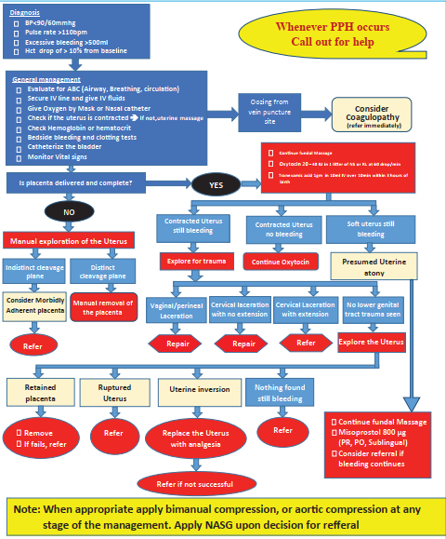

Figure 2.5. Flow chart for PPH treatment at health centers

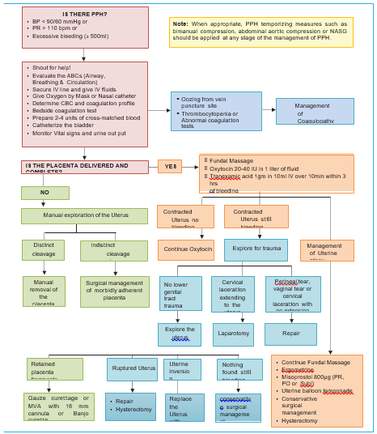
Figure 2.6. Flow chart for PPH treatment at hospitals
Monitoring
Follow up after controlling PPH:
- Watch for vaginal bleeding and take the woman’s vital signs:
- Every 15 minutes for one hour, then every 30 minutes for two hours.
- Palpate the uterine fundus to ensure the uterus remains contracted.
- Complete documentation.

2.13.4. First Trimester Vaginal Bleeding
Introduction
Bleeding in the first three months (first 12–14 weeks) of pregnancy. Vaginal bleeding in early pregnancy is common, but may indicate life-threatening disease. Women of childbearing age with abdominal pain or vaginal bleeding should be presumed pregnant.
Diagnosis
History and physical examination:
- Ask for LNMP, events during current pregnancy, degree and duration of bleeding, abdominal pain, cramps, fever, dizziness, and syncope.
- Risk factors for ectopic: tubal surgery, pelvic inflammatory disease (PID), prior abortion, IUD.
Examination:
- Abdominal tenderness; internal cervical os open or closed, clots or products of conception (POC), adnexal mass, adnexal or uterine tenderness or masses.
- Obtain vital signs. If hemodynamically unstable (HR >100, SBP <90), give 1–2 L crystalloids.
Possible causes and differential diagnosis:
- Ectopic pregnancy: Gestational sac outside of endometrial cavity
- Peritonitis or abnormal vitals suggest rupture (life threatening). Rule out in all reproductive age women presenting with complaint of lower abdominal pain and/ vaginal bleeding. If ultrasound shows fetus in the endometrial cavity, ectopic pregnancy is unlikely.
- Recent induced abortion or complications
- Spontaneous abortion:
- May be threatened (minimal vaginal bleeding with closed cervix and no passage of conceptus), inevitable (bleeding with open internal cervical os or rupture of membrane), Incomplete (open os, POC visualized), complete (closed os, fetus and placental materials fully expelled).
- Septic abortion: fever, abdominal pain, foul-smelling vaginal discharge; can complicate any abortion.
- Molar pregnancy:
- Abnormal trophoblastic proliferation
- Bleeding at 12–16 weeks, uterus larger than expected, passage of grape-like material, US with “snowstorm” pattern.
Non-pregnancy-related vaginal or cervical pathology: laceration, ulcer, cervical cancer, etc.
Laboratory:
- Urine human chorionic gonadotropin (hCG) test
- CBC
- Blood group and Rh screen
- Cross match if heavy bleeding/hemodynamic instability
- If possible, quantitative serum hCG
Pelvic ultrasound: transvaginal or transabdominal
- Diagnostic of intrauterine pregnancy (IUP): intrauterine double gestational sac, fetal pole, or heart activity
- Diagnostic of ectopic pregnancy: outside uterus, ectopic fetal pole, or heart activity
- Suggestive of ectopic: Moderate-to-large free fluid or adnexal mass without IUP
- Indeterminate: Empty uterus, nonspecific fluid, and single gestational sac/”pseudo sac”
- Normal pregnancy unlikely if no gestational sac on transabdominal US with hCG >6500 mIU/mL or transvaginal US with hCG >3500 mIU/mL
- For pregnancy of unknown location (PUL), serial serum hCG is more important than single value
- Culdocentesis: If US is not available. Detects hemoperitoneum, but less sensitive and specific. If positive, treat as ruptured ectopic.
- Examine passed uterine contents: Rinse and place in saline/tap water. Blood dissolves, chorionic villi will be fluffy and finger-like. Presence of villi excludes ectopic.
Recommended treatment
General
- Intravenous fluid/blood as needed for hemodynamic instability.
- Anti-D immunoglobulin if Rh-negative (50 ug in first trimester, 300 ug after first trimester), analgesics.
Ectopic: Consult obstetric or transfer
- Laparotomy/Laparoscopy: Unstable, peritoneal signs, evidence of rupture.
- Medical management (rarely, for unruptured): Methotrexate (50 mg/m2 BSA IM x 1); only if definite ectopic by ultrasound, tubal mass <3.5cm, no fetal cardiac activity, no evidence of rupture, minimal pain, hCG <5000. Needs close follow-up for serial hCG levels until zero (2–3 months).
- If ultrasound is indeterminate or not available, admit for serial exams. Or, if patient is pain-free, stable, hCG <above values or pregnancy <6 weeks, and resources available, can discharge for repeat hCG in 48 hours and ultrasound in 7 days.
Spontaneous abortion (inevitable, incomplete):
- If heavy bleeding, start resuscitation with fluid, transfuse as needed.
- Gently remove fetal tissue if visualized in cervical os then MVA if <14 weeks; D and E if >14 weeks (needs highly trained /skilled provider).
- If febrile, doxycycline 100mg, ceftriaxone 1 gm IV and Metronidazole 500 mg IV or ampicillin 2 gm IV, Gentamicin 2mg/kg IV and Metronidazole 500 mg IV.
Threatened abortion:
- Expectant management; close follow up with pelvic rest.
Molar pregnancy:
- Consult obstetrician or transfer for evacuation, ensure follow up for hCG trend.
Disposition
- Admit for ruptured ectopic, hemodynamic instability, falling hematocrit, severe pain, and fever.
- Discharge if abortion with minimal blood loss and good OB follow-up.
- Link for additional comprehensive abortion care services.
- Instructions to return for fever, worsening abdominal pain, or significant increase in bleeding.

2.13.15 Abnormal Uterine Bleeding
Abnormal uterine bleeding (AUB) requires medical attention but can be managed in an outpatient setting. Occasionally, an exacerbation of chronic AUB is severe enough to necessitate emergency medical care. Evaluation and management of women experiencing such episodes must be expedited to establish the source of bleeding and prevent or treat excessive blood loss.
Acute uterine bleeding has been described as excessively heavy or prolonged bleeding of uterine origin sufficient in volume as to require urgent or emergent intervention. This may occur with ovulatory or anovulatory bleeding. In childbearing women, a complication of pregnancy must always be considered.
Management
Hemodynamically unstable women with AUB: Women who present to an ambulatory setting and are found to be hemodynamically unstable should be transferred immediately to an acute care setting.
Stabilizing the patient:
- Fluid resuscitation and blood product replacement: Hemodynamically unstable patients are prepared for resuscitation in the standard fashion: airway assessment, placement of two large-bore (14 gauge or larger) peripheral intravenous lines, and type and cross-matching of blood in preparation for transfusion. Fluid resuscitation and replacement of red blood cell and/or plasma components are administered as appropriate
- Intrauterine tamponade
- Uterine curettage
- High-dose intravenous estrogen
- If IV estrogen is unavailable, oral high-dose (every 6 hourly in the first 24 hour) estrogen progestin contraceptive could be used
- Also, IV tranexamic acid could be used in case of severe bleeding

2.13.6. Hyperemesis Gravidarum
Introduction
Hyperemesis Gravidarum (HG) is a severe form of nausea and vomiting during pregnancy resulting in dehydration and weight loss.
Diagnosis:
Signs/symptoms:
- Severe nausea and vomiting
- Dehydration: loss of skin elasticity, sunken eyeballs, dry mucus membranes and lips
- Headache/confusion
- Fainting
- Symptoms and signs of complications
- Usually >5% weight loss and ketone on urine analysis
NOTE: The diagnosis of hyperemesis is considered in the presence of severe nausea and
vomiting after exclusion of other causes of nausea and vomiting during pregnancy.
Recommended management principles
- Correction of fluid and electrolyte deficits
- Identification and treatment of any comorbidities
- Identification and management of complications
Outpatient management
IV fluids:
- Infuse one liter over 1–2 hours and then 1000 mL over 4 hours (i.e., 2 liters over 5–6 hours), followed by further assessment, including urine ketone testing.
- Discharge the patient from outpatient care with PO medications and dietary advice. Or, admit for inpatient care.
Medications:
- Vitamin B6 (pyridoxine): - 10–25mg PO BID-QID and Meclizine 25 mg PO TID, or
- Metoclopramide: 5–10 mg PO TID, or
- Promethazine: 12.5–25 mg PO TID to QID, or
- Ondansetron: 4–8 mg PO TID
Dietary advice:
- Avoid empty stomach; advise intake of small and frequent diet.
- Restriction of coffee and spicy, odorous, high-fat, acidic, and very sweet foods.
- Counsel on preferably taking protein rich, salty (e.g., nuts), low fat, tasteless and dry
snacks/meals.
- Encourage on fluid intake (better tolerated if cold, clear, and carbonated or sour).
- Advise on taking peppermint containing products (e.g., chewing gum, candy) to reduce postprandial nausea.
- Advise not to take drugs that may cause nausea and vomiting (e.g., iron supplement
should be temporarily discontinued).
- Advise on taking ginger or ginger containing preparations.
- Counsel on avoiding of environmental triggers: Stuffy rooms, strong odors (e.g., perfume, chemicals, food, smoke), heat, humidity, noise, and visual or physical
motion (e.g., flickering lights, driving).
Inpatient management
Indications for admission:
- Weight loss > 5% from pre-pregnancy
- Ketonuria above +2
- Electrolyte imbalance
- Deranged renal and liver function tests
- Persistent vomiting/failed OPD management
Fluid management:
- Oral feeding withheld for 24–48 hrs.
- Give 1–2 liters of isotonic saline or ringer lactate within 1–2 hrs.
- Continue fluid repletion at a rapid rate (1–2 L over the next 2–3 hrs) until the clinical signs of hypovolemia improve (e.g., low blood pressure, low urine output, and/or impaired mental status).
- Avoid dextrose containing fluid until thiamine is supplemented with the initial
rehydration fluid.
- Give maintenance fluid after deficit is corrected:
- 4 ml/kg/hr for the first 10 hrs
- 2 ml/kg/hr for the next 10 hrs
- 1 ml/kg/hr for the rest
In addition, replace ongoing loss vitamins:
- Thiamine (vitamin B1): Give 100 mg IV with the initial rehydration fluids before administration of dextrose containing fluids and another 100 mg daily for the next 2–3 days (i.e., 10 ampoules of vitamin B complex containing 10 mg of thiamine per 24 hrs (3 ampoules/liter).
- Vitamin B6: Give 10–25 mg in every liter (i.e., at least 5 ampoules of vitamin B complex containing 2 mg of vitamin B-6 in each bag of fluid).
Electrolyte management:
- Depends on the electrolyte abnormality detected on lab tests
Antiemetics:
First line
- Meclizine 25mg IV TID, or
- Metoclopramide 5–10 mg IV TID, or
- Promethazine 5–10 mg IM every 6–8 hrs
Second line:
- Serotonin antagonists: Ondansetron 4–8 mg IV or PO, TID
Third line:
- Chlorpromazine 25mg IV or IM QID
- Shift to the next line of antiemetic drugs if emesis continues without improvement
after 24 hrs of therapy
Diet:
- PO diet can be resumed after a short period of gut rest.
- Dietary recommendations stated above for outpatient management similarly applies
for in patient cases.
Adjunctive treatment:
- If the patient has acid reflux or PUD administer anti-acid suspensions or H2 receptor
blockers as needed.
Monitoring
- Vital signs (twice daily)
- Weight (at presentation, then daily)
- Features of dehydration
- Input and output
- Urine ketone (daily)
- Appetite
Refractory patients:
- Corticosteroids
- Initiate nasogastric tube feeding.
- Discuss individualized decision on pregnancy termination if a patient doesn’t show
improvement and deteriorating despite taking all available therapeutic measures (in
cases of life-threatening conditions such as Wernicke’s encephalopathy, liver, and renal failure).
Disposition
Criteria for discharge:
- Improvement of ketone level in the urine
- Tolerating oral fluids and possibly food for at least 24 hrs hours after urine is free for
ketone and with PO antiemetic
- Give appropriate antiemetic to be taken at home
NOTE: Antiemetic should be taken for at least 1 week and with proper advice

2.13.7. Labor
Introduction
Labor is a process where regular uterine contraction results in progressive cervical dilatation and effacement which ends in the delivery of the fetus, placenta, and membranes.
Normal labor is classified/staged as:
- First stage of labor: The period between onset of regular uterine contractions to full cervical dilatation
- Latent phase: Onset of regular uterine contraction to 5 cm of cervical dilatation
- Active phase: The phase of labor after 5 cm of cervical dilatation to full cervical dilation
- Second stage of labor: The stage of labor between full cervical dilatation and delivery of the last fetus
- Third stage of labor: The stage of labor between delivery of the last fetus and delivery of the placenta and membranes
NOTE: Always rule out false labor to avoid unnecessary interventions and transfer to labor and delivery unit if time allows.
Admission criteria
- For a woman without known risk and intact membrane if cervical dilation is ≥ 4 cm
- Those women with ruptured membranes or known risk factor, can be admitted at any cervical dilatation
Recommended management
Fetal feart rate monitoring (FHR)
- Use Pinnard stethoscope or doppler device for women with no known problem.
- Count the FHR immediately after a contraction for 1 min, every 30 min for low-risk pregnancy, and every 15 min for high-risk pregnancy.
- Continuous electronic FHR monitoring is preferred to monitor high-risk pregnancies.
- FHR 110–160 BPM is normal for term normal fetus. If FHR is <110 or >160, manage as non-reassuring fetal heart rate (NRFHR).
- Avoid supine position.
- In general, encourage oral intake of liquid diet (tea, juice) but not hard foods.
Preparation for delivery
- Notify the labor ward/emergency staff that delivery is imminent.
- Take the woman to the delivery room (if it is a separate room).
- Make sure all the equipment for delivery and newborn care are available at the emergency room.
- The birth attendant should wash hands and wear complete personal protection equipment (gloves, gown, apron, mask, cap, and eye protection).
- Place sterile draping in such a way that only the immediate area around the vulva is exposed.
- Perineal care: Clean the vulva and perineum with antiseptics/tap water (downward and away from the introitus). Wipe feces downwards.
- Perineal guard to support perineum is recommended during childbirth for reduction of perineal trauma and facilitation of birth.
- Routine episiotomy should be avoided and individualization is important.
- Check for cord around the neck. If present, disentangle it from around the head or, if tight, clamp at two sites and cut the cord.
- After delivery of the head, wipe the mouth and nose (routine suctioning of oropharynx is not recommended).
- Delay cord clamping for 1–3 minutes after delivery.
- Clamp the cord 4–5 cm away from the umbilicus.
- If any difficulties to establish spontaneous breathing, immediately start bag and mask ventilation.
Active management of the third stage of labor
- Administer uterotonic medication within 1 minute of birth of the last baby (refer to PPH section)
- Controlled cord traction
- Verification of uterine tone and if the uterus is not well contracted, uterine massage
Management of cord prolapse
- Call for assistance
- Secure IV fluid
- Check for cord pulsation; if absent, confirm fetal heart beat with fetoscope or U/S
- Discontinue oxytocin if being given
- Careful pelvic examination immediately after spontaneous rupture of fetal membranes
- Prepare for resuscitation of the newborn
- In cord presentation, do not rupture fetal membranes at any stage of labor
- Client be placed in steep Trendelenberg or knee-chest position
- Do not manipulate the cord
- Avoid exposure of the cord to cold environment to avoid cord spasm (keep in vagina)
- Emergent preparation for immediate cesarean delivery

Complaint / clinical condition |  | Level of acuity |  | Intervention
Imminent birth  Active vaginal bleeding  Hemodynamically unstable  Seizures  Coma  Altered level of consciousness  Abnormal FHB tracing /NRFHRP/  Absent fetal movement  Cord prolapse  Acute severe abdominal pain  Severe cardiorespiratory distress  Suspected sepsis |  | Level 1 (Resuscitative) |  | Immediate intervention  Continuous care  Initiate emergency care  Transfer immediately to labor & delivery ward, HDU or OR.  Inform and mobilize the labor ward &/or OR teams, call the most senior persons preferably Obstetrician and Anesthesiologist (if available). Or  Refer to next level of Health Institution with all pre-referral care and accompanying medical personnel.
Suspected Preterm labor or Preterm PROM  Bleeding associated with cramping and moderate in amount and GA<37 weeks but no vital signs derangement  Hypertension: SBP≥160 OR/& DBP ≥ 110mmHg  HTN with cerebral or visual symptoms  Epigastric or right upper quadrant pain  Non-Reassuring BPP  Abnormal Doppler study  Decreased fetal movement  Major trauma  Shortness of breath  Unattended delivery |  |   Level 2 (Emergent) |  | Intervention in ≤15 minutes  Keep in the triage room until medical assessment or room on L&D ward available.  Open IV line access & obtain blood for basic lab tests( BG& Rh, CBC/Hgb, X-match, RBS & other important tests)  Keep NPO,  Inform Senior health provider (Obstetrician or IESO/GP/HO)  Obtain urine sample for PT, U/A  Monitor Fetal Condition  Bed side Ultrasound for BPP  Re-assessment every 15 minutes
Signs of active labor in GA ≥ 37weeks  Bleeding associated with cramping (mild to moderate in amount and GA ≥37weeks)  Mild HTN: BP <160/110 mmHg with or without associated signs and symptoms  Abdominal or back pain which is more severe than expected in normal pregnancy  Flank pain,  Hematuria  Nausea & vomiting &/or diarrhea with suspected  Dehydration |  |   Level 3 (Urgent) |  | Intervention in ≤30 minutes  Keep in the triage room until medical assessment or room on L&D ward available.  Open IV line access & obtain blood for basic lab tests as required  Keep NPO, Inform Senior staffs (Obstetrician or IESO/GP/HO)  Obtain urine sample for PT, U/A  Monitor Fetal Condition  Bed side Ultrasound for BPP  Re-assessment every 15 mins
Signs of early labor  Term PROM  Spotting type of bleeding  Minor trauma( Motor vehicle accident, or fall down injury)  Nausea/Vomiting &/or diarrhea with no dehydration  Signs of infection (i.e. fever, chills) |  | Level 4 (Less Urgent) |  | Intervention in ≤60 minutes  Keep in the triage room until medical assessment or room on L&D ward available.  Monitor Fetal Condition  Bed side Ultrasound  Re-assessment every 30 mins
Anything that does not seem to pose threat to the woman or fetus |  | Level 5 (Non Urgent) |  | Intervention in ≤120 minutes  Link to ANC, regular OPD or other RH services as required
Figure 2.7. Acuity level assessment and intervention guide in obstetrics

Part 3. Pediatric Emergency

Chapter 3.1. Pediatric Respiratory Emergency Approach to a Child with Respiratory Failure

3.1.1. Introduction and Principles of Management
Respiratory distress
Refers to the use of a compensatory mechanism to maintain oxygenation and ventilation.
- Increased respiratory rate for age
- Increased work of breathing (WOB)
- Tachycardia, hypertensive, anxious looking
Respiratory failure
Defined by inadequate oxygenation or ventilation with inability to meet metabolic demand of the body with the following indicators:
- Marked tachypnea, bradypnea, apnea
- Cyanosis (late sign)
- Respiratory failure with or without respiratory distress
- Poor or absent air movement
- Change in mental status is key in differentiating respiratory failure and distress. Infants could maintain saturation of oxygen while progressing to respiratory failure; do not solely rely on pulse oximeter.
Newborns:
- Respiratory failure should be recognized early as the pre-arrest state.
- As young infants are mainly nasal breathers, clearing noses can improve their breathing.
- Keep children with respiratory distress in a comfortable position.
Respiratory failure can be
- upper airway
- lower airway
- parenchymal, and
- control of breathing.

3.1.2. Upper Airway Obstruction
Croup (laryngotracheobronchitis)
Introduction
- Croup is an acute viral infection of the upper airway that mostly occurs in children aged 6 months to 3 years.
- Croup manifests with a barking cough, hoarseness, stridor, and increased WOB.
- Diagnosis does not require radiograph.
Classification of croup
- Grade 1 (mild): Stridor at rest, no retractions
- Grade 2 (moderate): Stridor at rest, mild retractions
- Grade 3 (severe): Marked respiratory distress, irritability, pallor or cyanosis, exhaustion, and 50% require intubation.
Be aware of important differentials, especially in atypical and severe cases.
Recommended management
Mild:
- Dexamethasone (0.15 to 0.6 mg/kg intramuscular (IM)/intravenous (IV)/po stat, max 16 mg), or prednisolone 1 mg/kg stat
- Advise hydration, antipyretic, and tell parents the danger signs that indicate they should bring the child to the health facility.
Moderate:
- Provide oxygen
- Epinephrine 0.5 ml/kg maximum 5 ml of 1:1000 nebulization; repeat after 30 minutes as needed
- Dexamethasone (0.15-0.6mg/kg IM/IV stat, max 16 mg), or prednisolone 1 mg/kg stat
Severe:
- Keep patient calm and in a comfortable position, avoid procedures (throat examination, lab test).
- Give 100% oxygen.
- Nebulize adrenaline and steroid as above.
- Intubate (preferably in double set-up with expert physician in intubation and, if intubation fails, ENT or surgeon to do tracheostomy) if altered mentation, and hypoxemia despite the appropriate treatment. If this takes time, do cricothyroidotomy to buy time. (see the procedure on)
- Intubate with smaller 0.5 mm one size smaller than the predicted normal endotracheal tube size for age.
The age-based formula presented by Cole [ID (mm) = (age/4) + 4.0] has long been used to select the appropriate ETT size in children. This formula is suitable for uncuffed ETTs; however, recent changes in the understanding of pediatric airway anatomy, redefined the use of cuffed ETTs.
Monitoring
- Monitor vital signs, respiratory effort and air entry, mental status.
- Observe for at least 3 hours post-nebulization of croup as rebound symptoms may occur.
Disposition
- No need to keep patients in the emergency room for mild croup.
- For moderate croup observe for 3 hours before discharge.
- For severe croup or if patient required more than two doses of epinephrine, admit to ICU.
Epiglottitis
Introduction
Though rare, epiglottitis is a life-threatening bacterial infection of the epiglottis. Symptoms include abrupt onset of high fever (toxic), respiratory distress, drooling, muffled voice, swallowing difficulty, and limitation of neck movement and sits tripod position (The person sits upright, leans forward, and puts their hands on their outstretched arms for support. They may also thrust their jaw forward and stick their tongue out)
Recommended management
- Minimize interventions, e.g., avoid oral examination, securing IV, or any other manipulation because this might induce laryngospasm.
- Administer 100% O2.
- Intubation (double set-up for intubation, where if intubation is difficult tracheostomy could be done; consider needle cricothyroidotomy if intubation and tracheostomy are delayed).
- Intubate with smaller 0.5 mm one size smaller than the predicted normal endotracheal tube size for age.
- Preferably intubate with inhalational anesthesia if possible.
- Keep the patient on maintenance fluids after securing the airway.
- Give IV ceftriaxone.
Monitoring
Monitor vital signs, respiratory effort and air entry, mental status.
Disposition
The patient should be transported without delay to an operating theater or ICU to get a definitive airway.
Bacterial tracheitis
Introduction
A life-threatening bacterial infection of the trachea with purulent exudates presents as croup with stridor, hoarseness of breath, and barking cough but patient is more toxic, with high fever and poor response to adrenaline.
Recommended treatment
Manage as croup patient and give ceftriaxone.
Disposition
Transfer the patient to inpatient ward, preferably the ICU.

3.1.3. Lower Airway Obstruction
Asthma
Introduction
- Asthma exacerbation is worsening of asthma symptoms—shortness of breath, cough, wheezing or chest tightness, and progressive decrement in lung function.
- Clinical symptoms include cough, shortness of breath, wheezing, chest tightness, and severity score of acute asthma exacerbation.
- Classification: Refer the below algorithm in this page.
- For diagnosis: Client should be at least 6 months before asthma diagnosis.
- Recurrent cough, wheezing, and heavy breathing
- Presence of atopic and/or family history of allergy/asthma or positive asthma predictive index
- Blood eosinophilia >500 ul
- Short-acting B agonist (SABA) bronchodilator responsiveness (NB: Lack of response could be seen in severe cases, so does not exclude asthma.)
Mild and moderate exacerbation: refer to the table below
Mild asthma | Moderate asthma | Severe asthma
Normal mental state  Talks in sentences  Little or no accessory muscle use SPO2 >92%  Wheeze + normal breath sounds | Normal to agitated mental state  Talks in phrases  Mild to moderate accessory muscle use  SPO2 90–92%  Wheeze + reduced breath sounds | Agitated or confused mental state  Talks in single words or unable to talk  Significant accessory muscle use  SPO2 <90%  Wheeze + significantly reduced breath sounds
Note: If patient has signs or symptoms from two different categories, always treat according to the most severe feature.
Administer oxygen via nasal cannula or facemask if SPO2 < 90% or there are signs of respiratory distress.
Mild to moderate  Bronchodilators  <6 years via metered dose inhaler (MDI) /spacer  2 puffs or 2.5 mg per nebulizer  Consider adding ipratropium 1–2 puffs  >6 years via MDI/spacer  10 puffs or 2.5 mg per nebulizer  Repeat every 20 minutes as needed for the first hour  Corticosteroids (by mouth [PO] or IV):  PO: Prednisolone 2-mg/kg/day (max. 20 mg for <2 years, 30 mg for 2–5 years, 40 mg for 6–11 years, and 50 mg for over 12 years), for 3 days in a single dose or two divided doses  IV: Dexamethasone: 0.6 mg/kg daily or 0.3 mg/kg bid |  | Severe  Bronchodilators  Via MDI + spacer  <6years: Salbutamol 6 puffs  >6 years: Salbutamol 12 puffs  Repeat every 20 minutes as needed  If absent air entry at onset, consider:  IM/subcutaneous (SC): Epinephrine .01 ml/kg (1:1000) (max.0.5ml)  Corticosteroids:  IV: Dexamethasone 0.6 mg/kg stat then 0.3 mg/kg Q12 hours (max 20mg)  If no response:  1st IV: Magnesium sulfate 50 mg/kg over 20 minutes; give 2nd dose as needed  IV: Aminophylline 5 mg/kg over 30 minutes can repeat every 8 hours
Response after 20 minutes?  Good:  Discharge on salbutamol 2–6 puffs every 4–6 hours as needed | Response after 20 minutes?  Good:  Observe for additional 2 hours  Discharge on salbutamol 2–6 puffs every 4–6 hours as needed  Continue steroid as above
 |  | Admit to ICU
 |  | Arrange for admission
Prior to discharge:
Arrange for follow-up appointment.
Review correct use of inhaler and controllers.
Give instructions on when to return if asthma worsen.
Table 3.1. classification of asthma
Managing severe asthma exacerbation
Give high flow oxygen, steroids, and SABA simultaneously.
Short-acting B agonist
- Salbutamol MDI with spacer for three doses every 20 minutes (or more frequent based on severity) or use continuous nebulization (0.3 mg/kg/hr)
- puffs for a child <6 years and 12 puffs for >6 years and older
- Nebulizer driving flow: Minimum of 5–10 L/min and as specified by the manufacturer
Steroid
- Prednisolone 2 mg/kg/d (max 60 mg daily) PO or IV/IM dexamethasone 0.6 mg/kg/d (max 20 mg) or IV hydrocortisone 4 mg/kg stat, then 2 mg/kg Q6 hourly
Intravenous fluid
- Give 10 ml/kg normal saline for dehydrated patients.
Magnesium sulfate
- 50% solution, 0.1 ml/kg (50 mg/kg) IV dilute with 50 ml saline over 20–30 minutes. Watch for drug side effect hypotension, neurologic side effect (e.g. deep tendon reflex)
- Repeat as needed or give continuously at 10-20mg/kg /hr.
Aminophylline
- Reserved for non-responders with beta-agonist and magnesium sulfate.
- Loading 5–6 mg/kg over 30–60 min then 0.5–1.0mg/kg/hr continuously (max 300 mg) or 3 to 5 mg/kg every 6–8 hours, dilute in equal saline and give over 20–60 min.
Side effects:
- Arrhythmia, hypotension, disorientation, fits, gastrointestinal symptoms.
- Stop immediately if child vomits, has a pulse rate >180/min, headache, or convulsion.
Subcutaneous beta-agonist
Epinephrine
- Children with poor air flow, cannot cooperate with nebulization, did not improve with continuous nebulization, or no response with all the above management
- 1:1000 solution (max dose 0.4mg), 0.01mg/kg/dose, repeat every 15–20 min x 3 doses.
Other considerations
- Chest X-ray (CXR) only if no response or if concern for pneumothorax or other differentials
- Consider noninvasive ventilation like bi-level positive airway pressure ( BiPAP) early in the course
NB: Give the above treatments back-to-back if the child is in impending respiratory failure.
Consider adding azithromycin 10mg/kg daily for those requiring prenatal ICU (PICU) admission, other antibiotics should be used only based on strong evidence of bacterial infection.
Intubation and ventilation
- Intubation is best avoided unless mandatory; try your best early as above to avoid it.
Indications for intubation:
- Cardiopulmonary arrest
- Rapid change in mentation
- No improvement despite maximum therapy and the patient is exhausted.
- If patient develops respiratory failure, the bag mask ventilation should be used slowly.
- If patient arrests need intubation, intubate early as possible and give exhalation time and use smaller tidal volume.
- Use ketamine+/- propofol as sedative.
- Avoid muscle relaxant if possible and intubate rapidly with a cuffed tube.
- Anticipate hypotension and give normal saline (NS) bolus during intubation.
Monitoring
- Monitor vital signs, WOB, air entry, ability to talk, and mental status.
Complications
- Hypotension and pneumothorax should be anticipated and managed accordingly.
Disposition
- Discharge with prednisolone for 3–5 days or dexamethasone for 2 days and continue salbutamol puff.
- Consider controller initiation before discharge and arrange follow-up in 1-2 weeks.

Bronchiolitis
Introduction
- Bronchiolitis is characterized by a prodromal symptom of viral infection followed by lower respiratory symptoms, including wheeze, crackles, and a variable degree of increased WOB in infants under 2 years of age.
Diagnosis: All the following must be met for a bronchiolitis diagnosis:
- Age between 6 weeks and 2 years
- Preceding upper respiratory tract infection (URTI) within the past 7 days
- The first episode of lower respiratory symptoms with bilateral polyphonic wheeze +/- hyperinflation with or without crackles
- Consider other differential than bronchiolitis if there is:
- Comorbidity (severe acute malnutrition, HIV, CHD, Down syndrome, rickets, etc.) and unvaccinated
- Age <6 weeks and >2 years
- Children older than 6 months with recurrent episodes more than 6 weeks apart
Recommended management
- Mild to moderate illness
- Can be managed as outpatient with follow-up in 24–48 hours.
- Ensure adequate feeding/hydration.
- Antipyretics as needed.
- Nasal clearance as needed.
- No steroid or bronchodilator.
- Severe and critically ill
- Keep at the emergency department or admit to pediatric ICU (critical) and admit all with risk factors for severity (Down syndrome, prematurity, congenital heart disease, chronic lung disease, neurologic problems).
- Start O2 (high flow nasal cannula or continuous positive airway pressure [CPAP] for more severe cases and maintain saturation above 90%).
- Nasal suctioning only as needed; as little handling as possible.
- Hydration: Intolerant to oral feed use a nasogastric (NG) tube or IV fluid for critical cases.
- Nebulize with 5 ml hypertonic saline OR adrenaline.
- Consider azithromycin for critical children.
- Trial of salbutamol (only in critical cases and if severe >6 month).
- Do not do CXR, complete blood count (CBC), C-reactive protein (CRP) test, blood culture, or cerebrospinal fluid (CSF) for all; do only when indicated or in CRITICAL cases with suspected complications.
- Otoscopy and urinalysis for febrile infants with severe bronchiolitis.
Monitoring
- Close monitoring of vital signs, WOB, hydration status, and mentation
Disposition
- Counsel parents that symptoms may persist for up to 3 weeks.
- Infants with one or more risk factors are at risk of requiring more significant interventions.
- Infants without any risk factors can be safely discharged home but arrange adequate follow-up as needed.
- Counsel parents that symptoms may persist for up to 3 weeks.
Pertussis
Introduction
- Suspect pertussis if a child has been having a severe cough for more than 2 weeks, especially if the disease is known to be occurring locally.
- The most useful diagnostic signs are:
- Paroxysmal coughing followed by a whoop when breathing in, often with vomiting.
- Young infants may not whoop; instead, the cough may be followed by cessation of breathing (apnea) or cyanosis, or apnea may occur without coughing.
- Also, examine the child for signs of pneumonia and ask about convulsions.
- Child not immunized against pertussis.
Recommended management
- Give oxygen to children who have spells of apnea or cyanosis, or severe paroxysms of coughing or low oxygen saturation < 90% on a pulse oximeter.
- Use nasal prongs, not a nasopharyngeal catheter or nasal catheter, which can provoke coughing.
- If apnea occurs, clear the airway immediately with gentle suction, give manual respiratory stimulation or bag ventilation, and administer oxygen.
- Avoid, as far as possible, any procedure that could trigger coughing, such as throat examination.
- Do not give cough suppressants, sedatives, mucolytic agents, or antihistamines.
- Give paracetamol for fever.
Fluid
- Encourage breastfeeding or oral fluids.
- If the child cannot drink, pass a nasogastric tube and give small, frequent amounts of fluid to meet the child’s maintenance needs.
- If there is respiratory distress, give maintenance fluids by IV to avoid the risk of aspiration and reduce triggering coughing.
- Ensure adequate nutrition by giving smaller, more frequent feeds. If there is continued weight loss despite these measures, feed the child by nasogastric tube.
Antibiotics
- Give azithromycin at 10 mg/kg (maximum, 500 mg) on the first day, then 5 mg/kg (maximum, 250 mg) once a day for 4 days.
- If there are signs of pneumonia, treat with amoxicillin-clavulanic acid or ceftriaxone (severe).
- Follow the national guideline for management of severe pneumonia.
Monitoring
- Teach the child’s mother to recognize apneic spells and alert the nurse if they occur.
- The nurse should check every 3 hours that the prongs or catheter are in the correct place and not blocked with mucus, and that all connections are secure.
- Admit to the ICU infants, severe cases, and those who have apnea.
Complications
- Pneumonia
- Malnutrition: Children with pertussis may become malnourished as a result of reduced food intake and frequent vomiting.
- Sub-conjunctiva hemorrhage and epistaxis are common during pertussis.
- No specific treatment is needed.
- Umbilical or inguinal hernias may be caused by violent coughing.
- Do not treat them unless there are signs of bowel obstruction but refer the child for surgical evaluation after the acute phase.
Public health measures
- Give DPT immunization to any child in the family who is not fully immunized and to the child with pertussis.
- Give a DPT booster to previously immunized children.
- Give azithromycin promptly to all household members and other close contacts, such as children in day care, regardless of age, history of immunization, or symptoms. Continue for 5 days.
Disposition
- Treat mild cases in children aged ≥6 months at home with supportive care.
- Admit infants aged <6 months to the hospital. Also admit any child with pneumonia, convulsions, dehydration, severe malnutrition, or prolonged apnea or cyanosis after coughing.
Summary
Croup | Anaphylaxis | Foreign body aspiration
Nebulized epinephrine  (0.5 ml/kg L epinephrine, max 5 ml)  Corticosteroids  Dexamethasone  (0.6 mg/kg, max 16 mg IM stat) | IM epinephrine 0.01 mg/kg IM q 5 min salbutamol puff  Antihistamine  Corticosteroids for prevention of recurrence  IV fluids | Allow position of comfort  Refer rigid.  Bronchoscopy  Refer to foreign body removal section,
Table 3.2. Upper airway obstruction (management for selected conditions)
Bronchiolitis | Asthma
Nasal suctioning and oxygen | Salbutamol+/-
Hydrate the child | Ipratropium
 | Corticosteroids
 | SQ epinephrine
 | Magnesium sulfate
Table 3.3. Lower airway obstruction (management for selected conditions)
Pneumonia/pneumonitis |  | Infectious chemical aspiration | Pulmonary edema cardiogenic and noncardiogenic (ARDS)
Salbutamol  Antibiotics (as indicated)  Put on oxygen (consider CPAP) |  | Poisoning/overdose  See poising section | Noninvasive or invasive ventilator support with positive end-expiratory pressure (PEEP)  Consider vasoactive support  Consider diuretic
Table 3.4. Lung tissue (parenchymal) disease (management for selected conditions)
Increased intracranial pressure (ICP) | Neuromuscular disease
See ICP section | See GBS section
Table 3.5. Disordered control of breathing (management for selected conditions)

3.2. Pediatric Cardiovascular Emergency

3.2.1. Shock in Pediatrics
Introduction
Shock is the inability of the circulatory system to provide adequate oxygen and nutrients to meet the body’s metabolic demand.
Shock is a life-threatening condition caused by the systemic failure of the circulatory system. It causes inadequate perfusion of major organs that eventually leads to multi-organ failure due to ischaemia if not corrected. Children often show few signs of shock even after severe fluid depletion due to high physiological reserves. This also means that when symptoms do occur, patients are likely to deteriorate rapidly

Clinical manifestation
- Hypotension or need for vasoactive medication to maintain blood pressure (BP)
- Decreased urine output <0.5 ml/kg/hr
- Capillary refill >3 sec
- Hypo or hyperthermia; cold (vasoconstriction) or warm (vasodilation)
- Altered mental status
Severity of shock
- Compensated shock:
  - BP maintained by compensatory mechanism and normal mentation
  - Minimum systolic BP:
    - Newborn: 60 mmHg
    - Infant (1 month to 1 year): 70 mmHg
    - Child (1 to 10 years): 70 + (2 × age [in years]) mmHg
    - Child older than 10 years: 90 mmHg
- Decompensated (hypotensive) shock:
  - Late phase of shock when physiological compensation fails. In this phase, BP is low and there is a change in mental status.
NB: Hours may pass before a patient goes into decompensated shock; once the patient is in decompensated shock, they will soon go to cardiac arrest.

Causes of shock
- Hypovolemic shock is caused by:
  - External fluid loss through, for example, hemorrhage, diarrhea, vomiting, complications of diabetes, or burns
  - Internal third space loss through, for example, malnutrition, nephrotic syndrome, or chronic liver diseases

Recommended management
Recognize early, maintain airway, breathing.
- For a well-nourished child:
- 20 ml/kg NS/Ringer's lactate (RL) fast then reassess; if no improvement, repeat 20 ml/kg and reassess. Give third bolus if no improvement until signs of adequate perfusion.
- If hypovolemic shock due to diarrhea may need bolus, for example, in case of cholera. Consider septic shock if there is no response after adequate fluid bolus.
NB: After the patient is out of shock, assess for dehydration. If there is dehydration, manage with 70 ml/kg of NS/RL over 5 hours (less than 1 year) or 2 and ½ hour (age above 1 year).
- For a child with severe acute malnutrition (SAM):
- 5% dextrose in NS or 5% dextrose in ringer lactate 15 ml/kg over 1 hour with close monitoring of vital signs.
  - If there are signs of improvement (pulse and respiration rates are lower after 1 hour): Repeat IV 15 ml/kg over 1 hour, then switch to oral or nasogastric tube (NGT) rehydration with ReSoMal, 10 ml/kg/h for up to 10 hours.
  - If there is no response after a bolus of 15 ml/kg, consider septic shock and transfuse a fresh blood at 10 ml/kg slowly over 3 hours.
NB: If the shock is from bleeding, control bleeding by direct pressure, give 20 ml/kg of NS/RL, repeat two to three times as needed and prepare blood for possible transfusion.
NB: Replace ongoing loss with oral rehydration solution (ORS) (10 ml/kg for each loss) if well-nourished or with ReSoMal if the child has malnutrition.

3.2.2. Cardiogenic Shock

Introduction
- Cardiogenic shock is failure of the heart as a pump, resulting in decreased cardiac output.
- Differentiating cardiogenic from septic shock can be difficult, so a thorough medical history and physical examination are important to identify the type of shock.
  - Gallop, rales, jugular venous distension, hepatomegaly, cardiomegaly, and pulmonary congestion

Recommended management
- Follow bradycardia /tachycardia algorism if cause is rhythm problem.
- Give 5 to 10 ml/kg over 30 minutes NS/LR bolus, repeat as needed for structural causes.
- Inotrope infusion (adrenaline or dopamine if not in hypotensive state or milrinone or dobutamine if there is no hypotension).
- If arrhythmia, manage it properly (see section on arrhythmia).
- Consult expert early and admit the patient to the ICU.

3.2.3. Distributive Shock

Introduction

The classic picture of neurogenic shock is hypotension without tachycardia or cutaneous vasoconstriction and respiratory muscle weakness.

Recommended management
Give fluid as for hypovolemic shock and if patient does not improve, raise BP by vasopressors (dopamine, epinephrine) infusion. If the patient has a spinal injury, transfer with spinal immobilization.

3.2.4. Anaphylaxis Shock

Introduction
Anaphylaxis shock is a severe allergic reaction that may cause airway obstruction and shock.
- Clinical manifestation
- Respiratory: Difficulty breathing, wheezing, persistent cough, stridor, chest pain, or tightness in the chest
- Cardiovascular: Irregular heartbeat, hypotension, or collapse
- Neurological: Dizziness, altered consciousness, confusion, or sudden behavior change
- Gastrointestinal: Nausea, vomiting, diarrhea, abdominal or pelvic pain
- Skin: Widespread hives, severe itching, rash, redness, or pale or bluish color
- Swelling: Swelling of the lips, throat, tongue, or uvula
- Other: Hoarse voice, difficulty talking, loss of bladder control, fainting, feeling of impending doom, or agitation.

Recommended management
- Adrenaline 0.01 mg/kg IM (1:1000)/0.01 ml/kg (max 0.5 mg) in the thigh; repeat every 5–15 min for persistent or recurrent symptoms.
- If there are signs of airway obstruction, call the anesthesiologist for immediate intubation or tracheostomy in parallel with rapid IM administration of epinephrine. Do emergency cricothyroidotomy if intubation is delayed.
- Administer oxygen and salbutamol using an MDI and spacer or nebulization if wheezing.
- Give diphenhydramine 1 mg/kg IM or IV (max 50 mg). Preferred orally if patient stable.
- Consider cimetidine (5 mg/kg PO; maximum 300 mg), may work synergistically with Diphenhydramine.
- 20ml/kg of IV /IO NS if the child is in shock and repeat as needed.
- Systemic steroid: dexamethasone 2 mg/kg PO/IV (max 50 mg) or prednisolone 1-2 mg/kg PO (max 80 mg).
NB: Adrenaline is the mainstay of management.

3.2.5. Septic Shock

Introduction
- Septic shock is sepsis + cardiovascular dysfunction evidenced by persistent hypotension or need for vasopressors despite adequate fluid resuscitation.
- Diagnosis of septic shock is clinical and laboratory has limited utility.

Recommended management
- Manage using the Airway, Breathing, Circulation, Disability, and Exposure (ABCDE) method.
- Assess if child has malnutrition. (Manage malnourished child as above.)
- 20 ml/kg RL or NS bolus then assess response. If no response, repeat up to total of 40 to 60 ml/kg if no malnutrition. If the patient is hypotensive, give fluid rapidly. If patient is in a compensated state, give fluid over 30 minutes.
- Inotrope if no response to fluid administration. Preferred is adrenaline/noradrenaline 0.15 mg/kg diluted in 50 ml of N/S. Start with 1 ml/hr (i.e., 0.05 ug/kg/min) and progressively escalate every 10 to 15 minutes till 0.35 ug/kg/min).
- Use dopamine if adrenaline or noradrenaline is not available.
- Consider blood transfusion in patients with refractory shock.
- Broad-spectrum antibiotic within first hour of diagnosis after taking blood culture.
- If blood culture delays antibiotics, give antibiotic as soon as possible.
- Drain abscess.
- Metabolic and electrolyte correction:
- Frequently check and correct hypoglycemia.
- If persistent hyperglycemia, use dextrose-free maintenance fluid.
- Correct hypocalcemia if < 1.1 mmol/L.
- Steroids:
- Only in inotrope refractory shock and/or persistent hypoglycemia and patients previously on steroids.
- Dose hydrocortisone 1–2 mg/kg then 1 mg/kg/dose IV four times a day (QID).

3.2.5. Obstructive Shock

Introduction
Caused by obstruction of blood flow either into or out of the heart.

Recommended management of obstructive shock
Ductal dependent |  | Tension | Cardiac |  | Pulmonary embolism
LV | Outflow | Pneumothorax | Tamponade
Obstruction (e.g., coarctation of aorta, aortic stenosis)
Prostaglandin E1 |  | Needle | Pericardiocentesis |  | 20 ml/kg NS/LR bolus, repeat
Expert |  | decompression | 20 ml/kg NS/LR |  | as needed
Consultation |  | 20 ml/kg NS/LR followed by chest tube insertion | bolus |  | Consider | thrombolytic,
 |  |  |  |  | anticoagulant

Table 3.6. Cause and management of obstructive shock

Monitoring
- Assess pulse rate, volume, rhythm
- Take blood pressure
- Check capillary refill
- Check level of consciousness and urine output
- Look for signs of fluid overload (pulmonary edema or new or worsening hepatomegaly that should limit further fluid bolus therapy)

Disposition
- Consider referring to inpatient ward or ICU depending on severity

3.2.6. Congestive Heart Failure

Introduction
Congestive heart failure is the failure of the heart to pump enough blood to meet the body’s metabolic demand as a result of ventricular dysfunction, volume, or pressure overload with the clinical features of:
- Respiratory distress, tachycardia, poor appetite, feeding difficulty, and failure to grow
- Dyspnea, profuse perspiration, palpitation, exercise intolerance, orthopnea, raised jugular venous pressure (JVP), hepatomegaly, and edema

Recommended management
- General measures
- ABCDE: Put patient on monitor.
- Positive pressure ventilation may be required for pulmonary edema.
- Intubation may be required for refractory heart failure.
- Bed rest recommended but absolute restriction rarely necessary.
- Fluids and diet: 2/3 of maintenance through NG tube or IV fluid while increasing calorie.
- Low sodium formula not recommended as it may exacerbate diuretics induced hyponatremia. Breast milk is an ideal low salt diet.

Control of heart failure states
- Decrease congestion
- Diuretics: First line to decrease preload
  - Furosemide: IV 1 mg/kg up to 2 mg/kg/dose. 1 mg/kg/dose twice a day (BID) up to max 6 mg/kg/day
  - Spironolactone: 1–2 mg/kg/day
  - If no improvement, add hydrochlorothiazide: 1 mg/kg/hr oral every 12 hours
- Decrease afterload and prevention of cardiac remodeling
- Angiotensin-converting-enzyme (ACE) inhibitor:
  - Monitor BP and renal function
  - Indications: Cardiomyopathies, mitral and aortic insufficiency, left–right shunt lesions
  - Contraindicated in obstructive lesions
  - Captopril, oral, initial dose: 0.5–1 mg/kg/24 hours in three doses (8 hourly) for 24–48 hours
  - Increase by 0.5 mg/kg/24 hours every 24–48 hours until maintenance of 3–5 mg/kg/24
  - Enalapril oral 0.2–1 mg/kg/day single dose or two divided doses. Start low and increase by 0.2 mg/kg/day at 1–2-day intervals.
- B blockers:
  - Generally, not used in acute decomposition
  - Use especially in ischemic heart disease
  - Metoprolol: 0.1 mg/kg dose BID up to max 1 mg/kg do
  - Carvedilol: 0.025 mg/kg/dose BID up to max 0.5 mg/kg/dose BID
- Increase contractility
- Digoxin: Add for persistent symptoms despite treatment with other agents (diuretics and ACE I). Dose: 3–5 microgram/kg/dose oral 12–24 hourly.

Recommended treatment of precipitating factors
- Blood transfusion for heart failure with hemoglobin <8 mg/dl
- Treatment of infections: Infective endocarditis, pneumonia, malaria, etc.
- Treatment of arrhythmias and other precipitant

Elimination of underlying cause
- Surgical or catheter-based interventions to correct underlying structural defect

Monitoring
- Assess pulse rate, volume, rhythm
- Blood pressure
- Peripheral edema
- S3 gallop
- Level of consciousness and urine output
- Signs of fluid overload (pulmonary edema or new or worsening hepatomegaly that should limit further fluid bolus therapy)

Disposition
- Patients should be admitted to a critical care unit with continuous monitoring. It is very important to record any arrhythmia that occurs in the emergency department (ED).

3.2.7. Hypertension in Children
Children aged 1–13 years | Children aged ≥13
Normal BP: 5th to 90th percentile | Normal BP: 90/60 to 120/80 mmhg
Elevated BP: ≥90th percentile to <95th percentile or 120/80 mmhg to <95th percentile (whichever is lower) | Elevated BP: 120/<80 to 129/<80mmhg
Stage 1: ≥95th percentile to <95th percentile + 12 mmhg or 130/80 to 139/89 mmhg (whichever is lower) | Stage 1: 130/80 to 139/89 mmhg
Stage 2: ≥95th percentile + 12 mmhg or ≥140/90 mmhg (whichever is lower) | Stage 2: ≥140/90 mmhg

Table 3.7. Stage of blood pressure

Causes
- Primary hypertension (HTN): No underlying cause identified.
- Secondary HTN: Identifiable cause present. 98% pediatric hypertension is secondary.
  - Renal/renovascular: Most common cause
  - Endocrinologist disease: Thyroid, parathyroid, and adrenal diseases
  - Cardiovascular: Coarctation of the aorta
  - Nervous system: Increased ICP, autonomic dysfunction (e.g., tetanus, Guillain -Barrie syndrome)
  - Tumors: Wilms tumor, neuroblastoma, pheochromocytoma
  - Miscellaneous: Chronic upper airway obstruction, hypercalcemia, drugs, e.g., steroids

Drug | Class | Dose | Route | Comment
Esmolol | B-blocker | 100–500 mcg/kg/min | IV infusion | Very short-acting—constant  Infusion preferred. May cause profound bradycardia  Produced modest reductions in BP in a pediatric clinical trial
Hydralazine | Vasodilator | 0.2–0.6 mg/kg/dose | IV, IM | Should be given every 4 hours when given IV bolus
Labetalol | α- and b-blocker | Bolus 0.2–1.0 mg/kg/dose up to 40 mg/dose infusion 0.25–3.0 mg/kg/hr | IV bolus or infusion | Asthma and overt heart failure are relative contraindications
Table 3.8

Drug | Dose | Onset of action | Maximum effect | Duration of action | Side effects | Contraindications
Nifedipine | 0.25–0.5mg/kg PO  Maximum dose: 10 mg /dose 3 times every 30 min.  Max. dose:3 mg/kg/day–120 mg/day | 5 min | 30–60 min | 4–6 hours | Headache, tachycardia, hypotension, rash | Shock, advanced aortic stenosis, encephalopathy/cranial hypertension
Enalapril | 5–10 mcg/kg IV in 5 min  Maximum: 0.5 mg dose  Maintenance: Every 6–8 hour  0.08 mg/kg/dose 24 hours PO  Max. dose 5 mg | 1 min | 4 hours | 6 hours | Hypotension
Hydralazine | 0.1–0.2mg kg dose IV, IM  Max. dose: 20mg dose | 10–12 min | 20–40 min | 3–8 hours | Hypotension, headache, tachycardia
Table 3.9. Drugs for hypertensive urgency

Clinical manifestation
- Seizure, altered mentation, headache, dizziness, visual disturbance, tachycardia/palpitations, congestive heart failure
- Hypertensive crisis: Presentation with hypertensive urgencies and emergencies
- Hypertensive emergency: Rare in children; hypertensive encephalopathy with seizures, renal insufficiency, eyes (papilledema, retinal hemorrhages, exudates), and heart failure. Treat seizure
- Hypertensive urgency: Severe elevation in BP without severe symptoms
- Treatment goals are to manage hypertensive emergency and achieve target BP level to reduce risk of target organ damage
- Indications for pharmacologic therapy include:
- Severe symptomatic hypertension with crisis
- Stage 2 hypertension without a modifiable risk factor
- Hypertension in patients with comorbidities such as diabetes (types 1 and 2) or chronic kidney disease (CKD)

Recommended management
- Avoid medications that increase BP (e.g., ketamine) during intubation.
- Treat seizure with benzodiazepine.
- A stepwise reduction in BP, reduced by no more than 25% in the first 6 to 8 hours. Plan to normalize BP over 3 to 4 days.
- Except in children with intracranial hemorrhage, ischemic or traumatic brain injury, manage hypertensive emergency by initial IV bolus of labetalol or hydralazine.
- Subsequently, continuous infusion of labetalol with strict monitoring of BP.
- In hypertensive urgency, use oral agents such as nifedipine, unless oral medications are not tolerated.
- Drugs for management of hypertensive emergency in children aged 1–17 years

Monitoring
- Mental status
- Seizure activity
- Papilledema and retinal hemorrhages
- Signs and symptoms of heart failure
- Hematuria and decrement in urinary output (UOP)
- Continuous BP monitoring (e.g., automatic BP measurements every minute).

Disposition
- Admit hypertensive emergencies to the PICU.

3.3. Fluid Therapy in Infants and Children

3.3.1. Introduction and Principles of Management
- Maintenance fluid (MF) represents the quantity of IV fluids required to maintain hydration in a euvolemic child who is not experiencing ongoing loss, e.g., diarrhea, burn, etc.
- Maintenance IV fluids are used in a child who cannot be fed enterally.
- Glucose in MF provides approximately 20% of the normal caloric needs.

Recommended management

Weight | Fluid therapy/day | Hourly fluid rate | Remark
0–10kg | 100 ml/kg | 4 ml/kg/hr
11–20kg | 1000 ml + 50 ml/kg for each kg >10kg | 40 ml/hr + 2 ml/kg/hr x (wt-10 kg)
>20kg | 1500 ml + 20 ml/kg for each kg >20kg | 60 ml/hr + 1 ml/kg/hr x (wt-20kg) | Maximum fluid per day = 2.4 liters
Table 3.10. Fluid therapy
For example, a 26 kg child who is nothing by mouth (NPO) waiting for surgery: 60 ml/hr + 1 ml/kg/hr x (wt-20kg): 60 ml/hr + 1ml (26-20) = 66 ml/hr of IV fluid is needed.
Types of fluid
- Solution with 5% dextrose in ringer lactate or NS with 5% dextrose (DNS). A solution less than 0.45% NS should not be used except for with neonates.
- Potassium in replacement therapy should wait until the patient has adequate urine output.
- Resuscitation fluid: crystalloid (NS, RL) 20 ml/kg; after 60 ml/kg, consider colloid (see section on pediatric shock).
NB:
The neonates’ fluid requirement is not included in this guideline.
Maintenance may be increased or decreased depending on the clinical situation.
Increase maintenance if excessive sweating, profuse diarrhea, vomiting, radiant warmer, fever, surgical drainage/third spacing need increase.
Decrease maintenance if MF humidified mechanical ventilator, renal failure decreases insensible loses.

Recommended management of complications of MF
- Fluid overload: Restrict fluid intake and consider diuretics.
- Extravasation: Examine IV site daily and change the site if there is any swelling; elevate limb.
- Electrolyte and acid base disturbance: Correct accordingly.
- Hypo/hyperglycemia: Give glucose/correctional insulin.

Monitoring
- Check vital signs and urine output every 1 hour.
- Examine IV sites at least daily.
- Monitor renal blood flow (RBS) every 4–6 hours if hypoglycemia increases the glucose level of 10% dextrose.

3.3.1. Electrolyte Therapy in Infants and Children

Introduction and principles of management
- Normal daily electrolytes
- Recommended management
- Sodium imbalance

Hypothermia
- Hypothermia occurs when serum sodium level <135 meq/L (<135 mmol/L).
- Initiate treatment immediately if neurologic symptoms are present and sodium is <120. Give 3% saline, preferably through a central line. Administer over 15 to 20 minutes to gain rapid correction.
- The target is 120–125 meq/L or until seizure stops.1.2 ml/kg of 3% saline will raise the level by 1 meq/L /L.
- Correct hypernatremia slowly. Rapid correction of sodium more than 12 meq/L /L in the first 24 hours or an average of 0.5 meq/L per L/hr, except in neurologic symptoms or typically with sodium level <120 mmol/L where rapid correction is required.
- Formula to get required sodium: 0.6 x (weight in kg) x (target Na+-measured Na+) and use NS or D5NS fluid to correct.
If hypovolemic and hemodynamically unstable:
Correct instability with NS boluses (20 mL/kg) over 5 minutes followed by reassessment after each bolus.
For euvolemic hyponatremia:
After correcting serum sodium level, institute water restriction and treat the underlying disorder.
For hypervolemic hyponatremia (edema):
Institute sodium and water restriction and administer diuretics if needed to treat the clinical condition (e.g., congestive heart failure).
Example: A 7-week-old child (4 kg) is symptomatic with Na+=114
Step 1: This child needs urgent correction. Since Na+ <120, the amount of sodium chloride ( NaCL) required is:
0.6x (weight in kg) x (target Na-measured Na) 0.6x4x (120-114) = 14.4 mEq of Na+ needed.
1 ml 3% saline is 0.5 mEq/L or in order to get 14.4meq we need 28 ml of 3 % saline Or.
NB: 0.9% NS = 0.15 meqNa+/L but 3 % saline = 0.5 meq/L Na+/L. If 3% saline is not available, give NS fluid bolus 20ml/kg.
Step 2: Raise the serum sodium level an additional 12 meq over the next 24 hours from the current 120 meq/L = 0.6 x 4 kg (132 desired Na-120 Na) = 29 meq/L /L of additional sodium needed over the next 24 hours.
NB: 1 teaspoon of table salt (NaCl) has 2.3 gm of Na+.
1 mg NaCl has 17 meq/L Na+. 1 mgNa+ has 43mEqNa+.
NS has 0.9 gm of NaCl/100ml. 3% NaCl has 3 gm NaCl/100ml.

Hypernatremia (>145)
Goals of management
- To quickly correct underlying hypovolumia
- To treat the underlying cause of hypernatremia, e.g., diabetic insipidus
- To carefully lower the serum sodium level, usually by replacement of the body’s total water deficit)
Recommended treatment
- Correct serum sodium gradually to avoid cerebral edema.
- Therefore, closely monitor serum sodium levels every hour initially to ensure that the level is reduced no faster than 0.5 meq/L /h and no more than 12 meq/L in the first 24 hours.
- Estimate free water deficit by one of the following methods and correct dehydration over 48–72 hours:
- 0.6x patient weight in kg x (patient sodium/140 -1) or 3–4 ml x desired change in serum sodium x body weight (kg).
- Type of fluid: Correct shock with NS followed by ½ NS (0.45%) with 5% dextrose (with potassium) to replace the remaining free water deficit. Avoid ringer lactate because it is more hypotonic than NS and may cause rapid correction decrease in serum sodium concentration.
- Typical fluid: 5% dextrose with half NS (with 20 mEq/L potassium chloride [KCl] unless contraindicated).
- Typical rate: 1.25–1.5 times maintenance.
- Frequent measurement, initially every 2–3 hours. If the correction rate is not adequate, the rate or type of fluid should be changed.
- The maximum rate of sodium fall: 10 to 12 meq/L /day. Monitor serum sodium every 2 to 4 hours, later every 6–8 hours if the correction speed is adequate.
- If Na falls ≥ 0.6 -1 meq/L/hr, slow IV rate. If sodium decreases too rapidly, either increase sodium concentration of intravenous fluid or decrease rate of intravenous fluid.
- If Na falls < 0.5 mEq/hr, increase the flow IV rate or are imminent, consider a short infusion of 3% Nacl (2–3 ml/kg) over 1–2 hours if the child is hypovolemic.
- If sodium decreases too slowly, either decrease sodium concentration of intravenous fluid or increase rate of intravenous fluid.
- Replace ongoing losses as they occur in chronic conditions, without exceeding in both cases a correction > 10–12 mEq/l/day.
NB: 1L of D5 0.45% NS will provide 400ml of free water. To prepare D5 0.45% NS (use 1/2 distilled water (DW) and 1/2 DNS fluid in our setting).

3.3.2. Potassium Imbalance

Hypokalemia
Classification
- Mild (k=3–3.5mEq/l)
- Moderate (k=2.5–2.9 mEq/l)
- Severe (k<2.5 mEq/l)
Recommended management
- Check renal function test as we need to be careful of potassium administration in renal failure.
- Treat underlying causes, e.g., reduce dose of diuretic.
- Use oral or IV route depending on severity.
- Oral is safe and preferred for asymptomatic and normal ECG. Oral replacement with potassium, 2 to 5 mEq/kg/day every 4 to 6 hours.
- If symptomatic or ECG is abnormal. If K<2.5 and life-threatening complication arrhythmias or respiratory muscle weakness, use IV route 0.5 1 meq /kg (maximum 20 meq/dose) in 1 to 2 hours with adequate solution dilution with NS, preferably with central line.
- Administer with continuous ECG monitoring and increase of MF KCl 40 to 60 meq/L in such patients.
- If concentration is more than 60 meq/L, use central line as it is vein irritant.
- When hypokalemia is resistant or refractory to K+ replacement, magnesium deficiency is may be the likely cause and treat the hypomagnesemia.

Hyperkalemia
Hyperkalemia is a serum potassium level of >5.5 mEq/L.
Recommended management
- Any patient with ECG abnormality, K>6.0–6.5 meq/L, associated acidosis, hypocalcemia, hyponatremia need emergent therapy.
- Asymptomatic patients with normal ECG findings usually do well with therapy to enhance potassium excretion.
- Sodium polystyrene sulfonate is a resin that exchanges sodium for potassium administered PO or by enema.

Increase cardiac  stability | Agent |  | Dose
Increase cardiac  stability |  | Calcium gluconate, 10%* | 100 milligrams/kg(1ml/kg/dose) IV at rate not to exceed 100 milligrams/min; onset of action, minutes; duration of action, 60 min, maximum 3
Table 3.11. Summary of treatment of hyperkalemia

Hypocalcemia
Hypocalcemia is a serum calcium level <8 mg/dL (2 mmol/L) or ionized calcium level <1 mmol/L.
Total calcium can be affected by the level of albumin; therefore it is better to follow ionized calcium.
Recommended treatment
- If asymptomatic, treat with oral calcium 50 mg/kg/day in 3–4 doses.
- If symptomatic, give IV calcium o.5ml/kg of 10% calcium gluconate diluted in an equal amount of saline over 10 minutes. Stop calcium gluconate administration if the ECG or the heart rate drops by 20 BPM from the baseline.
- Correct abnormal magnesium, potassium, and PH.
- Hypomagnesemia causes refractory hypocalcemia.
- Treat underlying cause, e.g., rickets.
 | Treatment | Comments
Hypocalcemia | 10% calcium gluconate IV, 100 milligrams/kg at a rate of <100 milligrams/min | Continues ECG monitoring
Hypercalcemia | Hydrate with twice maintenance fluids, furosemide 1–2 milligrams/kg IV to a maximum of 40 milligrams | Treat underlying cause
Hypomagnesemia | 10% magnesium sulfate, 25–50 mg/kg over 30 min
Hypermagnesemia | Hydration, diuresis 1–2 milligrams/kg IV furosemide to maximum 40 milligrams, or 10% calcium gluconate IV, 0.5 ml/kg
Table 3.12. Treatment of hypo and hyper calcium and magnesium
Recommended management of complications of electrolyte imbalance
- Further electrolyte imbalance:
- Stop administration of electrolytes once the imbalance is corrected or for over correction.
- Neurologic sequelae:
- Continue supportive care and consider mannitol if cerebral edema is suspected.
- Extravasation and tissue necrosis:
- Stop administration and change IV site with possible bigger cannula or central line if available.
- Arrhythmia:
- Stop further administration. Give binder/membrane stabilizer if indicated (e.g., Calcium gluconate for hyperkalemia and hypermagnesemia, phosphate binder for hyperphosphatemia).
- Manage arrhythmia.
- Acid base disturbance:
- Correct accordingly.
Monitoring
- Vital signs and urine output: every 1 hour
- ABG: every 6 hours if available
- ECG: continuous
Disposition
Patients should be admitted to critical care unit for close cardiac monitoring and serial monitoring of the serum electrolyte levels (i.e., severe hypokalemia, severe hyperkalemia, hypocalcemia, etc.)

3.4. Pediatric Renal Emergency

Introduction
- Acute kidney injury (AKI) is the abrupt loss of kidney function that results in a decline in glomerular filtration rate (GFR), retention of urea.
- AKI is defined as any of the following:
  - Increase in serum creatinine by > 0.3 mg/dl within 48 hours.
  - Increase in serum creatinine to > 1.5 times baseline, which is known or presumed to have occurred within the prior 7 days.
  - Urine volume < 0.5 ml/kg/h for 6 hours.
Classifications
The most widely used classification separates AKI into three categories based on the anatomic location of the initial injury:
- Prerenal disease is caused by reduced renal perfusion (e.g., gastrointestinal or reduction of effective circulation [e.g., heart failure, when renal perfusion is restored, urine flow, and GFR usually return to normal]).
- Intrinsic renal disease is characterized by structural damage to the renal parenchyma.
- Postrenal disease is the result of obstructions to the urinary tract.
Stage | Serum creatinine | Urine output
1 | 1.5–1.9 times baseline  OR  ≥0.3 mg/dl increase | <0.5 ml/kg/h for 6–12 hours
2 | 2.0–2.9 times baseline | <0.5 ml/kg/h for ≥ 12 hours
3 | 3.0 times baseline  OR  Increase in serum creatine in to >4.0 mg/dl  OR  Initiation of renal replacement therapy  OR  In patients <18 years, decrease in eGFR to <35 ml/min per 1.73m2 | <0.3 ml/kg/hr for ≥24 hrs  OR  Anuria for ≥ 12 hrs
Table 3.13. Staging of AKI according to severity (KDIGO AKI definition and staging)
Clinical manifestation
- Edema, decreased or no urine output, gross and microscopic hematuria, and/or hypertension
- Signs of dehydration
- Signs of systemic involvement from underlying disease may be noted.
Laboratory and imaging evaluation
- Urinalysis, renal function test, serum electrolyte, abdominal ultrasound, blood gas analysis, tests like complement studies (C3, C4), CBC, and serologic testing for streptococcal infection are done depending on the suspected etiology.
Treatment of AKI
- The management approach mostly depends on the classification of AKI.
- The basic principles of general management of AKI in a child include:
- Fluid management, electrolyte and metabolic management
- Nutritional support
- Adjustment of drug dosing, renal replacement therapy, specific pharmacologic therapies
- Dialysis: uremia, refractory electrolyte imbalance, uncontrolled hypertension, refractory fluid overload, toxins, acidosis
Monitoring
- Blood pressure
- S3 gallop
- Level of consciousness
- Input and urine output should be followed strictly
- Signs of fluid overload (pulmonary edema, peripheral edema)
- Serial electrolyte follow-up
Disposition
- If the child remains oliguric or anuric despite management and has clinical evidence of excess volume:
  - A pediatric nephrologist should be consulted given the potential need for RRT (renal replacement therapy).
  - Indications for admission include hypertension and impaired renal function causing fluid or electrolyte abnormalities.
  - Severe electrolyte abnormalities should be treated in the PICU.

3.5. Pediatric Neuro-Emergency

3.5.1. Status Epilepticus in Infants and Children

Introduction
Status epilepticus is continuous or recurrent seizure activity without regaining consciousness and lasting for more than 5 minutes. Electrolyte abnormality, hypoglycemia, head trauma, brain infection, stroke, hypoxic-ischemic insult, hypertension, Renal or hepatic encephalopathy, and brain tumors are possible causes.

Recommended treatment
- Initial treatment algorithm
    - Manage ABCD.
    - Do not insert anything in the mouth like an oral airway or spatula.
- Termination of status epilepticus
  - Diazepam 10 mg/ml IV, 0.25 mg/kg (0.05 ml/kg max 20 mg) IV, or per rectum as 0.5 mg/kg (0.1 ml/kg). (Use IV cannula without needle, NG tube, and insert 4 to 5 cm in the rectum).
  - Check blood glucose. If hypoglycemia or not able to determine glucose, give 5 ml/kg D10% IV stat.
  - If still convulsing after 5–10 minutes, give second dose of diazepam. If seizure continues, consider third dose of diazepam and phenytoin 20 mg/kg IV/IO over 20 minutes (i.e., 1 mg/kg/min over 20 minutes) max of 50 mg/minute.
    - In patients taking phenytoin chronically, use initial dose of 5–10 mg/kg unless serum level is very low.
    - Add phenobarbital 20 mg/kg over 20 minutes (max 300 mg) if phenytoin is not effective or contraindicated (allergy, known therapeutic level), as needed.

Refractory status epilepticus
- IV bolus followed by continuous infusion of midazolam, propofol, thiopental, or ketamine can be used.
- Thiopental 3 to 5 mg/kg bolus, followed by boluses of 1 to 2 mg/kg every 3 to 5 minutes until a clinical response is achieved; maximum total dose of 10 mg/kg. Thereafter, infuse at a rate of 3 to 5 mg/kg/h.
- Propofol at 1–2 mg/kg loading and 20 mcg/kg/minute titrated to 5–10 mcg/kg/min; be cautious as it may lead to propofol infusion syndrome.
- Ketamine is an alternative with 0.5–2 mg/kg loading then continuous infusion. Often, therapy is maintained for 1 or more days before it is gradually tapered, usually over a few days. Nonconvulsive status epilepticus may occur after refractory seizure; suspect if subtle muscle jerks, eye deviation, or abnormal eye movements.
Laboratory studies
- Glucose, electrolyte, CBC, blood and spinal fluid cultures, toxic screens, tests for inborn errors of metabolism, anti-epileptic drug levels, lumbar puncture, toxicologic screen, CT or MRI based on clinical scenario.
- EEG: type of status epilepticus and monitoring response; detect nonconvulsive seizure.
Monitoring
- Phenytoin rapid infusion may lead to hypotension and cardiac dysrhythmias, which requires cardiac monitoring.
- Phenobarbital may cause significant sedation and hypotension and respiratory depression that may need intubation.
- Benzodiazepines can also cause sedation and respiratory depression that may last hours.
- Follow-up of vital signs, Mental status and any electrolyte derangements that may contribute to the seizures should be followed serially.
Disposition
Children with status epilepticus requiring intubation should be admitted to the PICU, even if successfully treated in the ED. Children who present in status epilepticus should be admitted to the hospital for monitoring and observation.

Management of increased intracranial pressure (ICP)
Introduction
Increased ICP occurs in many serious neurological conditions caused by abnormal increase (e.g., infections, blood, and tumor) in CSF, increase in blood flow or brain and presented by headache, vomiting, depressed level of consciousness, and hypertension +/− bradycardia.
Neuroimaging
If there is no obvious metabolic/toxic cause for coma, child should get a CT with or without an MRI. NB: Normal CT scan does not rule out raised ICP.
Recommended management
The goal is to maintain appropriate cerebral perfusion pressure (CPP): Anything that affects ICP or mean arterial pressure (MAP) will affect CPP.
- Address ABCDE
  - Treatment of hypoxia, hypercarbia, hyperthermia, and hypotension
  - Bed elevation to 30 degrees with neutral position, not >40 degrees
- Airway
  - Indications for endotracheal intubation include:
    - GSC of ≤ 8 or rapid decrement of Glascow coma scale (GCS) by 3 or more from baseline
    - Acute herniation requiring controlled hyperventilation
- Medications for rapid sequence intubation during ICP:
  - Lidocaine IV or as local anesthetic prevents ICP surges.
  - Etomidate is the generally favored sedative due to its rapid onset action and minimal side effects.
  - Thiopental can be used for hemodynamically stable patients.
  - Benzodiazepines may provide cerebral protection; use in hemodynamically stable seizing patients.
  - Ketamine may increase MAP and ICP but could be considered in trauma patients.
  - Rocuronium is preferred for paralysis in brain tumor as succinylcholine may increase ICP.
- For intubated patient
  - Avoid high PEEP, which may increase intrathoracic pressure and impede venous drainage.
  - Deep sedation with continuous infusion of diazepam/midazolam with morphine/fentanyl.
  - Neuromuscular blockade if ICP remains elevated despite adequate sedation.
  - Lidocaine (1 mg/kg IV) or fentanyl (1–2 mcg/kg) before endotracheal tube (ETT) suction (be careful of cumulative dose to avoid toxicity).
- Breathing
  - Maintain PaCO2 between 35–40 mmHg unless signs of impending herniation.
  - Aggressive hyperventilation is reserved for acute brain herniation or ICP that fails to respond to other management.
- Circulation
  - Treat hypovolemia with isotonic fluids and avoid hypotonic fluids.
  - Do not treat hypertension with antihypertensive medications.
- Disability and exposure
  - Treat all seizures; use prophylactic phenytoin with high-risk patients (parenchymal abnormalities, depressed skull fractures, or severe traumatic brain injuries).
  - Avoid high temperature.
  - Maintain adequate analgesia and sedation.
Specific measures
- Mannitol
  - 0.25 to 1 g/kg IV bolus then three times a day (TID) or QID.
  - Monitor electrolytes and renal function.
- Hypertonic saline (HTS)
  - 3% HTS initial bolus 2 to 6 mL/kg then continuous infusion at rate of 0.1 to 1 mL/kg/hr. Unlike mannitol, HTS does not cause profound osmotic diuresis, and the risk of hypovolemia as a complication is decreased.
  - HTS maintains efficacy with repeat dosing even in patients who have stopped responding to mannitol.
Complications
- Osmotic demyelination syndrome and heart failure have not been reported.
- Renal insufficiency is associated with serum osmolality >320 mOsm/L.
- ml/kg of HTS will increase serum sodium by 0.8 meq/l.
- Maintain serum Na b/n 145-160 meq/l and serum osmolality 300–320 mosm/L.
Surgical management
- CSF drainage: Neurosurgical consult in uncontrolled ICP as intracranial drain can be placed to remove CSF.
- Corticosteroids
  - Indicated for vasogenic edema with mass (tumors and abscesses); (not in ICP from infarction, hemorrhage, or head trauma).
  - Dexamethasone 0.25–0.5 mg/kg QID; maximum dose 16 mg/day.
Monitoring
- Invasive cardiopulmonary monitoring, EEG, and ICP monitoring.
- Clinically follow vital signs, mental status, pupillary reaction changes, seizure activity.
Disposition
- Patients should be admitted and monitored in a critical care unit.
- If neurosurgical intervention is warranted, then urgent consultation should be done.
- If neurosurgical interventions are unavailable at the treating facility, urgent referral should be made to a capable center after initial stabilization.

3.6. Pediatric Gastroenterology Emergency

3.6.1. Diarrhea
  - Passage of >3 loose stools/day or watery stool at any frequency.
  - Diarrhea results from altered intestinal water and electrolyte transport.

Classification
  - Acute: duration <2weeks
  - Persistent: duration 2–4 weeks
  - Chronic: duration >4weeks
  - Dysentery,With blood
Acute diarrhea refers to <14 days of symptoms. It may be further classified as follows:
  - Watery diarrhea
  - Invasive (bloody) diarrhea
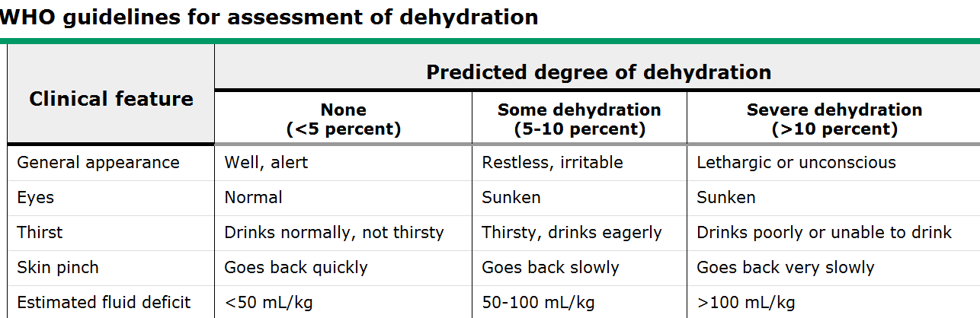
Table 3.14. World Health Organization (WHO) guidelines for assessment of dehydration
For classification of dehydration (DHN), two signs from Table 3.14 (the above table) must be present.

Recommended management
- No DHN: plan A
- Treat diarrhea at home:
- Rules of three F’s:
  - Give extra FLUID
  - Continue FEEDING
  - When to come for FOLLOW-UP
- Give ORS: 10 ml/kg OR
  - 50–100 ml for children under 2 years per bowel movement
  - 100–200 ml for children >2 years
- Other fluids:
- Breast milk, food-based fluids (soup, rice water, yogurt) or clean water
- Frequent breast feeding
- Cow’s milk or formula
- Continue other foods if the child started
- Return/follow-up: see the child in 2 days
- Come back immediately if the child becomes sick (unable to drink, sicker, fever, dysentery)
Some DHN (loss estimated at 5% of the child body weight (average): plan B:
- Treat with ORS:
  - Volume is 75 ml/kg.
  - Give over 4 hours.
  - Continue breastfeeding.
  - If vomiting, wait 10 minutes.
  - After 4 hours, reassess and classify DHN.
Severe DHN (loss estimated at 10% of body weight): plan C
- Start IV immediately
  - Ringer’s lactate or NS
  - Volume is 100 ml/kg
Infants (under 12 months of age) | First give 30 ml/kg over 1 hour | Then give 70 ml/kg over 5 hours
Children >12months of age | Over 30 minutes | Over 2 1/2 hours
Table 3.15. Recommended fluid intake for severe DHN
Always reassess after every fluid because the child’s dehydration status may worsen; replace on ongoing loss.
Role of antibiotics:
Use of antibiotics should be guided by clinical circumstances, as below.
Patients with watery diarrhea:
For patients with known or suspected cholera in the setting of moderate to severe volume depletion, and for patients with known or suspected cholera in the setting of an epidemic, antibiotic therapy is warranted.
Empiric treatment for Shigella infection:
For patients with invasive diarrhea, empiric antibiotic therapy with activity against Shigella species is warranted.
Patients with persistent symptoms:
For patients with invasive diarrhea that does not remit within two days of starting empiric antibiotic therapy
Patients with amebiasis:
Treatment of amebiasis consists of metronidazole (35 to 50 mg/kg per day in three divided doses for 7 to 10 days in children; maximum 750 mg orally, three times daily)
Preventive strategies:
- Promotion of exclusive breastfeeding
- Improved complementary feeding practices
- Immunization (measles, cholera, rotavirus)
- Improved water and sanitary facilities and promotion of personal and domestic hygiene
- Improved case management of diarrhea

Severe acute malnutrition and dehydration
- Difficult to diagnose.
- Consider the diagnosis. When there is significant recent loss, a clear change in the child’s appearance, or recent sinking witnessed by the mother.
- Edematous: weight loss >2% per day.
- Monitor the patient every 30 minutes for 2 hours, then hourly for the next 6–12 hours.
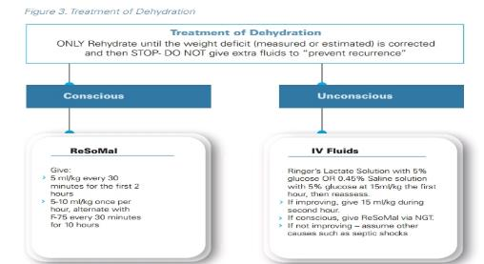
Figure 3.1. Treatment of dehydration
Contents of ReSoMal as prepared from standard ORS:
- Water: 2 liters
- WHO-ORS: one 1-liter packet
- Sugar: 50 g
- Mineral mix solution*: 40 ml or one leveled scoop CMV(combined minerals and vitamins)
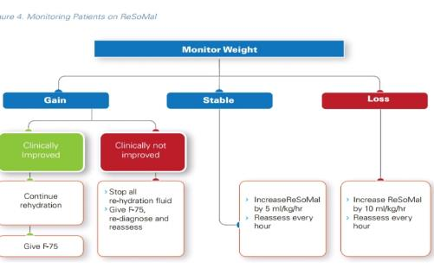
Figure 3.2. Monitoring patience on ReSoMal

Shock
- Give oxygen.
- IV fluid at 15 ml/kg over 1 hour. Use Ringer’s lactate with 5% dextrose; or 0.45% half NS with 5% dextrose.
- If improved, repeat IV 15 ml/kg over 1 hour, then switch to oral or NGT rehydration with ReSoMal, 10 ml/kg/h for up to 10 hours.
- If child fails to improve, give maintenance IV fluids (4 ml/kg/h) while waiting for blood, transfuse fresh whole blood at 10 ml/kg slowly over 3 hours.

3.7. Infectious Diseases

3.7.1. Severe and Complicated Malaria

Introduction
A patient with P. falciparum asexual parasitemia and the presence of one or more of the following clinical or laboratory features, in the absence of an identified alternative cause, is considered to have severe and complicated malaria:
- Impaired consciousness or unrousable coma: Glasgow coma score <11 or Blantyre coma score <3 in children.
- Prostration: generalized weakness so that the patient is unable walk or sit up without assistance.
- Multiple convulsions: more than two episodes in 24 hours.
- Acidosis respiratory distress: rapid, deep breathing; clinically a base deficit of >8 mEq/L or venous plasma lactate >−5 mmol.
- Hypoglycemia: blood or plasma glucose <2.2 mmol/L or <40 mg/dL.
- Shock; capillary refill >−3s or temperature gradient on leg mid to proximal limb but no hypotension. Decompensated shock is defined as systolic BP s <70 mm Hg in children or <80 mm Hg in adults.
- Pulmonary edema: radiologically confirmed or oxygen saturation <90% on room air, respiratory rate >30/min; often chest in drawing and crepitation on auscultation.
- Jaundice: clinical plus evidence of other vital organ dysfunction.
- Severe normocytic anemia: Hb <5 g/dl, or packed cell volume <15% in children <12 years of age.
- Hyperparasitemia: p. falciparum parasitemia >2%/100,000/μl in low intensity.
- Renal impairment: serum creatinine >265 μmol/l or 3 mg/dL or blood urea >20 mmol/L.
- Recommended management

Management of complications
- Coma (cerebral malaria): ABCDE, correct hypoglycemia by infusing dextrose (4 ml/kg of 10% dextrose given by slow IV infusion over 3–5 minutes, or water sugar via NGT.
- Convulsions: Maintain airways; treat promptly with intravenous or rectal diazepam (0.5–1.0 mg/kg) or intramuscular paraldehyde. Check blood glucose.
- Hyperpyrexia: Administer tepid sponging, fanning, a cooling blanket, and antipyretic drugs. Paracetamol is preferred over more nephrotoxic drugs.
- Hypoglycemia: Check blood glucose, correct hypoglycemia, and maintain with glucose containing infusion.
- Severe anemia: Transfuse with screened fresh whole blood.
- Acute pulmonary edema: Prop patient up at an angle of 45°, give oxygen, give a diuretic, stop intravenous fluids, intubate and add PEEP/CPAP in life-threatening hypoxemia.
- Acute renal failure: Exclude prerenal causes, check fluid balance and urinary sodium. If in established renal failure add hemofiltration or hemodialysis, or if unavailable, peritoneal dialysis.
- Spontaneous bleeding and coagulopathy: Transfuse with screened fresh whole blood (cryoprecipitate, fresh frozen plasma and platelets, if available); give vitamin K injection.
- Metabolic acidosis: Exclude or treat hypoglycemia, hypovolemia and septicemia. If severe, add hemofiltration or hemodialysis.
- Shock: Suspect septicemia, take blood for cultures, give parenteral broad-spectrum antimicrobials, correct hemodynamic disturbances.
Specific antimalarial treatment
- Artesunate
  - Above 20 k; IV is preferable/IM artesunate (2.4 mg/kg on admission [time = 0], then at 12 h and 24 h, then once a day is the recommended treatment. If the patient can take orally and is improving, change to full dose oral artemether- lumefantrine. For full three-day course of second-line drug.
  - For children under 20 kg, the dose of artesunate is 3 mg/kg.
  - IM artesunate (2.4 mg/kg at 0, 12, and 24 hours after admission, then change to full dose of artemether- lumefantrine.
  - Duration of treatment: Treatment should be discontinued when the patient tolerates oral treatment any time after 24 hours of parenteral artesunate. Additionally, a single-dose primaquine should be added for p. Falciparum cases.
  - IV or IM artesunate has been shown to significantly reduce the risk of death from severe malaria compared to IV quinine.
- Artemether is an acceptable alternative if parenteral artesunate is not available: 3.2 mg/kg body weight IM given on admission (first day), then 1.6 mg/kg body weight per day on second and third days.
NB: NEVER ADMINISTER BY IV. Anterior thigh is the preferred site for providing the IM injection and the frequency of administration should be once daily.
- Quinine hydrochloride is an acceptable alternative if parenteral artesunate is not available for severe malaria.
- Dosage: 20 mg salt/kg body weight on admission (IV infusion or divided IM injection), then 10 mg/kg body weight every 8 hours; infusion rate should not exceed 5 mg salt/kg body weight/hour.

Monitoring
- Antimalarial medication should be given parenterally, under close supervision.
- Comatose patients should be managed in an ICU.

Disposition
- ICU or critical care room

3.7.2. Tetanus

Introduction
- Tetanus is an acute, spastic paralytic illness caused by tetanospasmin in neurotoxin produced by Clostridium tetani.
- Clinical diagnosis manifests with one of four patterns: generalized, localized, cephalic, and neonatal tetanus.

Sign and symptoms
- Trismus (masseter muscle spasm)
- Risus sardonicus (sardonic smile of tetanus)
- Spasm and patient remain conscious: opisthotonus that lasts seconds to minutes and aggravated by sight, sound, touch, manipulation, laryngeal spasm, and asphyxiation
- Autonomic effects: tachycardia, dysrhythmias, labile hypertension, diaphoresis, and cutaneous vasoconstriction
- Fever may reach 40 degrees Celsius.

Recommended treatment
Supportive care and spasm control
- Keep patient in dark, quiet room, and decrease stimulus that precipitate spasm.
- Generalized tetanus with frequent spasm needs early intubation/tracheostomy.
- Gentle suctioning as required.
- Ensure maintenance of the fluid, electrolyte, and caloric needs.
Diazepam: 0.1–0.2 mg/kg every 3–6 hours IV; subsequently titrated to control tetany, effective dose is sustained for 2–5 weeks + chlorpromazine 0.55 mg/kg/dose every 6 to 8 hours.
Neuromuscular blocking agents: used when sedation alone is inadequate
Halting toxin production
- Optimal wound management to eradicate spores and necrotic tissue.
- Antimicrobial: metronidazole 30 mg/kg/day every 8 hours (preferred) IV or penicillin G 100,000 U/kg/day IV, at 4–6 hour intervals, for 7–10 days.
Neutralization of unbound toxin
- Single injection of 500 U of tetanus immune globulin (TIG) IM; doses as high as 3000–6000 U can be used.
- If TIG is not available, IV human immunoglobulin and or tetanus antitoxin (TAT): 1,500–3,000 U to be administered after skin testing.
Management of autonomic dysfunction (hypertension)
- Magnesium sulfate is the drug choice and labetalol is an alternative.
- Morphine sulfate (0.5-1 mg/kg/hr by continuous IV infusion) to control autonomic dysfunction and to induce sedation.
NB: Don't insert NG tube unless the patient is fully sedated. Careful nursing attention to mouth, skin, bladder, and bowel function is needed.
Active immunization
As tetanus infection does not confer immunity, the patient should receive active immunization (a total of three doses of tetanus and diphtheria toxoid spaced at least two weeks apart), commencing immediately upon diagnosis.
Complications
- Laryngospasm airway obstruction
- Aspiration of secretion and risk of pneumonia
- Laceration, hematoma, rhabdomyolysis with myoglobinuria and renal failure, long bone, or spinal fracture resulting from spasm
- Venous thrombosis and rarely pulmonary embolism
- Gastric ulceration and paralytic ileus
- Decubitus ulceration
- Iatrogenic complication from medications and ventilation

Monitoring
- Cardiorespiratory monitoring

Disposition
- ICU or tetanus room (dark and quite room)

3.7.3. Measles

Introduction
Measles is a highly contagious viral disease with serious complications and high mortality. It is rare in infants under 3 months of age.
Diagnose measles if the child has:
- Fever, a generalized maculopapular rash, and one of the following: cough, runny nose, or red eyes.
- In children with HIV infection, these signs may not be present, and the diagnosis of measles may be difficult.

Severe complicated measles diagnosis
Diagnose severe complicated measles if the child has the above symptoms plus:
- Inability to drink or breastfeed; vomits everything
- Convulsions
- Lethargy or unconsciousness
- Corneal clouding
- Deep or extensive mouth ulcers
- Pneumonia
- Dehydration
- Stridor due to measles croup
- Severe malnutrition
- Bloody diarrhea
Recommended treatment
Children with severe complicated measles require treatment in hospital.
- ABCDE
- Administer oxygen if in respiratory distress.
- Check random blood sugar and treat accordingly.
- If the temperature is ≥39°C, give paracetamol.
- Vitamin A therapy: Give oral vitamin A to all children with measles.
- Give oral vitamin A 50,000 IU (for a child aged <6 months), 100,000 IU (6–11 months), or 200,000 IU (12 months up to 5 years) for 2 days.
- If the child shows any eye signs of vitamin A deficiency or is severely malnourished, a third dose must be given 2–4 weeks after the second dose on follow-up.
- Assess the child’s nutritional status.
- Encourage continued breastfeeding and/or frequent small feeds.
- Check eyes:
  - If there is a pus discharge, clean the eyes using cotton wool boiled in water, or a clean cloth dipped in clean water.
  - Apply tetracycline eye ointment, three times a day for 7 days.
  - Never use steroid ointment. Use a protective eye pad to prevent other infections.
    - If there is no improvement, refer to an eye specialist.
- Check for mouth ulcers and treat:
  - If the child is able to drink and eat, clean the mouth with clean, salted water (a pinch of salt in a cup of water) at least four times a day.
  - Apply 0.25% gentian violet to the sores in the mouth after cleaning.
  - If the mouth ulcers are severe and/or smelly, give IM/IV benzyl penicillin (50,000 units/kg every 6 hours) and oral metronidazole (7.5 mg/kg three times a day) for 5 days.
  - If the mouth sores result in decreased intake of food or fluids, the child may require feeding via a nasogastric tube.
- Neurological complications: convulsions, excessive sleepiness, drowsiness, or coma may be a symptom of encephalitis or severe dehydration.
Monitoring
Take the child’s vital signs twice a day and check for the presence of the above complications.
Follow-up
- Recovery following acute measles is often delayed for many weeks or even months, especially in children who are malnourished.
- Arrange for the child to receive the third dose of vitamin A before discharge, if this has not already been given.
Public health measures
- If possible, isolate children admitted to the hospital with measles for at least 4 days after the onset of the rash. Ideally, they should be kept in a separate ward from other children.
- In malnourished and immune-compromised children, isolation should be continued for the duration of the illness.
- When there are measles cases in the hospital, immunize all other children above the age of 6 months (including those seen in outpatient departments, children admitted in the week following a measles case, and HIV-positive children).
  - If infants aged 6–9 months receive measles vaccine, it is essential for the second dose to be given as soon as possible after 9 months of age.

Non-severe measles diagnosis
Diagnose non-severe measles in a child whose mother clearly reports that the child has had a measles rash, or if the child has fever, a generalized rash, and one of the following: cough, runny nose, or red eyes, but none of the features of severe measles.
Recommended treatment
- Treat as an outpatient.
- Vitamin A therapy:
  - Check whether the child has already been given adequate vitamin A for this illness. If not, give 50,000 IU (if aged <6 months), 100,000 IU (6–11 months) or 200,000 IU (12 months to 5 year) for 2 days.
- Supportive care
  - Fever: If the child’s temperature is ≥39°C, give paracetamol.
  - Nutritional support: Assess the child’s nutritional status by measuring the mid upper arm circumference. If malnourished, treatment must be given.
  - Encourage the mother to continue breastfeeding or give frequent small meals depending on the age of the child. Check for mouth ulcers and treat as above.
  - Eye and mouth care
  - Standard and droplet precautions are recommended.
Monitoring
- Ask the mother to return with the child in 2 days.

3.8. Pediatrics Glycemic Control

3.8.1. Pediatric Diabetic Ketoacidosis

Introduction
Diabetic ketoacidosis (DKA) presents with polysymptoms (polyuria, polydipsia, and polyphagia) and combinations of nausea, vomiting, abdominal pain, deep fast breathing, altered consciousness, and dehydration, based on severity.
Diagnostic criteria for DKA
Clinical presentation plus blood glucose >200 mg/dL, bicarbonate <18 mmol/L, and pH 7.3 with ketonuria (dipstick +1 and above) or ketonemia.
Classification
- Severe: Acidotic breath and altered mentation, severe dehydration, PH <7.1 bicarbonate <5 mmol/L
- Moderate: Acidotic breathing and irritable mental status, some dehydration, PH 7.1–7.25, bicarbonate <10 mmol/L
- Mild: No acidotic breathing and normal; mentation PH <7.35, bicarbonate <18

Investigation
RBS, urine analysis, serum electrolyte, blood urea nitrogen (BUN), creatinine, osmolality, and blood gas if available. Blood cultures and other laboratory tests only as clinically indicated.

Recommended management
- ABCDE
- Severe and moderate DKA with no shock, 0.9% saline 10 ml/kg over 1 hour.
- Patients with shock, NS 20 ml/kg bolus as quickly as possible in 20 minutes. Repeat as necessary, with careful reassessment after each bolus.
- If septic shock, fluid boluses until out of shock, broad-spectrum antibiotic, and consider vasopressors (see section 3.2.4 for sepsis management)
Subsequent fluid management
- Calculate fluid deficit and MF
  - Deficit is assumed 5% for mild, 7% for moderate, and 10% for severe DKA (e.g., for weight 10 kg and mild, it will be 5% x 10 kg = 500 ml).
  - For weight 10 kg and severe, it will be 10% x 10 kg = 1000 ml.
  - (Maintenance fluid MF48 hours) + deficit fluid − bolus fluid) = ______ ml/48 hours, which is similar to 1 and ½ maintenance fluid.
- Type of fluid
  - Use NS in the first 1 hour and for at least 4–6 hours for severe DKA.
  - Change fluid to 0.45% NS once corrected sodium is normal.
  - After 4 hours of fluid and when RBS reaches 270 mg/dl, change the fluid to ½ NS in 5% DW for infants and DNS for older children (to make this in our setting, use half fluid DNS and half DW).
  - When RBS <150, change fluid to 10% dextrose in NS (to prepare this make 15% of the fluid 40% dextrose and 85% DNS) or 10 dextrose in ½ NS.
  - Oral fluids should be introduced only when clinical improvement has occurred.
  - In areas with limited care and when IV fluids are unavailable, arrange urgent transport to a facility that can provide IV fluid.
  - Give little sips (or a small volume thorough a syringe) of ORS as frequently as possible (if there is no vomiting).
  - If vomiting does not occur after 1–2 hours, give ORS at a rate of 5 ml per kg body weight per hour.
  - In some cases, it may be possible to insert a nasogastric tube and slowly rehydrate with ORS at 5 ml per kg body weight per hour.
Potassium replacement therapy
- Start potassium after the patient passes urine.
- Potassium 40 meq/L after K level known or adequate urine passed K <3 mmol /L after the initial bolus: K+ of 60 mEq/L or greater may be necessary.
  - [K+] <3 mEq/L: give 0.5 mEq/kg of KCL over 1 hour and delay insulin administration for 1 hour.
  - [K+] = 3 to 4.5 give 3.5 mEq/L: after bolus fluid and child passes urine, 40 mEq/L of KCL.
  - [K+] = 4.6 to 5.0: give only 20 mEq/L of potassium/L.
  - [K+] > 5.0, withheld K in the initial fluids till normalizes and patient passes urine.
The maximum recommended rate of IV potassium replacement is usually 0.5 mmol/kg/h. If hypokalemia persists despite a maximum rate of potassium replacement, then the rate of insulin infusion can be reduced.
Insulin therapy
- Start after 1 hour of fluid resuscitation as IV infusion 0.1 IU/kg/hr regular insulin (0.05 U/kg/hr for children under 2 years).
  - Dilute 50U regular insulin in 50 ml NS to make 1 u = 1 ml.
  - Infuse insulin via a dedicated IV line.
  - Ensure that the infusion is clearly labeled and carries a “do not flush” order.
- If continuous infusion is not possible, use (0.3–0.4 U/kg every 3–4 hours SC administration of regular insulin with half this dose for children under 2 years. Consider the first dose ½ IV and ½ IM.
- If again this is not visible, use subcutaneous insulin dose: 0.5 unit/kg every 6 hours (but 0.25 IU/kg every 6 hours for under-5 children), except the first dose ½ IV and ½ IM (because SC will not be absorbed right away in a dehydrated child in the first dose).
NB:
If your setting doesn’t have a perfuser it is better to refer children under 2 years to a setting where there is perfuser.
If the random blood glucose drops, adjust the decline by changing the fluid rather than decreasing the dose of insulin.
- Do not omit insulin, but decrease by 50% if
  - Rapid decline of glucose (100 mg/hr), do the RBS every one hour.
  - The child becomes hypoglycemic <70 mg/dl.
  - Unresponsive hypokalemia despite treatment. Maintain the blood glucose between 150 and 250 mg/dl.
  - If IV perfusion is used, give SC insulin 30 minutes before infusion is stopped.
- Continue IV insulin until blood glucose <200 mg/dl and metabolically stable (PH >7.3 and Hco3 >15)
- When child is ketone free and stable, can start combination Neutral Protamine Hagedorn (NPH) (Neutral protamine Hagedorn) and regular insulin.
Possible complications
- Cerebral edema
- Electrolyte abnormality (hypokalemia, hyperkalemia, hypophosphatemia)
- Hypoglycemia
- Profound metabolic acidosis
Treat complications
- Cerebral edema: If there are signs of ICP (see section on ICP, section 3.5.1) give the child mannitol 1 gm/kg IV over 10 minutes.
- Hypoglycemia: Change fluid to 10% glucose in NS and decrease insulin by half.

Monitoring
- Use the DKA flow sheet for monitoring (attached in annex)
- Serum [K+] every 2 to 4 hours until the acidosis and hyperglycemia are normalized; more frequently if hypokalemia is encountered.

Disposition
- Admit to ICU as much as possible: severe DKA patients, patient younger than 2 year of age, GCS < 12, [Na+] > 150 mmol / L, [K+] < 2.5 mmol/L and cerebral edema.
- If the child cannot be transported (e.g., roads blocked), give oral rehydration as (see above) and SC insulin 0.05 units/kg every 1–2 hours.
- Insulin should be started after an hour of fluid resuscitation.

3.8.2. Hypoglycemia

Definition
- Hypoglycemia: Any value with (blood glucose: <3.05 mmol/l or <55 mg/dl) is common in children under 3 years old, but clinical symptoms in infancy are nonspecific.
- Obtaining critical sample can be considered to identify specific cause of hypoglycemia.

Recommended management
- Goal of treatment is to maintain blood sugar between 70–100 mg/dl. Any symptomatic hypoglycemia should be corrected with 200 mg/kg (2ml/kg) of 10% dextrose, followed by maintenance of 10% glucose for age RBS level has to be done after 15 minutes of dextrose bolus; if it is low (<50mg/dl), repeat the bolus to 5 ml/kg.
- In an unconscious child, prevent further hypoglycemia by initiating NG feeding once the child is fully conscious. Start feeding with PO. Continue to monitor the blood glucose level and treat accordingly.
- If no IV line, give dextrose in water via NG tube until IV accessed.

3.9. Pediatric Oncology Emergency

3.9.1. Hyper Leukocytosis

Introduction and principle of care
Peripheral leukocyte > 100,000 cells/ml which lead to increased viscosity and microvascular stasis and thrombosis to organs.
Clinically significant if > 200,000 cells/ml in acute myeloid leukemia (AML) and > 300,000 cells/ml in acute lymphoblastic leukemia (ALL).
End organ involved | Clinical features and imaging
Lung | Tachypnea, dyspnea, hypoxemia, pulmonary infiltrate, acidosis
Lung | CXR: may reveal varying degree of diffuse interstitial or alveolar infiltrate
CNS | Headache, lethargy, tinnitus, blurred vision, seizure, stroke, ataxia, retinal hemorrhage
CNS | CT: hemorrhage or leukemic infiltrate
Others | Renal failure, priapism, dactylitis, Tumer lysis syndrome (TLS), consumptive coagulopathy, myocardial ischemia, acute limb ischemia, bowel infraction
Table 3.16. Organs involved and clinical features
Laboratory
- CBC, platelet count, lactate, PT, aPTT, fibrinogen, electrolyte, organ function tests, uric acid, CXR, CT, and/or MRI as indicated.
- PaO2 should be relied on more than SPO2 as methemoglobin may be elevated.

Recommended management
Goals of management
- Prevent/manage tumor lysis syndrome (TLS) (see section 3.9.2 on TLS).
- Prevent/manage leukocytosis.
- Manage dissemination intravascular coagulation (DIC).
Supportive care
- Vigorous hydration (3 L/m²/24 hours) to reduce risk of TLS and increase urine output.
- Transfuse only in severe anemia with congestive heart failure (whole blood 5–10 ml/kg over 3–4 hours) because transfusion can increase viscosity further.
NB: Avoid packed red blood cell transfusion.
- Fresh frozen plasma (FFP) and vitamin K to correct coagulopathy
- Maintain platelet above 50,000/mm³
- Cytoreduction
Asymptomatic:
- Hydroxyurea: 50–100 mg/kg given PO 3–4 doses daily
Symptomatic:
- Induction chemotherapy, e.g., for ALL, cytarabine with anthracycline can be started.
- Consider low dose prednisolone for reduction phase prior to induction chemotherapy phase in patients with ALL and WBC > 300,000–500,000/mm³.

Monitoring
- Vital signs, urine output
- Monitor for leukostasis

Disposition
- Transfer to oncology unit if no complications
- Patients with TLS and leukostatic crisis should be admitted to the ICU for continuous cardiac monitoring or respiratory support.

3.9.2. Tumor Lysis Syndrome

Introduction
TLS is a metabolic abnormality due to rapid release of intracellular metabolites from dying cells that exceed excretory capacity of the kidneys. TLS can happen spontaneously or following chemotherapy.
Metabolite or electrolyte | Criterion for diagnosis
Uric acid | > 8 mg/dL or 25% increase from the baseline
Potassium | > 6mEg/L or 25% increase from the baseline
Phosphorus | > 6.5 mg/dl (children), > 4.5 mg/dl (adult), or 25% increase from the baseline
Calcium | > 25% increase from the baseline
Table 3.17. Cairo-Bishop definition of laboratory and clinical tumor lysis syndrome
Clinical tumor lysis syndrome
- Laboratory TLS (LTLS) and one or more of the following:
- Creatinine ≥ 1.5 upper limit of normal (ULN) (age > 12 years of age or adjusted)
- Cardiac arrhythmia or sudden death
- Seizure
N.B. Laboratory TLS is defined as two or more of the above present within three days before treatment or seven days after chemotherapy.
Laboratory: CBC, electrolytes, urea, creatinine, uric acid.

Recommended treatment and prevention
- Intermediate and high-risk patients
- IV fluid (preferred NS) 2–3 L/m²/day (or 200 ml/kg/day in a child ≥ 10kg)
  - Target urine output of 3–5 ml/kg/hr
- Begin 24–48hr before chemotherapy and continue 48–72 hours after
- Mannitol or furosemide if adequate diuresis not achieved and for fluid overload
- Dialysis for AKI and medically refractory and dangerous metabolic derangements
- Allopurinol 50–100 mg/m² or 10 mg/kg/day TID
- Hypocalcemia: Give calcium only for symptomatic hypocalcemia (seizure, tetany, and bradycardia)
- Aluminum containing antacids to prevent gut absorption of phosphate

Monitoring
- Electrolytes every 8–12 hours in the acute phase
- Strict input/output and vital sign monitoring
- Continuous ECG monitoring

Disposition
- Admit to oncology ward or refer to oncology center.

3.9.3. Superior Mediastinal Syndrome (SMS) and Superior Vena Cava Syndrome (SVCS)

Introduction
- SVCS refers to signs and symptoms resulting from compression, obstruction, or thrombosis of the superior vena cava.
- SMS = SVCS + tracheal compression.
Superior vena cava syndrome | Superior mediastinal syndrome
Swelling, plethora, and cyanosis of the face, neck, and upper extremities | Cough, hoarseness, dyspnea, orthopnea, wheezing, chest pain, dysphagia, and stridor
Suffusion of the conjunctiva | Supine position worsens symptoms
Altered mental status | Altered mental status and syncope
Table 3.18. Superior Mediastinal Syndrome (SMS) and Superior Vena Cava Syndrome (SVCS)
NB: Distal trachea can still collapse after intubation by external pressure and ventilation difficulty.
Laboratory
- Radiograph and CT (if tolerated). Test for CBC, LDH, uric acid, α-fetoprotein, and β-hCG (human chorionic gonadotropin), pleural fluid analysis.
- Echocardiogram: cardiac function and possible intravascular thrombus.
- If high risk, perform least invasive tests with local anesthesia (e.g., bone marrow aspirate).

Recommended management
- Position the patient upright. DO NOT PUT PATIENT IN RECUMBENT POSITION, even while taking an image.
- Noninvasive ventilation temporarily reduces the degree of airway obstruction and improves airflow.
- IV access preferably in lower extremities.
- Keep child calm, minimal handling, no sedation:
  - If intubation cannot be avoided, anesthesiologists and ENT surgeons should be present, and intubation done with spontaneous breath without deep sedation and paralysis.
  - Empiric treatment with radiation, chemotherapy, or both when diagnostic tests are not safe; biopsy as soon as mass shrinks and patient is stable.
  - Prednisolone 60 mg/m2/day (2 mg/kg/day) or dexamethasone 6 mg/m²/day in two divided doses or methyl prednisolone 48 mg/m²/day (1.6 mg/kg/day) should be employed.
  - Anticoagulation for thrombosis with no evidence of hemorrhage.

Monitoring
- Closely monitor the patient’s vital signs, input/output, ECG monitor, and mental status.

Disposition
- Refer to hemato-oncology center immediately.

3.9.4. Febrile Neutropenia

Introduction
A single oral temperature >38.3C or >38.0C sustained for >1 hour or occurring twice within 24 hours in a child with ANC < 500 or ANC < 1000 expected to decrease to <500 in 48 hours; etiologies can be Gram positive and negative rods, gram positive cocci, viruses, fungi, and anaerobes.
Clinical manifestation:
- Unexplained fever without evident focus
- Examine thoroughly every system (e.g., anal area) (avoid per rectal [PR] exam though!), including skin.
Investigations: CBC, Blood cultures, urine cultures, Gram stain and culture from suspicious sites

Recommended management
- Empiric antibiotic with in 1 hour of triage and response assessed in 3–5 days.
- Ceftriaxone and gentamycin for uncomplicated patients
- Modify antibiotic based on blood culture or if patient deteriorates, consider vancomycin at a dose of 60 mg/kg/day IV divided every 8h (max 4 g/day) in the following situations:
  - Patients with AML receiving high-dose cytarabine
  - Presentation with hypotension or other evidence of shock and mucositis
  - Skin breakdown or catheter site infection
  - Vegetation on echocardiogram
- Stop antibiotics if culture is negative, patient afebrile, ANC > 500, or if ANC > 200 and rising, and a total duration of not more than 7–10 days in Gram positive and 10–14 days in Gram negative infections.
- Add antifungal like amphotericin B if no response to 3–5 days of antibiotics treatment.

Monitoring
- Vital signs, ECG, mental status, urine output

Disposition
- Admit to general ward with infection precautions (“clean room”).

3.9.5. Typhilitis

Introduction and clinical features
- Necrotizing colitis is mostly in neutropenic patients with hematologic malignancies with breakdown of gut mucosal integrity as a result cytotoxic chemotherapy.
- Cecum is most commonly affected site; mostly a polymicrobial infection.
- Should be considered in neutropenic patients with fever and abdominal pain.
- Abdominal distension, nausea, vomiting, watery or bloody diarrhea, paralytic ileus, signs of peritonitis and shock.
Investigations: Blood and stool culture, imaging including plain abdominal film and CT scan

Recommended management
- NPO, NG suction; packed red cell and platelet transfusions, as indicated
- Broad-spectrum antibiotics: piperacillin-tazobactam or cefepime/ceftazidime plus metronidazole or meropenem, or ciprofloxacin plus metronidazole or Augmentin fungal coverage is needed if fever is protracted >72 hours.
Indications for surgical intervention
- Persistent gastrointestinal (GI) bleeding despite resolution of neutropenia and thrombocytopenia. Evidence of free air in the abdomen on abdominal radiograph and clinical deterioration

Monitoring
- Follow the mental status; capillary refill, weight, urine output, vital signs, skin pinch, and liver size should be recorded before and after treatment.

Disposition
- Hemodynamically unstable patients should be admitted to and managed in the PICU.

References
- AHA/AAP: Pediatric Advanced Life Support (PALS) 2020
- SCCM: Pediatric Fundamental Critical Care Support (PFCCS) 2018
- Ethiopian National ETAT guideline, 2014
- Khemani, R.G., Smith, L.S., Zimmerman, J.J. and Erickson, S., 2015. Pediatric Acute Lung Injury Consensus Conference G. Pediatric acute respiratory distress syndrome definition, incidence, and epidemiology: proceedings from the pediatric acute lung injury consensus conference. Pediatr Crit Care Med, 16(5 Suppl 1), S23-40
- Kneyber, M.C.J., de Luca, D., Calderini, E. et al. Recommendations for mechanical ventilation of critically ill children from the Paediatric Mechanical Ventilation Consensus Conference (PEMVECC). Intensive Care Med 43, 1764–1780 (2017). https://doi.org/10.1007/s00134-017-4920-z
- Furham and Zimmerman text book of Pediatric critical care 2015
- PALS 2020
- Baracco, R. and Mattoo, T.K., 2014. Pediatric hypertensive emergencies. Current hypertension reports, 16(8), p.456.
- Flynn, J.T., Kaelber, D.C., Baker-Smith, C.M., Blowey, D., Carroll, A.E., Daniels, S.R., de Ferranti, S.D., Dionne, J.M., Falkner, B., Flinn, S.K. and Gidding, S.S., 2017. Clinical practice guideline for screening and management of high blood pressure in children and adolescents. Pediatrics, 140(3).
- Text book of pediatric infectious disease, 4th edition
- International society of pediatric and adolescent diabetes; ISPAD 2018
- Nelson text book of pediatrics 21st edition
- Fuhrman and Zimmerman Pediatric critical care, 5th edition, 2016
- SCCM: Pediatric Fundamental Critical Care Support (PFCCS) 2018
- Lanzkowsky P, management of oncologic emergencies from: Manual of pediatric hematology and oncology Philip Lanzwosky 5th edition. Academic Press, 2011.
- Tintinal’s 9th edition Fluid and electrolyte mangment in pediatrics page 851-856
- Fundamental of critical care second edition chapter 8 Fluid, electrolyte and neuroendocrine metabolic derangements page 8-1-8-16
- AFEM Handbook of Acute and Emergency Care. 2nd ed. Cape Town, South Africa: Oxford University Press; 2018
- American Society of Anesthesiologists Task Force on Management of the Difficult Airway. Practice guidelines for management of the difficult airway: an updated report by the American Society of Anesthesiologists Task Force on Management of the Difficult Airway. Anesthesiology. 2003 May;98(5):1269–77. Erratum in: Anesthesiology. 2004 Aug;101(2):565. PMID: 12717151.
- Bair AE, Caravelli R, Tyler K, Laurin EG. Feasibility of the preoperative Mallampati airway assessment in emergency department patients. J Emerg Med. 2010 Jun;38(5):677–80. doi: 10.1016/j.jemermed.2008.12.019. PMID: 19297115.
- Cook TM, MacDougall-Davis SR. Complications and failure of airway management. Br J Anaesth. 2012 Dec;109 Suppl 1:i68–i85. doi: 10.1093/bja/aes393. PMID: 23242753.
- Cormack RS, Lehane J. Difficult tracheal intubation in obstetrics. Anaesthesia. 1984 Nov;39(11):1105–11. PMID: 6507827.
- Greenland KB. Airway assessment based on a three column model of direct laryngoscopy. Anaesth Intensive Care. 2010 Jan;38(1):14–9. PMID: 20191771.
- Mallampati SR, Gatt SP, Gugino LD, Desai SP, Waraksa B, Freiberger D, Liu PL. A clinical sign to predict difficult tracheal intubation: a prospective study. Can Anaesth Soc J. 1985 Jul;32(4):429–34. PMID: 4027773.
- Nørskov AK, Rosenstock CV, Wetterslev J, Astrup G, Afshari A, Lundstrøm LH. Diagnostic accuracy of anaesthesiologists’ prediction of difficult airway management in daily clinical practice: a cohort study of 188 064 patients registered in the Danish Anaesthesia Database. Anaesthesia. 2015 Mar;70(3):272–81. PMID: 25511370.
- Rich JM. Recognition and management of the difficult airway with special emphasis on the intubating LMA-Fastrach/whistle technique: a brief review with case reports. Proc (Bayl Univ Med Cent). 2005 Jul;18(3):220–7. PMC1200729.
- Yentis SM, Lee DJ. Evaluation of an improved scoring system for the grading of direct laryngoscopy. Anaesthesia. 1998 Nov; 53(11):1041–4. PMID: 10023271.
- American College of Surgeons and the Committee on Trauma. ATLS: Advanced Trauma Life Support. American College of Surgeons; 2018.
- Walls R, Hockberger R, Gausche-Hill M. Rosen's Emergency Medicine. Elsevier Health Sciences; 2018.
- Hachimi-Idrissi S, Watelet JB. First-line attitudes in acute medicine. B-ENT. 2016; Suppl 26(1):31–39. PMID: 29461732.
- American Academy of Orthopaedic Surgeons (AAOS). Advanced Assessment and Treatment of Trauma. Jones & Bartlett Learning; 2009.
- American College of Surgeons and the Committee on Trauma. ATLS: Advanced Trauma Life Support. American College of Surgeons; 2018
- Dawodu ST, Aden McLaughlin. Traumatic Brain Injury (TBI): Definition and Pathophysiology. In: Traumatic Brain Injury (TBI): Definition and Pathophysiology. New York; 2017.
- American College of Surgeons and the Committee on Trauma. ATLS: Advanced Trauma Life Support. American College of Surgeons; 2018.
- Walls R, Hockberger R, Gausche-Hill M, Erickson TB, Wilcox SR. Rosen's Emergency Medicine 10th edition: Concepts and Clinical Practice E-Book. Elsevier Health Sciences; 2022.
- Nowicki J, Stew B, Ooi E. Penetrating neck injuries: a guide to evaluation and management. Ann R Coll Surg Engl. 2018 Jan; 100(1):6–11.
- Tension pneumothorax—time for a re-think?, S Leigh-Smith 1, T Harris 1, PMCID: PMC1726546 PMID: 15611534.
- American College of Surgeons and the Committee on Trauma. ATLS: Advanced Trauma Life Support. American College of Surgeons; 2018.
- Leech C, Porter K, Steyn R, et al. The pre-hospital management of life-threatening chest injuries: a consensus statement from the Faculty of Pre-Hospital Care, Royal College of Surgeons of Edinburgh. Trauma. 2016;19(1).
- American College of Surgeons and the Committee on Trauma. ATLS: Advanced Trauma Life Support. American College of Surgeons; 2018
- Walls R, Hockberger R, Gausche-Hill M, Erickson TB, Wilcox SR. Rosen's Emergency Medicine 10th edition: Concepts and Clinical Practice E-Book. Elsevier Health Sciences; 2022.
- Moore EE, V. Feliciano D, Mattox KL. Trauma. Eighth Edition. McGraw Hill Professional; 2017.
- American College of Surgeons and the Committee on Trauma. ATLS: Advanced Trauma Life Support. American College of Surgeons; 2018.
- Walls R, Hockberger R, Gausche-Hill M, Erickson TB, Wilcox SR. Rosen's Emergency Medicine 10th edition: Concepts and Clinical Practice E-Book. Elsevier Health Sciences; 2022.
- Moore EE, V. Feliciano D, Mattox KL. Trauma. Eighth Edition. McGraw Hill Professional; 2017.
- Pathophysiology of burn BMJ 2004; 328 doi: https://doi.org/10.1136/bmj.328.7453.1427 (Published 10 June 2004)Cite this as: BMJ 2004;328:1427
- Walls R, Hockberger R, Gausche-Hill M, Erickson TB, Wilcox SR. Rosen's Emergency Medicine 10th edition: Concepts and Clinical Practice; 2022.
- R. Palao, I. Monge, M. Ruiz, J.P. Barret. Chemical burns: Pathophysiology and treatment. Burns. 2010 May; 36(3):295–304.
- Macaluso C, McNamara. Evaluation and management of acute abdominal pain in the emergency department. Int J Gen Med. 2012;5. PMC3468117.
- Tintinalli JE, Stapczynski JS, Ma OJ, Yealy D, Meckler GD, Cline DM. Tintinalli's Emergency Medicine: A Comprehensive Study Guide, 9th edition. McGraw Hill Professional; 2019.
- Walls R, Hockberger R, Gausche-Hill M. Rosen's Emergency Medicine. Elsevier Health Sciences; 2018.
- Acute Arterial Occlusion, David A. Smith; Craig J. Lilie., Author Information and Affiliations, Last Update: January 2, 2023.
- Callum K. ABC of arterial and venous disease: Acute limb ischaemia; 2000
- Stephens E. Peripheral Vascular Disease. In: Schraga, ed., Peripheral Vascular Disease; 2017.
- Hotchen AJ, McNally MA, Sendi P. The classification of long bone osteomyelitis: a systemic review of the literature. J Bone Jt Infect. 2017 Sep12;2(4):167–174.
- Bury DC, Rogers TS, Dickman MM. Osteomyelitis: Diagnosis and Treatment; 2021.
- Helm C, Huschart E, Kaul R, Bhumbra S, Blackwood RA, Mukundan D. Management of acute osteomyelitis: a ten-year experience. Infect Dis Rep. 2016 Sep 29;8(3):6350.
- Goldman L, Schafer AI. Goldman-Cecil Medicine, 25th edition. Elsevier; 2016
- Horowitz DL, Katzap E, Horowitz S, Barilla-LaBarca ML. Approach to Septic Arthritis; 2011
- Carpenter CR, Schuur JD, Everett WW, Pines JM. Evidence-based Diagnostics: Adult Septic Arthritis; 2011
- Shirtliff ME, Mader JT. Acute Septic Arthritis; 2002
- Tintinalli JE, Stapczynski JS, Ma OJ, Yealy D, Meckler GD, Cline DM. Tintinalli's Emergency Medicine: A Comprehensive Study Guide, 9th edition. McGraw Hill Professional; 2019.
- Walls R, Hockberger R, Gausche-Hill M. Rosen's Emergency Medicine. Elsevier Health Sciences; 2018.
- Tong SYC, Davis JS, Eichenberger E, Holland TL, Fowler VG. Staphylococcus aureus infections: epidemiology, pathophysiology, clinical manifestations, and management. Clin Microbiol Rev. 2015 Jul;28(3):603–61.
- Ramakrishnan K, Salinas RC, Agudelo Higuita NI. Skin and Soft Tissue Infections. Am Fam Physician. 2015;92(6):474–83.
- Stevens DL, Bisno AL, Chambers HF, et al. Practice guidelines for the diagnosis and management of skin and soft tissue infections; 2014.
- Walls R, Hockberger R, Gausche-Hill M. Rosen's Emergency Medicine. Elsevier Health Sciences; 201
- Comprehensive guidelines from authoritative sources such as the American Academy of Otolaryngology-Head and Neck Surgery (AAO-HNS) and relevant clinical studies and reviews on tonsillopharyngitis management.
- Centers for Disease Control and Prevention, National Center for Emerging and Zoonotic Infectious Diseases (NCEZID), Division of Healthcare Quality Promotion (DHQP), November 2022., “CDC Guideline for Hand Hygiene in Health-Care Settings” or “Guideline for Isolation Precautions: Preventing Transmission of Infectious Agents in Healthcare Settings, 2007”, IPC as "multiple health workers from different professional backgrounds work[ing] together with patients, families, carers, and communities to deliver the highest quality of care."Outlines the key elements of IPC, including teamwork, communication, roles/responsibilities, and patient-centeredness. Identifies organizational, professional, and patient-related factors that can facilitate or hinder the implementation of effective IPC. Discusses the role of leadership, resources, and organizational culture in supporting IPC.
- CETL 2010, Feedback Opportunities, A Training Resource for Healthcare Professionals. Handout: Breaking bad news.
- Baile WF, Buckman R, Lenzi R, Glober G, Beale EA, Kudelka AP. SPIKES—A six-step protocol for delivering bad news: application to the patient with cancer. Oncologist. 2000;5(4):302–11.
- Buckman R. Breaking bad news: why is it still so difficult? Br Med J (Clin Res Ed). 1984;288(6430):1597–99.
- Fallowfield L, Jenkins V. Communicating sad, bad, and difficult news in medicine. The Lancet. 2004;363(9405):312–9.
- Rosenberg AR, Wolfe J, Wiener L, Lyon M, Feudtner C. Navigating a new normal: Recommended professional practices when children have serious life-threatening illnesses. Pediatrics. 2016;138(6):e20162886.
- Warnick A, Beebe D. Telling the child with cancer. J Pediatr Oncol Nurs. 1989;6(2):71–5.
- World Health Organization. The Clinical Use of Blood Handbook. Geneva: WHO; 2017.
- Bates I, Chapotera GK, McKew S, van den Broek N. Maternal mortality in sub-Saharan Africa: the contribution of ineffective blood transfusion services. BJOG. 2008;115(11):1331–9.
- Alem A, Enawgaw B, Gelaw A, Kenaw T. Transfusion-related adverse events at the University of Gondar Hospital, Northwest Ethiopia. J Blood Med. 2017;8:141–6.
- Ethiopian Federal Ministry of Health. National Blood Transfusion Service Strategic Plan 2016–2020. Addis Ababa, Ethiopia: FMOH; 2016.
- Goel R, Tobian AAR, Shaz BH. Noninfectious transfusion-associated adverse events and their mitigation strategies. Blood. 2019;133(17):1831–9. doi: 10.1182/blood-2018-10-833988
- Oakley FD, Woods M, Arnold S, Young PP. Transfusion reactions in pediatric compared with adult patients: a look at rate, reaction type, and associated products. Transfusion (Paris). 2014; 55(3):563–70. doi: 10.1111/trf.12827
- Ministry of Health Ethiopia. Obstetrics Management Protocol for Hospitals. 2121
- Gabra A. Complications of hyperemesis gravidarum; a disease of both mother and fetus, review article. Crit Care Obst Gyne. 2121;5(1)1.
- Cydulka RK, Fitch MT, Joing SA, et al. Tintinalle’s Emergency Medicine, A Comprehensive Study Guide, 8th edition. McGraw Hill/Medical; 2017.
- Diagnosis and Management of Shock in Emergency department, Emergency Medicine Practise, An Evidenced Based Approach to Emergency Medicine, EBMEDICINE.NET.
- Marino PL. Marino's, The ICU Book, 4th edition. LWW; 2013.
- National Integrated Emergency Medicine Training. Participants manual, 2021.
- Tintinalli’s Emergency Medicine: A Comprehensive Study Guide, 9th edition. McGraw Hill Education; 2020.
- Ethiopian Federal Ministry of Health: National Emergency Treatment Protocol, 1st edition, November 2016.
- Rosen’s Emergency Medicine: Concepts and Clinical Practice, 10th edition. Elsevier, Inc.;2023.
- Tintinalli’s Emergency Medicine: A Comprehensive Study Guide, 8th , E. Tintinalli, J. Stephan Stapczynski, O. John Ma, Donald M. Yealy, Garth D. Meckler, David M. ClineLetko E, Papaliodis DN, Papliodis GN, et al. Stevens-Johnson syndrome and toxic epidermal necrolysis: a review of the literature. Ann Allergy Asthma Immunol 2005;94:419.
- Ministry of Health Ethiopia. Obstetrics Management Protocol for Hospitals. 2021.
- Butalia S, et al. Hypertension Canada’s 2018 guidelines for the management of hypertension in pregnancy. Can J Cardiol. 2018;34(5):526–31.
- Louis JM, et al. Preeclampsia: a report and recommendations of the workshop of the Society for Maternal-Fetal Medicine and the Preeclampsia Foundation. Amer J Obstet Gynecol. 2022;227(5):B2–B24
- Holliman KD, Lowe V, Nonni G. Management of blood pressure in pregnancy: new perspectives from the CHAP trial. Curr Opin Obstet Gynecol. 2023;35(2):81–6
- Webster SN. Creasy & Resnik's Maternal–Fetal Medicine: Principles and Practice. Wiley Online Library; 2023.
- Ministry of Health national Guideline on Prevention and Management of Postpartum Hemorrhage. 2022, Ethiopia.
- World Health Organization. WHO recommendations: uterotonics for the prevention of postpartum hemorrhage. 2018.
- Bridgman‐Packer, D. and S. Kidanemariam, The implementation of safe abortion services in Ethiopia. Internat J Gyn Obstet. 2018;143:19–24.
- Tariku M. Magnitude of severe acute maternal morbidity and associated factors related to abortion: a cross-sectional study in Hawassa University Comprehensive Specialized Hospital, Ethiopia, 2019. BioMed Research Internat. 2020:1–10
- Gabra A. Complications of hyperemesis gravidarum; a disease of both mother and fetus, review article. Crit Care Obst Gyne. 2018;5(1):1.
- Fleisher GR, Ludwig S. Textbook of Pediatric Emergency Medicine. Lippincott Williams & Wilkins; 2010. https://www.amazon.com/Textbook-Pediatric-Emergency-Medicine-Fleisher/dp/1605471593.
- Pediatric Basic and Advanced Life Support: 2020 American Heart Association Guidelines for Cardiopulmonary Resuscitation and Emergency Cardiovascular Care. Alexis A. Topjian, MD, MSCE, Chair, Tia T. Raymond, MD, Vice-Chair, Dianne Atkins, MD, Melissa Chan, MD, Jonathan P. Duff, MD, MEd, Benny L. Joyner Jr, MD, MPH, Javier J. Lasa, MD, Eric J. Lavonas, MD, MS, Arielle Levy, MD, MEd, Melissa Mahgoub, PhD, Garth D. Meckler, MD, MSHS, Kathryn E. Roberts, MSN, RN, Robert M. Sutton, MD, MSCE, and Stephen M. Schexnayder, MD On behalf of the Pediatric Basic and Advanced Life Support Collaborators, https://doi.org/10.1161/CIR.0000000000000901
- https://www.sccm.org/tab-pages/pediatric-fundamental-critical-care-support-self-study?PWP57f5689392c54854bccac791a7d69f2f=true#Tab-3089
- Emergency Triage Assessment and Treatment (ETAT + Ethiopia) Manual for Participants Ethiopia Federal Democratic Republic of Ethiopia, guideline, 2014
- Khemani RG, Smith LS, Zimmerman JJ, Erickson S. Pediatric Acute Lung Injury Consensus Conference G. Pediatric acute respiratory distress syndrome definition, incidence, and epidemiology: Proceedings from the pediatric acute lung injury consensus conference. Pediatr Crit Care Med. 2015;16(5 Suppl 1):S23–40
- Kneyber MCJ, de Luca D, Calderini E et al. Recommendations for mechanical ventilation of critically ill children from the Paediatric Mechanical Ventilation Consensus Conference (PEMVECC). Intensive Care Med. 2017;43:1764–80. https://doi.org/10.1007/s00134-017-4920-z
- Zimmerman JJ. Furham and Zimmerman’s Pediatric Critical Care. Elsevier; 2015
- PALS 2020
- Baracco R, Mattoo TK. Pediatric hypertensive emergencies. Current Hypertension Reports. 2014;16(8):456.
- Flynn JT, Kaelber DC, Baker-Smith CM, Blowey D, Carroll AE, Daniels SR, de Ferranti, SD, Dionne JM, Falkner B, Flinn SK, Gidding SS. Clinical practice guideline for screening and management of high blood pressure in children and adolescents. Pediatrics. 2017;140(3).
- Textbook of Pediatric Infectious Diseases, 2-Volume Set: 2-Volume Set 4th Edition by James Cherry MD MSc (Author), Gail J. Demmler-Harrison MD (Author),
- ISPAD Clinical Practice Consensus Guidelines 2018: Definition, epidemiology, and classification of diabetes in children and adolescents
- Elizabeth J Mayer-Davis 1,2, Anna R Kahkoska 1,2, Craig Jefferies 3, Dana Dabelea 4, Naby Balde 5, Chun X Gong 6, Pablo Aschner 7, Maria E Craig 8,9
- https://www.researchgate.net/publication/298167271_Effective_feedback_in_the_education_of_health_professionals
- Fleisher, G. R., & Ludwig, S. (2010). Textbook of Pediatric Emergency Medicine. Lippincott Williams & Wilkins. https://www.amazon.com/Textbook-Pediatric-Emergency-Medicine-Fleisher/dp/1605471593
- AFEM Handbook of Acute and Emergency Care. 2nd ed. Cape Town, South Africa: Oxford University Press; 2018
- American Society of Anesthesiologists Task Force on Management of the Difficult Airway. Practice guidelines for management of the difficult airway: an updated report by the American Society of Anesthesiologists Task Force on Management of the Difficult Airway. Anesthesiology. 2003 May;98(5):1269–77. Erratum in: Anesthesiology. 2004 Aug;101(2):565. PMID: 12717151.
- Bair AE, Caravelli R, Tyler K, Laurin EG. Feasibility of the preoperative Mallampati airway assessment in emergency department patients. J Emerg Med. 2010 Jun;38(5):677–80. doi: 10.1016/j.jemermed.2008.12.019. PMID: 19297115.
- Cook TM, MacDougall-Davis SR. Complications and failure of airway management. Br J Anaesth. 2012 Dec;109 Suppl 1:i68–i85. doi: 10.1093/bja/aes393. PMID: 23242753.
- Cormack RS, Lehane J. Difficult tracheal intubation in obstetrics. Anaesthesia. 1984 Nov;39(11):1105–11. PMID: 6507827.
- Greenland KB. Airway assessment based on a three column model of direct laryngoscopy. Anaesth Intensive Care. 2010 Jan;38(1):14–9. PMID: 20191771.
- Mallampati SR, Gatt SP, Gugino LD, Desai SP, Waraksa B, Freiberger D, Liu PL. A clinical sign to predict difficult tracheal intubation: a prospective study. Can Anaesth Soc J. 1985 Jul;32(4):429–34. PMID: 4027773.
- Nørskov AK, Rosenstock CV, Wetterslev J, Astrup G, Afshari A, Lundstrøm LH. Diagnostic accuracy of anaesthesiologists’ prediction of difficult airway management in daily clinical practice: a cohort study of 188 064 patients registered in the Danish Anaesthesia Database. Anaesthesia. 2015 Mar;70(3):272–81. PMID: 25511370.
- Rich JM. Recognition and management of the difficult airway with special emphasis on the intubating LMA-Fastrach/whistle technique: a brief review with case reports. Proc (Bayl Univ Med Cent). 2005 Jul;18(3):220–7. PMC1200729.
- Yentis SM, Lee DJ. Evaluation of an improved scoring system for the grading of direct laryngoscopy. Anaesthesia. 1998 Nov; 53(11):1041–4. PMID: 10023271.
- American College of Surgeons and the Committee on Trauma. ATLS: Advanced Trauma Life Support. American College of Surgeons; 2018.
- Walls R, Hockberger R, Gausche-Hill M. Rosen's Emergency Medicine. Elsevier Health Sciences; 2018.
- Hachimi-Idrissi S, Watelet JB. First-line attitudes in acute medicine. B-ENT. 2016; Suppl 26(1):31–39. PMID: 29461732.
- American Academy of Orthopaedic Surgeons (AAOS). Advanced Assessment and Treatment of Trauma. Jones & Bartlett Learning; 2009.
- American College of Surgeons and the Committee on Trauma. ATLS: Advanced Trauma Life Support. American College of Surgeons; 2018
- Dawodu ST, Aden McLaughlin. Traumatic Brain Injury (TBI): Definition and Pathophysiology. In: Traumatic Brain Injury (TBI): Definition and Pathophysiology. New York; 2017.
- American College of Surgeons and the Committee on Trauma. ATLS: Advanced Trauma Life Support. American College of Surgeons; 2018.
- Walls R, Hockberger R, Gausche-Hill M, Erickson TB, Wilcox SR. Rosen's Emergency Medicine 10th edition: Concepts and Clinical Practice E-Book. Elsevier Health Sciences; 2022.
- Nowicki J, Stew B, Ooi E. Penetrating neck injuries: a guide to evaluation and management. Ann R Coll Surg Engl. 2018 Jan; 100(1):6–11.
- Tension pneumothorax—time for a re-think?, S Leigh-Smith 1, T Harris 1, PMCID: PMC1726546 PMID: 15611534.
- American College of Surgeons and the Committee on Trauma. ATLS: Advanced Trauma Life Support. American College of Surgeons; 2018.
- Leech C, Porter K, Steyn R, et al. The pre-hospital management of life-threatening chest injuries: a consensus statement from the Faculty of Pre-Hospital Care, Royal College of Surgeons of Edinburgh. Trauma. 2016;19(1).
- American College of Surgeons and the Committee on Trauma. ATLS: Advanced Trauma Life Support. American College of Surgeons; 2018
- Walls R, Hockberger R, Gausche-Hill M, Erickson TB, Wilcox SR. Rosen's Emergency Medicine 10th edition: Concepts and Clinical Practice E-Book. Elsevier Health Sciences; 2022.
- Moore EE, V. Feliciano D, Mattox KL. Trauma. Eighth Edition. McGraw Hill Professional; 2017.
- American College of Surgeons and the Committee on Trauma. ATLS: Advanced Trauma Life Support. American College of Surgeons; 2018.
- Walls R, Hockberger R, Gausche-Hill M, Erickson TB, Wilcox SR. Rosen's Emergency Medicine 10th edition: Concepts and Clinical Practice E-Book. Elsevier Health Sciences; 2022.
- Moore EE, V. Feliciano D, Mattox KL. Trauma. Eighth Edition. McGraw Hill Professional; 2017.
- Pathophysiology of burn BMJ 2004; 328 doi: https://doi.org/10.1136/bmj.328.7453.1427 (Published 10 June 2004)Cite this as: BMJ 2004;328:1427
- Walls R, Hockberger R, Gausche-Hill M, Erickson TB, Wilcox SR. Rosen's Emergency Medicine 10th edition: Concepts and Clinical Practice; 2022.
- R. Palao, I. Monge, M. Ruiz, J.P. Barret. Chemical burns: Pathophysiology and treatment. Burns. 2010 May; 36(3):295–304.
- Macaluso C, McNamara. Evaluation and management of acute abdominal pain in the emergency department. Int J Gen Med. 2012;5. PMC3468117.
- Tintinalli JE, Stapczynski JS, Ma OJ, Yealy D, Meckler GD, Cline DM. Tintinalli's Emergency Medicine: A Comprehensive Study Guide, 9th edition. McGraw Hill Professional; 2019.
- Walls R, Hockberger R, Gausche-Hill M. Rosen's Emergency Medicine. Elsevier Health Sciences; 2018.
- Acute Arterial Occlusion, David A. Smith; Craig J. Lilie., Author Information and Affiliations, Last Update: January 2, 2023.
- Callum K. ABC of arterial and venous disease: Acute limb ischaemia; 2000
- Stephens E. Peripheral Vascular Disease. In: Schraga, ed., Peripheral Vascular Disease; 2017.
- Hotchen AJ, McNally MA, Sendi P. The classification of long bone osteomyelitis: a systemic review of the literature. J Bone Jt Infect. 2017 Sep12;2(4):167–174.
- Bury DC, Rogers TS, Dickman MM. Osteomyelitis: Diagnosis and Treatment; 2021.
- Helm C, Huschart E, Kaul R, Bhumbra S, Blackwood RA, Mukundan D. Management of acute osteomyelitis: a ten-year experience. Infect Dis Rep. 2016 Sep 29;8(3):6350.
- Goldman L, Schafer AI. Goldman-Cecil Medicine, 25th edition. Elsevier; 2016
- Horowitz DL, Katzap E, Horowitz S, Barilla-LaBarca ML. Approach to Septic Arthritis; 2011
- Carpenter CR, Schuur JD, Everett WW, Pines JM. Evidence-based Diagnostics: Adult Septic Arthritis; 2011
- Shirtliff ME, Mader JT. Acute Septic Arthritis; 2002
- Tintinalli JE, Stapczynski JS, Ma OJ, Yealy D, Meckler GD, Cline DM. Tintinalli's Emergency Medicine: A Comprehensive Study Guide, 9th edition. McGraw Hill Professional; 2019.
- Walls R, Hockberger R, Gausche-Hill M. Rosen's Emergency Medicine. Elsevier Health Sciences; 2018.
- Tong SYC, Davis JS, Eichenberger E, Holland TL, Fowler VG. Staphylococcus aureus infections: epidemiology, pathophysiology, clinical manifestations, and management. Clin Microbiol Rev. 2015 Jul;28(3):603–61.
- Ramakrishnan K, Salinas RC, Agudelo Higuita NI. Skin and Soft Tissue Infections. Am Fam Physician. 2015;92(6):474–83.
- Stevens DL, Bisno AL, Chambers HF, et al. Practice guidelines for the diagnosis and management of skin and soft tissue infections; 2014.
- Walls R, Hockberger R, Gausche-Hill M. Rosen's Emergency Medicine. Elsevier Health Sciences; 201
- Comprehensive guidelines from authoritative sources such as the American Academy of Otolaryngology-Head and Neck Surgery (AAO-HNS) and relevant clinical studies and reviews on tonsillopharyngitis management.
- Centers for Disease Control and Prevention, National Center for Emerging and Zoonotic Infectious Diseases (NCEZID), Division of Healthcare Quality Promotion (DHQP), November 2022., “CDC Guideline for Hand Hygiene in Health-Care Settings” or “Guideline for Isolation Precautions: Preventing Transmission of Infectious Agents in Healthcare Settings, 2007”, IPC as "multiple health workers from different professional backgrounds work[ing] together with patients, families, carers, and communities to deliver the highest quality of care."Outlines the key elements of IPC, including teamwork, communication, roles/responsibilities, and patient-centeredness. Identifies organizational, professional, and patient-related factors that can facilitate or hinder the implementation of effective IPC. Discusses the role of leadership, resources, and organizational culture in supporting IPC.
- CETL 2010, Feedback Opportunities, A Training Resource for Healthcare Professionals. Handout: Breaking bad news.
- Baile WF, Buckman R, Lenzi R, Glober G, Beale EA, Kudelka AP. SPIKES—A six-step protocol for delivering bad news: application to the patient with cancer. Oncologist. 2000;5(4):302–11.
- Buckman R. Breaking bad news: why is it still so difficult? Br Med J (Clin Res Ed). 1984;288(6430):1597–99.
- Fallowfield L, Jenkins V. Communicating sad, bad, and difficult news in medicine. The Lancet. 2004;363(9405):312–9.
- Rosenberg AR, Wolfe J, Wiener L, Lyon M, Feudtner C. Navigating a new normal: Recommended professional practices when children have serious life-threatening illnesses. Pediatrics. 2016;138(6):e20162886.
- Warnick A, Beebe D. Telling the child with cancer. J Pediatr Oncol Nurs. 1989;6(2):71–5.
- World Health Organization. The Clinical Use of Blood Handbook. Geneva: WHO; 2017.
- Bates I, Chapotera GK, McKew S, van den Broek N. Maternal mortality in sub-Saharan Africa: the contribution of ineffective blood transfusion services. BJOG. 2008;115(11):1331–9.
- Alem A, Enawgaw B, Gelaw A, Kenaw T. Transfusion-related adverse events at the University of Gondar Hospital, Northwest Ethiopia. J Blood Med. 2017;8:141–6.
- Ethiopian Federal Ministry of Health. National Blood Transfusion Service Strategic Plan 2016–2020. Addis Ababa, Ethiopia: FMOH; 2016.
- Goel R, Tobian AAR, Shaz BH. Noninfectious transfusion-associated adverse events and their mitigation strategies. Blood. 2019;133(17):1831–9. doi: 10.1182/blood-2018-10-833988
- Oakley FD, Woods M, Arnold S, Young PP. Transfusion reactions in pediatric compared with adult patients: a look at rate, reaction type, and associated products. Transfusion (Paris). 2014; 55(3):563–70. doi: 10.1111/trf.12827
- Ministry of Health Ethiopia. Obstetrics Management Protocol for Hospitals. 2121
- Gabra A. Complications of hyperemesis gravidarum; a disease of both mother and fetus, review article. Crit Care Obst Gyne. 2121;5(1)1.
- Cydulka RK, Fitch MT, Joing SA, et al. Tintinalle’s Emergency Medicine, A Comprehensive Study Guide, 8th edition. McGraw Hill/Medical; 2017.
- Diagnosis and Management of Shock in Emergency department, Emergency Medicine Practise, An Evidenced Based Approach to Emergency Medicine, EBMEDICINE.NET.
- Marino PL. Marino's, The ICU Book, 4th edition. LWW; 2013.
- National Integrated Emergency Medicine Training. Participants manual, 2021.
- Tintinalli’s Emergency Medicine: A Comprehensive Study Guide, 9th edition. McGraw Hill Education; 2020.
- Ethiopian Federal Ministry of Health: National Emergency Treatment Protocol, 1st edition, November 2016.
- Rosen’s Emergency Medicine: Concepts and Clinical Practice, 10th edition. Elsevier, Inc.;2023.
- Tintinalli’s Emergency Medicine: A Comprehensive Study Guide, 8th , E. Tintinalli, J. Stephan Stapczynski, O. John Ma, Donald M. Yealy, Garth D. Meckler, David M. ClineLetko E, Papaliodis DN, Papliodis GN, et al. Stevens-Johnson syndrome and toxic epidermal necrolysis: a review of the literature. Ann Allergy Asthma Immunol 2005;94:419.
- Ministry of Health Ethiopia. Obstetrics Management Protocol for Hospitals. 2021.
- Butalia S, et al. Hypertension Canada’s 2018 guidelines for the management of hypertension in pregnancy. Can J Cardiol. 2018;34(5):526–31.
- Louis JM, et al. Preeclampsia: a report and recommendations of the workshop of the Society for Maternal-Fetal Medicine and the Preeclampsia Foundation. Amer J Obstet Gynecol. 2022;227(5):B2–B24
- Holliman KD, Lowe V, Nonni G. Management of blood pressure in pregnancy: new perspectives from the CHAP trial. Curr Opin Obstet Gynecol. 2023;35(2):81–6
- Webster SN. Creasy & Resnik's Maternal–Fetal Medicine: Principles and Practice. Wiley Online Library; 2023.
- Ministry of Health national Guideline on Prevention and Management of Postpartum Hemorrhage. 2022, Ethiopia.
- World Health Organization. WHO recommendations: uterotonics for the prevention of postpartum hemorrhage. 2018.
- Bridgman‐Packer, D. and S. Kidanemariam, The implementation of safe abortion services in Ethiopia. Internat J Gyn Obstet. 2018;143:19–24.
- Tariku M. Magnitude of severe acute maternal morbidity and associated factors related to abortion: a cross-sectional study in Hawassa University Comprehensive Specialized Hospital, Ethiopia, 2019. BioMed Research Internat. 2020:1–10
- Gabra A. Complications of hyperemesis gravidarum; a disease of both mother and fetus, review article. Crit Care Obst Gyne. 2018;5(1):1.
- Fleisher GR, Ludwig S. Textbook of Pediatric Emergency Medicine. Lippincott Williams & Wilkins; 2010. https://www.amazon.com/Textbook-Pediatric-Emergency-Medicine-Fleisher/dp/1605471593.
- Pediatric Basic and Advanced Life Support: 2020 American Heart Association Guidelines for Cardiopulmonary Resuscitation and Emergency Cardiovascular Care. Alexis A. Topjian, MD, MSCE, Chair, Tia T. Raymond, MD, Vice-Chair, Dianne Atkins, MD, Melissa Chan, MD, Jonathan P. Duff, MD, MEd, Benny L. Joyner Jr, MD, MPH, Javier J. Lasa, MD, Eric J. Lavonas, MD, MS, Arielle Levy, MD, MEd, Melissa Mahgoub, PhD, Garth D. Meckler, MD, MSHS, Kathryn E. Roberts, MSN, RN, Robert M. Sutton, MD, MSCE, and Stephen M. Schexnayder, MD On behalf of the Pediatric Basic and Advanced Life Support Collaborators, https://doi.org/10.1161/CIR.0000000000000901
- https://www.sccm.org/tab-pages/pediatric-fundamental-critical-care-support-self-study?PWP57f5689392c54854bccac791a7d69f2f=true#Tab-3089
- Emergency Triage Assessment and Treatment (ETAT + Ethiopia) Manual for Participants Ethiopia Federal Democratic Republic of Ethiopia, guideline, 2014
- Khemani RG, Smith LS, Zimmerman JJ, Erickson S. Pediatric Acute Lung Injury Consensus Conference G. Pediatric acute respiratory distress syndrome definition, incidence, and epidemiology: Proceedings from the pediatric acute lung injury consensus conference. Pediatr Crit Care Med. 2015;16(5 Suppl 1):S23–40
- Kneyber MCJ, de Luca D, Calderini E et al. Recommendations for mechanical ventilation of critically ill children from the Paediatric Mechanical Ventilation Consensus Conference (PEMVECC). Intensive Care Med. 2017;43:1764–80. https://doi.org/10.1007/s00134-017-4920-z
- Zimmerman JJ. Furham and Zimmerman’s Pediatric Critical Care. Elsevier; 2015
- PALS 2020
- Baracco R, Mattoo TK. Pediatric hypertensive emergencies. Current Hypertension Reports. 2014;16(8):456.
- Flynn JT, Kaelber DC, Baker-Smith CM, Blowey D, Carroll AE, Daniels SR, de Ferranti, SD, Dionne JM, Falkner B, Flinn SK, Gidding SS. Clinical practice guideline for screening and management of high blood pressure in children and adolescents. Pediatrics. 2017;140(3).
- Textbook of Pediatric Infectious Diseases, 2-Volume Set: 2-Volume Set 4th Edition by James Cherry MD MSc (Author), Gail J. Demmler-Harrison MD (Author),
- ISPAD Clinical Practice Consensus Guidelines 2018: Definition, epidemiology, and classification of diabetes in children and adolescents
- Elizabeth J Mayer-Davis 1,2, Anna R Kahkoska 1,2, Craig Jefferies 3, Dana Dabelea 4, Naby Balde 5, Chun X Gong 6, Pablo Aschner 7, Maria E Craig 8,9
- https://www.researchgate.net/publication/298167271_Effective_feedback_in_the_education_of_health_professionals
- Fleisher, G. R., & Ludwig, S. (2010). Textbook of Pediatric Emergency Medicine. Lippincott Williams & Wilkins. https://www.amazon.com/Textbook-Pediatric-Emergency-Medicine-Fleisher/dp/1605471593
Breaking Bad News
- Bad news is defined as “any information that adversely and negatively affects the patients’ view of future”.
- Breaking bad news is a sensitive, complex yet important communication skill that all healthcare professionals must be able to execute well and avoid a drastic effect on the patient experience.
- The aim for any health-professional is to use their skills to deliver bad news clearly, honestly and sensitively in order that patients can both understand and feel supported.
- It is important to realize that the environment and healthcare professionals’ behavior will have a profound influence upon the patient and family in all respects.”

SPIKES: The Six-Step Protocol for Delivering Bad News
This unfortunate acronym nevertheless helps memories the steps and considers their elements:
STEP 1: SETTING UP the interview
STEP 2: Assessing the patient’s PERCEPTION S
STEP 3: Obtaining the patient’s INVITATION
STEP 6: Giving KNOWLEDGE and information to the patient
STEP 5: Addressing the patient’s EMOTIONS with empathic responses
STEP 6: Strategy and summary

SETTING UP the interview
- The aim of this step is to get the physical context right, maximize privacy, and avoid interruption in order to help patients listen and understand, respect confidentiality, and provide support. Liaise with staff as necessary.
- The more reassured you feel about the setting, the more at ease, and hence more available and helpful you will be to the patient.
- Planning:
- What? Make sure you have checked all the available information and have test results (including getting the right patient!).
- Decide general terminology to be used.
- Where? Arrange for some privacy,
- Who? Decide who will break the news. Should other staff or significant others be present?
- Starting off. Introductions and appropriate opening

Assessing the patient’s PERCEPTION
- Find out how much the patient knows.
- In particular, how serious the patient thinks the illness is, and/or how much it will affect the future.
  - What have you made of the illness so far?
  - What did doctor X tell you when they sent you here?
- This helps you gage how close the patient’s understanding is to the medical reality and will inform pacing, as well as whether the patient is in denial.
- The style and emotional content of the patient’s statements provide you with information.
- Terms that are used or avoided and tone of voice will give information about the patient’s level of understanding and whether they have taken in the implications of the information.
- It is important to learn the patient’s level of understanding and articulation so that the professional can later begin the information-giving at the same level.
- Verbal (words the patient uses to convey emotion) and nonverbal (body posture, hand movements) will indicate possible anxiety under a brave front.
- You are not required to judge these responses, change them, or try to make them better. They are, however, important data to help you understand what is going on for the patient.

Obtaining the patient’s INVITATION
- Find out how much the patient wants to know.
- In any conversation about bad news the real issue is not “do you want to know?” but “at what level do you want to know?”
- This is a potentially controversial issue. Guidelines for informed consent indicate information that patients need to make informed decisions.
- Respecting patients’ autonomy also means that patients have a right not to know or want to hear information.
- The challenge in communication is how to know what a patient wants and also how to ensure that there are other opportunities if a patient decides at present not to learn all the details.
- Rob Buckman,1984 illustrates how skilful communicators deal sensitively with situations where patients explicitly say they do not wish to know, while leaving the door open and giving information about treatment and management that patients need for decision-making.
- Unless the patient is asked, it is not possible to know how much they wish to know, and the doctor may be projecting their own reticence to fully disclose the information.
- There are, however, ways of asking questions. “You don’t want to be bothered with the details, do you?” is obviously a leading question.
- The doctor must be committed to honesty and fully informing the patient. In that frame of reference, pacing and phrasing of questions are geared to this goal.
- Examples questions include:
  - “Would you like me to tell you the details of the diagnosis?”
  - “If this turns out to be something serious, are you the kind of person who likes to know exactly what’s going on?”

Give KNOWLEDGE and information to the patient
- First decide on your objectives for the consultation.
- This does not mean that you forge blindly ahead with your own agenda, ignoring the patient’s responses.
- It does mean that you keep in mind what you want to cover and how you are progressing to fulfill your agenda.
- The four crucial headings are Diagnosis, Treatment Plan, Prognosis, and Support.
- Check whether your objectives are legitimate.
- Sometimes doctors want the patient to accept their advice on treatment, not get upset, and feel optimistic and reassured about the future.
- It is not possible to predict how patients will respond to news.
- One of the difficulties for doctors is accepting that mentally competent and informed patients have a right to (a) accept or reject treatment offered and (b) react to news and express their feelings in any (legal) way they choose.
- Aligning (start from the patient’s starting point): Having found out what the patient already understands, reinforce those parts that are correct using the patient’s words if possible. This builds the patient’s confidence that they have been heard and are being taken seriously.
- The process of aligning helps the next stage of modifying, correcting, or educating a patient with new information.
- Educating: Changing the patient’s understanding in small steps and observing the patient’s responses, reinforcing those that bring the patient closer to the medical facts and emphasizing the relevant medical information if the patient strays from an accurate understanding.
- The warning shot, e.g., “Well, the situation does appear to be more serious than that.” Give information in small chunks.
- Check reception often and clarify, for example, ask
  - “Am I making sense?”
  - “This might be a bit bewildering. Do you follow roughly what I’m saying?”
- Reinforce information often and clarify, for example,
  - “Could you just tell me the general drift of what I have been saying, to check I’ve explained it clearly?”
- Repeat important points. Patients who are upset or shocked do not hear or remember well.
- Use diagrams, written messages as an aide memoir, audiotapes, or leaflets.
- Check your level. Try to simplify without patronizing.
- Listen to patient’s agenda:
  - What are their concerns, e.g., patients may be more worried about hair loss from chemotherapy than potential risks of the disease.
- Listen to the buried questions and invite questions.

Addressing the patient’s EMOTIONS with empathic responses
- Respond to the patient’s feelings.
- This is a difficult challenge in breaking bad news.
- Patients’ responses can vary from silence to distress, denial, or anger.
- Observe the patient and give them time.
- Acknowledge any shock they may feel and ask them what they are thinking or feeling.
- Listen and explore if you are unclear what the patient is expressing and then respond empathically.
- Empathic reflection lets the patient know you have registered what they are conveying to you in words or body language.
- While a person is experiencing strong emotions, it is difficult to discuss anything further as they will find it difficult to listen.
- Allow silence.
- By showing empathy, you allow the patient to express their feelings and worries and provide support.
- Do not argue.
- Allow expression of emotion without criticism.

Strategy and summary
- Planning and follow-through.
- Patients will look to health professionals for help in making sense of the confusion and offering plans for the future.
- Demonstrate an understanding of the patient’s list of problems.
- Indicate that you can distinguish the fixable from the unfixable.
- Make a plan or strategy and explain it.
- Prepare for the worst and hope for the best.
- Identify the patient’s coping strategies and reinforce them.
- Identify other sources of support for the patient and incorporate them.
- Invite questions.
- Tell them what happens next.
- When a patient has left:
  - Check your own feelings.
  - Deal with the next patient sensitively, as they may have been neglected.

Annexes
Annex 1: GCS Scoring
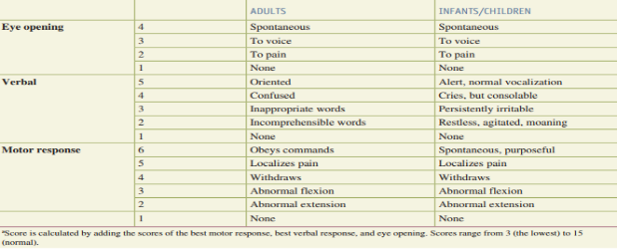

Annex 2: Algorithm for the management of blunt abdominal injury
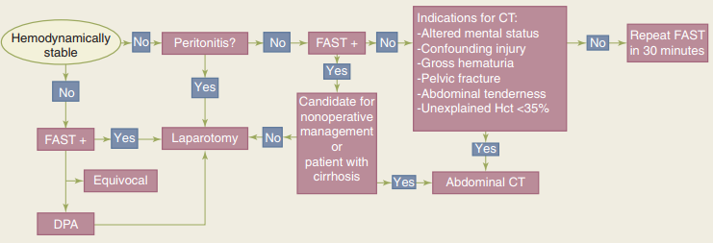
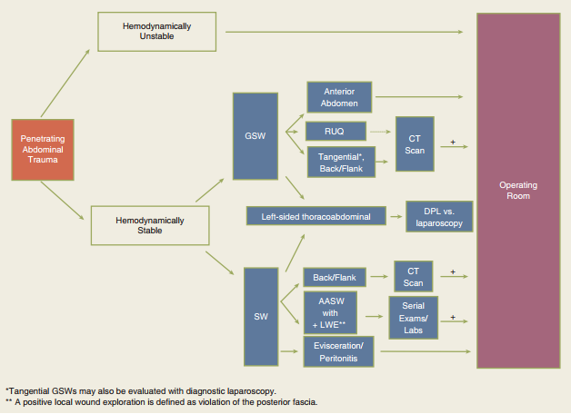
Figure A.1. Algorithm for the management of penetrating abdominal injury
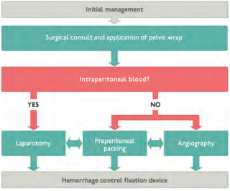
Figure A.2. Algorithm for the management of pelvic fracture and hemorrhagic shock

